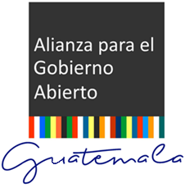

NATIONAL OPEN GOVERNMENT

ACTION PLAN

GUATEMALA 2016 – 2018

DISCLAIMER
This translation was made possible by the generous support of the American people through the United States Agency for International Development (USAID). The contents are the responsibility of the Open Government Partnership in Guatemala and do not necessarily reflect the views of USAID or the United States Government.
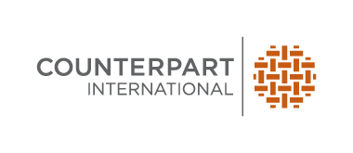

OPEN GOVERNMENT PARTNERSHIP GUATEMALA
“Transparency, Collaboration, and Participation”

www.gobiernoabierto.transparencia.gob.gt

CONTENTS

ACRONYMS 5
INTRODUCTION 7
I. OPEN GOVERNMENT ACTIONS IN GUATEMALA 8
First National Open Government Action Plan 2012-2014 8
Second National Open Government Action Plan 2014-2016 10
Third National Open Government Action Plan 2016-2018 16
II. DRAFTING PROCESS FOR THIRD NATIONAL OPEN GOVERNMENT ACTION PLAN 2016-2018 18
a) Methodology and Activity Schedule 18
b) Public Call 23
c) Development of an Activity Schedule 25
Three Regional Open Consultation Forums Addressing 5 Central Work Themes of the National Open Government Action Plan 26
Thematic Roundtables on the Five Central Work Themes of the Plan 29
Thematic Roundtable on Fiscal Transparency 30
Thematic Roundtable on Access to Public Information and Institutional Archives 31
Thematic Roundtable on Citizen Participation 32
Thematic Roundtable on Accountability 33
Thematic Roundtable on Technological Innovation 34
III. 22 COMMITMENTS OF THE THIRD NATIONAL OPEN GOVERNMENT ACTION PLAN FOR GUATEMALA 2016-2018 41
Institutions that Participated in the Drafting Process for the National Open Government Action Plan 2016-2018 89

ACRONYMS
AC, Acción Ciudadana (Guatemalan chapter of Transparency International)
ACPN, Asociación Ciudadana Pro Nación (Pro Nation Citizen Associaton)
AGA, Alianza para el Gobierno Abierto (Open Government Partnership)
AIP, Acceso a la Información Pública (Access to Public Information)
ANAM, Asociación Nacional de Municipalidades (National Association of Municipalities)
CFPMCR, Comisión de Finanzas Públicas y Moneda del Congreso de la República (Public Finance Comission, Congress of the Republic)
CGC, Contraloría General de Cuentas (General Comptroller’s Office)
CIIDH, Centro Internacional para Investigación en Derechos Humanos (International Centre for Human Rights Research)
CONADI, Consejo Nacional para la Atención de las Personas con Discapacidades (National Network for Support to Disabled Persons)
CONADUR, Consejo Nacional de Desarrollo Urbano y Rural (National Council for Urban and Rural Development
CONAP, Consejo Nacional de Aéreas Protegidas (National Council of Protected Areas)
CONRED, Coordinadora Nacional para la Reducción de Desastres (National Coordinator for Disaster Reduction)
COPRET, Comisión Presidencial de Transparencia y Gobierno Electrónico (Presidential Commission for Transparency and Electronic Government)
CoST, Iniciativa de transparencia del sector de la construcción (Construction Sector Transparency Initiative)
CR, Congreso de la República (Congress of the Republic)
CUNOC, Centro Universitario del Occidente (Western University Center)
CUNOR, Centro Universitario del Norte (Northern University Center)
DAAFIM, Dirección de Asistencia a la Administración Financiera Municipal (Direction of Assistance to Municipal Management and Finances)
DAJ, Dirección de Asesoría Jurídica (Direction of Legal Counsel)
DAPF, Dirección de Análisis y Política Fiscal (Fiscal Analysis and Policy Management Directorate)
DCE, Dirección de Contabilidad del Estado (General State Accounts Office)
DCP, Dirección de Crédito Público (Public Credit General Office)
DCS, Dirección de Comunicación Social (Direction of Social Communication)
DEF, Dirección de Evaluación Fiscal (Direction of Fiscal Evaluation)
DEMI, Defensoría de la Mujer Indígena (Office for the Defense of Indigenous Women)
DMS, Distrito Municipal de Salud (Municipal Health District)
DNCAE, Dirección de Normativa de Contrataciones y Adquisiciones del Estado (State Contracting and Procurement Direction)
DTI, Dirección de Tecnologías de la Información (Direction of Information Technologies)
DTP, Dirección Técnica del Presupuesto (Technical Budgeting Direction)
EITI, Iniciativa para la Transparencia de las Industrias Extractivas (Extractive Industries Transparency Initiative)
FMI, Fondo Monetario Internacional (International Monetary Fund)
GA, Gobierno Abierto (Open Government)
Guatenóminas, Sistema de Nómina y Registro de Personal (Payroll ontrol system)
Guatecompras, Sistema de Adquisiciones y Contrataciones del Estado (Public procurement system)
ICEFI, Instituto Centroamericano de Estudios Fiscales (Central American Institute for Fiscal Studies)
INAP, Instituto Nacional de Administración Pública (National Institute of Public Administration)
INFOM, Instituto Nacional de Fomento Municipal (National Institute for Municipal Development)
PDH, Institución del Procurador de los Derechos Humanos (Human Rights Ombudsman’s Office)
ISR, Impuesto Sobre la Renta (Income tax)
LAIP, Ley de Acceso a la Información Pública (Access to Public Information Law)
MIIT, Mesa Técnica Interinstitucional de Innovación Tecnológica (Interagency Technological Innovation Roundtable)
MINEDUC, Ministerio de Educación (Ministry of Education)
MINFIN, Ministerio de Finanzas Públicas (Ministry of Public Finances)
MRI, Mecanismo de Revisión Independiente (Independent Revision Mechanism)
MTGA, Mesa Técnica de Gobierno Abierto (Open Government Technical Roundtable)
OCDE, Organización para la Cooperación y el Desarrollo Económicos (Organizaton for Economic Cooperation and Development)
OEA, Organización de Estados Americanos (Organization of American States)
OGP, Open Government Partnership (in English)
ONSEC, Oficina Nacional de Servicio Civil (National Civil Service Office)
OPF, Organización de Padres de Familia (National Parent Organization)
PAN, Plan de Acción Nacional (National Action Plan)
RENAP, Registro Nacional de Personas (National Registry of Persons)
ROI, Reglamento Orgánico Interno (Internal rules and regulations)
SAT, Superintendencia de Administración Tributaria (Superintendence of Tax Administration)
SCEP, Secretaría de Coordinación Ejecutiva de la Presidencia (Presidential Secretariat for Executive Coordination)
SCSP, Secretaría de Comunicación Social de la Presidencia (Presidential Secretariat for Social Communication)
SEGEPLAN, Secretaría de Planificación y Programación de la Presidencia (Presidential Planning and Programming Secretariat)
SENACYT, Secretaría Nacional de Ciencia y Tecnología (Presidential Science and Technology Secretariat)
SGP, Secretaría General de la Presidencia (General Secretariat of the Presidency)
SIAF, Sistema Integrado de Administración Financiera (Integrated Finance Administration System)
SICOIN, Sistema de Contabilidad Integrada (Integrated Accounting System)
SIGES, Sistema de Gestión (Management systems)
SIT, Superintendencia de Telecomunicaciones (Superintendence of Communications)
SNIP, Sistema Nacional de Inversión Pública (National System for Public Investment)
SPNF, Sector Público No Financiero (Non-Financial public sector)
STAR, Iniciativa de Recuperación de Activos Robados (Stolen Asset Recovery)
TN, Tesorería Nacional (National Treasury)
USAC, Universidad de San Carlos de Guatemala (University of San Carlos de Guatemala)

INTRODUCTION

Guatemala joined the Open Government Partnership (OGP) on July 27th of 2011 and ratified its membership in 2012. The Guatemalan government has implemented two biannual Open Government Action Plans to date, and drafted a third for the 2016-2018 period.

The Open Government Partnership currently has 70 participating countries that have adhered to the Declaration of Open Government at the highest level. This process involved sending Letters of Interest to participate, and Guatemala was subject to a review before it was deemed to be eligible by the OGP. Two biannual national action plans have since been created by government, civil society and interested stakeholders.
This third plan, however, will be the first National Open Government Action Plan that follows every OGP standard, from the methodology for consultation to the drafting of commitments using the SMART Method, approved by the Open Government Technical Roundtable.
The National Open Government Action Plan for the period that spans 2016-2018 was drafted to unify wills and efforts of all public institutions and civil society organizations that take part in the Open Government Technical Roundtable.
The year 2015 was marked by a political and institutional crisis triggered by the criminal proceedings taken against a network of high-level State and non-State plaintiffs accused of corruption and fiscal evasion. Public mobilization demanded the resignation of then Vice-President and President of Guatemala, both linked to the proceedings due to accusations of customs fraud, bribery and crimes of conspiracy, and both currently in prison.
In this political and institutional framework, amid the social outcry and the far-reaching demands for a profound reform to the Guatemalan political system, an Open Government initiative becomes a key mechanism for the prevention of corruption and the transformation of the public service. Representatives of public institutions and civil society came together to discuss and adhere to the 22 essential commitments that form the National Open Government Action Plan for 2016-2018 and its five core initiatives: a) Increase access to public information; b) Increase access to new technologies; c) Increase citizen participation; d) Increase public integrity and accountability; and e) increase fiscal accountability.
The following action plan is the result of the collaboration and participation of various stakeholders that represent the public sector, including the President and Vice President of the Republic, the Point of Contact with the Open Government Partnership, state institutions, autonomous and semi-autonomous public entities, as well as members of civil society organizations and citizens through public forums and consultations.

OPEN GOVERNMENT ACTIONS IN GUATEMALA

First National Open Government Action Plan 2012-2014

On April 9th, 2012 the Guatemalan Government presented its first National Open Government Action Plan, based on 2 key commitments divided into 8 actions, all aimed at the Executive branch of the Government.

1: Increase public integrity:
  - Expediting administrative processes.
  - Progressive eradication of secrecy in the awarding of goods, services, and public works.
  - Disclosure of results through results-based management methodologies.

2: Increase effectiveness in the execution of public spending:
  - Regulation to eradicate waste.
  - Regulations for the hiring of permanent, advisory, and consulting personnel.
  - Regulation of an effective, timely acquisitions plan.
  - Regulation of superfluous expenses.
  - Effective use of loans and donations.
The Presidential Commission for Transparency and Electronic Government (COPRET), responsible for monitoring the action plan, reported the following actions taken:
Action 1: Creation of the Presidential Secretariat for Control and Transparency
It was established by means of Government Decree 37-2012 with four lines of work: anti-corruption transparency, public information and electronic government.

Action 2: Presentation of Transparency Law and initiatives
The Presidency sent Congress two initiatives: a) Initiative 4461 “Law of strengthening institutions for transparency and quality of public spending” and b) Initiative 4462 “Law of strengthening transparency and public spending”.

Action 3: Implementation of results-based management methodologies.

Action 4: Development and improvement of electronic government and access to public information.

TABLE 1: ASSESSMENT OF PROGRESS BY COMMITMENT FOR FIRST OPEN GOVERNMENT ACTION PLAN 2012
No. | NAME OF COMMITMENT | TIMING | LEVEL OF COMPLETION | POTENTIAL IMPACT
1. | Expediting administrative processes | Behind schedule | Limited | Minor
2. | Progressive eradication of secrecy in the awarding of goods, services, and public works | Behind schedule | Limited | Minor
3. | Promotion of importance of results-based management methodologies | Behind schedule | Limited | Minor
4. | Regulation to eradicate waste | Behind schedule | Limited | Minor
5. | Regulations for the hiring of permanent, advisory, and consulting personnel | Behind schedule | Limited | Minor
6. | Regulation of an effective, timely acquisition plan | Behind schedule | Limited | Minor
7. | Regulation of superfluous expenses | Behind schedule | Substantial | Minor
8. | Pay consultants for productions of goods on  intermediate basis | Behind schedule | Not started | Minor
9. | Regulate resource expenditures | Behind schedule | Not started | Minor
10. | Make available information on public funds | Behind schedule | Limited | Minor
11. | Promote expedited execution to reduce interest payments | Behind schedule | Limited | Minor
12. | Construction Sector Transparency Initiative (COST) | On schedule | Substantial | Transformative
13. | Extractive Industries Transparency Initiative (EITI) | Behind schedule | Limited | Moderate
14. | Stolen Asset Recovery Initiative (STAR) | Behind schedule | Limited | Minor

Two important steps that were omitted during the creation and implementation of the First National Open Government Action Plan were: the invitation to civil society organizations and other stakeholders to participate in the consultation process, and the consultation to multiple stakeholders during implementation of the plan.

Second National Open Government Action Plan 2014-2016

The Second National Open Government Action Plan was presented in June of 2014 by the Executive Branch of the Government through the institution in charge of preparing the plan, the Presidential Commission for Transparency and Electronic Government (COPRET), as well as representatives of the civil society sector.

Drafting of this second plan initiated one month prior to the deadline for submitting the document. A public call for participants in its creation was published in the written media and four meetings were carried out with public entities and civil society organizations before the plan was presented to the Open Government Partnership. The Government proposed 22 commitments and the civil society sector proposed 26, for a total of 48 initiatives put forward in the action plan.

The Open Government Technical Roundtable was formed and consolidated with representatives of entities responsible for commitments, the three organizations representing the civil society sector (ICEFI, Congreso Transparente -Transparent Congress- and Guatecívica), and the Independent Revision Mechanism (Mecanismo de Revisión Independiente –MRI-), and met once a month.

The OGP Point of Contact held roundtables with the civil society sector and the MRI to analyze level of completion for each initiative and to choose which commitments would be discussed during meetings of the Open Government Technical Roundtable.

Five basic actions that encompass the 48 commitments put forward by government and civil society were identified in the National Open Government Action Plan for 2014-2016:
- Increase in public resources
- Transparency and citizen participation
- Increase in public integrity and accountability
- Improvement in public resources
- Natural resources governance
In the Mid Term Self-Assessment Report, the institution in charge of monitoring completion states that 28 of the 48 commitments made in the Second National Open Government Action Plan for 2014-2016 were completed, while 14 were substantially advanced and 6 had limited progress.

The following initiatives put forth in the Second National Open Government Action Plan were completed:
- Establishment of Open Government Technical Roundtable
- Creation of national catalog of online public services
- Implementation of systems to make tax exemptions and exonerations more transparent
- Day-long dialogues for citizen participation
- Advances in transparency for processes regarding loans and donations
- Translation of the Access to Public Information Law into 20 Mayan languages
- Creation of technical working groups with representatives of different sectors
- Publication of clearance certificates (finiquitos) of public officials extended by the General Comptroller’s Office
- Creation of a Manual for Standardization of Executive branch web portals
- Implementation of the Transparency School
- Implementation of the guide for the evaluation of Public Information Units for ministries, secretariats and other public institutions in the Executive branch
- Implementation and follow-up of CoST and EITI initiatives
- Implementation of Open Budget on web portals of the Executive branch
- Advances in the institutionalization of the first level of health assistance
- Advances in compliance with the new Fiscal Transparency Code and Manual of the International Monetary Fund
- Design and implementation of manuals, guidelines and technical provisions for accountability
- Improvement of Public Information Systems
- Publication of budget-related documents and mechanisms for citizen participation in open budgeting
- Publication of expenditures and resources earmarked to repair damages caused by natural disasters
- Creation of technical roundtables in different areas such as: Civil Society, Inter-agency relations, Academic sector, business sector, health, electronic government and public information
The following table details the 48 commitments contained in the National Open Government Action Plan for 2014-2016, divided into the 22 proposed by the government and the 26 proposed by the civil society sector.

48 COMMITMENTS CONTAINED IN THE SECOND OPEN GOVERNMENT ACTION PLAN 2016-2018
No. | PROPOSED BY: | NAME OF COMMITMENT | THEME
1 | Government | Effectiveness of information included in the web portal of Executive Branch institutions | Increase public resources
2 | Government | Implementation of Open Budgeting in all web portals | Increase public resources
3 | Government | Implementation of a specific Open Data web page in Executive Branch institutions | Increase public resources
4 | Government | Online citizen services | Increase public resources
5 | Government | Dissemination of results through communications media and institutional web portals | Increase public resources
6 | Government | Implementation of the Transparency School (Escuela de Transparencia) | Transparency and citizen participation
7 | Government | Raise awareness among the population in issues of transparency and the fight against corruption; and create spaces for citizen participation in decision making | Transparency and citizen participation
8 | Government | Establish technical work groups with Civil Society, Academic Sector, Business Sector, and Open Government | Transparency and citizen participation
9 | Government | Dissemination of actions included in the Open Government Action Plan through forums, conferences, and technical working groups | Transparency and citizen participation
10 | Government | Implementation of interoperability | Increase in public integrity and accountability
11 | Government | Executive Branch alerts on possible acts of corruption | Increase in public integrity and accountability
12 | Government | Gradual eradication of secrecy in the awarding of goods, services, and public works | Increase in public integrity and accountability
13 | Government | Make more transparent the progresses made regarding loans and donations by organization, counterpart, and component | Increase in public integrity and accountability
14 | Government | Implementation and follow-up of the CoST initiative | Increase in public integrity and accountability
15 | Government | Implementation and follow-up of the EITI initiative | Increase in public integrity and accountability
16 | Government | Creation of a national catalog of electronic services posted on the web portals of ministries and their corresponding executing units, and consolidation in a single source of information to allow a fast and effective search by citizens | Increase in public integrity and accountability
17 | Government | Streamlining of value processes in each Ministry through the use of technology | Increase in public integrity and accountability
18 | Government | Identify focal points for corruption in administrative and operative processes of ministries and increase data openness in these processes as part of the accountability that all institutions need to have | Increase in public integrity and accountability
19 | Government | Promote technological talent through workshops with the academic and private sectors, developing applications with geospatial data or open data techniques for the benefit of citizens and government | Increase in public integrity and accountability
20 | Government | Creation of a single web portal (Uniportal) that includes each electronic service provided in institutional web pages, by Ministry, and with concise descriptions. This single portal will not replace institutional webpages, but gather together all services provided by the government | Increase in public integrity and accountability
21 | Government | Promote transparency and accountability in the management of natural resources in order to guarantee that revenues from extractive industries be used to generate social well-being | Increase in public integrity and accountability
22 | Government | Ensure that resources earmarked to repair damages caused by natural disasters are used with strict transparency and accountability criteria | Increase in public integrity and accountability
1 | Civil Society | Improve levels of transparency and access to public information | Transparency and citizen participation
2 | Civil Society | Promote informed citizen participation and surveillance, and issue alerts | Transparency and citizen participation
3 | Civil Society | Increase public integrity | Increase in public integrity and accountability
4 | Civil Society | Standardize publication of public data | Increase in public integrity and accountability
5 | Civil Society | Strengthen the institution in charge of coordinating the National Open Government Action Plan | Increase in public integrity and accountability
6 | Civil Society | Complementary legislation to guarantee the right to free access to public information | Increase in public integrity and accountability
7 | Civil Society | Design and implement manuals, guidelines, and technical provisions for accountability | Increase in public integrity and accountability
8 | Civil Society | Expansion of informed participation in the existing spaces through community mapping | Improvement in public resources
9 | Civil Society | Active promotion of digital inclusion at a national level | Improvement in public resources
10 | Civil Society | Institutionalize the first level of health assistance | Improvement in public resources
11 | Civil Society | Full compliance with the new Fiscal Transparency Code and Manual of the International Monetary Fund | Improvement in public resources
12 | Civil Society | Publication of all budget-related documents | Improvement in public resources
13 | Civil Society | Open and institutionalize spaces for citizen participation in the budget drafting process | Improvement in public resources
14 | Civil Society | Reform the Integrated Accounting System (SICOIN), component of the Financial Management Integrated System (SIAF) | Improvement in public resources
15 | Civil Society | Reform the Local Government Portal (Portal GL), component of the Financial Management Integrated System (SIAF) | Improvement in public resources
16 | Civil Society | Integration and linkage to financial management systems and sub-systems | Improvement in public resources
17 | Civil Society | Full compliance with the Standard of the Global Forum for Tax Transparency of the Organization for Economic Cooperation and Development (OECD) | Improvement in public resources
18 | Civil Society | Publish tax collection goals and annual collection, control and audit plan | Improvement in public resources
19 | Civil Society | Make tax exemptions and exonerations more transparent | Improvement in public resources
20 | Civil Society | Standardize conditions for State procurement tenders | Improvement in public resources
21 | Civil Society | Regulate and make direct procurement and exceptions to State procurement more transparent | Improvement in public resources
22 | Civil Society | Strengthening of the issuing of reference prices for procurement in open tenders | Improvement in public resources
23 | Civil Society | Strengthening of the units or offices in charge of public procurement planning | Improvement in public resources
24 | Civil Society | Strengthening of internal audit units | Improvement in public resources
25 | Civil Society | Update web portals for trust funds, non-governmental organizations, and budget transfers | Improvement in public resources
26 | Civil Society | Electronic government and improvement of the quality of public services | Improvement in public resources

The report of the Independent Review Mechanism (MRI, for its initials in Spanish) published the following comparative results for the first and second National Open Government Action Plans for Guatemala:
CLASSIFICATION | FIRST PLAN | SECOND PLAN | REGIONAL AVERAGE
LEVEL OF COMPLETION (substantial or full) | 14% | 63% | 53%
IMPACT (potential or transformative) | 7% | 6% | 12%
RELEVANCE (to OGP values) | 50% | 77% | 86%
STELLAR (new criteria) | 1 | 1

The MRI report included the following recommendations about the next Open Government Partnership planning cycle:
- Adopt measures that encourage citizens, public service users, contractors, and public workers to report corruption, while also protecting whistleblowers, improving the capacity to identify and document acts of corruption.
- Prioritize and improve the quality of commitments, and build an action plan that aligns with the vision of the government, but with fewer, more ambitious commitments that can produce concrete results in the two-year OGP cycle.
- Strengthen the consultation and co-creation process, and use the OGP platform and action plan to facilitate dialogue, consensus, and collaboration.

Third National Open Government Action Plan 2016-2018

The Open Government Technical Roundtable constitutes a permanent space for dialogue between public entities and the representatives of the civil society sector that participate in the initiative. It has also become a mechanism for accountability, verification and monitoring of compliance to Action Plans that evidences the joint efforts towards its drafting and fulfillment.
The consultation and drafting period for the Third National Open Government Action Plan was postponed when the institution in charge of Open Government in Guatemala was not assigned a budget for 2016. This made it impossible for the Presidential Commission for Transparency and Electronic Government (COPRET) to continue upholding the 48 Open Government commitments contained in the plan, and also brought about a three-month delay in the drafting of the third biannual plan.
On March 31 of 2016, President Jimmy Morales appointed Zaira Mejía as the new Point of Contact with the Open Government Partnership. She was presented publicly to the Alliance for Transparency (Alianza por la Transparencia) on April 4 as the person responsible for Open Government initiatives in the country, charged with reactivating the Open Government initiative together with César Cabrera, the Open Government Contact before the Organization of American States (OEA, for its initials in Spanish), the completion and follow-up of the Second National Open Government Action Plan 2014-2016, and the drafting of the Third National Open Government Action Plan 2016-2018.
The OGP Point of Contact immediately began the calls for participation in drafting the plan, first among members of an inter-agency working group that had previously participated in Open Government and then among different institutions of the Executive branch that had already participated, along with other public entities and civil society organizations that expressed an interest in voluntarily participating in the drafting of the new plan.
The contact with OGP also received the support of the Organization of American States through Ambassador Milagro Martínez, in the initial phase through which awareness was raised in different social sectors. The various visits and meetings held in this preliminary phase later became part of the diagnostic paper “Situation and challenges to Open Government in Guatemala”, commissioned by President Jimmy Morales to Luis Almagro, Secretary General of the Organization of American States.
New participants were invited during this process, along with those who had already participated in the Open Government initiative in Guatemala: 11 civil society organizations, ministries and secretariats of the Executive branch, the Congress of the Republic (Congreso de la República), the General Comptroller’s Office (Contraloría General de Cuentas), the national university (Universidad de San Carlos de Guatemala), the Superintendence of Tax Administration (Superintendencia de Administración Tributaria –SAT-), the National Institute for Public Administration (Instituto Nacional de Administración Pública –INAP-), the Secretariat for Science and Technology, the Vice Ministry of Technology of the Ministry of Governance (Ministry of the Interior), the National Institute for Municipal Development (Instituto Nacional de Fomento Municipal), the National Association of Municipalities (ANAM), for its initials in Spanish), among other institutions that have joined the Open Government Technical Roundtable.
The support of the Organization of American States (OEA) was extremely important in this stage, and initial meetings of the Open Government Technical Roundtable were held in its central offices.

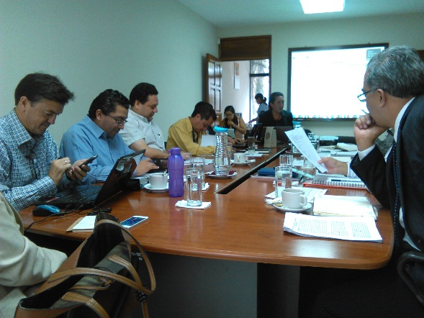 | 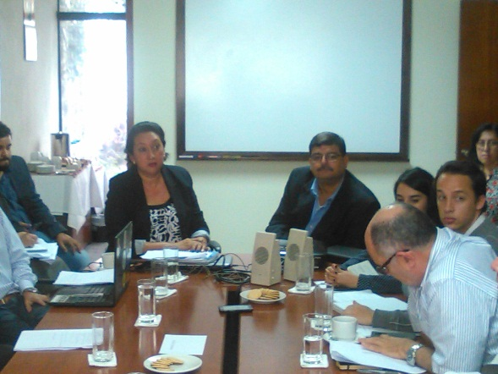
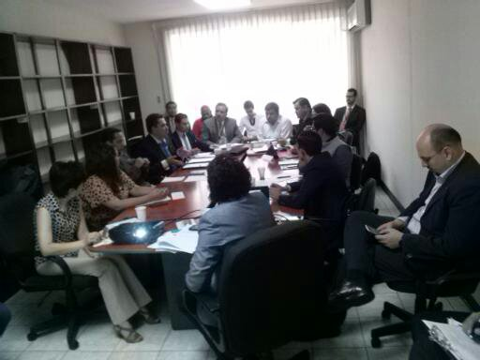

The methodology for the consultation process and the drafting of the plan was based on OGP directions and good practices, as well as internal country needs identified through the open call to participation and proactive participation of citizens in the process, together with a lack of financial resources of the OGP.
The Third National Action Plan includes some goals from the Second Open Government Action Plan 2014-2016, which were included specifically to provide continuity to the plan. An in-depth revision of commitments acquired by the country in the second document, together with results from the Independent Review Mechanism (MRI), allowed for a clear definition of the most relevant initiatives and the importance of their continuity. The objectives included twice in the second plan were consolidated, correcting the situation.

DRAFTING PROCESS FOR THIRD NATIONAL OPEN GOVERNMENT ACTION PLAN 2016-2018

a) Methodology and Activity Schedule

The methodology to be used for drafting the Third National Open Government Action Plan 2016-2018 was approved on Monday, May 12th by the Open Government Technical Roundtable. Before setting the dates for the methodology and activity schedule, the contact consulted plan deadlines with the OGP Support Team, to ensure that the country would comply even though the consultation process began four months behind schedule. The OGP Support Team responded that although the June 30 deadline could not be altered, Guatemala could submit their plan to the Open Government Partnership on August 31st at the latest without a report of non-compliance. The methodology and activity schedule was thus designed to allow for a submittal on that date. All information related to the methodology, activities and consultation process was published on the website gobiernoabierto.transparencia.gob.gt.
The methodology for the Third National Open Government Action Plan 2016-2018 was designed to draw from five central themes:
- Access to Public Information and Institutional archives
- Technological Innovation
- Citizen Participation
- Accountability
- Fiscal Transparency
The first stage, termed “I am Open Government”, aimed to make known the concept of open government among citizens and public entities through a campaign that made public the methodology and central themes proposed for the plan and invited citizens to state their opinion and participate in space for citizen consultation through the Open Government website gobiernoabierto.transparencia.gob.gt. This in turn generated statistics and provided valuable inputs regarding citizen opinions that were used by the technical roundtable to draft initiatives and commitments.
Meetings were also held during this first stage with representatives of State Ministries, Secretariats, State Organisms, members of the Civil Society sector and the Academy among others, to raise awareness about open government and the drafting process for the Third National Open Government Action Plan 2016-2018, to collect input about programs pertinent to the subject and to establish points of contact with various institutions. During the raising awareness stage, the support from the Organization of American States office in Guatemala was extremely helpful, facilitating a space for the OGP point of contact to meet with stakeholders about the drafting of the action plan.
The second stage, termed “Consultation Forums for Citizen Opinions about the Five Central Themes of the National Action Plan” allowed the team to define strategic goals based on citizen opinion inputs from various geographical regions throughout the country, through an open, collaborative and inclusive method in three departments: Guatemala, Quetzaltenango and Alta Verapaz. An Open Government Forum was carried out in Guatemala City as well, organized by the Organization of American States and the Guatemalan Government, with participation of representatives from different sectors of Guatemalan society.
Two thematic round tables were organized as part of the third stage within an open, collaborative and inclusive framework, to draft open government objectives and commitments for August of 2016 to June of 2018 and use the SMART Method criteria to set goals, objectives, deadlines and responsibilities. Technical delegates and high authorities of public entities participated in the process, as well as civil society organizations and other interested stakeholders.
And during the fourth stage, the Open Government Technical Roundtable evaluated commitments proposed during the consultation process. A discussion between technical representatives and leaders of different sectors led to the evaluation of initiatives, their compliance to the SMART Method, their viability, and their degree of relevance. This stage led to their inclusion in the Third National Open Government Action Plan 2016-2018.
Additional meetings of the Open Government Technical Roundtable were necessary to edit and refine the 22 initiatives included in the plan, and to assure their compliance to Open Government principles of transparency, collaboration and participation. The goals were set to conform to the following criteria: Specific, Measurable, Attainable, Relevant and Timely, as per the SMART goal-setting method.
A consensus was reached between technical delegates, representatives of different sectors, stakeholders and members of the Open Government Technical Roundtable, which led to a high-level roundtable attended by the President and Vice President of the Republic, the President of the Judicial Body (Organismo Judicial), the diplomatic community, high authorities to be held accountable for the 22 commitments, institutional points of contact and delegates of the technical roundtable, during which goals and initiatives included in the National Open Government Action Plan were validated and approved.
The methodology approved on May 12 of 2016 by the Open Government Technical Roundtable is comprised of nine major stages. An extraordinary technical meeting was later added to stage 6, as well as two extraordinary technical meetings during stage 7 to refine and systematize commitments proposed during the consultation phase. Also added to the methodology were five technical work roundtable meetings to edit and improve wording, unify goals and adapt open government principles to the plan.
OGP points of contact from Guatemala, El Salvador and Honduras participated in the Sub-Regional Meeting of the Northern Triangle of Central America, that took place in San Salvador, El Salvador from July 19 to 21 of 2016, as well as representatives of civil society organizations from the three countries. During this meeting, Guatemala agreed to send the OGP Support Unit the document for revision and possible recommendations before final validation and approval of the National Open Government Action Plan 2016-2018, to be sent by the point of contact on the appointed date.

METHODOLOGY AND ACTIVITY SCHEDULE FOR NATIONAL OPEN GOVERNMENT ACTION PLAN 2016-2018 CONSULTATION PROCESS (May 17 to August 11 of 2016)

No. | ACTIVITY | DATE | PARTICIPANTS | RESULT
1. | Public call for participation in consultation process (press conference). | May 17 | President of the Republic of Guatemala, civil society, interested stakeholders | Marks the beginning and validates process
2. | Creation of a space for citizen opinion on Open Government website, promotion of “I am Open Government” campaign on websites and social media of interested stakeholders | May 17 to June 14 | General public | Generation of inputs for drafting of commitments and initiatives, statistics of public opinion
3. | Open Government Forum (OAS) held in the National Palace of Culture | May 19 | Diverse stakeholders | Awareness raising and generation of inputs for drafting of National Open Government Action Plan
4. | Forums for open citizen consultation | June 7 to 13 | Civil society, government, interested stakeholders, general public | Awareness raising and generation of inputs for drafting of National Open Government Action Plan
 | Forum 1: Centro Cultural Universitario, Guatemala City. | June 7 | Civil society, government, interested stakeholders, general public | Awareness raising and generation of inputs for drafting of National Open Government Action Plan
 | Forum 2: Centro Universitario de Occidente, Quetzaltenango, Quetzaltenango. | June 9 | Civil society, government, interested stakeholders, general public | Awareness raising and generation of inputs for drafting of National Open Government Action Plan
 | Forum 3: Centro Universitario Nor Oriente, Cobán, Alta Verapaz | June 13 | Civil society, government, interested stakeholders, general public | Awareness raising and generation of inputs for drafting of National Open Government Action Plan
5. | Technical Roundtable Meetings (2 rounds) | June 15 to July 7 | Government, civil society, interested stakeholders | Discussion and drafting of commitments
 | Fiscal Transparency Technical Meeting held in Ministry of Public Finances | June 15 and 27 | Diverse stakeholders | Proposal of commitments
 | Access to Public Information Meeting held in Human Rights Ombudsman’s Office | June 17 and 29 | Diverse stakeholders | Proposal of commitments
 | Citizen Participation Meeting held in Casa Larrazábal, Congress of the Republic | June 20 and July 4 | Diverse stakeholders | Proposal of commitments
 | Accountability Meeting held in General Comptroller’s Office (Contraloría General de Cuentas) | June 22 and July 5 | Diverse stakeholders | Proposal of commitments
 | Technological Innovation Meeting held in Presidential Science and Technology Secretariat (SENACYT) | June 24 and July 7 | Diverse stakeholders | Proposal of commitments
6. | Meeting of Technical Roundtable and Open Government Workshop for discussion on viability and impact of commitments generated by thematic roundtables | July 13 | Members of the Open Government Technical Roundtable and observers | First draft with unified commitments accepted by Open Government Technical Roundtable
6.1 | Extraordinary Meeting of the Open Government Technical Roundtable to edit and improve wording of commitments proposed under the plan | July 15 | Members of the Open Government Technical Roundtable and observers | Systematization and unification of goals and unification of different commitments presented
7. | Meeting of the Open Government Technical Roundtable to present first version of National Open Government Action Plan 2016-2018 | July 18 | Members of the Open Government Technical Roundtable and observers | Approval of first draft of action plan for 2016-2018
7.1. | Extraordinary Meeting of the Open Government Technical Roundtable for systematization of proposed commitments | July 22 | Members of the Open Government Technical Roundtable and observers | Systematize, unify and refine commitments proposed for plan
7.2 | Organization of roundtables as per the OGP’s recommendation to refine wording, systematize goals and better incorporate OGP principles | July 26 to 29 | Work groups for 5 central themes, stakeholders responsible for proposed commitments | Systematize, restructure, unify goals in relation to commitments proposed for plan
7.3 | Extraordinary Open Government Technical Roundtable for the final reviewand technical validation of commitments proposed for the National Open Government Action Plan 2016-2018 | August 5 | Members of the Open Government Technical Roundtable and observers | Technical validation of  National Open Government Action Plan 2016-2018
8. | Open Government Technical Roundtable Meeting for approval and validation of final draft of National Open Government Action Plan 2016-2018 | August 11 | Members of the Open Government Technical Roundtable and observers | National Open Government Action Plan 2016-2018
9. | Submission of final draft of National Open Government Action Plan 2016-2018 to Open Government Partnership | August 12 to 14 | Open Government Partnership Point of Contact for Guatemala | Official presentation of plan to OGP

b) Public Call

On May 17 of 2016, President of Guatemala Jimmy Morales made a public call for a consultation to inform the Third National Open Government Action Plan 2016-2018, during a press conference with Vice President Jafet Cabrera, the Secretariat for Hemispheric Affairs for OAS James Lambert, the Minister of Public Finances Julio Héctor Estrada, the OGP Point of Contact for to OAS César Cabrera and the OGP Point of Contact to Guatemala, Zaira Mejía.
During the press conference, Guatemalan President Jimmy Morales called for public institutions, State organisms, decentralized and autonomous entities, and civil society organizations to participate in drafting the National Open Government Action Plan 2016-2018. President Morales mentioned the importance of the five central work themes that formed the basis of the plan: 1) Access to Public Information and Institutional Archives; 2) Technological Innovation; 3) Citizen Participation; 4) Accountability, and 5) Fiscal Transparency.
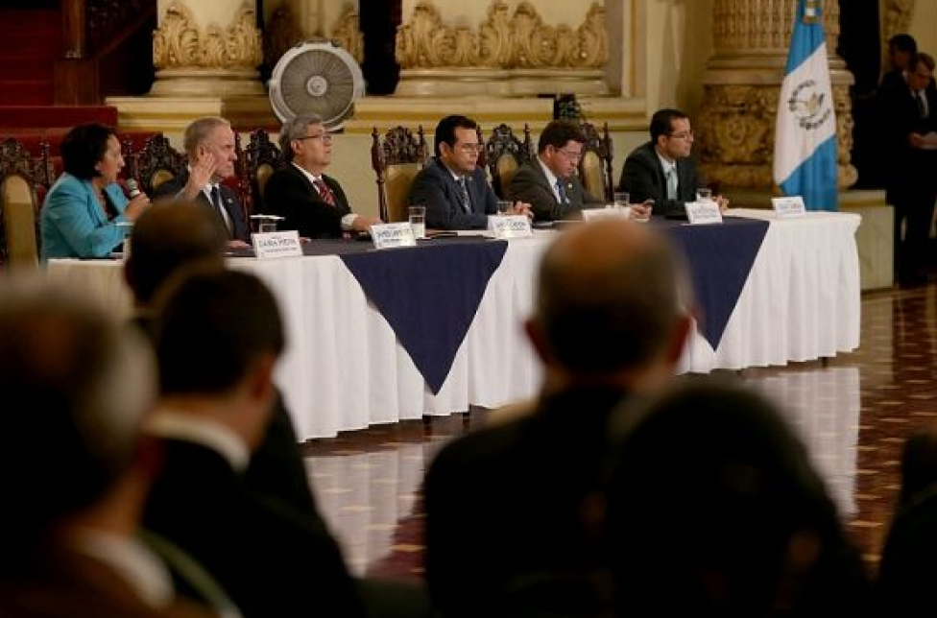

On May 19 of 2016, the Organization of American States and the Guatemalan government organized the forum “Tools for Open Government”, attended by the President and Vice President of the Republic, high ranking government officials, OGP points of contact, civil society organizations, the diplomatic community and interested stakeholders. President Jimmy Morales reiterated his call for all sectors of society to participate in drafting the Third Open Government Action Plan 2016.2018, and requested support and active involvement from the different institutions of the Executive Branch of government as well as representatives of the civil society.
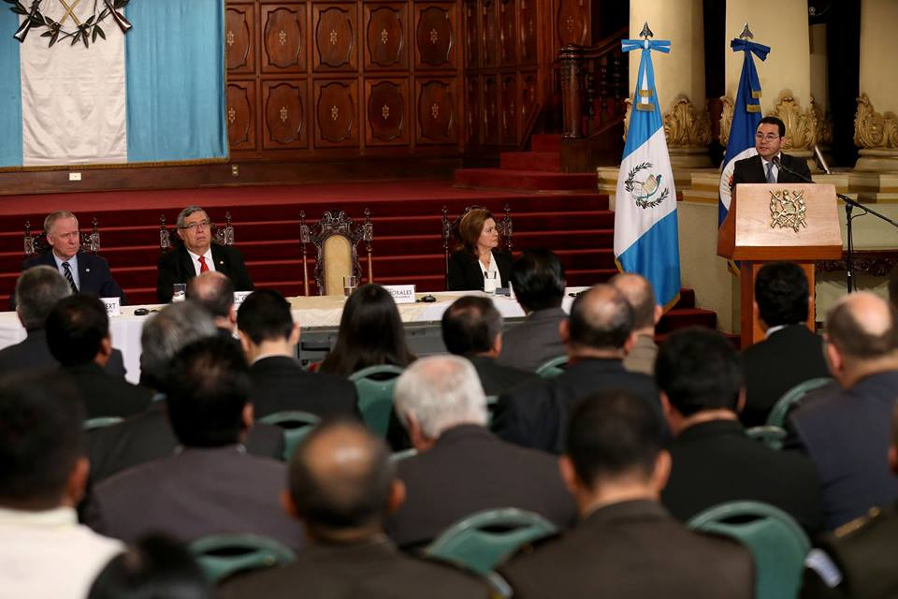

c) Development of an Activity Schedule

On May 25 of 2016, the institutions that currently formed the Open Government Technical Roundtable were convened to discuss the methodology and activity schedule for Guatemala, Quetzaltenango and Alta Verapaz: civil society organizations, the Executive Branch, the Congress of the Republic, the General Comptroller’s Office, San Carlos University of Guatemala, the National Registry of Persons (RENAP) and the Superintendence of Tax Administration (SAT).
Interest and collaboration showed by all public institutions and civil society organizations towards achieving the best results possible was at that time very valuable, especially with the limitations and time constraints of all. It is important to recognize the support the San Carlos University of Guatemala, that donated facilities, helped with logistics and provided local facilitators for the three regional forums, as well as the collaboration and support received during the open consultation forums, thematic roundtables and technical open government meetings from the United States Agency for International Development (USAID) through Counterpart International, organization that executes a project for strengthening of civil society organizations.
An open call for hiring of facilitators was necessary for regional forums. Ten facilitators were selected and divided by the five central work themes. Each topic also had a government facilitator and a representative of the civil society sector, trained on June 6 of 2016 and certified the Institute of Public Administration (INAP). Facilitators were later in charge of holding discussions with citizens and collecting input and citizen opinions for drafting of commitments during thematic roundtables.

Training of Facilitators from Public Entities and Civil Society Organizations for Regional Open Consultation Forums

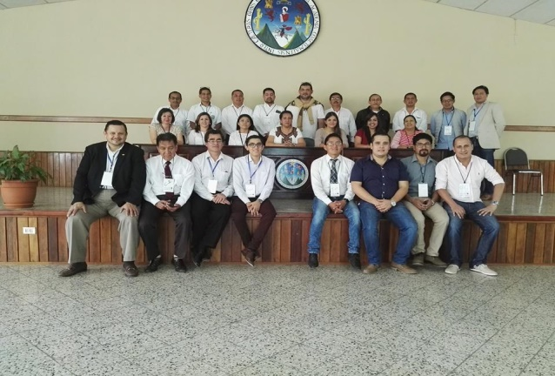
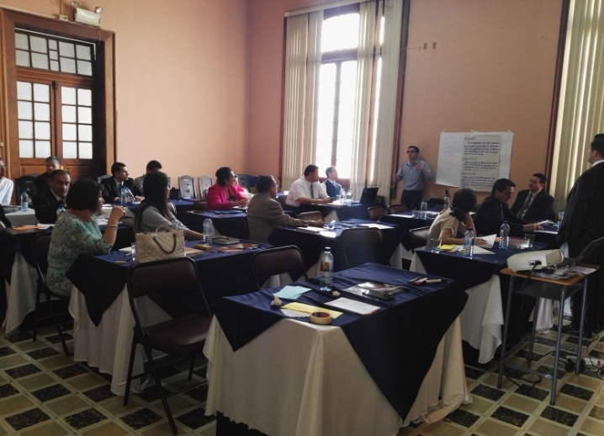

Three Regional Open Consultation Forums Addressing 5 Central Work Themes of the National Open Government Action Plan

The first Open Consultation Forum was held on June 7 of 2016 in the Universidad de San Carlos Cultural Center. Awareness of the importance of open government was raised among attendants, who also participated in discussions and expressed their opinions about the topic and about the five central work themes. The representative of the university praised the work carried out by OGP and pledged the university’s unconditional support to the initiative. The forum was held as a response to proposals put forward by civil society organizations.

The forum was attended by 113 citizens, students, and representatives of public institutions and civil society organizations who shared their views on the five central work themes:
- Access to Public Information and Institutional Archives
- Technological Innovation
- Citizen Participation
- Accountability
- Fiscal Transparency

The second open consultation forum was held using the same methodology at the Centro Universitario de Occidente (CUNOC), in Quetzaltenango, an office of the Universidad de San Carlos. This second consultation was held on June 9, 2016 and 206 citizens participated, among them university students, departmental delegates, representatives of public institutions and civil society organizations.

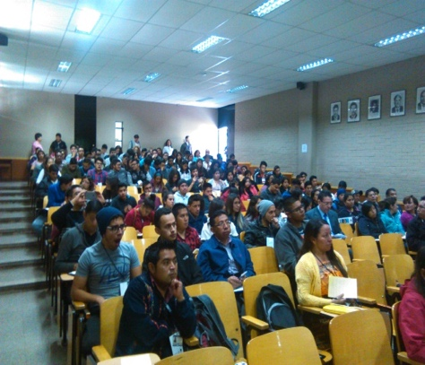
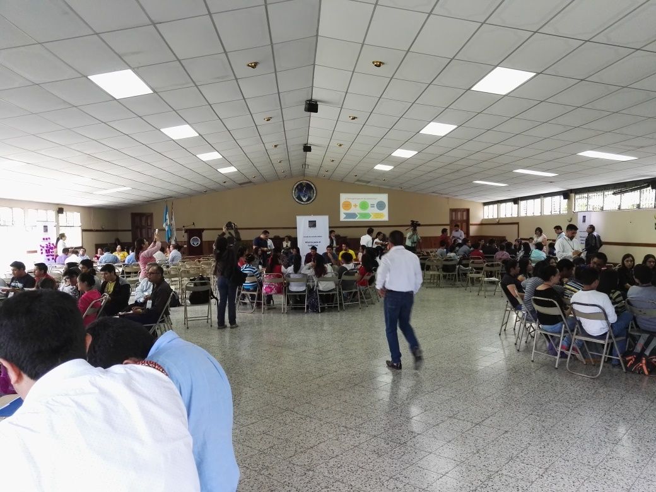

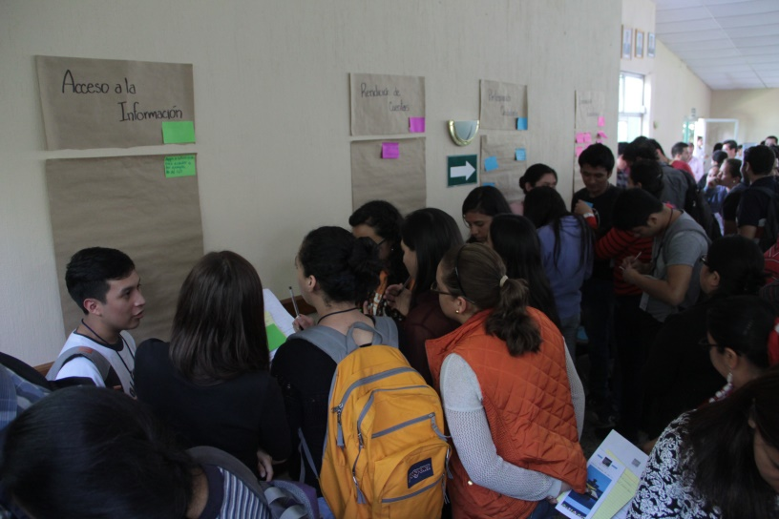
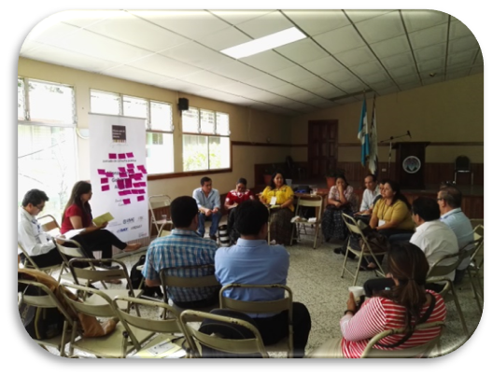
The third open consultation forum was held at the Centro Universitario de Nororiente (CUNOR) of the Universidad de San Carlos in Cobán, Alta Verapaz on June 13, 2016 and 212 citizens participated, among them university students, representatives of civil society organizations, and departmental delegates of public institutions and academia.
Citizen interest in open government topics was evidenced by the total participation of 531 citizens in the three regional forums, especially in Quetzaltenango and Cobán, Alta Verapaz. There is, however, a glaring lack of information about the topic at a national level. It is important to conduct an outreach and awareness-raising campaign about principles and values of open government directed at the general public.
The following institutions and technical staff joined forces to carry out the three regional forums:
- Open Government Partnership Point of Contact for Guatemala and Technical Roundtable
- University of San Carlos (Universidad de San Carlos de Guatemala)
- Civil Society Coordinating Network for Open Government (Congreso Transparente -Transparent Congress-, Acción Ciudadana -Transparency International-, and the Central American Institute for Fiscal Studies –ICEFI-)
- General Comptroller’s Office (Contraloría General de Cuentas)
- Superintendence of Tax Administration of Guatemala (Superintendencia de Administración Tributaria –SAT)
- Superintendent of Telecommunications (Superintendencia de Telecomunicaciones)
- Ministry of Public Finances
- National Registry of Persons (Registro Nacional de las Personas –RENAP-)
- The Congress of the Republic of Guatemala
- Presidential Science and Technology Secretariat
- Ministry of the Interior (MINGOB)
- Counterpart International and the United States Agency for International Development (USAID)
- Presidential Secretariat for Social Communication (Secretaría de Comunicación Social)

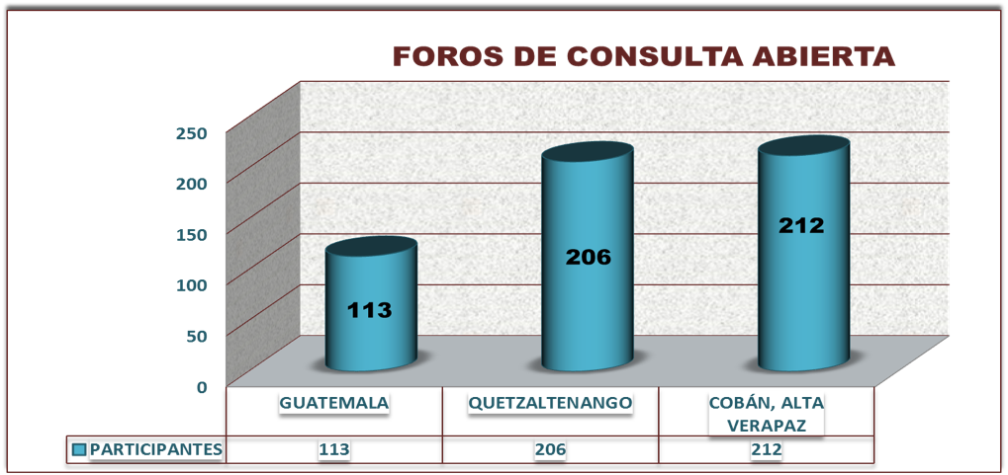

Table prepared by OGP Point of Contact based on attendee list.

Thematic Roundtables on the Five Central Work Themes of the Plan
It was established in the methodology for the action plan that two rounds of thematic roundtables would be held, based on the five central work themes. Citizen opinions were collected and systematized after each open consultation forum, and civil society organization presented advances in commitments made in the second plan for each thematic area. This generated a baseline for commitments proposed for the National Open Government Action Plan 2016-2018.
The Open Government Point of Contact explained how each commitment should be structured, based on the SMART method and the template provided by the OGP. Later, during the second round of thematic working groups, commitment proposals were presented by representatives of public institutions, civil society organizations and citizens interested in contributing ideas for central work themes. Thematic roundtables were carried out with support from the following institutions:

LOCATION OF THEMATIC ROUNDTABLES
THEMATIC ROUNDTABLES | INSTITUTION PROVIDING WORK SPACE
- Access to Public Information and Institutional Archives | Human Rights Ombudsman’s Office
- Citizen Participation | Congress of the Republic
- Accountability | General Comptroller’s Office
- Technological Innovation | Presidential Science and Technology Secretariat
- Fiscal Transparency | Ministry of Public Finances

Thematic Roundtable on Fiscal Transparency

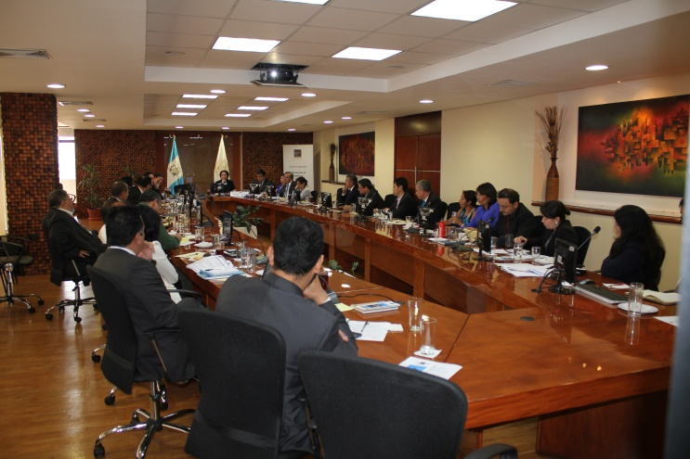
The first Thematic Roundtable on Fiscal Transparency was held on June 15, 2016 at the Ministry of Public Finances. Minister Julio Héctor Estrada participated, as well as the OGP Point of Contact Zaira Mejía, officials and delegates of public institutions, representatives of civil society organizations and interested stakeholders. Attendees showed an interest in presenting commitments, and the Minister also showed support for the process. Facilitators of open consultation forums presented results of systematization of citizen opinions to inform each thematic work theme.

The second Thematic Roundtable on Fiscal Transparency was held on June 27. The OGP Point of Contact reported on the number of proposed commitments received and each proponent explained the initiative:

- Superintendence of Tax Administration (SAT): Proposals presented: 2
- The International Center for Human Rights Research (CIIDH) Proposals presented: 11
- Central American Institute for Fiscal Studies (ICEFI) Proposals presented: 6
- Ministry of Public Finances (MINFIN): Proposals presented: 8
- Acción Ciudadana (Transparency International): Proposals presented: 2
- Transparente.gt Proposals presented: 1
          - Total proposals presented: 30
The Thematic Roundtable on Fiscal Transparency received the largest number of commitments from public institutions and civil society organizations: 30. Initiatives were later systematized in order to achieve fewer commitments and avoid duplication of goals, while including all proposals received.

Thematic Roundtable on Access to Public Information and Institutional Archives

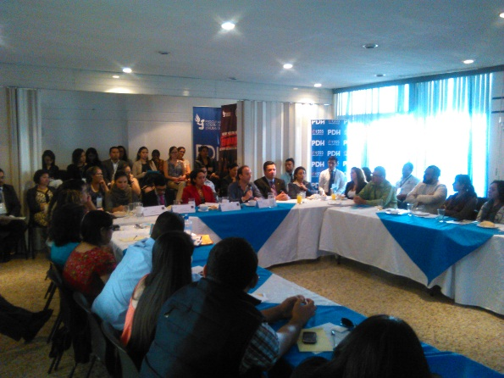
The Thematic Roundtable on Access to Public Information and Institutional archives was held in the Human Rights Ombudsman’s Office on Friday, June 17 of 2016. Ombudsman Jorge de León Duque attended the meeting, along with the OGP Point of Contact for Guatemala, representatives of public institutions, civil society organizations and citizens interested in the subject.
Meeting attendants discussed the need to strengthen mechanisms for the Access to Public Information Law (LAIP) so that obligations are met by all. All five thematic roundtables used the same methodology as the work meeting on Fiscal Transparency, and additional meetings had to be held to systematize, unify objectives and reduce the amount of commitments proposed, prior to their submission to the Open Government Technical Roundtable.
As was the case during the first thematic meeting, facilitators of open forums were given time to present citizen opinions collected during the consultation process, in this case with respect to access to public information and institutional archives.
The second Thematic Roundtable on Access to Public Information and Institutional Archives was held on June 24, also in the Human Rights Ombudsman’s Office. The OGP Point of Contact reported on the number of proposed commitments received and each proponent explained the initiative:

- Presidential Planning and Programming Secretariat (SEGEPLAN): Proposals presented: 1
- Acción Ciudadana (Transparency International): Proposals presented: 6
- Ministry of Communications: Proposals presented: 1
- Human Right’s Ombudsman’s Office (PDH): Proposals presented: 3
- National Registry of Persons (RENAP): Proposals presented: 3
- Office for the Defense of Indigenous Women (DEMI): Proposals presented: 1
- Ministry of Labor (MINTRAB): Proposals presented: 1
- National Council for Protected Areas (CONAP): Proposals presented: 2
- Presidential Secretariat for Executive Coordination (SCEP): Proposals presented: 1
          - Total proposals presented: 19

Thematic Roundtable on Citizen Participation

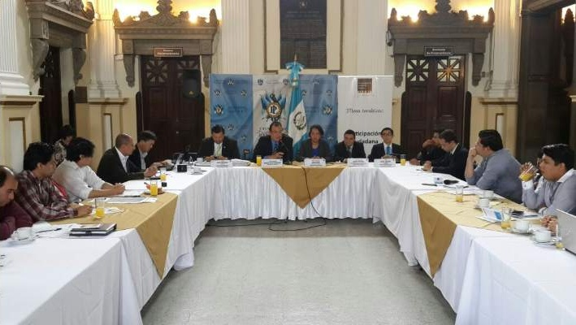
The Thematic Roundtable on Citizen Participation was held on Monday, June 20 in the Congress of the Republic. Marco Tulio Coronado attended in representation of the President of the Congress. Also present were the OGP Point of Contact, delegates from public institutions, representatives of civil society organizations and citizens interested in the subject. Meeting participants showed an interest in mechanisms to promote citizen participation, and facilitators of open forums were given time to present citizen opinions collected during the consultation process.
The second Thematic Roundtable on the subject was held on July 4, also in the Congress of the Republic. Proposed commitments were presented following work plan methodology, and participants determined the merger of some goals and commitments that passed to the next phase by consensus.
Proposals for citizen participation were presented by the following organizations and institutions:
- National Registry of Persons (RENAP): Proposals presented: 2
- Guatecívica (NGO) Proposals presented: 3
- Open municipalities (Munis abiertas): Proposals presented: 1
- Pro Nación Association: Proposals presented: 1
- Estudio 3 Majois: Proposals presented: 1
        - Total proposals: 8

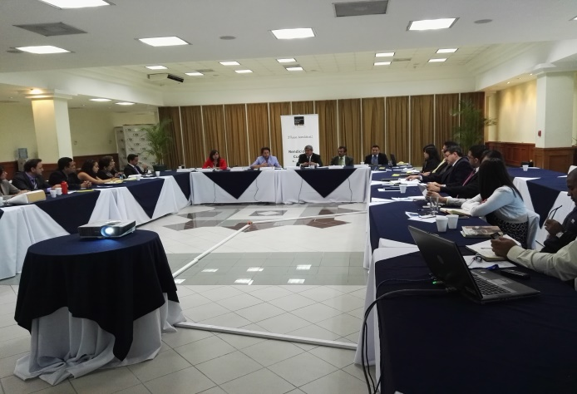
Thematic Roundtable on Accountability

The Thematic Roundtable on Accountability was held on June 22 at the Comptroller General’s Office. Carlos Enrique Mencos Morales, Comptroller General, attended the meeting as did the OGP Point of Contact for Guatemala, representatives of public institutions and civil society organizations, and interested citizens. The Comptroller General emphasized the commitment of his office to following up on commitments related to accountability and stated that all participants are responsible for good, clear, transparent accountability. As in previous meetings, open forum facilitators took the floor to present systematization of citizen opinions about accountability.

At the second Thematic Roundtable on Accountability, held on July 5th, the Point of Contact reported on the number of proposed commitments and allowed each organization to present their proposal. The Comptroller General attended the meeting and emphasized his intention to support efforts toward an open government, but added that all State agencies must participate for the result to lead to a real Open Government. The Comptroller also pointed out that the effort will not be visible in the short term, but long-term achievements will be essential for future generations.
Proposals for accountability were presented by the following organizations and institutions:
- National Coordinator for Disaster Reduction (CONRED): Proposals presented: 3
- Comptroller General’s Office: Proposals presented: 1
- Guatecívica (NGO): Proposals presented: 1
- Acción Ciudadana (Transparency International): Proposals presented: 2
- Estudio 3 Majois: Proposals presented: 1
- Total proposals: 9

Thematic Roundtable on Technological Innovation
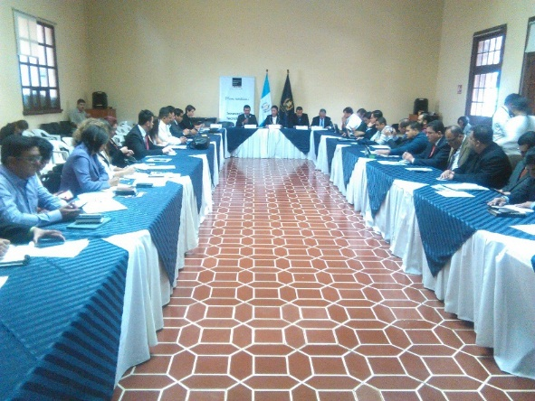
On June 25, 2016 the first Thematic Roundtable on Technological Innovation was held at the Presidential Science and Technology Secretariat (SENACYT). Secretary Oscar Manuel Cóbar Pinto presided the meeting, along with the OGP Point of Contact, the Vice Minister of Technology for the Ministry of Governance (Ministry of the Interior) along with public officials, representatives of civil society organizations and interested citizens. The Secretary said that, as technology is a crosscutting issue in all thematic areas of the open government process and there is an urgent need to promote science and technology and develop the potential of youth, the SENACYT will responsibly lead the process.

The second panel was held at the Ministry of Governance (Ministry of the Interior), on July 7, 2016 and was widely attended. The OGP Point of Contact presented the report with proposals received and each proponent explained the initiative. The Vice Minister of the Fourth Vice Ministry of Technology of the Ministry of Governance (Ministry of the Interior) participated and emphasized that technology is a valuable tool that can positively affect the population in need of information and public services, if it is well used and channeled correctly.

Proposals for citizen participation were presented by the following organizations and institutions:
- Transparente.gt: Proposals received: 1
- National Coordinator for Disaster Reduction (CONRED): Proposals received: 1
- Acción Ciudadana (Transparency International): Proposals received: 1
- Guatecívica Organization: Proposals received: 1
- National Civil Service Office (ONSEC): Proposals received: 1
- National Registry of Persons (RENAP): Proposals received: 2
- Red Ciudadana (Citizen Network): Proposals received: 3
- Institutional Group: Proposals received: 7
- Silvio Gramajo: Proposals received: 2
- Open Government Technical Roundtable Proposals received: 2
- Vice Ministry of Technology Proposals received: 1
Total proposals: 22

Meeting of Open Government Technical Roundtable, held on July 13, 2016
The meeting was held in the banquet hall of the National Palace of Culture. Representatives of the civil society sector attended through the Civil Society Coordinating Network for Open Government, as well as independent organization, points of contact and representatives of public institutions participating in the Open Government Technical Roundtable.
The total number of proposals received was announced during the meeting: commitments generated and systematized during past thematic roundtables. Every institution and civil society organization was able to present their proposal. It was necessary to hold two extraordinary roundtables to allow for all commitments to be presented, and to allow for a consensus among members of the technical roundtable about which commitments would be included in the National Open Government Action Plan 2016-2018.
The 33 commitments generated in thematic roundtables and presented in the meeting of the Open Government Technical Roundtable are detailed below:
PROPOSED COMMITMENTS DRAFTED IN 5 THEMATIC ROUNDTABLES
No. | WORK THEME | PROPOSED COMMITMENTS IN THEMATIC ROUNDTABLES | PROPOSED COMMITMENTS UNIFIED AND SYSTEMATIZED IN THEMATIC ROUNDTABLES AND PRESENTED TO OPEN GOVERNMENT TECHNICAL ROUNDTABLE
1. | ACCOUNTABILITY | 9 | 3
2. | CITIZEN PARTICIPATION | 8 | 5
3. | ACCESS TO PUBLIC INFORMATION AND INSTITUTIONAL ARCHIVES | 19 | 5
4. | TECHNOLOGICAL INNOVATION | 22 | 8
5. | FISCAL TRANSPARENCY | 30 | 12
Total………… |  | 88 | 33
Table prepared by OGP Point of Contact based on proposals received.
Extraordinary Meetings of the Open Government Technical Roundtable, held on July 15 and 22, 2016
Two extraordinary meetings of the Open Government Technical Roundtable were held to continue the discussion and analysis of the 33 proposed commitments created in thematic roundtables. Both were held in the largest hall of the Ministry of Interior, and allowed for the systematization and merging of goals which resulted in 31 proposed commitments.

Proposals were transformed into 31 during Extraordinary Technical Roundtables
No. | WORK THEME | COMMITMENTS PROPOSED IN THEMATIC ROUNDTABLES | PROPOSED COMMITMENTS SYSTEMATIZED AND UNIFIED TO PRESENT TO OPEN GOVERNMENT TECHNICAL ROUNDTABLE | PROPOSED COMMITMENTS SYSTEMATIZED AND UNIFIED IN TECHNICAL ROUNDTABLE
1. | ACCOUNTABILITY | 9 | 3 | 3
2. | CITIZEN PARTICIPATION | 8 | 5 | 3
3. | ACCESS TO PUBLIC INFORMATION AND INSTITUTIONAL ARCHIVES | 19 | 5 | 5
4. | TECHNOLOGICAL INNOVATION | 22 | 8 | 8
5. | FISCAL TRANSPARENCY | 30 | 12 | 12
Total………… |  | 88 | 33 | 31
Table prepared by OGP Point of Contact based on proposals systematized.
Recommendations of the OGP Support Unit were made known to the members of the Open Government Technical Roundtable during the extraordinary technical work meeting on July 22, 2016. It was necessary to carry out a day of workshops with those directly responsible for each commitment to refine wording and consistency with OGP principles of transparency, collaboration and participation.
It was also necessary to revise goals, which should be consistent, specific and achievable in the time of implementation of the action plan. The representative of the Central American Institute for Fiscal Studies (ICEFI) presented a proposal for systematization of the 12 commitments for fiscal transparency that could reduce the amount of commitments included in this work theme.

Thematic Roundtables for Goal Systematization, Commitment Unification and Editorial Fine-tuning Using OGP Principles, held from July 26 to July 29, 2016
- Thematic Roundtable on Fiscal Transparency: Tuesday July 26, 2016 from 8:00 to 13:00 hours in the Ministry of Public Finances. Product: Systematization and fine-tuning of 12 commitments into 7 final proposed commitments for fiscal transparency.
- Thematic Roundtable on Accountability: Wednesday July 27, 2016 from 8:00 to 12:00 hours at the General Comptroller’s Office. Product: Systematization and fine tuning of 2 commitments into 2 final proposed commitments for accountability (one of the commitments was removed by the proposing organization, Guatecívica, the night before the meeting).
- Thematic Roundtable on Access to Public Information and Institutional Archives: Wednesday July 27, 2016 from 14:00 to 17:00 hours at the offices of the organization Congreso Transparente (Transparent Congress). This meeting had to be extended into a second meeting held in the Ministry of the Interior on July 29, 2016 from 9:00 to 12:00 hours. Product: Systematization and fine-tuning of 5 proposed commitments. During the first meeting, held on July 27 the representative of the Human Rights Ombudsman’s Office stated that the institution would not be responsible for any Open Government commitment, offering however any technical support that does not generate additional costs to the institution. It became necessary to restructure commitments and propose new responsible parties for Open Government initiatives in this work area. The final proposal is made up of five pledges of Access to Public Information and Institutional Archives, which would be known and discussed at the next meeting of the Open Government Technical Roundtable.
- Thematic Roundtable on Citizen Participation: Thursday July 28, 2016 from 8:00 to 12:00 in the Congress of the Republic. Product: Systematization and fine-tuning of commitments into 3 final commitments proposed for citizen participation.
- Thematic Roundtable on Technological Innovation: Thursday July 28, 2016 from 14:00 to 17:00 at the Presidential Science and Technology Secretariat. Product: Systematization and fine-tuning of 8 commitments into 6 final commitments proposed for technological innovation.

FINAL COMMITMENTS PROPOSED AS A RESULT OF ROUNDTABLES
HELD FROM JULY 26 TO JULY 29, 2016

No. | WORK THEME | COMMITMENTS PROPOSED
1. | ACCESS TO PUBLIC INFORMATION AND INSTITUTIONAL ARCHIVES | 5
2. | TECHNOLOGICAL INNOVATION | 6
3. | CITIZEN PARTICIPATION | 3
4. | ACCOUNTABILITY | 2
5. | FISCAL TRANSPARENCY | 7
Total………… |  | 23
Table prepared by OGP Point of Contact based on proposals received.

Extraordinary Meetings of the Open Government Technical Roundtable for Validation of Commitments and National Open Government Action Plan, held on August 5 of 2016 in the Banquet Hall of the National Palace of Culture.
The 23 proposed commitments that were systematized and improved in the five workshops held from July 26 to 29 were announced during the meeting. The relevance of each proposal was also discussed, and changes suggested by the technical roundtable were incorporated. Each of the technicians directly responsible for each commitment was asked about willingness to cooperate and comply with commitments made by the institutions they represented.
Of the commitments presented during meetings, only the first initiative pertaining to Access to Public Information and Institutional Archives, “Improve level of compliance and proactive publication in access to public information” was left outside the action plan during the meeting, as the institution responsible for this commitment indicated that a lack of funding made it impossible to comply. The technical roundtable suggested holding a meeting with senior officials of the Congress of the Republic, the Ministry of Public Finances, the Human Rights Ombudsman's Office and the OGP Point of Contact to find a solution to the issues. The commitment was not included in the plan because the meeting was impossible to schedule prior to its submission.
Commitment No. 5, also pertaining to the work theme Access to Public Information and Institutional Archives, was edited to take into account the recommendations and resolutions of the technical roundtable, and was sent out to Congress for their review and validation.
The draft of the National Open Government Action Plan 2016-2018 is therefore composed of 22 commitments:
No. | WORK THEME | COMMITMENTS PROPOSED
1. | ACCESS TO PUBLIC INFORMATION AND INSTITUTIONAL ARCHIVES | 4
2. | TECHNOLOGICAL INNOVATION | 6
3. | CITIZEN PARTICIPATION | 3
4. | ACCOUNTABILITY | 2
5. | FISCAL TRANSPARENCY | 7
Total………… |  | 22
Table prepared by OGP Point of Contact based on proposals systematized.

Members of the Open Government Technical Roundtable were informed during the meeting the National Open Government Action Plan 2016-2018 would be validated and approved on August 11, 2016 from 9:00 to 11:00 in the Hall of Flags of the National Palace of Culture, in the presence of the President and Vice President of the Republic.
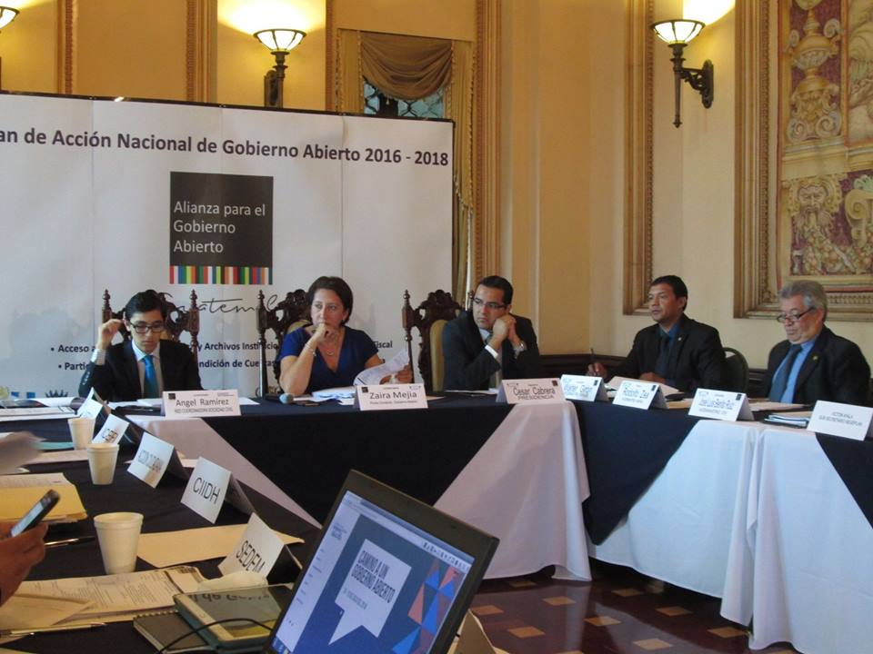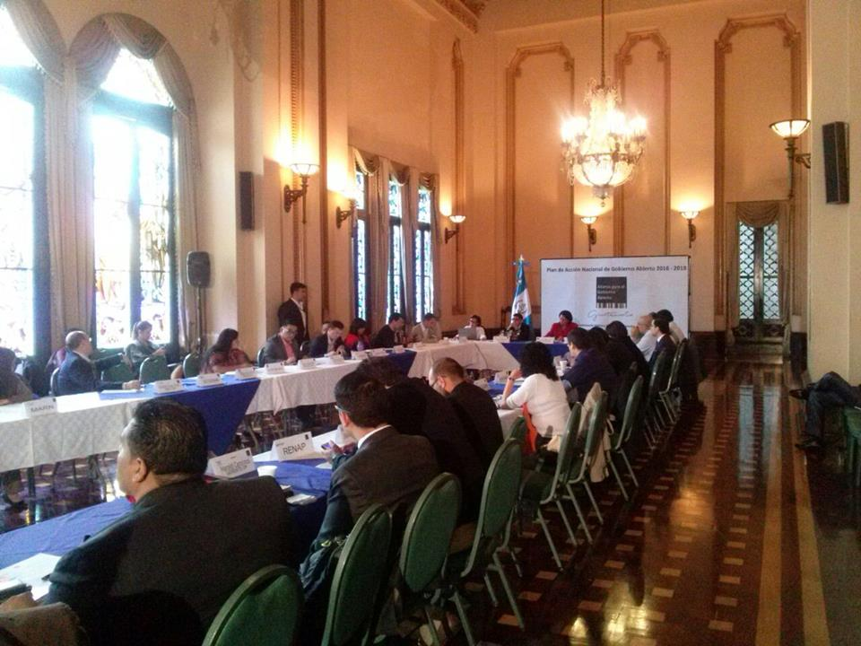

High-Level Meeting of the Open Government Technical Roundtable for Validation and Approval of National Open Government Action Plan 2016-2018
A High-Level Meeting of the Open Government Technical Roundtable was held on August 11, 2016 to briefly and concisely present the 22 commitments proposed in the action plan: 4 commitments for Access to Public Information and Institutional Archives; 6 for Technological Innovation; 3 for Citizen Participation; 2 for Accountability; and 7 for Fiscal Transparency. All commitments were validated by high authorities of public institutions and civil society organizations directly responsible for compliance.
Representatives of civil society organizations were able to express opinions about the drafting process and implementation of the National Open Government Action Plan 2016-2018. The Organization of American States (OEA) presented a diagnostic study about “the situation and challenges of Open Government in Guatemala”. The President and Vice President of the Republic expressed support for the Open Government Initiative and pledged to support the implementation of the National Open Government Action Plan 2016-2018.
Jimmy Morales, President of the Republic of Guatemala, publicly approved the National Open Government Action Plan 2016-2018 and joined all attendants in an oath to uphold the action plan together with the President of the Supreme Court of Justice, the Comptroller General, members of the diplomatic community, representatives of civil society organizations and all public institutions, autonomous and semi-autonomous, that participate in the Open Government Partnership in Guatemala.

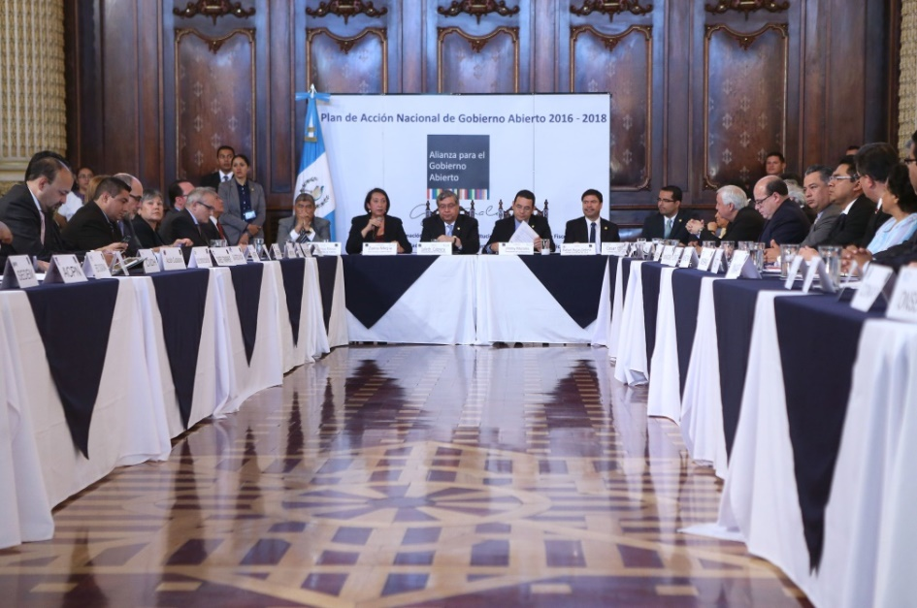

22 COMMITMENTS OF THE THIRD NATIONAL OPEN GOVERNMENT ACTION PLAN FOR GUATEMALA 2016-2018

No. | NAME OF COMMITMENT |  | RESPONSIBLE PARTY
ACCESS TO PUBLIC INFORMATION AND INSTITUTIONAL ARCHIVES
1. | TRAINING IN ACCESS TO PUBLIC INFORMATION AND INSTITUTIONAL ARCHIVES |  | NATIONAL INSTITUTE OF PUBLIC ADMINISTRATION
2. | TRAINING TO EDUCATIONAL PERSONNEL IN ACCESS TO PUBLIC INFORMATION AND INSTITUTIONAL ARCHIVES |  | COORDINATOR: MINISTRY OF EDUCATION  COORDINATOR: SAN CARLOS UNIVERSITY OF GUATEMALA
3. | EVALUATION OF GOOD PRACTICES IN ACCESS TO PUBLIC INFORMATION |  | ACCIÓN CIUDADANA (TRANSPARENCY INTERNATIONAL)  GUATECAMBIA
4. | ESTABLISH A MULTISECTOR ROUNDTABLE TO DISCUSS, DEVELOP AND PRESENT A BILL TO STRENGTHEN THE RIGHT TO ACCESS TO PUBLIC INFORMATION AND INSTITUTIONAL ARCHIVES, AS WELL AS A REGULATING INSTITUTION |  | CONGRESS OF THE REPUBLIC/PRESIDENCY  HUMAN RIGHTS COMMISSION
TECHNOLOGICAL INNOVATION
5. |  | CREATE AND IMPLEMENT AN OPEN DATA WEB PORTAL, CREATE AND APPROVE A NATIONAL POLICY ON OPEN DATA | COORDINATOR: PRESIDENTIAL SCIENCE AND TECHNOLOGY SECRETARIAT  VICE MINISTRY OF TECHNOLOGY OF THE MINISTRY OF THE INTERIOR
6. |  | TECHNOLOGICAL SUPPORT FOR OPEN GOVERNMENT WORK THEMES THROUGH THE ESTABLISHMENT OF AN INTER INSTITUTIONAL TECHNICAL ROUNDTABLE FOR TECHNOLOGICAL INNOVATION | PRESIDENTIAL SCIENCE AND TECHNOLOGY SECRETARIAT
7. |  | DESIGN AND IMPLEMENTATION OF AN ONLINE DIRECTORY OF PUBLIC SERVICES | COORDINATOR: PRESIDENTIAL SCIENCE AND TECHNOLOGY SECRETARIAT  NATIONAL SCIENCE AND TECHNOLOGY SECRETARIAT

No. | NAME OF COMMITMENT |  | RESPONSIBLE PARTY
8. |  | DIGITAL INCLUSION AND INMERSION AT A MUNICIPAL LEVEL | COORDINATOR: PRESIDENTIAL SCIENCE AND TECHNOLOGY SECRETARIAT  MUNICIPAL LIASION: NATIONAL ASSOCIATION OF MUNICIPALITIES
9. |  | DESIGN OF ONLINE PLATFORM FOR PUBLIC INFORMATION QUERIES | COORDINATOR: PRESIDENTIAL SCIENCE AND TECHNOLOGY SECRETARIAT  NATIONAL INSTITUTE OF PUBLIC ADMINISTRATION
10. |  | “DIGITAL NATION” NATIONAL BROADBAND CONNECTIVITY PLAN | SUPERINTENDENCY OF TELECOMMUNICATIONS
CITIZEN PARTICIPATION
11. | DESIGN AND IMPLEMENTATION OF A PILOT PROGRAM OF “IDEATHONS” AS MECHANISMS FOR CITIZEN COLLABORATION AND PARTICIPATION AT A MUNICIPAL LEVEL, TO IMPROVE MUNICIPAL SERVICES |  | COORDINATOR: NATIONAL MUNICIPAL DEVELOPMENT INSTITUTE  SUB COORDINATOR: NATIONAL ASSOCIATION OF MUNICIPALITIES
12. | CREATE AND INSTITUTIONALIZE CITIZEN OPINION MECHANISMS FOR LEGISLATIVE PROPOSALS |  | CONGRESS OF THE REPUBLIC
13. | RAISE PUBLIC AWARENESS OF OPEN GOVERNMENT AS A MECHANISM FOR CITIZEN PARTICIPATION |  | PRESIDENTIAL SECRETARIAT FOR SOCIAL COMMUNICATION
ACCOUNTABILITY
14. | ACCOUNTABILITY MECHANISMS IN LOCAL GOVERNMENT |  | COMPTROLLER GENERAL’S OFFICE
15. | PROMOTE TRANSPARENCY IN ACTIONS TOWARDS DISASTER RISK REDUCTION |  | NATIONAL COORDINATING OFFICE FOR DISASTER REDUCTION (CONRED)
FISCAL TRANSPARENCY
16. | ACTIONS TOWARDS AN OPEN AND PARTICIPATORY BUDGETING PROCESS |  | 1. COORDINATOR: MINISTRY OF PUBLIC FINANCES (OPEN BUDGET CABINET)  2. PRESIDENTIAL PLANNING AND PROGRAMMING SECRETARIAT (SEGEPLAN)  3. GENERAL COMPTROLLER’S OFFICE  4. CONGRESS OF THE REPUBLIC OF GUATEMALA
17. | ACTIONS TOWARDS COMPLIANCE WITH THE INTERNATIONAL MONETARY FUND (IMF) FISCAL TRANSPARENCY CODE AND MANUAL |  | MINISTRY OF PUBLIC FINANCE

No. | NAME OF COMMITMENT | RESPONSIBLE PARTY
18. | ACTIONS AIMED AT IMPROVING THE AVAILABILITY AND QUALITY OF BUDGET INFORMATION | MINISTRY OF PUBLIC FINANCE
19. | ACTIONS AIMED AT MOVING TOWARDS OPEN HIRING PRACTICES | MINISTRY OF PUBLIC FINANCE
20. | ACTIONS AIMED AT MOVING TOWARDS FISCAL TRANSPARENCY | SUPERINTENDENCE OF TAX ADMINISTRATION (SAT)
21. | ADVANCES IN THE IMPLEMENTATION OF THE FIRST LEVEL HEALTH CARE MODEL | MINISTRY OF PUBLIC HEALTH AND SOCIAL ASSISTANCE
22. | ACTIONS THAT CONTRIBUTE TO IMPROVING THE QUALITY OF EDUCATION | MINISTRY OF EDUCATION

- Access to Public Information and Institutional Archives
 | Access to Public Information and Institutional Archives
 | 1. TRAINING IN ACCESS TO PUBLIC INFORMATION AND INSTITUTIONAL ARCHIVES
 | Lead implementing agency |  | National Institute of Public Administration (INAP)
 | Name of responsible person from implementing agency |  | Doctor Marco Tulio Cajas López
 | Title, Department |  | Manager
 | E-mail |  | mcajas@inap.gob.gt
 | Phone |  | 24198181
 | Other Actors Involved | Government Ministries, Department/Agency | Institutions that take part in the Open Government Technical Roundtable, Entities bound to comply with the Access to Public Information Act, Human Rights Ombudsman’s Office (PDH)
 |  | CSOs, private sector, multilaterals, working groups | Civil society organizations participating in Open Government and other interested organizations, international cooperation agencies
 | Status quo or problem addressed by the commitment |  | Lack of information on the part of persons and public service employees about access to public information as a human right and about the importance of the good management of institutional archives
 | Main objective |  | Improve the capacity of public officials to promote a culture of transparency in regards to access to public information and institutional archives
 | Brief description of commitment |  | Create and develop a mandatory training plan for all public servants
 | OGP challenge addressed by the commitment |  | Improved public integrity and improvement of public services
 | Relevance |  | Strengthen the capacities of public officials on access to public information and institutional archives, both in Spanish and majority indigenous languages and develop formats for persons with disabilities, to guarantee the rights protected by the Access to Public to Information Law and contribute to increased transparency and accountability
 | Ambition |  | Full knowledge of the Access to Public Information Law (LAIP) and its content by public servants
 | Milestones, preliminary objectives and final goals in order to verify compliance with the commitment (mechanisms) |  |  | Responsible institution | Ongoing or new commitment | Start date | End date
 | - Create a permanent training program on access to public information and institutional archives in Spanish, majority indigenous languages and for persons with disabilities. |  |  | INAP-AC  PDH | New | January 2017 | June 2017
 | - Implement a specific training program for the subject. |  |  | INAP | New | July 2017 | June 2018

Access to Public Information and Institutional Archives
2. TRAINING TO EDUCATIONAL PERSONNEL ON ACCESS TO PUBLIC INFORMATION AND INSTITUTIONAL ARCHIVES
Lead implementing agency |  | Coordinator for Primary-Secondary Education: Ministry of Education  Coordinator for Superior Education: University of San Carlos de Guatemala
Name of responsible person from implementing agency |  | Doctor José Inocente Moreno Cámbara  Doctor Carlos Guillermo Alvarado Cerezo
Title, Department |  | Vice Minister of Design and Verification of Educational Quality  Rector of the University
E-mail |  | jmoreno@mineduc.gob.gt  rector@usac.edu.gt
Phone |  | 2418-9672  2411-9595
Other actors involved | Government Ministries, Department/Agency
 | Civil society, academic sector, private initiative, work groups and multilaterals | Universities, civil society organizations participating in Open Government and other interested stakeholders
Status quo or problem addressed by the commitment |  | Lack information about access to public information as a human right and lack of knowledge about application of the Access to Public Information Law.
Main objective |  | Promote the education of students and faculty on access to public information, in order to foster a culture of transparency.
Brief description of commitment |  | Educate the teaching community in matters of access to public information.
OGP challenge addressed by the commitment |  | Increase in public integrity
Relevance |  | Strengthen culture of transparency and accountability by including educational materials on the right of access to public information in major indigenous languages and templates for persons with disabilities.
Ambition |  | Full knowledge of the Access to Public Information Law and public awareness of its content.
Milestones, preliminary objectives and final goals in order to verify compliance with the commitment (mechanisms) |  |  | Responsible institution | Ongoing or new commitment | Start date | End date
- To include materials on the right to access public information in all teacher training programs developed by the Ministry of Education. |  |  | MINEDUC | New | September 2016 | June 2018
- To include materials on the right to access public information in curriculum of studies in universities. |  |  | USAC | New | September 2016 | June 2018

 | Access to Public Information and Institutional Archives
 | 3. EVALUATION OF GOOD PRACTICES IN ACCESS TO PUBLIC INFORMATION
 | Lead implementing agency |  | Coordinator: Acción Ciudadana (Guatemalan Chapter of Trasnsparency International)  Sub coordinator: Guatecambia
 | Name of responsible person from implementing agency |  | Manfredo Marroquín  Ángel Ramírez
 | Title, Department |  | President  General Coordinator
 | E-mail |  | manfredomarroquin@accionciudadana.org.gt  aramirez@congresotransparente.org.gt
 | Phone |  | 2388-3400  5517-9893
 | Other actors involved | Government Ministries, Department/Agency | Entities bound to comply with the Access to Public Information Law, Human Rights Ombudsman’s Office (PDH)
 |  | Civil society organization, private initiative, associations, multilateral work groups | Civil society organizations participating in Open Government initiatives, the National Association of Municipalities (ANAM), other interested parties and international cooperation agencies
 | Status quo or problem addressed by the commitment |  | Lack of a mechanisms to recognize those entities bound to comply with the Access to Public Information Law that encourage, promote and achieve effective compliance with this Act.
 | Main objective |  | Recognize entities bound to comply with the Access to Public Information Law, that meet quality standards and generate good practices of access to public information.
 | Brief description of commitment |  | Run a program to recognize good practices generated and implemented by multi-disciplinary commissions in each institution.
 | OGP challenge addressed by the commitment |  | Increase public integrity and improve public services
 | Relevance |  | Promote the public recognition of the entities bound to comply with the Access to Public Information Law, to decrease public perception of opacity and promote the continuous improvement of these entities, promoting transparency and accountability.
 | Ambition |  | Change the perception of public institutions towards compliance with the Access to Public Information Law, to improve efficiency of public services.
 | Milestones, preliminary objectives and final goals in order to verify compliance with the commitment (mechanisms) |  |  | Responsible institution: | New or ongoing commitment | Start date | End date
 | 1. Define the methodology for evaluation and rating of entities bound to comply with the Access to Public Information Law. |  |  | Acción Ciudadana and Guatecambia  Support from PDH | New | September 2016 | December 2016
 | 2. Create a roundtable for assessment of good practices |  |  | Acción Ciudadana, Guatecambia,  Support from  PDH | New | January  2017 | February 2017
 | 3. Implement the methodology and rating of entities bound to comply with the Access to Public Information Law, based on the identification of best practices. |  |  | Acción Ciudadana, Guatecambia Support from PDH | New | January 2017 | December 2017
 | 4. Hold public awards ceremony and publicize results. |  |  | Acción Ciudadana, Guatecambia, OGP Point of Contact,  Support from PDH | New | March 2018 | April 2018
Reference: Two civil society organizations (Acción Ciudadana and Guatemcambia) are responsible for this commitment because of their best practices.

Access to Public Information and Institutional Archives
4. ESTABLISH A MULTISECTOR ROUNDTABLE TO DISCUSS, DEVELOP AND PRESENT A BILL TO STRENGTHEN THE RIGHT OF ACCESS TO PUBLIC INFORMATION AND INSTITUTIONAL ARCHIVES, AS WELL AS A REGULATING INSTITUTION
Lead implementing agency |  | Congress of the Republic/Human Rights Commission
Name of responsible person from implementing agency |  | Congressman Ronald Arango
Title, Department |  | President of the Human Rights Commission of Congress
E-mail |  | ronaldarango@hotmail.com
Phone |  | 2244-7878
Other actors involved | Government Ministries, Department/Agency | Open Government Technical Roundtable, entities bound to comply with the Access to Public Information Law that wish to participate, PDH
 | Civil society, private initiative, work groups, multilaterals | Civil society organizations that participate in Open Government and other organizations that wish to participate
Status quo or problem addressed by the commitment |  | Access to public information is not strengthened enough to ensure prompt consultation and maximum publicity.
Main objective |  | Strengthen the human right of access to public information and promote a system of institutional archives.
Brief description of commitment |  | Install a multi-sectorial roundtable for discussion, preparation and discussion of a bill to strengthen the right of access to public information and institutional archives, as well as the regulatory institution.
OGP challenge addressed by the commitment |  | Increase in public integrity, improved public services and more effective management of public resources.
Relevance |  | Promote mechanisms that strengthen access to public information and institutional archives through a multi-sectorial technical roundtable based on collaboration and participation.
Ambition |  | Generate proposals that help ensure promptness in consultations and maximum transparency in public information, promoting transparency in public administration.
Milestones, preliminary objectives and final goals in order to verify compliance with the commitment (mechanisms) |  |  | Responsible institution | Ongoing or new commitment | Start date | End date
- Install a multi-sectorial technical roundtable to discuss, develop and submit a bill to strengthen the right of access to public information, institutional filing systems and capabilities of the regulatory agency. |  |  | Presidential of Human Rights Commission for Open Government Technical Commission | New | August 2016 | February 2017

- Technological Innovation
 | Technological Innovation
 | 5. CREATE AND IMPLEMENT AN OPEN DATA WEB PORTAL, CREATE AND APPROVE A NATIONAL POLICY ON OPEN DATA
 | Lead implementing agency |  | Coordinator: SENACYT  Vice Ministry of Technology of the Ministry of the Interior
 | Name of responsible person from implementing agency |  | Oscar Cóbar  Walter Girón Figueroa
 | Title, Department |  | Presidential Science and Technology Secretary  Vice Minister of Technology
 | E-mail |  | ocobar@concyt.gob.gt  wgiron@mingob.gob.gt
 | Phone |  | 23172600  24138888
 | Other actors involved | Government Ministries, Department/Agency | Executive Branch, Human Rights Ombudsman’s Office and other public institutions.  Technological Innovation Technical Roundtable
 |  | Civil society, private initiative, multilateral work groups | Civil society organizations and other interested parties, universities and other interested stakeholders
 | Status quo or problem addressed by the commitment |  | There is currently no single web portal with integrated information and open data, and there is no National Open Data Policy in the country
 | Main objective |  | To have a single website that allows for publication of data in open formats, and a National Open Data Policy
 | Brief description of commitment |  | To integrate public information in open formats in a single website and achieve the approval of a National Open Data Policy
 | OGP challenge addressed by the commitment |  | Improvement in public services and more effective management of public resources.
 | Relevance |  | Improve trust and citizen participation to allow democratic access to public information, greater transparency and accountability and promote active communication with citizens.
 | Ambition |  | Create an institutional culture to create, publish and update information in open data formats, implement the Open Data web portal and provide citizens easy access to public information that allows them to reuse and re-distribute.
 | Milestones, preliminary objectives and final goals in order to verify compliance with the commitment (mechanisms) |  |  | Responsible institution | Ongoing or new commitment | Start date | End date
 | 1. Define the plan for creation and implementation of website. |  |  | SENACYT - MIIT | New | August 2016 | November 2016
 | 2. Establish in a participatory and collaborative manner the rules and procedures for structural and technical organization and classification or information. Establish periodicity of publications. |  |  | SENACYT- MIIT | New | August 2016 | November 2016
 | 3. Create and implement Open Data website. |  |  | SENACYT- MIIT | New | Nov. 2016 | December 2017
 | 4. Train institutions involved in the pilot project. |  |  | SENACYT– INAP– MIIT | New | January 2018 | March 2018
 | 5. Consolidate, publish and monitor information on Open Data website. |  |  | SENACYT- MIIT | New | January 2018 | June 2018
 | 6. Official launch of Open Data website. |  |  | Open Government Technical Roundtable | New | June 2018 | June 2018
 | 7. Create and approve National Open Data Policy. |  |  | SENACYT– Vice Ministry of Technology, MIIT  SEGEPLAN | New | August 2016 | June 2018

 |  |  | Technological Innovation
 |  |  | 6. TECHNOLOGICAL SUPPORT FOR OPEN GOVERNMENT WORK THEMES THROUGH THE ESTABLISHMENT OF AN INTER INSTITUTIONAL TECHNICAL ROUNDTABLE FOR TECHNOLOGICAL INNOVATION
 |  |  | Lead implementing agency |  | Presidential Science and Technology Secretariat
 |  |  | Name of responsible person from implementing agency |  | Dr. Oscar Manuel Cóbar Pinto
 |  |  | Title, Department |  | Presidential Secretary of Science and Technology
 |  |  | E-mail |  | ocobar@concyt.gob.gt
 |  |  | Phone |  | 2317-2600
 |  |  | Other actors involved | Government Ministries, Department/Agency | Executive Branch and other interested entities
 |  |  |  | Civil society organizations, private initiative, multilateral work groups | Civil society organizations participating in Open Government and other interested stakeholders  Universities and other stakeholders interested in participating
 |  |  | Status quo or problem addressed by the commitment |  | There are currently isolated efforts in implementation of the technological element of the National Open Government Action Plan.
 |  |  | Main objective |  | Establish an interagency coordination method for technological support in fulfilling the commitments for the National Open Government Action Plan 2016-2018.
 |  |  | Brief description of commitment |  | Unify efforts of institutions involved in fulfilling the commitments of the National Open Government Action Plan 2016-2018.
 |  |  | OGP challenge addressed by the commitment |  | Improving public services and striving for a more effective management of public resources.
 |  |  | Relevance |  | Integration of inter-agency efforts in technological improvement, for better results in meeting commitments of National Open Government Action Plan 2016-2018.
 |  |  | Ambition |  | Optimize technological capacities and resources for implementation of National Open Government Action Plan 2016-2018.
 |  |  | Milestones, preliminary objectives and final goals in order to verify compliance with the commitment (mechanisms) |  |  | Responsible institution | New or ongoing commitment | Start date | End date
 |  |  | - Establishment and maintenance of an inter-institutional technical innovation and technology roundtable. |  |  | SENACYT | New | August 2016 | June  2018
 |  |  | - Creation, development, monitoring and tracking of technological support for National Open Government Action Plan 2016-2018. |  |  | SENACYT– MIIT | New | August 2016 | April  2018
 |  |  | - Evaluation of results of technological accompaniment of National Open Government Action Plan 2016-2018. |  |  | SENACYT– MIIT | New | May  2018 | June  2018

 | Theme: Technological Innovation
 | 7. DESIGN AND IMPLEMENTATION OF AN ONLINE DIRECTORY OF PUBLIC SERVICES
 | Lead implementing agency |  | Coordinator – Presidential Science and Technology Secretariat (SENACYT)  INAP
 | Name of responsible person from implementing agency |  | Dr. Oscar Cóbar  Licenciado Marco Tulio Cajas
 | Title, department |  | Science and Technology Secretary  Manager of INAP
 | E-mail |  | ocobar@concyt.gob.gt  mcajas@inap.gob.gt
 | Phone |  | 2317-2600  2419-8181
 | Other actors involved | Government Ministries, Department/Agency | Executive branch and public institutions interested in participating  Inter-Institutional Technological Innovation Technical Roundtable
 |  | Civil society organizations, private initiatives , multilateral work groups | Civil society organizations participating in Open Government, universities and other interested stakeholders
 | Status quo or problem addressed by the commitment |  | The amount of government agency websites with different acronyms that make location of public services and information more difficult.
 | Main objective |  | Centralize information and public directory services provided by public administration in a single website.
 | Brief description of commitment |  | Create a website with information for citizens and a directory with links to public services.
 | OGP challenge addressed by the government |  | Improving public services and striving for a more effective management of public resources.
 | Relevance |  | The online directory of public services will strengthen citizen participation by making information available about products, procedures and programs, providing better services to citizens with friendly and efficient procedures.
 | Ambition |  | Centralize information about public services through an online directory that provides citizens with information quickly and conveniently.
 | Milestones, preliminary objectives and final goals in order to verify compliance with the commitment (mechanisms) |  |  | Responsible institution | New or ongoing commitment | Start date | End date
 | - Recover and update online public services and update level of automation. |  |  | SENACYT – INAP  - MIIT - | New | October  2016 | March  2017
 | - Describe and classify online public services in a collaborative and participatory manner. |  |  | SENACYT – INAP  - MIIT - | New | October  2016 | July  2017
 | - Create and implement an online platform for a directory of public services and utilities. |  |  | SENACYT – INAP  - MIIT - | New | July  2017 | December  2017
 | - Train in the use of the online directory of public services. |  |  | SENACYT – INAP  - MIIT - | New | January  2018 | June  2018

Technological Innovation
8. DIGITAL INCLUSION AND INMERSION AT A MUNICIPAL LEVEL
Lead implementing agency |  | Coordinator: Presidential Science and Technology Secretariat (SENACYT)  Enlace municipal: National Association of Municipalities (ANAM)
Name of responsible person from implementing agency |  | Doctor Oscar Cóbar  Ingeniero Edwin Escobar
Title, Department |  | National Science and Technology Secretary  President of the National Association of Municipalities
E-mail |  | ocobar@concyt.gob.gt  cecilia.garcia@anam.org.gt
Phone |  | 2317-2600  2324-2424
Other actors involved | Government Ministries, Department/Agency | INFOM, MINFIN, PDH, CONRED, SIT, Technical Inter-Institutional Roundtable for Technological Innovation, INAP and other interested parties
 | Civil society organizations, private initiatives, multilateral work groups | Civil society organizations participating in Open Government and other interested stakeholders.
Status quo or problem addressed by the commitment |  | The lack of technological infrastructure to promote transparency in access to public information in municipalities.
Main objective |  | Promote transparency in municipal management and strengthen access to public information.
Brief description of commitment |  | Create websites that foster transparency in a pilot Project for municipalities.
OGP challenge addressed by the government |  | Improve public services, increase public integrity and promote a more effective management of public resources.
Relevance |  | Contribute to fostering transparency, accountability, participation and citizen cooperation by allowing access to public information in municipal management.
Ambition |  | Encourage greater transparency and openness to citizen participation in municipalities through their websites.
Milestones, preliminary objectives and final goals in order to verify compliance with the commitment (mechanisms) |  |  | Responsible institution | New or ongoing commitment | Start date | End date
1. Planning, selection and presentation of the pilot municipalities project. |  |  | SENACYT - INAP - MIIT  ANAM  Guatecívica | New | August 2016 | October 2016
- Design of websites and technologies for transparency. |  |  | INAP  Guatecivica | New | November 2016 | March 2017
3. Promotion in pilot municipalities for an approval of minimum parameters required for the publication of public information. |  |  | SENACYT - INAP - MIIT  ANAM  Guatecívica | New | April  2017 | August 2017
4. Implementation of websites for transparency in pilot municipalities. |  |  | SENACYT - INAP | New | August  2017 | December 2017
5. Incorporate pilot municipalities in GL website for Ministry of Public Finances. |  |  | MINFIN | New | January 2018 | March  2018
6. Performance evaluation for transparency websites. |  |  | Guatecivica | New | January  2018 | May  2018

Technological Innovation
9. DESIGN OF ONLINE PLATFORM FOR PUBLIC INFORMATION QUERIES
Lead implementing agency |  | Coordinator – Presidential Science and Technology Secretariat (SENACYT)  INAP
Name of responsible person from implementing agency |  | Dr. Oscar Cóbar  Licenciado Marco Tulio Cajas
Title, Department |  | Presidential Science and Technology Secretary  Manager of INAP
E-mail |  | ocobar@concyt.gob.gt  mcajas@inap.gob.gt
Phone |  | 2317-2600  2419-8181
Other actors involved | Government Ministries, Department/Agency | Executive branch and public institutions that wish to participate  Inter-Institutional Technological Innovation Technical Roundtable, Human Rights Ombudsman’s Office (PDH)
 | Civil society organizations, private initiatives, multilateral work groups | Civil society organizations participating in Open Government, universities and other interested stakeholders.
Status quo or problem addressed by the commitment |  | There is currently no single online platform for public information requests by citizens.
Main objective |  | Design a single online platform for public information requests.
Brief description of commitment |  | Design a single online platform to process citizen requests for public information, in order to facilitate, manage and streamline processes.
OGP challenge addressed by the commitment |  | Improve public services, increase public integrity and promote a more effective management of public resources.
Relevance |  | Design of this online platform will establish the basis on which a single online website for public information will be developed and implemented. This will allow for access to public information, foster transparency and modernize institutions with open data techniques. It will also facilitate participation and citizen observation, interaction with institutions and use of innovative technologies.
Ambition |  | The single online platform for public information requests will provide citizens with security and certainty in their applications for public information, promote a culture of transparency, accountability and effectiveness of the entities bound to comply with the Access to Public Information Law, for citizens to regain trust in public services provided.
Milestones, preliminary objectives and final goals in order to verify compliance with the commitment (mechanisms) |  |  | Responsible institution | New or ongoing commitment | Start date | End date
- Diagnosis of existing online platforms. |  |  | SENACYT – INAP – PDH - MIIT | New | August 2016 | December 2016
- Design a single online platform for public requests for information. |  |  | SENACYT – INAP – PDH – MIIT | New | January 2017 | September 2017
- Presentation of final online platform design. |  |  | SENACYT-INAP-PDH-MIIT | New | September 2017 | December 2017

 | Technological innovation
 | 10. “DIGITAL NATION” NATIONAL BROADBAND CONNECTIVITY PLAN
 | Lead implementing agency |  | Superintendence of Telecommunications / Ministry of Communications
 | Name of responsible person from implementing agency |  | Coordinator: José Raúl Solares Chíu
 | Title, Department |  | Superintendent
 | E-mail |  | raul.solares@sit.gob.gt
 | Phone |  | 2321-1000
 | Other actors involved | Government Ministries, Department/Agency | Agencies of the Executive Branch, CONADI, ANAM and institutions interested in participating
 |  | Civil society, private initiative, multilateral work groups | Civil Society organizations participating in Open Government and other interested stakeholders, Organization of American States (OEA), Telecommunications operators
 | Status quo or problem addressed by the commitment |  | To bridge the digital divide in the country.
 | Main objective |  | Provide technological infrastructure and academic programs to 20% of official educational establishments in Guatemala.
 | Brief description of commitment |  | Guarantee connectivity, infrastructure, products and services that meet educational demands of the population.
 | OGP challenge addressed by the commitment |  | Improve public services, and promote a more effective management of public resources.
 | Relevance |  | With the reduction of the digital divide in the country, sociocultural conditions must be created to harmonize the relationship between those that govern and those that are governed, using information technologies as a key tool in citizen participation, as well as technological innovation and facilitation of effective communication channels.
 | Ambition |  | Guarantee that 6,702 educational institutions (20%) have connectivity, infrastructure, technology and contents for strengthening democracy of information; establish a plan for developing student potential.
 | Milestones, preliminary objectives and final goals in order to verify compliance with the commitment (mechanisms) |  |  | Responsible institution | New or ongoing commitment | Start date | End date
 | 1. Implement and monitor a pilot project in Patzún, Chimaltenango. |  |  | SIT  Municipality of Patzún | New | August  2016 | January  2017
 | 2. Implement and monitor multidisciplinary technical work groups with participation of stakeholders that strengthen and effectively implement educational work themes. |  |  | SIT | New | August  2016 | June  2018
 | - Feasibility study about the 20% of schools that will benefit from the program. |  |  | SIT  Ministry of Education | New | August 2016 | March  2017
 | 4. Train professors in technological skills. |  |  | Ministry of Education | New | January  2017 | June  2018
 | - Implement “Digital Nation” National Broadband Connectivity Plan Phase 1: Education |  |  | SIT | New | August  2016 | June  2018

- CITIZEN PARTICIPATION
 | Citizen Participation
 | 11. DESIGN AND IMPLEMENTATION OF A PILOT PROGRAM OF IDEATHONS AS MECHANISMS FOR CITIZEN COLLABORATION AND PARTICIPATION AT A MUNICIPAL LEVEL, TO IMPROVE MUNICIPAL SERVICES
 | Lead implementing agency |  | Coordinator: INFOM  Sub coordinator: ANAM
 | Name of responsible person from implementing agency |  | Coordinator: Oscar Suchini  Sub coordinator: Edwin Escobar
 | Title, Department |  | Coordinator: General Manager of INFOM  Sub coordinator: President of ANAM
 | E-mail |  | Coordinator: osuchini@infom.gob.gt  Sub coordinator: Cecilia.garcia@anam.org.gt
 | Phone |  | Coordinator: 2422-6900  Sub coordinator: 2324-2424 , Ext. 120
 | Other actors involved | Government Ministries, Department/Agency | Pilot municipalities
 |  | Civil society, private initiative, work groups and multilaterals | Civil society organizations participating in Open Government and other interested stakeholders
 | Status quo or problem addressed by the commitment |  | The low citizen participation and responsibility in municipal decision making.
 | Main objective |  | Promote collaborative spaces at a municipal level, as well as generation of open data for development.
 | Brief description of commitment |  | Build a pilot plan to foster collaborative spaces, participation and civic responsibility. Use “ideathon” methodologies to collect inputs, improve municipal public services and thus promote local development.
 | OGP challenge addressed by the commitment |  | Improve public services, increase public integrity and promote a more effective management of public resources.
 | Relevance |  | Promote citizen participation as a key element in the partnership for good governance, through a pilot plan of “ideathons” that will strengthen access to public information, citizen participation and innovation for improvement of municipal public services.
 | Ambition |  | The involvement and responsibility of citizens through information gathered in ideathons, analyzed and operationalized with indicators and variables for specific proposals for improvement of municipal utilities. This will allow for institutionalization of innovative good practices for creation of spaces for civic participation and co-creation to improve public services for local development.
 | Milestones, preliminary objectives and final goals in order to verify compliance with the commitment (mechanisms) |  |  | Responsible institution | New or ongoing commitment | Start date | End date
 | - Select a sample of municipalities to take part in the ideathon pilot plan, based on their levels of citizen participation and access to public information. |  |  | INFOM - ANAM Open Municipalities Project (Munis Abiertas) | New | September  2016 | December 2016
 | - Design ideathon methodology and project impact measurement baseline. |  |  | INFOM - ANAM Open Municipalities Project (Munis Abiertas) | New | September 2016 | January  2017
 | - Hold "ideathons". |  |  | INFOM - ANAM Open Municipalities Project (Munis Abiertas) | New | February  2017 | September  2017
 | - Systematize and validate information gathered in "ideathons". |  |  | INFOM - ANAM Open Municipalities Project (Munis Abiertas) | New | March  2017 | October  2017
 | - Present proposals for improvement to public services in pilot municipalities. |  |  | INFOM - ANAM - Open Municipalities Project (Munis Abiertas) | New | October  2017 | February  2018
 | - Evaluate strategies for civic participation, strategies for collaborative exercises and impact of access to public information. Make recommendations for continuation of pilot project. |  |  | INFOM - ANAM Open Municipalities Project (Munis Abiertas) | New | March  2018 | June  2018

 | Citizen Participation
 | 12. CREATE AND INSTITUTIONALIZE CITIZEN OPINION MECHANISMS FOR LEGISLATIVE PROPOSALS
 | Lead implementing agency |  |  | Congress of the Republic
 | Name of responsible person from implementing agency |  |  | Lic. Marco Tulio Coronado
 | Title, Department |  |  | Coordinator of the Unit of Transparency and Auditing of Public Revenues and Expenditures
 | E-mail |  |  | macovanhelsing@hotmail.com
 | Phone |  |  | 2244-7878
 | Other actors involved |  | Government Ministries, Department/Agency
 |  |  | Civil society, private initiative, work groups and multilaterals | Civil Society organizations participating in Open Government and other interested stakeholders.
 | Status quo or problem addressed by the commitment |  |  | Weakened and discredited Congress of the Republic, lack of legal initiatives and citizen opinion.
 | Main objective |  |  | Create and institutionalize mechanisms for constructive and participatory citizen discussion of Bills presented to Congress for approval.
 | Brief description of the commitment |  |  | Institutionalize mechanisms within Congress that allow for citizen participation, discussion and presentation of opinions about legal initiatives presented.
 | OGP challenge addressed by the commitment |  |  | Increase in public integrity.
 | Relevance |  |  | Strengthen the human right of access to public information through mechanisms that allow for citizens to know legal initiatives prior to their approval in Congress. Provide a space for citizens to express their views, positions and proposals on each issue to promote transparency and accountability.
 | Ambition |  |  | Institutional strengthening through citizen participation and inclusion in the discussion of legal initiatives.
 | Milestones, preliminary objectives and final goals in order to verify compliance with the commitment (mechanisms) |  |  |  | Responsible institution | New or ongoing commitment | Start date | End date
 | 1 | Design mechanisms for citizen participation in legal initiatives. |  |  | Congress of the Republic - ACPN | New | August 2016 | September 2016
 | 2 | Awareness raising and socialization of citizen participation mechanisms among members of the Legislative branch citizens in general. |  |  | Congress of the Republic -ACPN | New | September 2016 | November 2016
 | 3 | Implement mechanisms |  |  | Congress of the Republic - ACPN | New | September 2016 | November 2016
 | 4 | Institutionalize mechanisms |  |  | Congress of the Republic | New | November 2016 | January 2017

 | Citizen Participation
 | 13. RAISE PUBLIC AWARENESS OF OPEN GOVERNMENT AS A MECHANISM FOR CITIZEN PARTICIPATION
 | Lead implementing agency |  | Presidential Secretariat for Social Communication
 | Name of responsible person from implementing agency |  | Lic. José Alfredo Brito
 | Title, Department |  | Social Communication Secretary for the Presidency
 | E-mail |  | abrito@scspr.gob.gt
 | Phone |  | 2251-4025  2339-2502
 | Other actors involved | Government Ministries, Department/Agency | Executive, Legislative and Judicial Branches, Presidential Secretariat for Executive Coordination, ANAM, INFOM, Municipalities, PDH, USAC, RENAP and other interested stakeholders.
 |  | Civil society, private initiative, work groups and multilaterals | Civil society organizations participating in Open Government and other interested stakeholders.
 | Status quo or problem addressed by the commitment |  | Lack of knowledge on the subject of Open Government and its relationship with citizen participation.
 | Main objective |  | Constantly communicate the importance of Open Government as a mechanism for participation, civic responsibility and social audit.
 | Brief description of the commitment |  | Design and implement strategies for outreach and awareness raising about citizen participation mechanism through Open Government.
 | OGP challenge addressed by the commitment |  | To improve public services and increase public integrity.
 | Relevance |  | Mechanisms for citizen participation promoted through the dissemination of the principles and values of the OGP improve transparency through social audit.
 | Ambition |  | Increase knowledge on the subject of Open Government through its three fundamental principles of transparency, public participation and collaboration.
 | Milestones, preliminary objectives and final goals in order to verify compliance with the commitment (mechanisms) |  |  | Responsible institution | New or ongoing commitment | Start date | End date
 | 1. Design strategies for outreach and awareness raising of Open Government topics, including linguistic aspects. |  |  | SCSP OGP Point of Contact - Guatecívica | New | September 2016 | November 2016
 | 2. Implement strategies for outreach and awareness regarding Open Government. |  |  | SCP – OGP Point of Contact- Guatecivica | New | December 2016 | June 2018

- ACCOUNTABILITY
Accountability
- ACCOUNTABILITY MECHANISMS IN LOCAL GOVERNMENT
Lead implementing agency |  |  | Comptroller General’s Office
Name of responsible person from implementing agency |  |  | LIC. CARLOS ENRIQUE MENCOS MORALES
Title, Department |  |  | General Comptroller
E-mail |  |  | allima@contraloria.gob.gt
Phone |  |  | 24178700
Other actors involved |  | Government Ministries, Department/Agency | Municipalities of the country, INFOM, ANAM, MINFIN/DAAFIM
 |  | Civil society, associations, private initiative, work groups and multilaterals | Acción Ciudadana, Civil Society Organizations participating in Open Government and other interested stakeholders, international cooperation agencies.
Status quo or problem addressed by the commitment |  |  | Inadequate accountability by local governments.
Main objective |  |  | Implement standardized tools and procedures to improve accountability of local governments and promote transparency in municipal management of public resources.
Brief description of commitment |  |  | Agreements between the General Comptroller’s Office and municipalities for the design and operation of standardized tools and procedures that are easy to understand and promote accountability in local governments.
OGP challenge addressed by the commitment |  |  | Increased public integrity and improved public services.
Relevance |  |  | There will be a mechanism in place for the implementation of tools that will facilitate how municipal authorities provide information on the use of public funds, how they present the results achieved and report unfulfilled goals in their work plans. This information must be submitted to both the Comptroller General’s Office and citizens, to bring local authorities closer to communities.
Ambition |  |  | Strengthen accountability of local governments using standardized tools that enhance transparency in municipal management and citizen participation in monitoring results. Strengthen processes for social auditing to benefit citizens.
Milestones, preliminary objectives and final goals in order to verify compliance with the commitment (mechanisms) |  |  |  | Responsible institution | New or ongoing commitment | Start date | End date
1 | Sign agreements with local governments that decide to participate in this commitment. |  |  | General Comptroller’s Office | New | September 2016 | June 2018
2 | Design mechanisms and procedures to improve accountability of local governments. |  |  | General Comptroller’s Office | New | September 2016 | June 2017
3 | Implement mechanisms and procedures to improve accountability in local governments. |  |  | General Comptroller’s Office | New | January 2017 | June 2018

 | Accountability
 | 15. PROMOTE TRANSPARENCY IN ACTIONS TOWARDS DISASTER RISK REDUCTION
 | Lead implementing agency |  |  | National Coordinator for Disaster Reduction (CONRED)
 | Name of responsible person from implementing agency |  |  | Lic. Sergio García Cabañas
 | Title, Department |  |  | Executive Secretary for the National Coordinator for Disaster Reduction
 | E-mail |  |  | scabanas@conred.org.gt
 | Phone |  |  | 2324-0800, Ext. 1002
 | Other actors involved |  | Government Ministries, Department/Agency | ANAM, INFOM, PDH, institutions that form the National Coordinator for Disaster Reduction (CONRED)
 |  |  | Civil society, private initiative, work groups, multilaterals | Civil society organizations participating in Open Government and other interested stakeholders.
 | Status quo or problem addressed by the commitment |  |  | Unawareness of the Guatemalan population about the actions and resources necessary for the integrated management for disaster risk reduction.
 | Main objective |  |  | Accountability for management and execution of resources used in disaster risk reduction (prevention, mitigation, response, reconstruction with transformation, and recovery).
 | Brief description of commitment |  |  | Publicize the transparent management of costs and resources during integrated management for disaster risk reduction.
 | OGP challenge addressed by the commitment |  |  | Increase in public integrity and more effective management of public resources.
 | Relevance |  |  | Improve accountability through the implementation and application of mechanisms such as open formats, statistics and indicators that promote transparency in the allocation and use for a comprehensive management for disaster risk reduction. Open spaces for social auditing, assess the participation of civil society organizations and encourage citizen participation.
 | Ambition |  |  | Provide timely and accessible information to citizens. This will allow for more transparent actions involving resources for disaster risk reduction.
 | Milestones, preliminary objectives and final goals in order to verify compliance with the commitment (mechanisms) |  |  |  | Responsible institution | New or ongoing commitment | Start date | End date
 | 1. | Openly inform on CONRED’s budgetary allocation and resources for responses to emergencies or disasters according to Declarations of Public Calamity. |  |  | CONRED  MINFIN | New | August 2016 | June 2018
 | 2. | Update and raise awareness of the protocol for request and delivery of humanitarian aid. |  |  | CONRED | New | August 2016 | June 2017
 | 3. | Publish report on where resources and humanitarian aid were allocated, as well as amounts, in open data and accessible formats. |  |  | CONRED | New | August 2016 | June 2018
 | 4. | Publish statistics, analyses and indicators for emergencies reported, in open data and accessible formats. |  |  | CONRED | New | September 2016 | June 2018
 | 5. | Provide opportunities for participation, under OGP values and principles, to civil society organizations, to promote social auditing. |  |  | CONRED | New | September 2016 | June 2018
 | 6. | Generate a secure mechanism for persons affected by emergencies and disasters to make complaints and reports through a toll-free number. Enable a website for the organization responsible for this commitment with a tool for recording citizen complaints. |  |  | CONRED | New | September 2016 | June 2017

- FISCAL TRANSPARENCY
Fiscal Transparency
16. ACTIONS TOWARDS AN OPEN AND PARTICIPATORY BUDGETING PROCESS
Lead implementing agency |  |  | - Coordinator: Ministry of Public Finances (Gabinete para Presupuesto Abierto)  - Presidential Planning and Programming Secretariat (SEGEPLAN)  - General Comptroller’s Office (CGC)  - Congress of the Republic of Guatemala
Name of responsible person from implementing agency |  |  | - Coordinator: Víctor Martínez  - Miguel Ángel Moir  - Carlos Mencos  - Jairo Flores
Title, Department |  |  | - Coordinator: Vice Minister of Financial Administration  - Presidential Secretary for Planning and Programming  - General Comptroller of Accounts  - President of the Public Finance and Currency Commission
E-mail |  |  | - Coordinator: vmartinez@minfin.gob.gt  - miguel.moir@segeplan.gob.gt  - allima@contraloria.gob.gt  - jflores@congreso.gob.gt
Phone |  |  | - Coordinator: 2322-8888  - 2504-4444  - 2417-8700  - 2244-7878
Other actors involved |  | Government Ministries, Department/Agency | State ministries, Presidential Executive Coordination Secretariat (SCEP), National Council for Urban and Rural Development (CONADUR), Superintendence of Tax Administration (SAT) and other public institutions.
 |  | Civil society, private initiative, work groups, multilaterals | Civil society organizations participating in Open Government and other interested stakeholders.
Status quo or problem addressed by the commitment |  |  | Spaces for citizen participation are currently limited during the budgeting process. This prevents citizens from collaborating, discussing and providing feedback on program details and general budget priorities.
Main objective |  |  | Channels for citizen participation will be promoted in key stages of the budgeting process.
Brief description of commitment |  |  | Citizen participation will be promoted through open budget forums and other key stages of the process, in order to contribute to fiscal transparency.
OGP challenge addressed by the commitment |  |  | Effective management of public resources, increased public integrity.
Relevance |  |  | The public exercise of open budget forums, the public presentation of a proposal for investment, and the presentation of the audit report for the previous year’s budget provide the population with access to public information, foster participation and feedback on key budgeting aspects. In that sense, this commitment contributes to strengthening the values of an open government with fiscal transparency, accountability, citizen participation and access to public information.
Ambition |  |  | It is intended that the civil society and the general public know and provide recommendations on relevant issues during the budgeting process through mechanisms suggested by international standards, particularly those contained in the Global Initiative for Fiscal Transparency (GIFT).
Milestones, preliminary objectives and final goals in order to verify compliance with the commitment (mechanisms) |  |  |  | Responsible institution | New or ongoing commitment | Start date | End date
1) | The Ministry of Public Finances will conduct open budget forums (which include revenue estimates) during the budget formulation process, and issue legal provisions to institutionalize the process. |  |  | MINFIN (DTP) | New | March 2017 | July 2017
2) | The budget bill will include standards for institutions to adopt Open Government principles and mechanisms, thus promoting transparency, accountability and citizen participation in governance. |  |  | MINFIN (DTP) | New | November 2016 | July 2017
3) | The National Council for Urban and Rural Development (CONADUR) will make a public presentation on their proposed investments for the next fiscal year. |  |  | SEGEPLAN,  SCEP  CONADUR | New | March 2017 | July 2017
4) | Civil society will participate and provide inputs during budget discussions by participating in technical work groups. |  |  | Public Finance Commission of the Congress of the Republic | New | September 2016 | November 2016
5) | The Comptroller General’s Office will publish results of audit report for the previous year, under Open Government principles. |  |  | General Comptroller’s Office | New | June 2017 | June 2017

 | Fiscal Transparency
 | 17. ACTIONS TOWARDS COMPLIANCE WITH THE INTERNATIONAL MONETARY FUND (IMF) FISCAL TRANSPARENCY CODE AND MANUAL
 | Lead implementing agency |  |  | Ministry of Public Finances (MINFIN)
 | Name of responsible person from implementing agency |  |  | - Coordinator: Víctor Martínez  - Kildare Enríquez DTP  - Clara Luz Hernández DCE  - Rosa María Ortega DCP  - Wendy Beltetón Castellanos TN  - Carlos A. Mendoza DEF  - Juan Sebastián Blass DAPF  - Luis Albizurez DTI
 | Title, Department |  |  | - Coordinator: Vice Minister of Financial Administration  - Technical Budget Manager  - State Accounting Manager  - Public Credit Manager  - National Treasurer  - Director of Tax Assessment  - Director of Analysis and Fiscal Policy  - Director of Information Technologies
 | E-mail |  |  | - Coordinator: vmartinez@minfin.gob.gt  - dtp@minfin.gob.gt;  - chernan@minfin.gob.gt;  - rortega@minfin.gob.gt;  - wbelteton@minfin.gob.gt;  - camendoza@minfin.gob.gt;  - gblas@minfin.gob.gt;  - lalbizurez@minfin.gob.gt
 | Phone |  |  | Coordinator: 2322-8888  All: 2322-8888
 | Other actors involved |  | Government Ministries, Department/Agency | General Secretariat of the Presidency
 |  |  | Civil society, private initiative, work groups, multilaterals | International Monetary Fund (IMF), civil society organizations participating in Open Government and other interested stakeholders.
 | Status quo or problem addressed by the commitment |  |  | Within the framework of fiscal transparency and disclosure of information on public finances, there are still some recommendations from the International Monetary Fund that are pending compliance. International standards contained in the new code and manual on Fiscal Transparency must also continue to be met.
 | Main objective |  |  | To progress in meeting the standards of the IMF Code and Manual on Fiscal Transparency, so that citizens are aware of the state of public finances.
 | Brief description of commitment |  |  | The country’s short and medium term progress in meeting the standards contained in the IMF Code and Manual on Fiscal Transparency will provide the population with a greater knowledge of public finances.
 | OGP challenge addressed by the commitment |  |  | More effective use of public resources and increase in public integrity.
 | Relevance |  |  | Adopting recommendations of the International Monetary Fund, as well as the rules of its Code and Manual on Fiscal Transparency, will help good practices in transparency, citizen participation, accountability and access to public information in Guatemala.
 | Ambition |  |  | To progress in the implementation of budgeting methodology and guidelines in compliance with international standards contained in the International Monetary Fund’s Code and Manual of Fiscal Transparency.
 | Milestones, preliminary objectives and final goals in order to verify compliance with the commitment (mechanisms) |  |  |  | Responsible institution | New or ongoing commitment | Start date | End date
 | 1. | Public disclosure of:  - Report containing the results of the International Monetary Fund evaluation of fiscal transparency.  - Work plan with established goals to ensure progress in meeting the country’s IMF Code and Manual on Fiscal Transparency.  - Mechanisms for collaboration with civil society that may be established for that process. |  |  | MINFIN (DEF) | Ongoing | September 2016 | August 2017
 | 2. | Include a section on Fiscal Risk in each year's General Budget of Revenues and Expenditures, in response to the recommendations of the International Monetary Fund and the Fiscal Transparency Assessment recently carried out in the country. |  |  | MINFIN (DEF) | New | August 2016 | September 2016
 | 3. | To promote, disseminate and implement mechanisms that ensure the correct use of guidelines prepared by the Ministry of Public Finances to comply with Articles 4, 17 Bis and 17 Ter of Decree 101-97 of the Congress of the Republic Budget Law, establishing obligations that specifically promote accountability. |  |  | MINFIN (DTP) | New | September 2016 | July 2018
 | 4. | To carry out a study/diagnosis about legal, technical or technological challenges to the consolidation of an account for the non-financial public sector. |  |  | MINFIN (DAPF, DEF, DTI) | New | December 2016 | June 2018
 | 5 | To consolidate the non-financial public sector (consolidate interagency transfers in expenditure groups 4, current transfers and 5 capital transfers. |  |  | MINFIN (DAPF) | New | September 2016 | March 2017
 | 6 | To consolidate a non-financial public sector at the sectorial level (consolidate interagency transfers and other operations that were moved by legal mandate). |  |  | MINFIN (DAPF) | New | December 2016 | December 2017
 | 7 | The following actions are proposed for the Agenda on Fiscal Transparency:  - To form a technical roundtable to propose institutionalizing the MINFIN Fiscal Transparency Agenda. |  |  | MINFIN (DEF) | New | September 2016 | September 2016
 |  | - To discuss draft reform for the Organic Regulation of Procedures (ROI) for the Ministry of Public Finances. |  |  | MINFIN (DEF, DAJ) | New | September 2016 | October 2016
 |  | - A Government Agreement that creates a new Organic Regulation of Procedure (ROI) for the Ministry of Public Finances. |  |  | MINFIN (DEF, DAJ)  General Secretariat of the Presidency | New | November 2016 | June 2017
 |  | - To implement reform under the new Organic Regulation of Procedures (ROI) for the Ministry of Public Finances. |  |  | MINFIN (DEF, DAJ) | New | November 2016 | June 2018

Fiscal Transparency
18. ACTIONS AIMED AT IMPROVING THE AVAILABILITY AND QUALITY OF BUDGET INFORMATION

Lead implementing agency |  |  | Ministry of Public Finances (MINFIN)
Name of responsible person from implementing agency |  |  | - Coordinator: Víctor Martínez  - Carlos A. Mendoza, DEF  - Kildare Enríquez, DTP  - Clara Luz Hernández, DCE  - Liza Alvarado DCS  - Juan Blas DAPF  - Edgar Aníbal Hernández, SIAF
Title, Department |  |  | - Coordinator: Vice Minister of Financial Administration  - Director of Tax Assessment  - Technical Budget Manager  - State Accounting Manager  - Director of Social Communication  - Director of Analysis and Fiscal Policy  - Consultant on Fiscal Administration System
E-mail |  |  | - Coordinator: vmartinez@minfin.gob.gt  - camendoza@minfin.gob.gt;  - dtp@minfin.gob.gt;  - chernan@minfin.gob.gt;  - lalvarado@minfin.gob.gt,  - gblas@minfin.gob.gt  - ehernandez@minfin.gob.gt
Phone |  |  | Coordinator: 2322-8888  All: 2322-8888
Other actors involved |  | Government Ministries, Department/Agency | Presidential Planning and Programming Secretariat (SEGEPLAN)
 |  | Civil society, private initiative, work groups, multilaterals | Civil society organizations participating in Open Government and other interested stakeholders
Status quo or problem addressed by the commitment |  |  | Late publication of some of the budget documents related to the Open Budget Index, difficulty finding effective search methods for online budget information searches.
Main objective |  |  | Improve the quality, content and timely publication of the 8 documents or budget reports as recommended by international best practices. To restructure the fiscal transparency website and improve subsystems of the Integrated Finance Administration System (SIAF)
Brief description of commitment |  |  | Review and update the eight budget reports, and improve the fiscal transparency website and subsystems that make up the Integrated Financial Management System (SIAF).
OGP challenge addressed by the commitment |  |  | More effective management of public resources and increase in public integrity.
Relevance |  |  | The improvement in quality, content and timely publication of budget documents will result in a better country evaluation on the Open Budget Index. Consequently, budgetary information will be available for the public on the website and the Fiscal Transparency Portal of the Ministry of Public Finances. Therefore, this commitment helps promote good practices on fiscal transparency, accountability and citizen participation.
Ambition |  |  | Citizens in general will have timely information on budget issues, allowing them to increase their knowledge about the scope and limitations of public finance and strengthen their capacities for conducting social audit. On the other hand, improving budget information may increase Guatemala’s score on the Open Budget Index.
Milestones, preliminary objectives and final goals in order to verify compliance with the commitment (mechanisms) |  |  |  | Responsible institution | New or ongoing commitment | Start date | End date
1. | To establish the Open Data Users Roundtable for the Ministry of Public Finances. |  |  | MINFIN (DEF, DTI) | New | October 2016 | June 2018
2. | The following actions are proposed for the Fiscal Transparency Portal:  - Establish a working group to review the Fiscal Transparency website. |  |  | MINFIN (DEF, DTI) | New | August 2016 | September 2016
 | - Prepare the action plan to redesign the Fiscal Transparency website. |  |  | MINFIN (DEF, DTI) | New | September 2016 | October 2016
 | - Implement the plan and validate with users of the Fiscal Transparency website. |  |  | MINFIN (DEF, DTI) | New | November 2016 | June 2018
 | - Publish and adjust information on the Fiscal Transparency website in response to public feedback. |  |  | MINFIN (DEF, DTI) | New | November 2016 | June 2018
3. | Create an open space for participation and dialogue with civil society stakeholders, where they can be informed of MINFIN plans to improve the Financial Management Integrated System (SIAF) and provide feedback on its various components (SICOIN, SIGES, Guatenóminas, etc.) |  |  | MINFIN (DTI, SIAF) | New | February 2017 | June 2018
4. | The following actions are proposed for the key documents considered in the Open Budget Index:  - Form a review team for budget documents. |  |  | MINFIN (DEF, DTP, DAPF, DCE) | New | August 2016 | June 2018
 | - Form user focus groups to gather inputs on how to improve budget documents. |  |  | MINFIN (DEF, DTP, DAPF, DCE) | New | September 2016 | December 2016
 | - Define guidelines and implement changes to budget documents. |  |  | MINFIN (DEF, DTP, DAPF, DCE) | New | October 2016 | December 2016
 | - Timely publication, as set in timetable, of the 8 documents taken into consideration by the Open Budget Index: 1) Preliminary document, 2) Budget Proposal for the Executive Branch, 3) Approved budget, 4) Citizen Budget, 5)Reports delivered during the year, 6) Midyear report, 7) Year-end report, 8) Audit report. |  |  | MINFIN (DEF, DTP, DAPF, DCE) | New | January 2017 | June 2018
 | - Issuance of legal provision that institutionalizes the issue and timely publication of the 8 base documents for the Open Budget Index. |  |  | MINFIN (DEF, DAJ) | Ongoing | August 2016 | January 2017
5. | Publication and dissemination of reports to monitor implementation stages for loans and grants (subscription, execution, stakeholders, implementation progress and project completion). |  |  | MINFIN (DCP)  SEGEPLAN | Ongoing | September 2016 | July 2018

Fiscal Transparency
- ACTIONS AIMED AT MOVING TOWARDS OPEN HIRING PRACTICES
Lead implementing agency |  |  | Ministry of Public Finances - MINFIN
Name of responsible person from implementing agency |  |  | - Coordinator: Lionel López  - Karla Díaz DNCAE,  - Luis Albizurez DTI,  - Juan Carlos Carrera, DAJ
Title, Department |  |  | - Coordinator: Vice Minister of Income and Tax Assessment  - State Contracting and Procurement Manager  - Director of Information Technologies  - Director of legal counsel
E-mail |  |  | - Coordinator: llopez@minfin.gob.gt  - kdiaz@minfin.gob.gt  - lalbizurez@minfin.gob.gt  - jcarrera@minfin.gob.gt
Phone |  |  | - Coordinator: 2322-8888  - All: 2322-8888
Other actors involved |  | Government Ministries, Department/Agency | National Institute for Public Administration (INAP)
 |  | Civil society, private initiative, work groups, multilaterals | Civil society organizations participating in Open Government initiatives and other interested stakeholders
Status quo or problem addressed by the commitment |  |  | Limitations to advancing towards an open contracting practices persist, since there are no standardized documents that establish uniform formats for different executing agencies of government to follow the same criteria and strengthen institutions in this area.
Main objective |  |  | Implement the provisions and procedures updated in Guatecompras, according to reforms to the Law on Government Procurement, and assess the appropriateness of adopting the Open Data for Open Procurement standard, ensuring transparency and accountability.
Brief description of commitment |  |  | Standardize formats for different types of government procurement, and implement electronic reverse auctions and the general registry for government procurement.
OGP challenge addressed by the commitment |  |  | Effective management of public resources and increase in public integrity.
Relevance |  |  | The transparency in the public procurement system, and the implementation of the General Registry of State Procurement by the Ministry of Public Finances, contributes to better information on suppliers and contractors: their experience, technical and financial capacities can be investigated in advance to establish their eligibility to be hired. Such information contributes to fiscal transparency, accountability and citizen participation.
Ambition |  |  | To implement the reforms made to the Law on Government Procurement in relation to the standardization of government procurement bases and application of electronic reverse auctions in order to streamline public spending.  A fully operational General Registry of State Procurement will allow for proper government control of suppliers and allow for competition. Knowing technical, financial and other hiring requirements will allow for a greater openness towards a civil society that aims to monitor the registration and access to public information.  At the same time, Guatemala will assess the appropriateness of publishing data according to the Open Data Standard for Open Procurement, widely implemented strategy that allows for greater transparency and involvement of the civil society, while saving public resources.
Milestones, preliminary objectives and final goals in order to verify compliance with the commitment (mechanisms) |  |  |  | Responsible institution | New or ongoing commitment | Start date | End date
1. | New provisions and procedures used in Guatecompras, according to the Law on Government Procurement, will be updated, guaranteeing transparency and accountability in the process. |  |  | MINFIN (DNCAE/DAJ) | New | August 2016 | June 2018
2. | Standardization of formats for government procurement, each according to type of purchase, type of good or service. |  |  | MINFIN (DNCAE/DTI) | Ongoing | August 2016 | June 2018
3. | Design and implementation of electronic reverse auction modules. |  |  | MINFIN (DNCAE/DTI) | New | August 2016 | June 2018
4. | Design, creation and implementation of the electronic platform for the General Registry of State Procurement. |  |  | MINFIN (DNCAE/DTI) | New | August 2016 | June 2018
5. | Training on the Government Procurement registry system, aimed at government officials and civil society. |  |  | MINFIN (DNCAE/INAP) | New | August 2016 | June 2018
6. | Assess the desirability of open recruitment and use of data procurement (open contracting), and publish a report on the evaluation. |  |  | MINFIN (DNCAE) | New | August 2016 | June 2018

Fiscal Transparency
20. ACTIONS AIMED AT MOVING TOWARDS FISCAL TRANSPARENCY
Lead implementing agency |  |  | Superintendence of Tax Administration (SAT)
Name of responsible person from implementing agency |  |  | Lic. Abel Cruz Calderón SAT
Title, Department |  |  | Intendent of Collection and Management
E-mail |  |  | afcruzca@sat.gob.gt
Phone |  |  | 2329-7070
Other actors involved |  | Government Ministries, Department/Agency | Ministry of Public Finances (MINFIN), Fiscal Analysis and Policy Management Directorate (DAPF)
 |  | Civil society, private initiative, work groups, multilaterals | Civil society organizations participating in Open Government and other interested stakeholders
Status quo or problem addressed by the commitment |  |  | Citizens have no information about the performance of the Superintendence of Tax Administration. The problem must be analyzed from the following perspectives: Access to public information produced by the institution in open data formats: facilitation of a taxpayer registration, increase in the information available on the country’s progress in implementing the standards set by the Global Forum on Transparency and Exchange of Information organized by the Organization for Economic Co-operation and Development (OECD).
Main objective |  |  | Promote actions towards tax transparency and establish mechanisms to facilitate access to tax-related information. Modernize the taxpayer registry, publish institutional results reached by the SAT according to the goals set out in its work plan for 2016-2020, and continue efforts in compliance with international standards in tax matters.
Brief description of commitment |  |  | Promote tax transparency and establish mechanisms to modernize the registration of taxpayers.
OGP challenge addressed by the commitment |  |  | Effective management of public resources, improved public services and improved public integrity.
Relevance |  |  | Tax morale of citizens improves when actions are taken to ensure progress in fiscal transparency and access to tax information in open data formats, as well as the publication of studies on tax evasion, disclosure of corporate results according to the SAT work plan 2016-2020 and verification of compliance with standards that allows for the exchange of tax-related information with other jurisdictions and provide information on tax revenues by region and department.  In addition, establishing mechanisms that facilitate taxpayer registration and expand the database with relevant information will allow the Superintendence of Tax Administration to objectively analyze and control taxpayers.  Together, these actions contribute to fiscal transparency, accountability, and access to public information and citizen participation.
Ambition |  |  | The effective implementation of activities for this commitment will increase citizen capacities to evaluate the performance and recovery of the Superintendence of Tax Administration (SAT) and its compliance to international commitments to allow for the exchange of tax information with other countries, and allow citizens to access studies or statistics prepared by the institution.
Milestones, preliminary objectives and final goals in order to verify compliance with the commitment (mechanisms) |  |  |  | Responsible institution | New or ongoing commitment | Start date | End date
1. | Sign an agreement to exchange tax information between the Ministry of Public Finances and the Superintendence of Tax Administration. |  |  | MINFIN (DAPF)  SAT | New | August 2016 | December 2016
2. | Publish the following in open data formats:  - Tax statistics  - Electronic information system on “exempt entities”  - Additional information that the SAT determines is relevant to citizens. In this case, determination should occur as a result of a collaborative and open process designed to show the authorities of tax administration the views, needs, and suggestions of citizens and specialized users about information that should be published in these forums. |  |  | SAT | New | August 2016 | August 2017
3. | Publication and dissemination of studies carried out by the SAT on evasion of value added tax and income tax at the very minimum.  (Value Added Tax IVA) and the Income tax (ISR). |  |  | SAT | New | August 2016 | August  2017
4. | Institutionalize an annual public accountability exercise to inform the public on projects and goals proposed in the work plan for the period 2016-2020, as well as results reached for fulfillment of institutional mission, actions towards transparency and the fight against corruption. |  |  | SAT | New | January 2017 | February  2018
5. | Institutionalize mechanisms of information and disclosure of progress in implementing the standards of the Global Forum on Transparency and Exchange of Information organized by the Organization for Economic Co-operation and Development (OECD). This process also involves disclosure of peer assessment results carried out by the entity (Phase 1 and Phase 2), in order to verify that the SAT is able to exchange tax information with other jurisdictions. |  |  | SAT | Ongoing | August  2016 | June  2018
6. | Taxpayers Registry:  - Identification and Reclassification of Economic Activities codes for registration and/or updating taxpayer information.  - Updating and simplifying processes for taxpayer registration and/or actualization of information.  - Creating electronic form for taxpayer registration.  - Debugging current database for taxpayer records.  - Simplification of electronic process for notaries, presentation of notice of legalization of signatures for sale or disposition of land vehicles. |  |  | SAT | New | August 2016 | December 2016

Fiscal Transparency
21. ADVANCES IN THE IMPLEMENTATION OF THE FIRST LEVEL HEALTH CARE MODEL
Lead implementing agency |  |  | Ministerio de Salud Pública y Asistencia Social
Name of responsible person from implementing agency |  |  | Adrián Chávez
Title, Department |  |  | Technical Vice Minister
E-mail |  |  | achavez@mspas.gob.gt.com
Phone |  |  | 2444-7474
Other actors involved |  | Government Ministries, Department/Agency
 |  | Civil society, private initiative, work groups, multilaterals | Civil society organizations participating in Open Government and other interested stakeholders
Status quo or problem addressed by the commitment |  |  | Lack of assessment and information available on the feasibility of commitments established in decree 13-2013, with respect to capacity building for the Ministry of Public Health, as well as provision of primary care services. This mechanism was established after public sector institutions were prohibited from signing agreements for the execution of public resources through NGO’s, a modality that allowed the manipulation of public resources with impunity, opacity and corruption.
Main objective |  |  | Analyze and strengthen the proposal of a first level health care model that the Ministry of Public Health seeks to implement.
Brief description of commitment |  |  | To know the planning process and implementation of the first level health care model with emphasis on land use, resource gaps, financing, budgetary reorganization and human resources.
OGP challenge addressed by commitment |  |  | Contribute to improving public services and achieve a more effective management of public resources.
Relevance |  |  | The commitment helps strengthen the values of the Open Government Partnership: transparency, accountability and citizen participation.
Ambition |  |  | Effective implementation of a first level health care model will protect the health and nutrition of the population at and individual level, as families and as communities, through educational communication, health monitoring, early diagnosis, effective treatment and timely reference. It is an important group of preventive actions that could contribute towards compliance of Sustainable Development Objectives, and guarantee the right to enjoy a wide range of facilities, goods, services and conditions necessary to achieve the highest attainable standard of health.
Milestones, preliminary objectives and final goals in order to verify compliance with the commitment (mechanisms) |  |  |  | Responsible institution | New or ongoing commitment | Start date | End date
1. | Publish the results of the territorial reorganization at the Municipal Health District (DMS) level. This requires the presentation of DMS maps with sectors and territories, community distribution and current infrastructure (health posts, health centers and community centers). This also requires the submission of population census results by industry, territory and Municipal Health District (DMS). |  |  | Ministry of Public Health and Social Assistance | Ongoing | August 2016 | December 2017
2. | Publish physical and financial gaps by sector, territory and Municipal Health District (DMS): infrastructure of health posts, health centers and community health centers, human resources, furniture, surgical equipment, basic medical equipment, and two-wheeler vehicles. |  |  | Ministry of Public Health and Social Assistance | Ongoing | August 2016 | December 2017
3. | Develop a financial investment plan for implementation of first level health care and propose budget restructuring. |  |  | Ministry of Public Health and Social Assistance | Ongoing | August 2016 | August 2017

Fiscal Transparency
22. ACTIONS THAT CONTRIBUTE TO IMPROVING THE QUALITY OF EDUCATION
Lead implementing agency |  |  | Ministry of Education
Name of responsible person from implementing agency |  |  | Doctor José Inocente Moreno Cámbara
Title, Department |  |  | Vice Minister of Design and Verification of Educational Quality
E-mail |  |  | jmoreno@mineduc.gob.gt
Phone |  |  | 2411-9595, Ext. 3016, 1140 and 1278
Other actors involved |  | Government Ministries, Department/Agency
 |  | Civil society, private initiative, work groups, multilaterals | Civil society organizations participating in Open Government and other interested stakeholders
Status quo or problem addressed by the commitment |  |  | Students at the elementary level are lacking school meals and supplies since the beginning of the year. This situation results in a higher dropout rate and repetition, at a high cost to the national education system.
Main objective |  |  | Provide timely and the necessary school meals and supplies to students, crucial in the teaching and learning process, and reduce academic failure.
Brief description of commitment |  |  | Improve the availability of the Ministry of Education so that students have the supplies necessary for the teaching and learning process, and therefore lower the cost of academic failure.
OGP challenge addressed by the commitment |  |  | Contribute to improving public services and a more effective management of public resources.
Relevance |  |  | Promotes citizen participation by involving the academic community in monitoring the reduction of academic failure and delivering support programs, strengthening accountability and transparency.
Ambition |  |  | With the completion of activities planned by the Ministry of Education, conditions for an effective learning process improve for students and goals for sustainable development are more likely to be met, as quality education is the basis for improving lives and reaching sustainable development. This aspect is relevant because it is through education that people acquire the conditions and capacities needed to live as part of a society.
Milestones, preliminary objectives and final goals in order to verify compliance with the commitment (mechanisms) |  |  |  | Responsible institution | New or ongoing commitment | Start date | End date
1. | The following steps must be taken to ensure the timely delivery of school meals and supplies at the beginning of the school year:  - Inventory of schools without parent-led organizations (Organización de Padres de Familia –OFP).  - Publish the progress of meal and supply delivery to schools with or without OFP on the National System of Education Indicators (Sistema Nacional de Indicadores Educativos) website.  - Establish a technical roundtable formed by representatives of the Ministry of Education, the Ministry of Public Finances and civil society organizations to address underlying problems in this issue. |  |  | Ministry of Education | New | September  2016  April 2017  August  2016 | December  2016  July 2017  December  2016
2. | The following activities seek to reduce academic failure in the 1st grade, and information regarding these activities must be made public:  (a) Delivery of supplies, teaching materials and resources to schools.  (b) Record of meetings with parents.  (c) Record of academic risk. |  |  | Ministry of Education | New | April 2017  June 2017  June 2017 | July 2017  August 2017  August  2017

Institutions that Participated in the Drafting Process for the National Open Government Action Plan 2016-2018

Civil society organizations that conform the Civil Society Coordinating Network for Open Government, and other organizations that participate independently
1 | Acción Ciudadana- AC- (Citizen Action)
2 | Asociación Ciudadana Pro Nación –ACPN- (Citizen Association for the Nation)
3 | Asociación Desarrollo, Organización, Servicios y Estudios Socioculturales -DOSES- (Association for Development, Organization, Services and Sociocultural Studies)
4 | Centro Internacional para Investigación en Derechos Humanos -CIIDH- (International Centre for Human Rights Research)
5 | Centro Nacional de Información e Investigación en Desarrollo y Desastres -CENACIDE- (National Center for Information and Research of Development and Disasters)
6 | Guatecambia through its programs Congreso Transparente -CT- (Open Congress) and Munis Abiertas (Open Municipalities)
7 | Guatecívica (Guatecívica)
8 | Instituto Centroamericano de Estudios Fiscales –ICEFI (Central American Institute for Fiscal Studies)
9 | Observatorio de Pueblos Indígenas Nacional (National Observatory for Indigenous Peoples)
10 | Red Ciudadana (Citizen Network)
11 | Seguridad en Democracia-SEDEM (Association for the Study and Promotion of Security in Democracy )

EXECUTIVE BRANCH
1 | PRESIDENCY OF THE REPUBLIC (Presidencia de la República)
2 | VICE PRESIDENCY OF THE REPUBLIC (Vicepresidencia de la República)
3 | Ministry of Agriculture, Livestock and Food (Ministerio de Agricultura, Ganadería y Alimentación –Maga)
4 | Ministry of the Environment and Natural Resources (Ministerio de Ambiente y Recursos Naturales-MARN)
5 | Ministry of Communications, Infrastructure and Housing (Ministerio de Comunicaiones, Infraestructura y Vivienda –CIV)
6 | Ministry of Education (Ministerio de Educación –MINEDUC)
7 | Ministry of Economy (Ministerio de Economía –MINECO)
9 | Ministry of National Defense (Ministerio de la Defensa Nacional –MINDEF)
10 | Ministry of Social Development (Ministerio de Desarrollo Social –MIDES)
11 | Ministry of Energy and Mines (Ministerio de Energía y Minas –MEM)
12 | Ministry of Public Finance (Ministerio de Finanzas Públicas –MINFIN)
13 | Ministry of the Interior (Ministerio de Gobernación –MINGOB)
14 | Ministry of Foreign Affairs (Ministerio de Relaciones Exteriores –MINREX)
15 | Ministry of Public Health and Social Assistance (Ministerio de Salud Pública y Asistencia Social -MSPAS)
16 | Ministry of Labor (Ministerio de Trabajo –MINTRAB)
SECRETARIATS
17 | Presidential Secretariat for Executive Coordination (Secretaría de Coordinación Ejecutiva de la Presidencia -SCEP)
18 | Presidential Secretariat for Social Communication (Secretaría de Comunicación Social de la Presidencia –SCP)
19 | Presidential Planning and Programming Secretariat (Secretaría de Planificación y Programación de la Presidencia –SEGEPLAN)
20 | Presidential Science and Technology Secretariat (Secretaría Nacional de Ciencia y Tecnología –SENACYT)
21 | General Secretariat of the Presidency (Secretaría General de la Presidencia –SGP)
22 | Secretariat of Social Works of the Spouse of the President (Secretaría de Obras Sociales de la Esposa del Presidente de la República –SOSEP)

AUTONOMUS ENTITIES, PUBLIC INSTITUTIONS AND OTHER ENTITIES
1 | National Association of Municipalities (Asociación Nacional de Municipalidades –ANAM)
2 | Presidential Commission on Discrimination and Racism against Indigenous Peoples (Comisión Presidencial Contra la Discriminación y el Racismo – CODISRA)
3 | Presidential Commission of Ports and Airports (Comisión Presidencial de Puertos y Aeropuertos)
4 | National Council of Protected Areas (Consejo Nacional de Áreas Protegidas –CONAP)
5 | Congress of the Republic of Guatemala (Congreso de la República de Guatemala)
6 | National Coordinator for Disaster Reduction (Coordinadora Nacional para la Reducción de Desastres –Conred)
7 | General Comptroller’s Office (Contraloría General de Cuentas-CGC)
8 | Office for the Defense of Indigenous Women (Defensoría de la Mujer Indígena –DEMI)
9 | National Institute for Municipal Development (Instituto Nacional de Fomento Municipal –INFOM)
10 | National Institute of Public Administration (Instituto Nacional de Administración Pública –INAP)
11 | National Civil Service Office (Oficina Nacional de Servicio Civil –ONSEC)
12 | Human Rights Ombudsman’s Office (Institución del Procurador de los Derechos Humanos –PDH)
13 | National Registry of Persons (Registro Nacional de las Personas –RENAP)
14 | Superintendence of Tax Administration (Superintendencia de Administración Tributaria -SAT)
15 | Superintendence of Telecommunications (Superintendencia de Telecomunicaciones –SIT)
16 | University of San Carlos de Guatemala – USAC

INTERNATIONAL OBSERVERS AND ACCOMPANIMENT
1 | Organization of American States (Organización de Estados Americanos – OEA)
2 | United States Agency for International Development (Agencia de los Estados Unidos de América para el Desarrollo Internacional –USAID)
3 | Counterpart International -CPI

OBSERVERS
1 | Judicial Branch (Organismo Judicial -OJ)
2 | Public Prosecutor’s Office (Ministerio Público - MP)

Guatemala, August 11, 2016

The compliance date for Goal 1 under Commitment Number 13 was amended on August 26, 2016 with the approval of the Open Government Technical Roundtable.
The compliance date for Goal 2 under Commitment Number 13 was amended on August 26, 2016 with the approval of the Open Government Technical Roundtable.
The name of the responsible person under Commitment 16, led by the Congress of the Republic, was amended on August 26, 2016 with the approval of the Open Government Technical Roundtable.
The title of the responsible person under Commitment 16, led by the Congress of the Republic, was amended on August 26, 2016 with the approval of the Open Government Technical Roundtable.
The email of the responsible person for Commitment 16, led by the Congress of the Republic, was amended on August 26, 2016 with the approval of the Open Government Technical Committee.
The start date for compliance of Goal 2 under Commitment Number 16 was amended on August 26, 2016 with the approval of the Open Government Technical Roundtable.
The start date for compliance of Goal 5 under Commitment Number 17 was amended on August 26, 2016 with the approval of the Open Government Technical Roundtable.
The start date for compliance of Goal 5 under Commitment Number 18 was amended on August 26, 2016 with the approval of the Open Government Technical Roundtable.
The start date for compliance of Goal 6 under Commitment Number 20 was amended on August 26, 2016 with the approval of the Open Government Technical Roundtable.
The description of Goal 1 under Commitment Number 22 was amended from “ongoing” to “new commitment” on September 13, 2016 with the approval of the Open Government Technical Committee.
The description of Goal 2 under Commitment Number 22 was amended from “ongoing” to “new commitment” on September 13, 2016 with the approval of the Open Government Technical Committee.

