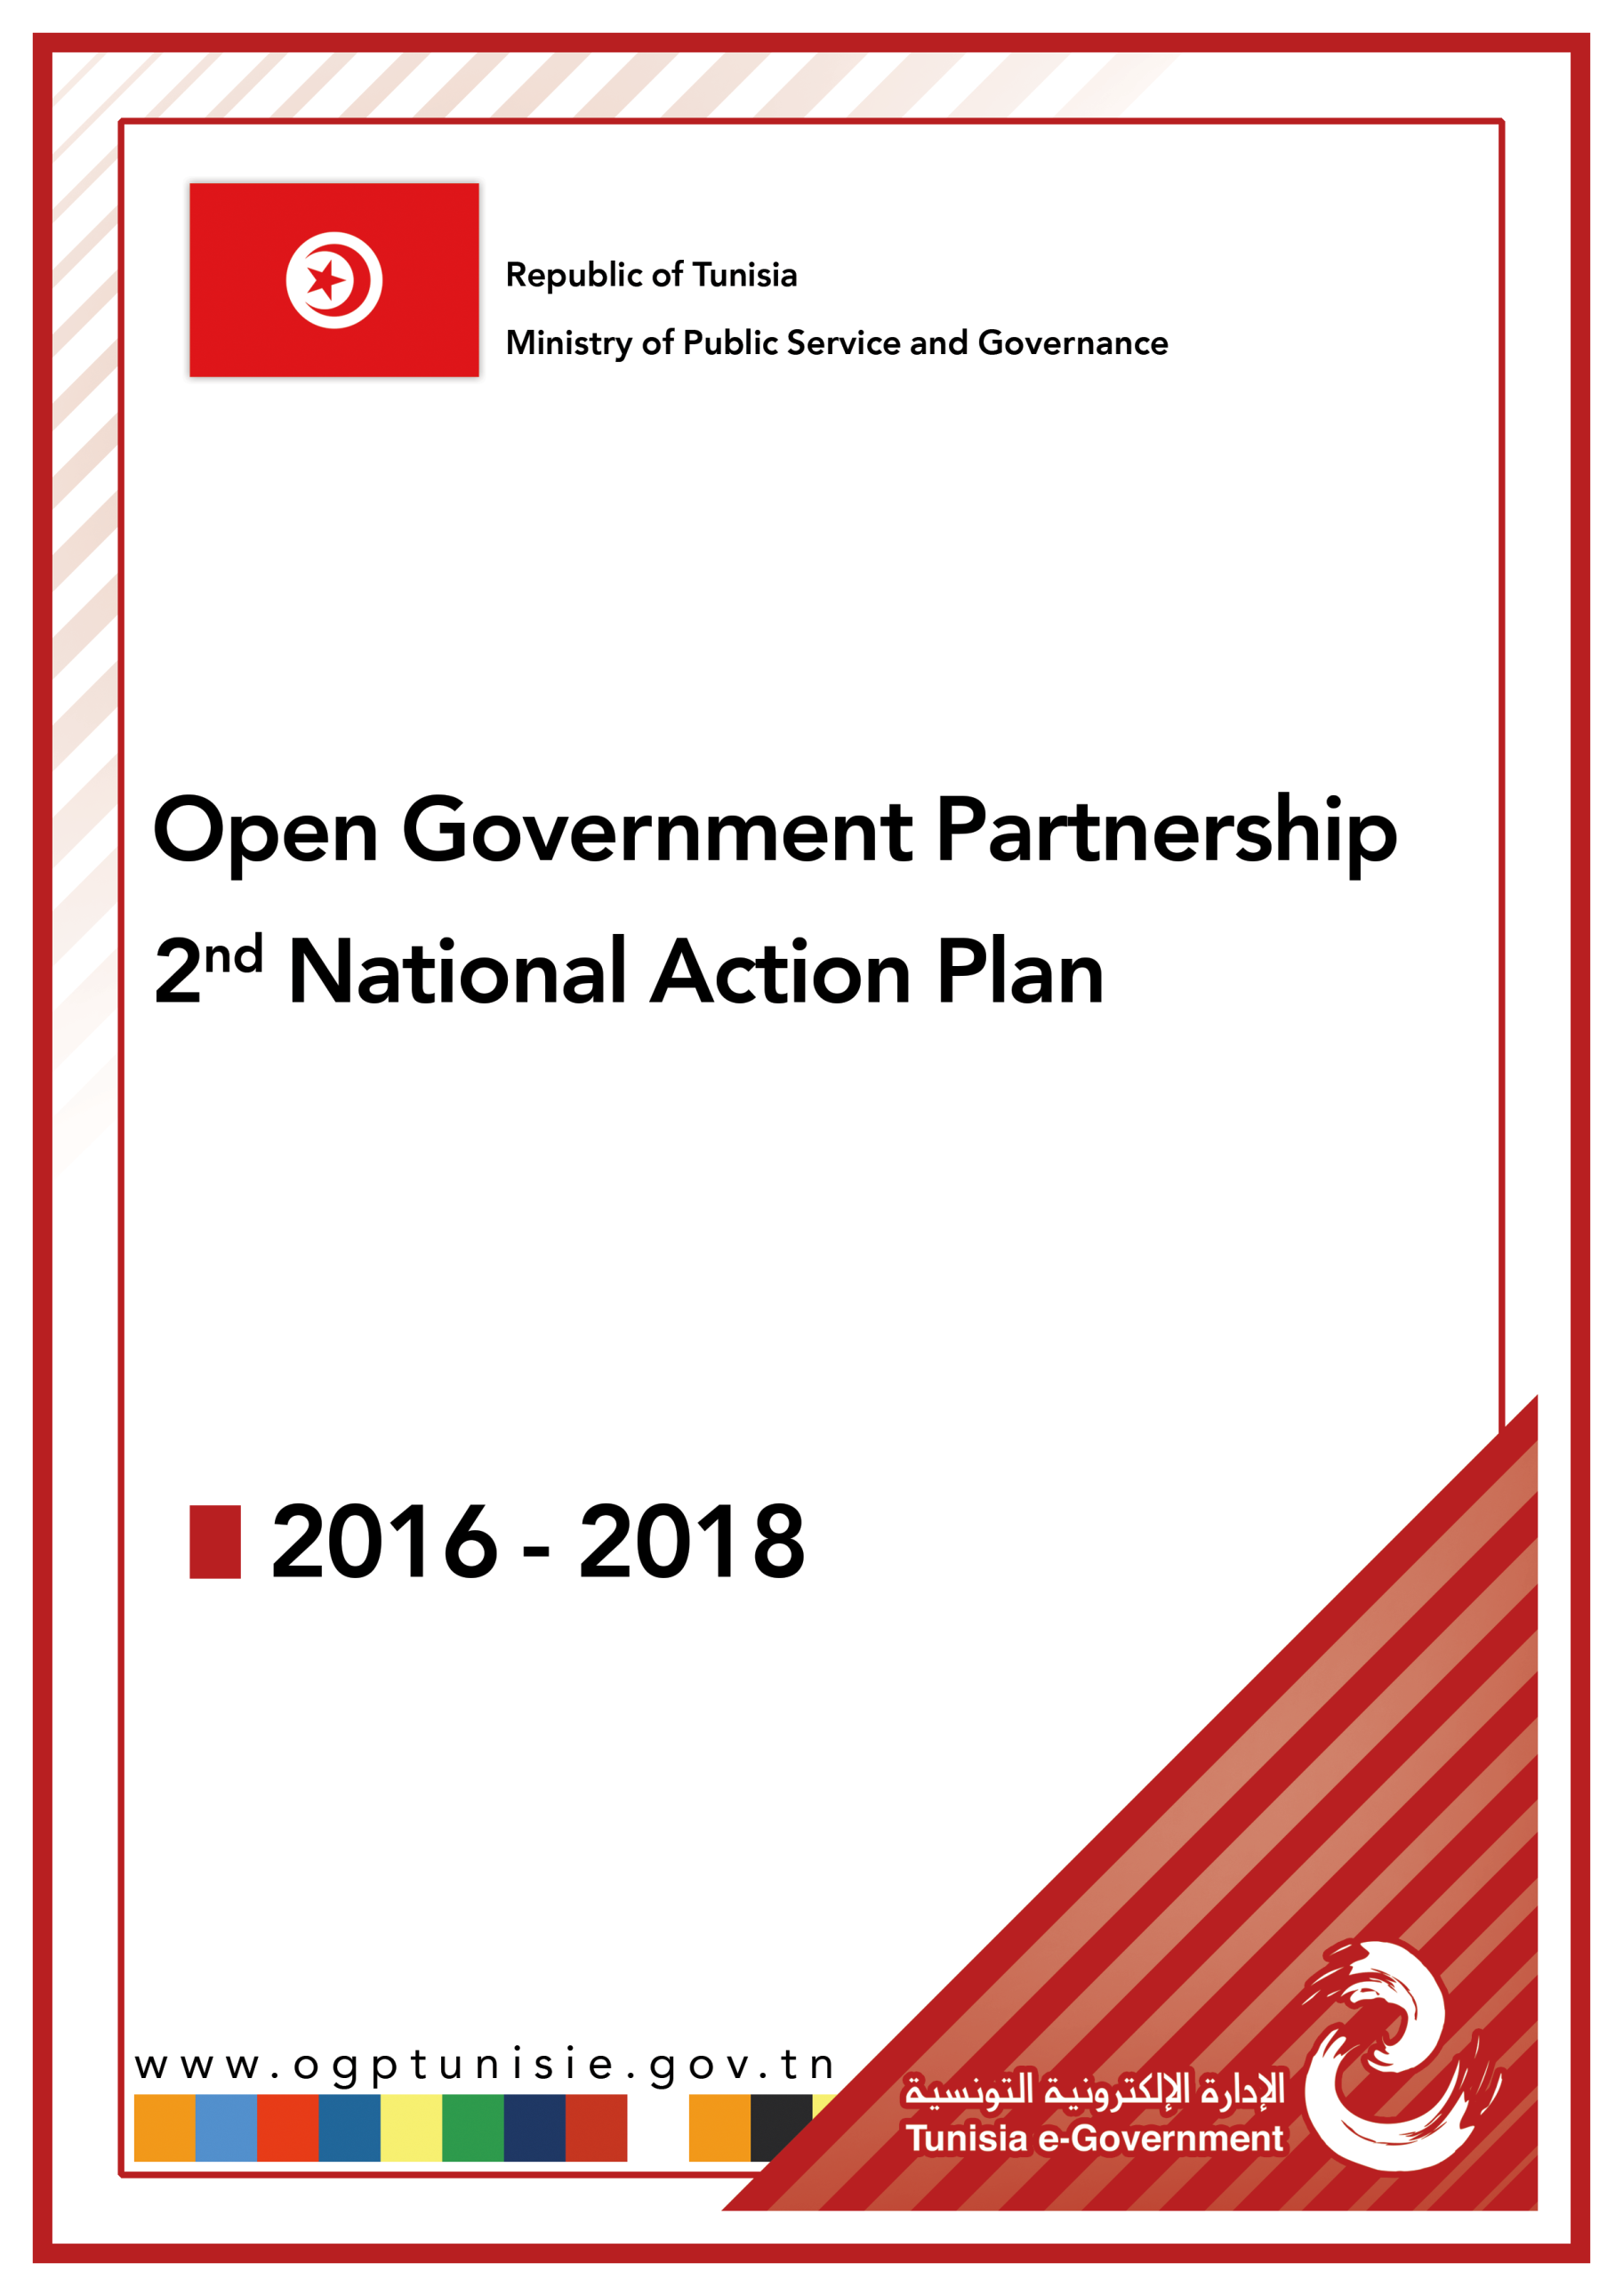

SUMMARY
I. Introduction 3
II. Effort to date to enhance Open Government 5
III. Action Plan development process 7
IV. Commitments 9
Enhance transparency of Government actions and opening up public data 9
1. Joining the extractive industries transparency initiative "EITI" 9
Lead Department: Ministry in charge with Energy and Mines 9
2. Modernizing the regulatory framework to enforce the Right to Access to Information : 9
3. The completion of the legal and regulatory framework of open data at the national level 11
4. Improve the transparency and local Gov Openness 12
5. Enhance the transparency in the cultural sector : “open culture” 12
6. Enhance the transparency in the environment and sustainable development sector 13
Lead Department: Ministry in charge of Environment and Sustainable Development. 15
7. Enhancing transparency in the transport sector 15
8. Promoting financial and fiscal transparency 16
Fighting against corruption and fostering the participatory approach 17
9. Elaborating a legal framework for citizen’s petitions: 17
10. Developing an integrated electronic civil petition and corruption reporting platform 18
11. Developing new mechanisms to promote interaction with the youth and enable them to pursue dialogue about public policies. 18
12. Adopting the corporate governance referential on the sectoral level : 19
Improving the quality of public services by using information and communication technologies 20
13. Developing mobile applications which could be downloaded on the mobile phone to reinforce transparency of government activities and participatory approach 20
14. Enhancing access to the archive 21
15. The development of an electronic mechanism to ensure transparency of Public Servants recruitment 21

Introduction
To enshrine the constitutional principles in financial and natural resources, good governance, and to adopt innovative, participatory and transparent approaches in public policies design and implementation, The Tunisian government has
the period 2016-2018. It is also an opportunity to valorize best practices issued from the first action plan to ensure inclusiveness of the OGP process by involving all stakeholders, and promote the relevance of commitments to the principles of open government.
Based on that, the elaboration of this second plan takes into account recommendations of the 1st Action Plan IRM mid Term Report (November 2015). It’s also an effort to expand and diversify participation in the action plan drafting through the involvement of various associations NGOs in this process and the organization of a number of communication activities.
This action plan contains commitments that covered most OGP principles, in particular these fields:
- Improving the right of access to information and the openness of administration,
- Reinforcing Good governance of natural resource,
- Enhancing Financial and fiscal transparency,
- Ensuring sustainable development,
- Adopting a gender approach in the process of budget elaboration,
- Strengthening openness in various sector such as culture, industry and environment,
- Regulating mechanisms and tools of citizen participation in public policies and Businesses,
- Improving youth involvement in public life and creating tools to promote participation in the public policy design.
Initiatives can be categorized as follow:
- Enhancing government transparency,
- Fighting corruption and establishing citizen participation and promoting open government culture,
- Enhancing public services quality,

Effort to date to enhance Open Government
As part of enshrining the principles of open government, several achievements have been made:
- Enshrining the principles of “Open Gov” within the constitution. According to Art 32: “The State guarantees the right to information and the right to access to information”

- Issuing a new Law (No. 22 of 2016, dated March 24, 2016) on the right to access to information, This law is considered as a real opportunity to enshrine the principles of transparency and integrity due to the procedures process which facilitate access to information and the creation of an independent authority that review complaints received in case of Gov refusal.
Strengthening integrity and corruption fighting in public sector
- Elaborating governance referential for public owned companies in accordance with international quality standards and encouraging corporate social responsibility in public and private sector. This referential is complying with the governance specification ISO 26000 that sets corporate social responsibility (CSR) standards. It will allow dissemination of the principles of governance such as transparency, integrity and accountability and to ensuring these principles' sustainability and application within the public and private sector, following standardized procedures.
- Developing an integrated electronic civil petition and corruption reporting platform. This platform will contribute to fight corruption and promote citizen participation. Using multiple channels (Website, Call center, SMS, face to face visits of citizens,…), the system will be a one stop shop to receive citizens’ complaints and report corruption cases. These complaints will be dispatched to different public structures at the central, regional and local levels. The system will ensure the follow up of petitions throughout the treatment process.
- Drafting a project of law related to the protection of Whistleblowers in the public sector: it aims at establishing mechanisms to report corruption cases, and setting up special measures to protect whistleblowers that witness corruption cases within the public sector.
Good Governance of the financial and national natural resources
- Development of a world class "Open Data" platform dedicated to information dealing with petroleum and mining sector: This portal aims to promote transparency in related.
- Publishing of agreements for exploration, research and exploitation of hydrocarbons in Tunisia as well as releasing all type of contracts between investors and the Tunisian Gov.
- Development of the open budget portal: this initiative is made in order to facilitate access to documents related to fiscal transparency and budget execution. This will favor data reuse by all users. This system includes a set of global data, which will be disseminated through the exploitation of automated information systems regarding the implementation of the State budget system. This will be considered as an important step towards transparency, corruption fight and reducing public resources waste. This platform is available at this link www.mizaniatouna.gov.tn.

Action Plan development process
The Tunisian national OGP action plan was elaborated according to the OGP procedures and guidelines, and according the IRM mid Term Report recommendations.
As part of the participatory approach, which was adopted during the elaboration of this action plan, a broad national consultation was organized, and various mechanisms were adopted in order to ensure a wide participation:
- Various meeting was organized within the public departments to present open government partnership initiative and to sensibilize public servants to the importance of engaging in this process. Representatives from civil society and NGOs had attended most of these meetings.
- Open days at the regional level were organized in partnership with civil society to present open government partnership initiative and open government process in Tunisia and sensitize citizen and civil society to the importance of engaging in this process. As a result of these events several proposals reflecting citizens’ aspirations were adopted.
- A workshop was organized on 23 March 2016 to announce the start of the national consultation via the web site www.consultations-publiques.tn and renewed the government's commitment to the process of open government partnership.
Also a communication plan was elaborated during the consultation phase to ensure wider participation and divulgation of open government principles. To achieve such as goal, many channels of communication were used as the organizing of seminars and symposia, press conferences and social media communication.
As a result of this consultation, 1104 proposals were received through different consultation means. To study and sort these proposals, a working group was constituted composed by representative from government and civil society pursuant these evaluation criteria:
- Specific: Describes the status quo and the problems it is trying to solve
- Describes the specific activities that will be undertaken,
- Describes the outcomes expected from the commitment implementation.
- Measurable: broken into clear, measurable milestones, lays out measurable, verifiable, benchmark that can demonstrate fulfillment and improvement
- Answerable: Specifies ownership by listing the implementing agency
Specifies civil society, multilateral; or private sector partners
- Relevant: Makes relevance to open government clear addresses transparency; accountability and /or public participation, addresses at least one grand challenge,
- Time-bound: Clearly states deadline, does not have to coincide with 2 year action plan cycle, milestones dates are made clear.

Commitments

Enhance transparency of Government actions and opening up public data

Joining the extractive industries transparency initiative "EITI"
Why do this :
This commitment is intended to promote transparency and accountability in the area of natural resources in order to enhance this sector governance and build trust between the government, business and civil society as well as to improve the business environment and make Tunisia a model of transparency in the MENA region.
Milestones:
This plan will be prepared to meet the requirements to join EITI initiative by:
- Appointing a high-level official to lead the implementation process of the initiative,
- Setting up a multi-stakeholder group to oversee the initiative implementation,
- Developing an action plan to implement the initiative,
- Publishing a report on extractive industries in accordance with the standards of the initiative and based on the principles of open data,
- Making a demand to join the initiative.
Deadline: July, 2018.

Lead Department: Ministry in charge with Energy and Mines

Modernizing the regulatory framework to enforce the Right to Access to Information :

Why do this:
Implementing of a FOA requires number of legal and administrative measures to regulate various aspects of this right.
Milestones:
The legal and administrative measures that will be undertaken are:
- Issuing a decree to create publics entities in each public department in charge of enforcing FOA,
- Establishing an independent public authority - the Commission of Access to Information - to oversee the implementation of the law and examine appeals against refusals by public authorities to disclose requested documents in the first instance,
- Creating a commission in order to identify fees should be charged for access to information request (exceptional cases),
- publication of the complementary regulation of the access to information Law,
- Drafting of a national action plan to facilitate the implementation of the law,
- Completing the organization of the archive and developing a system for the classification of administrative documents.
Deadline: March, 2017.
Lead Department: Ministry of Civil Service, Governance and Fight against Corruption (general directorate of public reforms), parliament, national archive institute.

The completion of the legal and regulatory framework of open data at the national level
Why do this:
The aim of this commitment is to make public data open by default, in formats that are usable and interoperable in order to improve Governance, citizen engagement, inclusive development and innovation.
Milestones:
The main milestones of this commitment are:
- Adopting a license to organize the public data re-use,

- Developing a network of the persons in charge of open data in the various public departments and agencies,

- Defining a national open data Charter,

- Elaborating an inventory by a number of sectors of data that can be opened and which could be published on the web while specifying the frequency of their updates and the departmental targets for the publication.
Deadline: March, 2017.
Lead Department: Ministry of Civil Service, Governance and Fight against Corruption (e-Government unit).

Improve the transparency and local Gov Openness
Why do this:
In accordance to the new constitution that calls for supporting decentralization and devoting transparency and local governance, this commitment will allow developing practical mechanisms to enshrine the principles of accountability and participation in the design and implementation of programs and projects at this level.
Milestones:
This trend will be established gradually. The first phase will be completed during the period of implementation of this plan through the following actions:
- Drafting a practical guide to explains the principles of open government and various applications at the local level in order to encourage projects and initiatives which could be launched in this field.
- The development of an electronic platform for open data at the local level:
- Choose at least a Municipality to establish open data system at the local level according to a certain number of criteria.
- The development of an open data system,
- Communication about the system and assisting citizens, especially the inhabitants in the concerned municipality to access it.
Deadline: July, 2018.
Lead Department: Ministry in charge of local affairs.

Enhance the transparency in the cultural sector : “open culture”
Why do this :
The aim of this commitment is to promote openess in the cultural sector in order to facilitate access to the culture heritage and stimulates innovative reuse in this field. This could generate several benefits especially an economic value by promoting foreign investment and tourism.
Milestones:
- Opening public cultural data:
The openness and sharing of public cultural data is guaranteed through the development of a central website. The website will include a set of data concerning all cultural fields (music, dance, books, scenic arts, audiovisual arts, cultural patrimony, fine arts, cultural institutions activities…) and boosting it with statistical results, ministry interventions, the budget, and public funding.
- Disseminating data about events and cultural festivals using modern technologies (cultural Agenda system):
The system of cultural agenda will provide users with digital information about cultural festivals and events on the central and regional level. The content will be comprehensive and easy handling as it will be joined by photos, posters and the festival’s program. This system can be browsed through various digital bearings enabling users to evaluate and give their opinion about it.
- Opening sound recordings and musical archive of the “Arab and Mediterranean Music Center”:
Disseminating and facilitating the access to the sound recordings and material archive of the Arab and Mediterranean Music Center through the development of two web sites in order to allow users especially journalists and researchers to exploit the digital data bases as well as paper and audiovisual documents. It could enhance the cultural heritage in this field and develop new high value uses of these data.
Deadline: July, 2018.
Lead Department: Ministry in charge of culture.

Enhance the transparency in the environment and sustainable development sector
Why do this:
Sustainable development is considered among the most important approaches which must be adopted in order to establish good governance and ensure integrated development. The aim is also to take into account the specificities of the different regions in Tunisia and the right of future generations to benefit from resources and healthy environment.
Milestones:
- Reaching the goal of sustainable development focused on the field of corporate governance "ODD 16"
This action aims to promote the principles and tools of good governance in the elaboration of Tunisian development plans, through the adoption of the objective indicators and the establishment of the three pillar of "Policy Brief" that have been formulated within the framework of the implementation of the goal of sustainable development “ODD16” in collaboration with the National Institute of Statistics and institutions intervening in the project.
To achieve this action, many activities should be accomplished:
- Drafting the “policy briefing” of the ninth component of target 16 and its ratification by all stakeholders,
- Elaborating of a governance study reference in Tunisia in the bases of policy briefing,
- Elaborating indicators fixed by all stakeholders,
- Monitoring and Implementing of 9th components of target 16
- Integrating policy briefing in the elaboration of the Tunisian development plan
- Evaluating the efficiency of these policies.
- Deadline: July 2018
- Lead Department: Ministry in charge of Civil Service, Governance and Fight against Corruption.

- Developing and deploying an open data platform related to environment and Sustainable Development
This platform will facilitate open data dissemination and allow multiple re-use by citizens and by the private sector to encourage innovation and the development of new high value services in environment and sustainable development. It is expected that this platform includes a number of open data sets that enhance transparency such as climate change, air pollution, waste, decontamination, the coastline, the natural repository, Sustainable Development Indicators , etc.
Deadline: March 2017
Lead Department: Ministry in charge of Environment and Sustainable Development.

- Developing and deploying a geographic information system about environment and sustainable development
This system will allow the collection, storage, analysis and dissemination of geographical data on the environmental and Sustainable Development field.
It is expected that this system contains a set of geographic data that enables retrospective analysis of the evolution of events and predict the risks and prevention, as well as guide the decision-making and formulate environmental policies.
The data that could be included in this system are: monitoring water quality, monitoring air quality, the disposition of the coastline and the follow-up of the marine environment, waste, industrial pollution, cleansing, follow-up forest and pastoral land use, conservation of biological diversity, quality of life, climate change and pre-warning, etc.
Deadline: July 2018.

Lead Department: Ministry in charge of Environment and Sustainable Development.

Enhancing transparency in the transport sector

Why do this:
This portal aims to provide access to the public data related to the transport sector (land, sea, air) in an open formats and facilitating its reuse to develop new systems and added value services, especially in the field of passenger Media (via WAP, smart phones ...).
Milestones:
This commitment will be achieved following these phases:
- The elaboration of a study on the project to determine the organizational and procedural priorities and to prepare the back office of the portal,
- The definition of the technical and functional specifications of the portal,
- Development of the portal and put it on line
Deadline: 2018
Lead Department: Ministry in charge of transport

Promoting financial and fiscal transparency
Why do it:
This commitment tends to devote the principle of fiscal justice and encourage the tax payers to respect their fiscal duties. It also aims at the increase of the state budget resources through better exploitation of the tax energy, especially by reducing tax expenditures.
Milestones:
The fulfillment of this commitment requires the publication of two reports:
- An annual report on tax expenditures accompanying the annual budget presented to the parliament,
- An annual report on fiscal obedience.
Deadline: 2018
Lead Department: Ministry of finance

Fighting against corruption and fostering the participatory approach

Elaborating a legal framework for citizen’s petitions:
Why do it:
To establish a new mechanism for collective petitions in order to regulate and organize citizen participation in the process of making public decisions. This commitment represents an essential mechanism that will enhance citizen participation in the design, implementation and evaluation of public policies.
Milestones:
Prepare a legal framework to regulate collective petitions.
Deadline: 2018
Lead Department: Ministry in charge with of public servant, governance and fighting corruption

Developing an integrated electronic civil petition and corruption reporting platform
Why do it:
This platform will contribute to fight corruption and promote citizen participation. Using multiple channels (Website, Call center, SMS, direct visits of citizens), the system will be a one stop shop to receive citizens’ complaints and report corruption cases. These complaints will be dispatched to different public structures at the central, regional and local levels. The system ensures the follow up of these petitions throughout the treatment process.
In addition, This Platform will allow the publication of accurate and categorized statistics about complaints and corruption cases notifications treated by different public structure.
Milestones:
This system will be implemented in phases to cover all public structures. The first one concerns 10 pilot public structures.
Deadline: 2018
Lead Department: Ministry in charge of public servant, governance and fighting corruption (the e-Government Unit and the central bureau of relationship with citizens).

Developing new mechanisms to promote interaction with the youth and enable them to pursue dialogue about public policies.
Why do this:
This commitment aims to involve youth in the development and implementation of open government principals in order to foster their participation and find tools to enable them to express their aspirations and express their voice to public officials and decision-makers regarding different public policies and programs especially actions included In the NAP-OGP 2016-2018.
Milestones:
To fulfil this objective, the following actions will be launched:
- Development of an e-platform allowing youth to provide feedback on the delivery of selected public services and that requires the responsible public structures to respond and address the issues raised.
- Co-creation (Government/CSO) of local councils which must include representatives of civil society and public authorities with a significant presence for the young people. The main goal of this action is to create a space facilitating discussion about key pain points and opportunities as articulated by youth CSOs which government could respond to.

- Deadline: July 2018.
- Lead Department: Ministry in charge of Civil Service, Governance and Fight against Corruption.

Adopting the corporate governance referential on the sectoral level :
Why do this:
After the drafting of the national reference for corporate governance “RNG” during the period of implementation of the first national OGP action plan, this aims to establish the principles and mechanisms of governance, in both public and private sectors. The work will be focused on instituting this national reference on a certain number of public and private institutions.
Milestones:
- organizing a training for trainers (10), auditors (10) and assistants (10) in the field of technical assistance in accordance with national reference for corporate governance,
- Establishing the national reference for corporate governance on a publicly owned companies and a private enterprise.
Deadline: July 2018.
Lead Department: Ministry in charge of Civil Service, Governance and Fight against Corruption.

Improving the quality of public services by using information and communication technologies

Developing mobile applications which could be downloaded on the mobile phone to reinforce transparency of government activities and participatory approach
Why do this:
Recognizing the potential of m-services for improving the transparency, accountability and efficiency of public services, the fulfilment of this commitment tend to facilitate access to, and the use of, mobile ICT services in several fields such as education, transport, health, etc.
Milestones:
The most important components of this project embodied in:
- defining a list of public services that will be developed through mobile phone technology,
- Developing the selected mobile ICT services,
- Promoting the developed m-services.
Deadline: July 2018.
Lead Department: Ministry of Civil Service, Governance and Fight against Corruption (e-Government unit).

Enhancing access to the archive
Why do this:
The aim is to facilitate access to a significant volume of historical documents since the Husseinit period until today. These documents are characterized by their originality, uniqueness and diversity of their content, dates, languages (Arabic, French, English, Turkish, Italian, and Hebrew).
Opening up these documents will offer enumerable benefits for many users, especially for researchers and developers of web/mobile applications in several fields.
Milestones:
To accomplish this commitment, the following actions will be carried out:
- developing an archival platform to allow access to documents that have been digitized,
- Organizing training in this field for all dealers with documents in order to have the necessary skills regarding organizing classifying and Coding documents.
Deadline: July 2018.
Lead Department: National Archive Institute.

The development of an electronic mechanism to ensure transparency of Public Servants recruitment
Why do this:
This commitment aims to facilitate access to information for all job seekers especially job opportunities in public sector. It will foster the principles of transparency and equal opportunity to ensure that the most capable person is selected for a position on the basis of merit, and refers to the right of every individual to be given fully fair consideration for any job in public sector for which they are qualified and skilled.
The goal of this commitment is also to reduce the risk of corruption and nepotism, as the lack of transparency could give the opportunity to receive bribes or enable certain people to benefit from the opportunities offered in this area.
Milestones:
The development of electronic mechanisms for the dissemination of information about job opportunities carried out by ministries, public institutions and public enterprises, particularly those exceptional Mandates by contract.
Deadline: July 2018.
Lead Department: Ministry in charge of Civil Service, Governance and Fight against Corruption.

