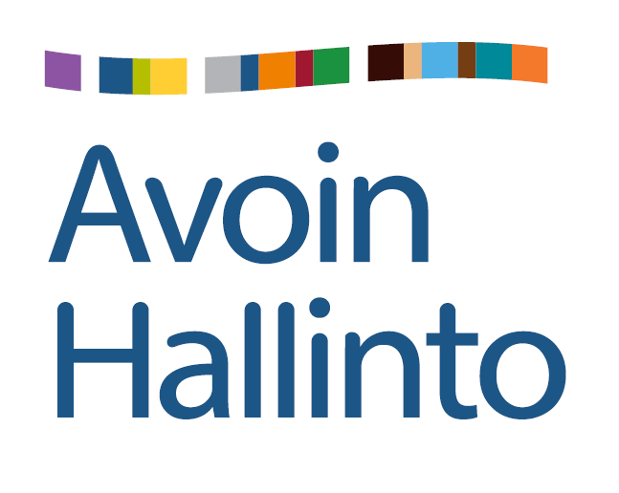

# Open Government

# Finland’s National Action Plan 2015 -2017

# Self-assessment– interim report

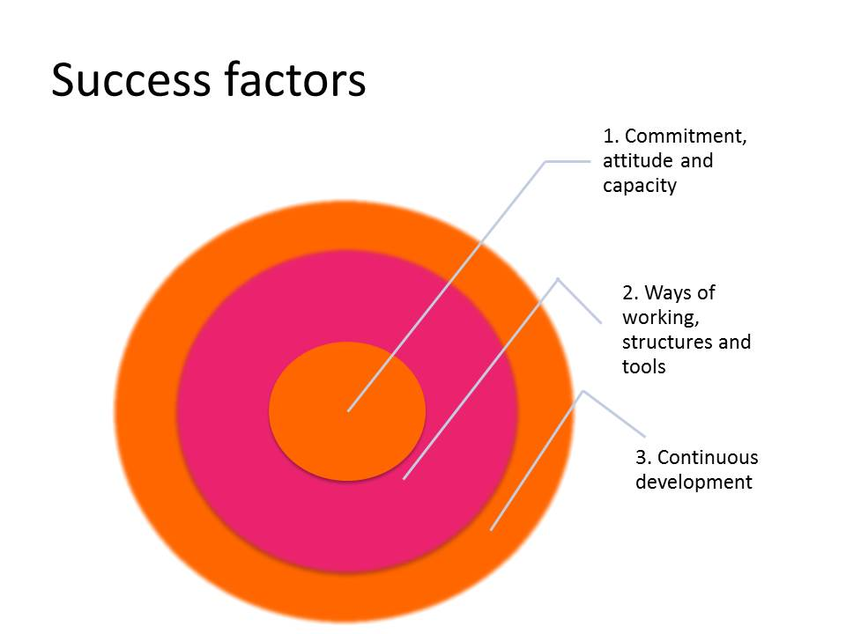

Contents

1. Background 3

2. Preparing the National Action Plan (2015-2017) 4

3. Implementation up-date 6

Clear Government 6

Open procedures 9

Enhancing participation of children, youth and the elderly 10

Communications 11

4. Assessment and conclusions 13

5. Conclusions 14

# Background

Finland joined the Open Government Partnership (OGP) in 2013. In Finland OGP work is conducted under the Finnish name Avoin hallinto and under the Swedish name Öppen Förvaltning. The Avoin hallinto –project coordinated by the Ministry of Finance works to open public administration and public information together with ministries, agencies and municipalities. In Finland the OGP work covers the whole public sector and all its levels. By opening public administration and public information the possibility of citizens and civil society organisations to take part in developing the Finnish society is secured.

Open government work is supported by a group consisting of representatives of civil society organisations, ministries, agencies and municipalities. The work is steered by a board of civil society policy that has been set up by the Ministry of Justice (KANE-board). In addition to this the open government civil servant network is of special importance. It includes members from state agencies. With the help of this network and through its work the implementation of the main targets of open government is ensured. For municipalities the Municipal Democracy Network functions as a similar tool and is coordinated by the Finnish Association of Local and Regional authorities.

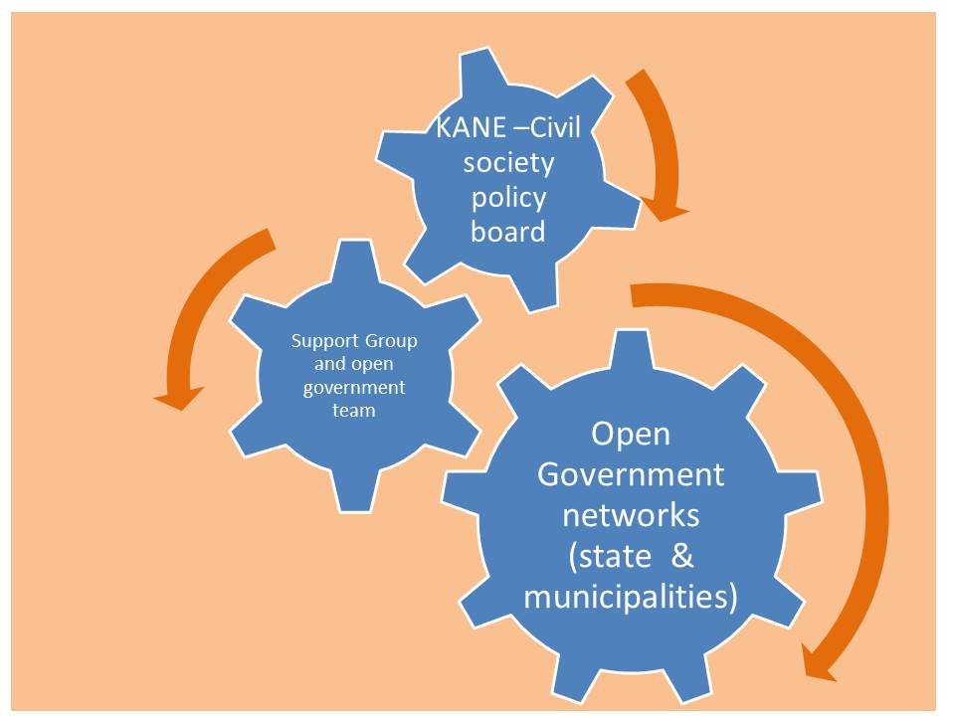

Picture 1 Open government actors

In September 2015 the Avoin hallinto – project asked the national agencies about how the goals had been achieved. According to this study the joint national principles of Open Government had been presented widely and in many ways in the agencies (in 45 out of the 48 that answered the study). Work has also been underway to make government administration more clear, but only in one out of three there is information about the impacts of this work. Most agencies have put a lot of effort into clear language (0ver 80% of the agencies). This has been done in many ways. Especially attention has been paid to the websites and making texts in the web clearer, but also training has been organized as well as testing of texts by customers and customer feedback has been used. Texts in plain language can be found but are still rather rare. But over half of the agencies have put effort into visualization (29/48). There have been interactive web castings also in many agencies (20/48). Consultation during the preparatory processes is also widespread. Only four agencies replied that this is not done. The situation is very different in four agencies where consultation is always done and in the rest (40 agencies) it is done, but depends on the project in hand.

# Preparing the National Action Plan (2015-2017)



Picture 2 Preparing the action plan

**The Principles of preparing the National Action Plan (NAP)**

There were a couple of main principles that the process tried to follow.

1. There were electronic participation methods as well as face-to-face meetings and seminars.
2. E-participation was organized at the beginning of the process, in the middle of the process and at the end of the process. Each time with an e-tool fitting the particular phase of the process. The big principle was to use national government’s joint tools (otakantaa.fi and lausuntopalvelu.fi). These were complimented with ZEF-tool in the beginning of the process when the discussion was about the themes of the NAP.
3. Face-to-face meetings were organized for different groups of citizens and civil servants both in the events organized by Avoin hallinto as well as events organized by others.
4. The aim was also to have participants from outside the metropolitan area.

About achieving these principles it can be stated that events and e-participation were successfully combined. There could have been more events, especially joining events organized by others and events organized outside the metropolitan area, but here the reality of scarce resources was an obstacle.

**The process of drafting the national action plan**

The development of the Finnish National Action Plan started with a kick-off workshop, which was held on the 28th of August 2014. The invitation to the seminar was widely distributed to civil society organisations, to citizens who had earlier participated in Open Government activities and civil servants. People were also asked to freely forward the invitation. The workshop was attended by 11 civil society organisations, 14 civil servants from municipalities, 31 from state government and 1 representing a company. Themes, which were raised in the workshop, were afterwards evaluated with a web- based evaluation tool (ZEF). 42 people joined in the evaluation process.

A workshop was arranged at the Open Finland 2014 conference to collect proposals for actions to be included in the Action Plan. An online consultation was held at otakantaa.fi –service from 25th of September to 3rd of November. People were able to support and comment proposed actions or propose new action. On the 7th of October the proposed themes and actions were discussed in the meeting of civil servants network. During November and December ideas were collected in 11 early morning round-table discussions. Each of these discussions had participants from one administrative branch: civil servant network members from the ministry and agencies.

At the end of November ideas for the new Action plan were collected face to face from citizens in the City of Vaasa at the Vaasa Christmas Market. 37 people gave their ideas in writing and 67 people voted for the most important theme(s). In the beginning of December the action plan was on the agenda in the Civil Society Policy Board, which consists of representatives of civil society organisations, research, ministries and Finnish municipalities. In January views to the action plan were asked in a student event in University of Eastern Finland in Kuopio. A draft action plan was made based on all the material. This draft was under open consulatation in the web in lausuntopalvelu.fi- service from 20th of December 2014 to 30th of January 2015 where it was possible to anyone to contribute. A resume was made of all the comments received and it was available at [www.avoinhallinto.fi](http://www.avoinhallinto.fi) as was the resume on how the comments had changed the draft action plan.

**Finalising the National Action Plan**

In Finland the timetable provided by the OGP for drafting the action plan was in between the parliamentary elections and the change of Government in Finland. Therefore it was not possible to take the draft action plan to the ministerial meeting as was the case with the first action plan. Finland informed OGP about this beforehand.

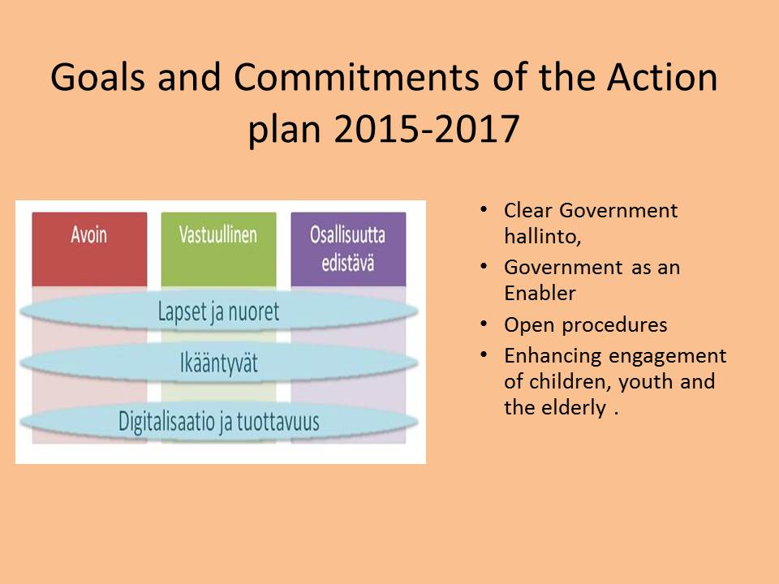

Picture 3 Goals and commitments of the action plan 2015-2017

# Implementation up-date

## Clear Government

Clear language is part of the goal of clear government. Linked to this goal a national campaign of clear language in civil service was carried trough. On Clear language day in 2015 the best success story of clear language was honored with a price. The best success story was The City of Helsinki’s Public Works Department. It won by one vote’s margin the second best success story that was the plain language communication of the hospital district of Satakunta. An Open Government experience card has also been produced of clear language. And in May 2016 the Prime Minister’s Office published [a clear language guide](http://verkkojulkaisut.vm.fi/zine/92/cover) for civil servants.

One goal has been to increase the provision of plain language material by authorities and municipalities. [A list](http://vm.fi/documents/10623/1193298/Avoimen+hallinto+tilannekatsaus+042016.pdf/9737094d-b1aa-4577-a61c-c66f57520bcd) of the materials produced in 2015-2015 has been put together. To increase the use of visualisations a meeting was organized to the Open Government network in the Ministry of Education and in May 2016 a “budget belongs to all” hackathon.

The preparatory work for the Accessibility directive (A Directive of the European Parliament and council of the accessibility of public sector organisations webpages ) is underway. Its coverage has been widened to for example schools and from webpages to digital services. The transition period will be approximately four years.

To enhance the accessibility of government services the shared service views for citizens, , companies and authorities are being developed. Service views are user interfaces, where citizens can select role-based services.

**Opening data reserves**

Opening up data reserves has been enhanced by creating a avondata.fi (Opendata.fi ) service. This service includes instructions to open data and the information about open data reserves.

The possibility of citizens to study from one service the data that concern him/herself and is maintained by government, has been enhanced in the national service architecture (KAPA) –project. In the development version of Suomi.fi (Finland.fi) it is possible already now to look one’s own personal data, vehicle data and estate data. The service will be fully functional in 2017. Agencies and municipalities are encouraged to include data reserves that include personal data in to the Suomi.fi service to increase the amount of data provided.

**Removing barriers of Volunteer work**

The group that looked into removing barriers of volunteer work has made proposals to administrative fields on cleaning away the obstacles. The Ministry of Justice has been now named as the coordinating ministry regarding voluntary work in the Finnish government. The democracy network that has representatives from all ministries is looking after the implementation of this work.

The Ministry of Justice has created a website, where guidance and advice has been gathered for organisations organizing voluntary work or for people interested in voluntary work. <http://www.demokratia.fi/tietotori/vapaaehtoistyo/>

These pages will be linked to be part of the Suomi.fi web service.

**Enhancing Citizen participation**

New models of action for improving e-participation possibilities of people living in sparsely populated areas have not yet been created. The planning will start in 2016. The possibilities of e-participation of citizens living in sparsely populates areas have been enhanced by developing demokratia.fi (democracy.fi) – services and by improving the availability of the fast broadband.

The project for sparsely populated areas “Broadband for all 2015” has been continued. During 2015 networks were built some 3 200 kilometers which meant that the availability of the broadband increased by 15 000 subscriptions. The project continues with the resources available by the name “Fast Broadband”. There was still at the end of the year 2015 23 millions of state aid that was still not allocated. Out of that 23 million 13 million worth of Government support had been applied for and were under process in the Communications Agency. Thus there were almost 10 million government support funds yet to be allocated.

Electronic democracy.fi services have been enhanced in the public administrations and in the civic society. Ministries and municipalities have been organized training session of open procedures and service use. Services have also been presented in various citizen and civil servant happenings. Training material and communication material has been produced (brochures, roll-up, pens, balls etc. At the end of the year 2015 a national marketing campaign was organized. It included also some targeted social media marketing (Facebook, twitter, Youtube) a tv-campaign, newsletters and advertising in newspapers. Koordinaatti - Development Centre of Youth Information and Counselling has been responsible for marketing of e-participation portal for youth: Nuortenideat.fi .

The marketing of democracy services in 2016 concentrates especially on lausuntopalvelu,fi (consultation ,fi) and Otakantaa.fi (Share your views with us) Services are being informed of and support for services introduction is provided first of all to ministries, state agencies and organisations and municipalities. Ministries will get the information about this service as part of the training on law drafting consultation guidelines. In addition to this the services are showcased in different happenings. Services are developed further on the basis of feedback from users.

|  |  |
| --- | --- |
| Democracy.fi number of users |  |
| Kansalaisaloite.fi (Citizen initiative) | Almost 500 citizen initiatives (03/2016) and webpage visits are around 2,5 million a year (average 200 000/month) |
| Kuntalaisaloite.fi (Municipal resident initiative) | 200 municipalities have joined the service (11/2015) and there are on average 20000 website visits per month. Around 1 100 initiatives have been sent to municipalities through this service (03/2016) |
| Otakantaa.fi (Share Your view with us – discussion forum) | Over 300 projects have been published on the website and there are on average 10 000 to 15 000 site visits per year. |
| Lausuntopalvelu.fi  (Consultation portal) | Over 500 organisations have started to use this service and over 1000 persons. Consultations requests have been published about 30 and 800 (03/2016) statements, site visits are around 3000 per month. |
| Nuortenideat.fi  (Ideas from young people) | was opened in 03/2015 and 68 organisations have started to use it. There are now 700 registered users in this service and around 400 (03/2016) ideas and requests/discussions have been published. There are 4000 site visits per month. |

Democracy acknowledgement was given in fall 2015 to the Tyrnävä municipality and to the National Institute for Health and Welfare’s equality information service Minna.

## 

## Open procedures

**A new project register for ministries- “Hankeikkuna - a Project window”**

The new web application of the project register is called the project window “Hankeikkuna”.*It replaces the joint project register of ministries and the parliament. The main goal of the register is to enhance the openness of public project information to citizens. It supports the open flow of information in ministries on on-going projects to citizens, media and all interested and helps the following of the projects. The service will be published in October 2016 to civil servants and to everybody in March 2017. From the register you can then find all up to date information on the following: implementation of the Government Programme, law drafting projects, important reform and development projects, Government institutions incl working groups) and their appointment, strategies and reports to Parliament.

There will be guidance to ministries on how to use the new project register. There will be active internal and external communication linked to the publishing and launch of the register and after that also in different occasions. This communication has already started and it is being done also linked to Avoin hallinto (OGP) activities.

**Consultation guidelines for law drafting have been revised**

The consultation guidelines for law drafting have been revised. The new guidelines were approved by the Government on 4th of February in 2016.

Consultation is a crucial step in the preparation of laws, statutes and regulations. The consultation guidelines steers the law drafting in ministries. In the consultation process stakeholder groups and citizens are given the possibility to share their views on law drafts under preparation. This new guideline replaces the Government’s decision-in-principle from year 2010. Now also material about the consultation process and methods has been published alongside the guidelines.

Lausuntopalvelu.fi service is meant for government’s use in asking for consultation responses. The idea is that lausuntopalvelu.fi will be taken into use in all consultations latest at the stage where ministries have joined the Governments joined document handling system. This service will make consultations completely electronic.

**Interactive web castings and activeness in social media**

The amount of interactive web castings will be increased. The exchange of best practices will be done through the government civil servants network for open government and info and experience cards of best practices will be prepared and published in autumn 2016 to enhance the amount of web castings.

In May 2016 the use of social media was a theme in the morning coffee session for the highest level leaders. The theme was handled by discussing the best practices of the Social and Health Ministry. Information gathering about work done in different administrative fields will be continued as well as sharing the information and experiences.

The State’s civil service ethics commission gave recommendations to state administration on use of social media in government 15th of June in 2016.

**Lobbying register and anti-corruption work**

The question of the lobbying register review and offering the information as open data is still under consideration. No further action has been yet taken.

Open government took part in 2015 in the anti-corruption day event. The goal is to take part in 2016 as well and to possibly enhance the co-operation even more with the anti-corruption work.

**Open Government principles have been taken on board in the work across administrative borders**

Open government has done and will be doing co-operation with the Government’s flagship projects especially in the area of enhancing engagement of youth and elderly. .

## Enhancing participation of children, youth and the elderly

In the Government’s flagship projects different kinds of methods have been tried out in engagement of children, youth and the elderly. Partner projects have been the following: Programme to address child and family services, Digitalization of public services, Municipality of the Future, Experimenting Digital Municipality, Home care for older people will be developed and informal care enhanced in all age groups

A day was organized to the councils of the elderly jointly with the Ministry of Social and Health affairs and Ministry of Environment for the elderly regarding questions around the living and home care of the elderly. 87 members of the elderly councils participated from around Finland. The councils from municipalities participated through the net- A web brainstorming around digital services and participation possibilities was arranged or the elderly in the internet. This had 1340 participants. The results of this web brainstorming were built forward by a workshop organized for elderly activists. In this workshop there were 46 participants. This workshop was organized together with three citizen organisations Valli - The Finnish Union for Senior Services, SOSTE Finnish Federation for Social Affairs and Health, ENTER ry - ICT association for seniors). The civil servants working in the different flagship projects worked as secretaries in this workshop. .

A Youth Forum was organized linked to the OECD:s Public Governance Ministerial in Helsinki in October 2016. The Youth Forum was preceded by national processes in different OECD-countries. In Finland the national process was organized through events (City of Pori, City of Kuopio, City of Helsinki etc), through school co-operation and through e-participation via the nuortenideat.fi – service. A day before the Ministerial meeting young people from different countries met with the ministers and continued to discuss about the results of the national youth forums at the House of the Estates in Helsinki. The initiative to organize the youth forum and the national youth forums came from the open government project in Finland.

In November 2015 an event regarding Children’s rights was organized in co-operation with the Office of the ombudsman for children, the Mannerheim League for Child Welfare and the Ministry of Education and Culture.

In May 2016 a summit was organised with the municipal youth councils about the Future of Municipalities in co-operation with the organisation of Youth councils. The event had 160 participants from around the country.

In co-operation with Finnish youth research  network a study on engagement of children in the preparation of the new Act on Early childhood education and care has been made.

In preparation of a new the Youth Act and the Child and Youth Policy Programme the engagement of children and the youth in the state government reforms will be enhanced.

Knowledge and case cards are being drafted based on the tested methods and events.

Possible partners for organizing a joint participation camp for the elderly, the youth and children have been identified. Planning will start in autumn 2016.

## Communications

In early 2016 a new brochure card was made for the avoin hallinto. This card is available at the different events. This card has contact information, information about why open government work is underway and the commitments of the current national action plan. There is also a note pad with the logo and contact information to be given out in events where avoin hallinto (open government) is present.

Besides its own events Avoin hallinto has been present in many events organized by others. First of these in 2016 was in City of Jyväskylä on the 21st of January. This was the youth work life forum. Open government material was given pout in Educa Fair in 29-30.1.2016. On the Allianssi Youth Cruise 13.-14.4.2016 information about open government was distributed and comments and views on the info cards on children an youth were asked for. In ValtioExpo (Government Fair) 17th of May 2016 open government material was distributed and a support clinic on topical open government issues was held. In City of Seinäjoki 18th to 19th of May 2016 the results of web brainstorm were presented at a Health and Social Affairs Fair (Tervesos). On the 31st of May a work shop was held for the elderly on digitalisation at the Ministry of Finance.

**Open Government Groups**

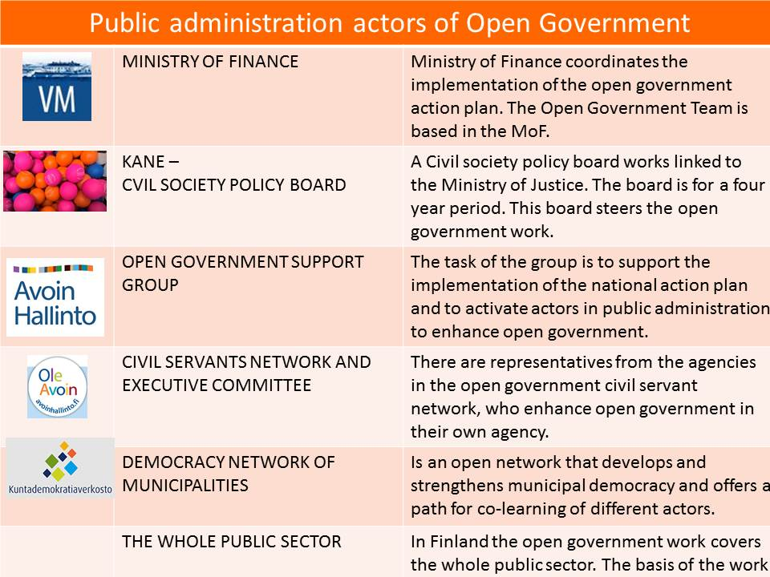

Picture 4 Open government actors

The executive committee of the open government civil servant network was established in autumn 2015. This committee works in co-operation with the municipal democracy network, it plans the open government civil servants networks events and other network happenings. In addition to this the executive committee helps put up smaller groups to work on the info and data cards.

In autumn 2015 open government civil servant network meetings were held in the Ministry of Environment and at Statistics Finland. In November an event was organized together with the with the Office of the ombudsman for children, the Mannerheim League for Child Welfare and Ministry of Education and Culture. In the January 2016 event of the open government network the representatives form OGP were present.

In April an event of the open government civil servants network was organized with Ministry of Interior and the Migration Agency taking care of the contents of the event. The event in May was organized in the Ministry of Social and Health Affairs under the title: Openness and engagement in the flagships projects of the health and welfare.

# Assessment and conclusions

In summer 2016 the second national open government plan is half way. As a whole the implementation of the plan is well underway.

There are however a lot of action points under the commitments in the action plan. Some of these have not got as much attention as others, due to the large amount of action points altogether. Because there is still the other year left to implement the action plan, it is possible to put new effort into the cation points that have bene left with less attention.

The two-year time cycle has led to fact that also the timespan of the action is two years even though in some it would have been good to have a longer timespan already from the beginning to ensure continuity and implementation. Also the timing inside the two year cycle is very similar for most of the action points. Meaning that the implementation starts right away when the two year period starts and last the two years.

Open government work has very scarce centralized resources. Therefore also the visibility of the work is fragmented. In the implementation it is therefore especially important the work and commitment of the civil servants network on state level and the activity of the municipalities.

For the implementation it has been important that the co-operation between different actors has developed positively. The actors and networks have stabilized. The co-operation with civil society organisations has been effective and positive. Special examples taken up have been the day organized in relation to the Children’s Rights day and the activist workshop for the elderly. The growing co-operation and better coordination inside public administration has also been a positive trend. In the international co-operation a positive development has been the birth of the Nordic co-operation inside OGP:

Open government communications have been strengthened with a monthly electronic newsletter, but there is a need for even more development in communication.

# Conclusions

