THE UNITED REPUBLIC OF TANZANIA

PRESIDENT’S OFFICE
REGIONAL ADMINISTRATION AND LOCAL GOVERNMENT

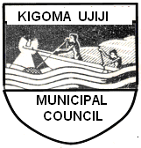

KIGOMA UJIJI MUNICIPAL COUNCIL
OPEN GOVERNMENT PARTNERSHIP ACTION PLAN
2017 – 2018



THE MUNICIPAL DIRECTOR
PO BOX 44
KIGOMA – TANZANIA OCTOBER, 2016
CONTENTS
LIST OF ACRONYMS 3
1.0 INTRODUCTION 4
2.0 OPEN GOVERNMENT EFFORTS TO DATE 6
3.0 NATIONAL ACTION PLAN DEVELOPMENT PROCESS 8
4.0 COMMITMENTS 12
4.1 LAND TRANSPARENCY 12
4.2 HEALTH SERVICE TRANSPARENCY 14
4.3 EDUCATION TRANSPARENCY 19
4.4 WATER SERVICE TRANSPARENCY 23
4.5 OPEN BUDGETS 26
5.0 CONCLUSION 30

LIST OF ACRONYMS

IRM Independent Reporting Mechanism
LAAC Local Authority Accounts Committee
MD Municipal Director
MEO (P) Municipal Education Officer (Primary)
MEO (S) Municipal Education Officer (Secondary)
MEPO Municipal Economy and Planning Officer
MHS Municipal Health Secretary
MIA Municipal Internal Auditor
MICTO Municipal Information Communication Officer
MMO Municipal Medical Officer
MPO Municipal Procurement Officer
MT Municipal Treasurer
MUPO Municipal Urban Planning Officer
MWE Municipal Water Engineer
OGP Open Government Partnership

KIGOMA UJIJI MUNICIPAL COUNCIL
OPEN GOVERNMENT PARTNERSHIP ACTION PLAN
2017 – 2018
- INTRODUCTION

The United Republic of Tanzania joined the Open Government Partnership (OGP) in September 2011. One of the major issues facing the local communities in Tanzania especially at local levels is openness on how government conducts its core business. The importance of OGP’s efforts lies in its initiative that aims to enhance transparency, empower citizens, fight corruption, accountability and harness new technologies to strengthen governance. Open Government operate jointly under partnership between Government and Civil Society Organizations to develop and implement developed Action Plan speed up to advance transparency and accountability in Government. With the above facts, Tanzania as well as Kigoma Ujiji Municipal Council decided to join OGP.

The Government of United Republic of Tanzania in collaboration with Civil Society developed and implemented two previous National Action Plans. National Action Plan I covering year 2012/13 to 2013/14 and National Action Plan II 2014/15 to 2015/16. The National Action Plan III is at final stage.

National Action Plan I had a total of 25 commitments covering issues mainly in Health, Water and Education. Due to the fact that, OGP was a new concept and with ambitious commitments, implementation did not go well as it was not able to reach at the regional, district, ward and village/streets levels, where the intended beneficiaries are found. The second National Action Plan was more streamlined with structured commitments in five priority areas as follows:
- Access to Information
- Open Budgets
- Open Data
- Land Transparency
- Extractive Industries Transparency
The third National Action Plan based on seven priority areas five of which was partially implemented in the second National Action Plan and added two newly one namely
- Medical and Health service Transparency
- Performance Management Systems

The implementation of both National Action Plan, first and Second and even the third one, faced and will face some challenges mainly being low level of knowledge on Open Government Partnership initiatives among the majority of citizens, Limited participation by Civil Society Organizations and scarcity of financial resources.

Generally in Tanzania, at Regional, District, Division, Ward and Village/Streets levels, no one had an idea of what Open Government Partnership is all about despite of implementation of two National Action Plans. Kigoma Ujiji as Subnational, wanted to take where the central government left to further step at lower level.


Kigoma Railway Station
- OPEN GOVERNMENT EFFORTS TO DATE
One of the great jobs done by the Kigoma Ujiji is to make people know and understand what Open Government Partnership is. Following developed and implemented country’s action plans and challenges faced and in order to make more citizens to understand the efforts made by open government, Kigoma Ujiji sees the gap and decided to joined the Open Government as a Subnational in order to bridge the gap and managed to disseminate, popularize, domesticate and spread information about the OGP initiatives comprehensively to grass root levels where central government failed to reach.

More people now in Kigoma Ujiji understand OGP and its roles than any other part of the country. More than 20 Civil Society Organizations in Kigoma Ujiji oriented on OGP roles and responsibilities and they are now ready to collaborate with the Municipality to expand open government initiatives to other people and areas.

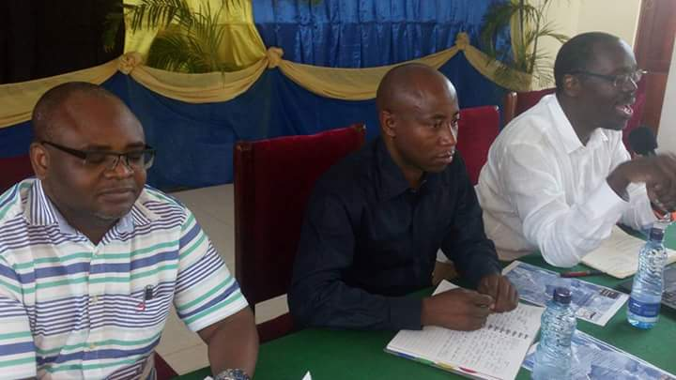
Prof. Kitila, Hon. Hussein Juma and Aidan Eyakuze in discussions on the first Action Plan

Kigoma Ujiji Municipality oriented its local residents, Municipal Councilors and Staff, Religious leaders, Local Members of Media and CSOs on Previous National Action Plans, commitments made and challenges faced with the aim of preparing them to participate during public consultation and meeting in order to develop proper, implementable first Action Plan and relevant commitments for the Municipality. This mostly took place in between July and August, 2016.

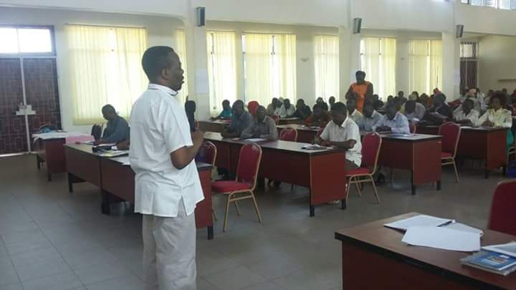
Hon. Zitto Kabwe (MP) speaking at OGP consultation meeting

After all, Kigoma Ujiji finished developing its first Action Plan for the year 2017 – 2018 which focuses in five priority areas out of six recommended by participants as follows;
- Land Transparency
- Education Transparency
- Water Services Transparency
- Health Services Transparency
- Open Budgets

The aim of developing this action plan in priority areas is to ensure citizens participation, transparency and utilizing the available technology to empower members of the public to hold the government more accountable to its citizens. The selected priority areas have great social, economic and political significance for the citizens in building good governance in the country.

- ACTION PLAN DEVELOPMENT PROCESS
In developing first action plan for Kigoma Ujiji Municipality, coordination unit goes through the following steps:
- Prepared simple documents that explain in details the history and the establishment of OGP, its roles and responsibilities that distributed in advance to local residents, Municipal Councilors and Staff, Religious leaders, Local Members of Media and Civil Society Organizations planed to be furnished with the knowledge of Open Government initiatives as proactively raise OGP awareness to different groups of stakeholders. These groups intended to spread more information at Wards and Streets level about Open Government. This was done considering the fact that, the concept of Open government was new and people need to be informed from the scratch.

- Kigoma Ujiji Municipality jointly with TWAWEZA (Experienced CSO) conducted a two days orientation training about OGP, National Action Plan (First and Second), The process to develop Action Plan and Commitments. The participants had a chance to go through the first two National Action Plans and see their weakness also challenges faced.

- The Municipality largely depends on Central Government budgets (95%), so even in setting up the priority area; central government’s priority has to be observed first. Senior staff responsible for OGP looked at 10 central Government focused priorities from all developed action plans and recommended six areas to be discussed by the stakeholders. The recommendation based on budget set by central government. Selecting priority area out of government budget, its implementation could be difficult as it will not get financial resources. The areas recommended are as follows:
- Land Transparency
- Education Transparency
- Water Services Transparency
- Health Services Transparency
- Open Budgets
- Open Data

- The selected priority areas handled over during the 2 days consultative meeting for the participants to go through and come out with the relevant Commitments to be implemented by the Kigoma Ujiji Municipal Council. In this two days consultative meeting, a total of 120 people participated. The participants were Municipal Councilors, Staff (Head office), Staff from Regional Commissioner’s office and District Commissioner’s office, Members of Media, Religious leaders, 20 Civil Society Organizations based in Kigoma and Municipal staff from lower level – Ward. Contributions from participants were noted down according the priority area as follows:
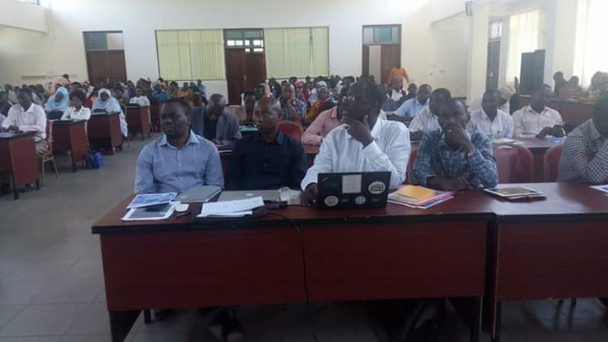
Land Transparency
Land sector received 8 contributions to be taken as commitments

Education Transparency
Education sector received 18 contributions to be taken as commitments

Water Services Transparency
Water sector received 8 contributions to be taken as commitments

Health Services Transparency
Health sector received 17 contributions to be taken as commitments

Open Budgets
Open budget received 8 contributions to be taken as commitments

Open Data
Open data received 4 contributions to be taken as commitments

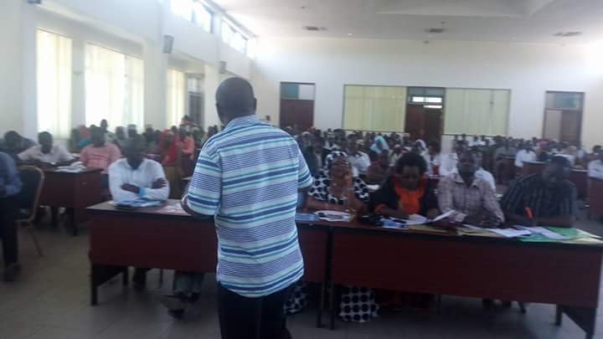
Prof. Kitila Mkumbo presenting at a consultation meeting for the first Action Plan
The stakeholders selected all six priority area as they see all are carrying equal importance. A total of 61 recommendations for commitments were registered. But since central government still in the process of formulating Open Data Policy, Implementation Strategy, Guidelines and License, OGP coordination Unit decided to drop 4 recommendations for open data buying time for central government to complete the process and proceeded with 57 recommendations. All data of the rest of priorities area to be reported separately in each of respective sector report.

- Kigoma Ujiji OGP Senior staff together with TWAWEZA scrutinized the 57 remained recommendations and come out with five relevant recommendations considered to be commitments and submitted before the meeting of Full Council on 31 August 2016 and passed as the official First Action Plan of Kigoma Ujiji Municipal Council for the period of 2017 – 2018.

Full Council meeting, is the highest decision making tool for the Municipality which include representative of the people from every ward within the Municipal area.

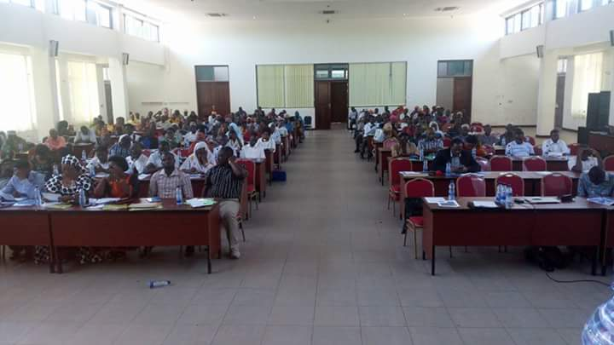
Participants of the working meeting to development the Council’s Action Plan

4.0 COMMITMENTS
Kigoma Ujiji selected five key priority areas from previous National Action Plans which seems not fully implemented to the level of public satisfaction at grass root. For each of the five (5) priority areas, the key principles and commitments are as detailed below;

COMMITMENT
Name and Number of Commitment |  | - Publish the Council’s Master Plan online with details information of all Land uses, Planned areas, Unplanned areas and Open spaces by July 2017
Name and contact information of responsible department/team |  | Brown Nziku  Municipal Urban Planning Officer (MUPO)  Department of Urban Planning, Land and Natural Resources  nzikub@gmail.com  +255 763 629090  Apollo Daudi  Municipal Information, Communication and Technology Officer  ICT – Section  apollodaudi77@gmail.com  +255 752 882 388
Other involved actors | Government | Ministry of Lands, Housing and Human Settlements  Ministry of Regional Administration and Local Government
Other involved actors | Civil Society, Private Sector | - KIUNGONET  - KIOO  - NYAKITONTO Youth for Development  - Hove Without Border  - Neighbours Without Borders  - Kigoma Ujiji TOSHANEWORK  - Promotion and Women Development  - MWOCACHI  - KIWOHEDE  - The Hope of Young Generation  - Kigoma Development Initiative (KDI)  - Members of Media  - Religious Leaders
Status quo or problem/issue to be addressed |  | Land is a very important resource for residents of Kigoma Ujiji and Tanzanians in general because of its scarcity. Kigoma Municipal Council officials spend a lot of time and financial resources in dealing with land conflicts. Time and finance spent in resolving land conflicts might have been used in other development activities to improve standard of lives of its residents.  One of the key factors observed that contribute by large percentage is lack of transparency and openness in handling issues pertaining to land.  Kigoma Ujiji Municipal Council decided to deal with to a minimum range this kind of conflicts by ensure fair, equitable and efficient governance of land matters and to reduce the potential for land conflicts.
Main Objective |  | Transparency on land issues to ensure fair, equitable and efficient governance of land matters and to reduce land conflicts, have in place data for revenue collection and future Municipal development.
Brief Description of Commitment  (140 character limit) |  | To prepare and have accessible online Municipal land use plan (with detailed information of all demarcated and titled land, unoccupied land and open spaces available for public use, reduce land conflicts as a results of information not being known, Municipal to have correct data for revenue collection/management and to have proper future plan for Municipal development.
Please describe the way in which this commitment is relevant to further advancing OGP values of access to information, public accountability, civic participation, and technology and innovation for openness and accountability (details above) |  | Having accessible online Land Use Plan in place, member of the public will have access to information on all matters as far as land is concerned. Openness to information will activate accountability of individual to public. Member of the public will have a courage to question their leaders/officials on use or allocation made to a certain plot if found its use has been changed. Citizens will be in a position to make public officials to take their responsibilities according to the laws (civic participation). Posting and being able to access information online at the time of an individual, it paves ways for complete openness and accountability.
Verifiable and measurable milestones to fulfill the commitment |  |  | New or ongoing commitment | Start Date | End Date
- Publish the council’s General Planning Scheme (Land use Plan) online for public use on January 2017  - Publish information on all measured and land titles issued, placed on the website of the Municipality for public use quarterly  - Publish information on unoccupied spaces in the Municipality for public use quarterly |  |  | New commitment | January, 2017 | July, 2017

COMMITMENT
Name and Number of Commitment |  | - Disclose information on the receipt of funds, medicines and medical supplies, distribution of medicines, medical supplies and patients treated on the website of the Municipality July 2017.
Name and contact information of responsible department/team |  | Dr. Peter Nsanya  Municipal Medical Officer (MMO)  Department of Health, Social Welfare and Nutrition  nsanyap@yahoo.com  +255 768 283 897  Mr. Estomih N. Urio  Municipal Health Secretary (MHS)  +255 754 673 074  Apollo Daudi  Municipal Information, Communication and Technology Officer  ICT – Section  apollodaudi77@gmail.com  +255 752 882 388
Other involved actors | Government | Ministry of Health, Community Development, Gender, the Elderly and Children  Medical Store Department (MSD)  Ministry of Regional Administration and Local Government
Other involved actors | Civil Society, Private Sector | - Single Parents Association  - Youth Against AIDS and Poverty  - Kigoma Development Initiative (KDI)  - Ndela  - Kigoma to Kigoma Children  - Hove Without Border  - Neighbours Without Borders  - Kigoma Ujiji TOMSHA NETWORK  - Youth for Education Against Poverty and AIDS  - KIWOHEDE  - Members of Media  - Religious Leaders
Status quo or problem/issue to be addressed |  | Provision of health services in Tanzania is a government responsibility. Kigoma Ujiji Municipal Council mainly depends on central government disbursement of funds to implement its budget for purchase of medical supplies and by small amount from its own source collection.  It’s a tendency of central government to release less amount of the approved budget, not in time or not at all for medical supplies. With small amount of financial resources, the capacity to provide services automatically goes down.  In so doing, residents of Kigoma do not get satisfying health services offered. Now and then Council’s officials receive complains that they either still funds or medical supplies. Due to this, staff is being discouraged and the relationship between the health workers and patients or public in general is always not good at all.  Kigoma Municipality investigated the cause and find out to be disclosed information on the receipt of funds, medical supplies and the distribution of medical supplies to be the source. Also, some of health workers are not trustful.  To deal with this, Kigoma Ujiji Municipal Council Commit itself to solve the problem in hand by tracking the all system and disclose the information so that residents may make a close follow up on provision of health services.
Main Objective |  | To manage medical commodities in the Municipal Council by tracking the whole supply chain from Medical Store Department (MSD) to the final consumer and bring about transparency and accountability on health sector.
Brief Description of Commitment  (140 character limit) |  | With the use of developed computer Software, the Municipal Council can manage and disclose online information on fund received, medical supplies, distribution of medicines, number of patients treated, the number of deaths, births, what kind of medical supplies to be ordered and when. Accountability and access to information to the public will be enabled.
Please describe the way in which this commitment is relevant to further advancing OGP values of access to information, public accountability, civic participation, and technology and innovation for openness and accountability (details above) |  | Municipal Council intend to use a computer Software called OKOA developed by local resident of Municipality to manage medical supplies in Council and provides public access to information.  This software has four direct users and one indirect user  - Municipal Council (Direct User)  • Access 100+ reports from all Hospitals, Dispensaries and Health Centers on disbursement of medical supplies to each health facility from MSD and its dispensing to patients, intelligence reports on drugs theft, inventory, finances, diseases, deaths, births, expired or due to expire drugs and highly demanded drugs  - National Medical Store (MSD) & Zonal Stores  • Manage its in-house drugs inventory, disbursement to each hospital, Health Center, dispensary and access inventory reports from any health facility in the country including expired drugs, out of stock drugs & highly demanded drugs  - Hospital/Dispensary/Health Center/MSD Pharmacy  • Manage drugs inventory, dispensing of those drugs to patients, record diseases, deaths, births in their facility and access 100+ reports including revenue collection, inventory, diseases, deaths, births  - Ministry Of Health  • Access 100+ reports from both MSD and all hospitals, health centers, dispensaries countrywide including inventory & disbursement of drugs at MSD to those health facilities in the country, drugs theft intelligence at those facilities, revenue collection and finances at all facilities, diseases, deaths and birth reports from all those health facilities in the whole country  - Public (Indirect Users)  • Residents can access reports generated and transferred to Municipal website for transparency. Those reports include drugs availability in hospitals, diseases, deaths and birth reports. Reports do not show patients details but only statistics of those diseases so that one can know what is going on and take precautions.
Verifiable and measurable milestones to fulfill the commitment |  |  | New or ongoing commitment | Start Date | End Date
- Publish Receipt of funds for the purchase of medical support and their allocation for public use monthly  - Publish Medical supplies procured for designated hospitals, health centres and dispensaries for public use monthly  - Publish the availability of medication in designated hospitals, health centres and dispensaries for public use monthly  - Publish the number of patients treated in designated hospitals, health centres and dispensaries and the most common diseases treated for public use monthly  - Publish Treatment prices for public use monthly  - Publish Reports of births, deaths and disease outbreaks for public use monthly  - Publish Health sector infrastructure, furniture and staffing levels for public use monthly |  |  | New commitment | January, 2017 | July, 2017

COMMITMENT
Name and Number of Commitment |  | - Posting Education sector data and receipts of free education fund online by July 2017
Name and contact information of responsible department/team |  | Mrs. Georgina Kalikela  Municipal Primary Education Officer (MEOp)  Department of Primary Education  georginadadi@yahoo.com  +255 787 800 303  Mr. Emmanuel Katemi  Municipal Secondary Education Officer (MEOs)  Department of Secondary Education  emmanuel.katemi@yahoo.com  +255 755 203 471  Apollo Daudi  Municipal Information, Communication and Technology Officer  ICT – Section  apollodaudi77@gmail.com  +255 752 882 388
Other involved actors | Government | Ministry of Education and Vocational Training  Ministry of Regional Administration and Local Government
Other involved actors | Civil Society, Private Sector | - Single Parents Association  - KIUNGONET  - KIVIDEA  - NYAKITONTO Youth for Development  - Hove Without Border  - Neighbours Without Borders  - Kigoma Ujiji TOMSHA NETWORK  - KIWOHEDE  - Youth Mothers Supporting  - The Hope of Young Generation  - Members of Media  - Religious Leaders  - Kigoma Development Initiative (KDI)
Status quo or problem/issue to be addressed |  | Education is a sector of exceptional importance. It serves a large part of the population of the municipality including parents, teachers, students and other stakeholders. It is a biggest sector that employs a big share of council’s employees. Given its size, everything has to be open to everyone to help delivery of quality services and monitoring can be easy. Currently not the case.  Being transparent in provision of services will help build confidence among these actors and encourage some to contribute to the growth and the provision of better education. Some stakeholders refuse to give their contribution either during budget session or implementation.  The aim of the council is to provide quality and affordable education that meet standards but it misses the stakeholders contribution and opinion, let be financial or materially. One of the reasons studied is lack of information to stakeholders. The council plans to disclose all information by publish online to reach majority of the public for their follow up and to improve education in Municipality.
Main Objective |  | To publish online all information/data on education sector for public use by July 2017
Brief Description of Commitment  (140 character limit) |  | Education is a sector of exceptional importance. It serves a large part of the population of the Municipality including parents, teachers, students and other stakeholders. Given its size, the transparent provision of services will help build confidence among these actors and encourage some to contribute to the growth and the provision of better education. The council plans to publish information relating to the provision of education services for use by the public.
Please describe the way in which this commitment is relevant to further advancing OGP values of access to information, public accountability, civic participation, and technology and innovation for openness and accountability (details above) |  | Kigoma Ujiji Municipal Council commit itself to disclose data on education as it increase transparency and provide feedback to underperforming institutions, diagnose problems and plan to reforms them. By opening up data on education help to ensure resources for education are prioritized and are being spent on intended beneficiaries. Community having access to information will themselves engage in monitoring schools and build trust and hence better outcomes.  To achieve this commitment, the Municipality intends to publish the following information:  - Education funding received each month by each primary and secondary school  - Expenditure per month on education by each primary and secondary school  - Funds received and spent on education sector development projects  - The number of students, teachers, and non-teaching staff at each school  - The number of classrooms, offices, latrines, desks, chairs, tables, teachers' houses and fences, showing needs, existing and shortage for each school  - Examination results and schools’ rankings on national, regional and council lists
Verifiable and measurable milestones to fulfill the commitment |  |  | New or ongoing commitment | Start Date | End Date
- Publish Education funding received each month by each primary and secondary school for public use  - Publish Expenditure per month on education by each primary and secondary school for public use  - Publish Funds received and spent on education sector development projects for public use monthly  - Publish the number of students, teachers, and non-teaching staff for each school for public use  - Publish the number of classrooms, offices, latrines, desks, chairs, tables, teachers' houses and fences, showing needs, existing and shortage for each school for public use monthly  - Examination results and schools’ rankings on national, regional and council lists for public use |  |  | New commitment | January, 2017 | July, 2017

COMMITMENT
Name and Number of Commitment |  | - Information on water services, sewerage, water sources and sewage ponds available for public access and use by July 2017
Name and contact information of responsible department/team |  | Eng. Sultan Ndoliwa  Municipal Water Engineer Officer (MWE)  Department of Water  ndoliso@@gmail.com  +255 758 122293  Apollo Daudi  Municipal Information, Communication and Technology Officer  ICT – Section  apollodaudi77@gmail.com  +255 752 882 388
Other involved actors | Government | Ministry of Water and Irrigation  Ministry of Regional Administration and Local Government
Other involved actors | Civil Society, Private Sector | - NYAKITONTO Youth for Development  - Kigoma to Kigoma Children  - Promotion and Women Development  - The Green World Vision  - The Hope of Young Generation  - Members of Media  - Religious Leaders  - Kigoma Development Initiative (KDI)
Status quo or problem/issue to be addressed |  | Water is life. Without water no activity can be done. Access to water fosters growth of economic activity. Presence of clean water supply reduces outbreaks of infectious diseases such as cholera and diarrhoeal disease.  Currently, only 40% of Kigoma Ujiji residents have access to equitable safe and clean water. No Sanitation services provided by the government except at individual level. Staff at Water authority is being paid but people do not know why not, when will and how they are getting this important service. Shouts are here and there.  The Municipality wants to address this issue by providing them with clear information about the provision of water services. The Municipal intends to links its residents with central government generated water points mapping system so that they can see on their own the status of service provision and make it easy for them to monitor.
Main Objective |  | To provide information on water services, sewerage, water sources and sewage ponds for public access and use
Brief Description of Commitment  (140 character limit) |  | Citizen demands high quality public service provision, by adopting open data and participatory planning for water point, distribution and monitoring of water supply can be managed.  Proactively publishing data help to identify amount of water use, access point location, management, consumption, and quality and investment decision. This can engage wider community in service improvement and planning appropriate reforms  Kigoma Ujiji intend to publish information online so as to allow citizen voices in policy planning to direct infrastructure investments where they are needed most
Please describe the way in which this commitment is relevant to further advancing OGP values of access to information, public accountability, civic participation, and technology and innovation for openness and accountability (details above) |  | To open data to improve access to water by making up to date information on the status and location of available water points to citizens in order to make water services more accessible, efficient and accountable.  To achieve this commitment, the Municipality intends to do the following:  - Provide status reports access to clean water and waste water every month for each street  - Publish information network of water supply and sewage networks to the entire Municipality  - Disclosure of revenue and expenditure on clean water and sewage projects  - Publish information on water sources and wastewater pools
Verifiable and measurable milestones to fulfill the commitment |  |  | New or ongoing commitment | Start Date | End Date
- Provide status reports access to clean water and waste water every month for each street  - Publish information network of water supply and sewage networks to the entire Municipality quarterly  - Disclosure of revenue and expenditure on clean water and sewage projects every month  - Publish information on water sources and wastewater pools monthly |  |  | New commitment | January, 2017 | July, 2017

COMMITMENT

Name and Number of Commitment |  | - To make budget data (Five key budget reports) and quarterly Audit Committee reports accessible online each year.
Name and contact information of responsible department/team |  | Wilfred C. Mwita  Municipal Economy and Planning Officer (MEPO)  Planning, Statistics and Monitoring Department  +255 755 314632  Apollo Daudi  Municipal Information, Communication and Technology Officer  ICT – Section  apollodaudi77@gmail.com  +255 752 882 388
Other involved actors | Government | Ministry of Finance and Planning  Ministry of Regional Administration and Local Government
Other involved actors | Civil Society, Private Sector | - KIUNGONET  - KIVIDEA  - NYAKITONTO Youth for Development  - Kigoma Ujiji TOMSHA NETWORK  - MWOCACHI  - KIWOHEDE  - Members of Media  - Religious Leaders  - Kigoma Development Initiative (KDI)
Status quo or problem/issue to be addressed |  | Kigoma Ujiji Municipal Council every year prepares and approves its budget. This budget is for the people of Kigoma Ujiji. Not so many people know what is in the budget and make a follow up. Regularly tend to complain. Executives find it to be the problem.  In order to provide citizens with comprehensive information on the Council’s plans and expenditure, useful platform is to disclose information particularly online. This is a user friendly and stakeholders can analyze the budget using a wide range of techniques. Residents can make follow up and ask their leaders in case they are not satisfied.  Also, residents of Municipality will be in the position to advice Municipality leaders on their priorities to be considered in the next budgets and to make them respond to their responsibilities.
Main Objective |  | To provide online Municipal budget reports and quarterly reports of the audit committee for public use.
Brief Description of Commitment  (140 character limit) |  | Kigoma Ujiji Municipal Council is committed to publish online key budgets documents in order to provide citizens with detailed information on the Municipal plans, collection and expenditure. Basically, online information provides useful platforms for stakeholders to analyze the budget and put their contributions that enable the Municipality to come out with effective and more implementable budget that answer peoples questions.
Please describe the way in which this commitment is relevant to further advancing OGP values of access to information, public accountability, civic participation, and technology and innovation for openness and accountability (details above) |  | Transparency in the budget process is central to the transparent operation of public institutions. The importance of budget transparency begins when the budget process starts, and continues throughout approval processes, during implementation and in the preparation and audit of accounts. When such information is openly and easily available, stakeholders can comment and submit their contributions to make the budget relevant and deliverable, and thus improve the lives of beneficiaries.  To achieve this commitment, the Municipality intends to do the following:  - Information on the annual budget to be disclosed for public use  - Budget priorities and local and outside sources of income to be disclosed  - The draft budget prepared by experts made open for public use  - The draft budget approved by Council made open for public use  - The budget as passed by Parliament made open for public use  - A “citizens budget” summary of revised budget as passed by Parliament prepared  - Mid-year budget reports made open for public use  - Income and Expenditure statements made open for public use  - Reports of debts made open for public use  - Audit reports made open for public use  - The results of the Municipal Council’s report to the Parliamentary Committee on Local Government Accounts (LAAC) made open for public use
Verifiable and measurable milestones to fulfill the commitment |  |  | New or ongoing commitment | Start Date | End Date
- Information on the annual budget to be disclosed for public use end of June 2017  - Budget priorities, local and outside sources of income to be disclosed on January 2017  - The draft budget prepared by experts made open for public use on January 2017  - The draft budget approved by Council made open for public use on February 2017  - The budget as passed by Parliament made open for public use on July 2017  - A “citizens budget” summary of revised budget as passed by Parliament prepared at Mid July 2017  - Mid-year budget reports made open for public use on January 2017  - Income and Expenditure statements made open for public use monthly  - Reports of debts made open for public use quarterly  - Audit reports made open for public use quarterly  - The results of the Municipal Council’s report to the Parliamentary Committee on Local Government Accounts (LAAC) made open for public use one month after |  |  | New commitment | January, 2017 | July, 2017

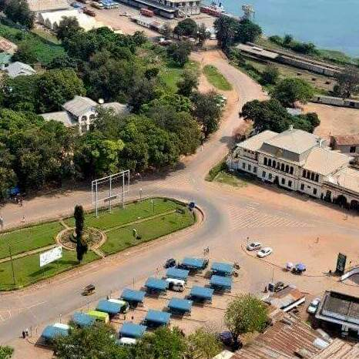
Kigoma Town

5.0 CONCLUSION
This Action Plan has been developed in partnership with stakeholders from the Municipal Council of Kigoma Ujiji, including the government, civil society, non-governmental organizations and the media. Implementation of the Action Plan will begin on January 1st, 2017. Quarterly reports on the implementation of the plan will be placed on the website of the Municipality of Kigoma Ujiji for public use.
It is the strong belief of the Municipal Council of Kigoma Ujiji that the commitments made in this plan will pave the way towards a transparent Municipality that is accountable for the delivery of services.

