REPUBLIC OF PARAGUAY

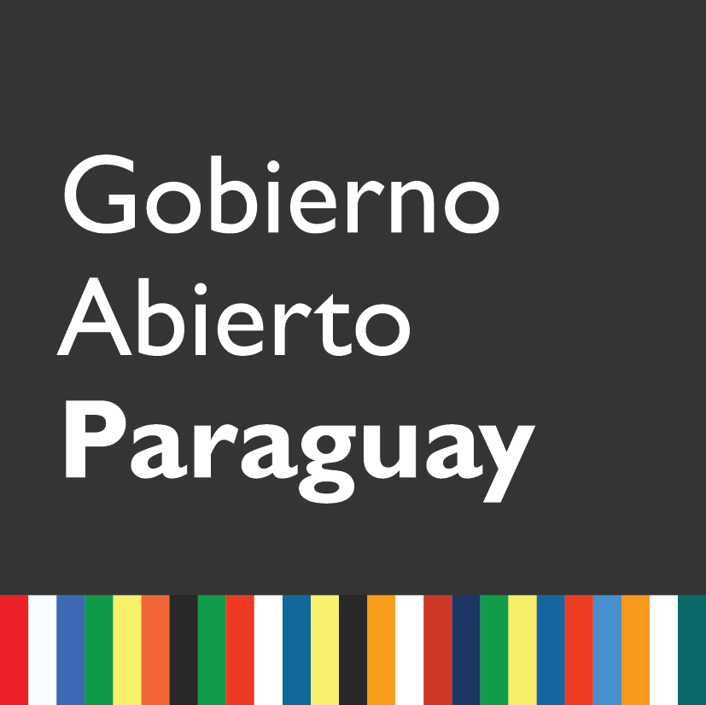

Midterm Self-Assessment Report National Action Plan 2016-2018

- Introduction and Background

The Open Government Partnership (OGP) is an international initiative that seeks to guarantee concrete commitments of governments with their citizens to promote transparency, citizen participation, accountability and technology and innovation that empower citizens, fight against corruption and take advantage of new technologies to strengthen governance.

Since 2011 the Republic of Paraguay has joined the OGP. This was possible because the country had experiences that fit the characteristics promoted by OGP and that required joint articulation and impulse, which were favored with this new modality of work in the field of transparency and integrity of public management. The request for incorporation to the OGP responded to the desire to promote a cultural change, in processes, in organizations and in the forms of relationship with the citizenry that demands greater transparency, efficiency and participation.

The first National Action Plan (NAP) 2012-2013 highlighted the implementation of three systems: 1) Exchange of information among government institutions for the development of a computer application that allows the exchange of information between government institutions. 2) Purchases by electronic catalog, with the purpose of strengthening the national system of public procurement, aiming above all to simplify and render more transparent the procurement and contracting processes and 3) Control of the administrative career (SICCA), implementing a system of management of persons and the Single Portal of Public Employment "Paraguay Concursa".

The second NAP 2014-2016 highlights the implementation of nine commitments. 1) Promulgation and implementation of the law of free citizen access to public information and government transparency 2) Design and implementation of an open data policy and promotion of capacity building in civil society for its use 3) Capacity building in Citizenship on public sector budget management 4) Transparency and Access to information on emblematic public projects 5) Follow-up to the Open Government Action Plan 2014-2016 6) Implementation of channels for social dialogue and citizen participation for consultation and monitoring of public policies 7) Creation and / or strengthening of 50 Municipal Development Councils 8) Citizen Control Panel of the National Poverty Reduction Program "Sowing Opportunities" and 9) Creation of a System of Electronic Legal Procedures in Public Procurement for public access.

The Third NAP 2016-2018 has 10 commitments: 1) Access to Public Information; 2) Open Data; 3) Citizen Participation and monitoring; 4) Accountability; 5) Local Government and Citizen Participation; 6) Environment and Natural Resources; 7) Health; 8) Education; 9) Poverty reduction and social development; 10) Citizen Oversight.

This NAP was co-drafted with the participation of different working groups: 62 organizations from the academic sector, from civil society, international agencies and working groups, and 47 public institutions. The methodology used promoted citizen participation and made it possible to build consensus among the participants and a link of the PAGA with the main objectives of the Paraguay 2030 National Development Plan (NDP) "a strategic document that facilitates the coordination of actions in the sectoral Executive Branch, as well as with various levels of government, civil society, private sector and, possibly, the Legislative and Judicial branches, which will allow to comply with the constitutional mandate established in Article 177 that establishes that national development plans will be indicative for the private sector, and mandatory compliance for the public sector. "

PND Paraguay 2030 is a strategic document that facilitates coordinating actions into sectorial bodies of executive branch, as well as various levels of government, civil society, private sector and eventually the Legislative and Judicial branches. It is an instrument to fulfill the constitutional mandate established in Article 177, which states that national development plans will be indicative for the private sector, and mandatory for compliance for the public sector.

At the same time, the NDP is aligned with the 2030 Agenda for Sustainable Development "to effectively implement 17 ambitious goals that seek, among other things, to end extreme poverty and hunger; improving the quality of health and education; and reduce environmental impact.

2) National Action Plan Process 2016-2018

Schedule of Co-creation and Launching of the Process

The development of the third Action Plan of Paraguay was initiated 8 months before the delivery date to ensure a great stage of awareness and the amplitude of channels and consultation. The schedule was agreed on the basis of three stages. In the first stage, the preliminary tasks and organization of the work for the design of the Plan were developed through the definition of a schedule that allows prior notice and due promotion of the activities, and also included the holding of a National Open Government Seminar as an official launch of the process on November 17, 2015 and participation in related events, seeking to raise awareness and inclusion of new actors in the co-creation process.

The second stage of initial development of commitments consisted of a wide public call for participation in the co-creation process and the holding of working sessions organized in eight thematic groups.

Finally, in the third stage, an Evaluation Committee was set up, at the request of the Joint Committee, whose task was to prioritize and define the commitments to be included in the Plan. The process was supported by the Democracy and Governance Program of the United States Agency for International Development in Paraguay (USAID/Paraguay) and the Center for Environmental and Social Studies (CEAMSO). The implementation of the assistance consultancy in the creation of the 3rdPlan was carried out by the NGO Seeds for Democracy.

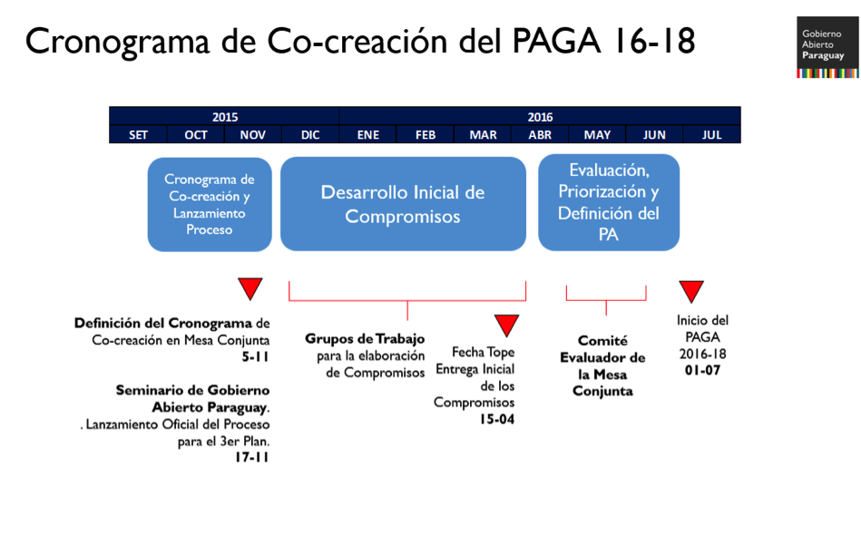

Initial development of commitments

In order for the elaboration of the commitments and targets to comply with the Open Government criteria, the key recommendations of the Independent Review Mechanism (IRM) of the 2014-2015 Progress Report were incorporated in relation to:

● Define specific themes and problems;
● Coordinate with other powers and levels of the state;
● Involve international working groups;
● Improve public participation and involvement of key actors and institutions;
● Incorporate specific commitments and targets into several goals to ensure accountability;
● Include working groups and environmental and natural resource commitments;
● Address commitments that help transparency and accountability of FONACIDE.

The working groups

Considering the MRI recommendations, eight groups were organized, each of which covered a single topic. These groups were: 1) Access to public information, open data and transparency; 2) Continuity of action plans; 3) Education; 4) Health; 5) Security and citizen control; 6) Poverty reduction and social development; 7) Environment and natural resources; and 8) A workshop for the inclusion of new actors. Seeking the possibility of developing specific thematic agreements within the framework of a participatory and democratic process and capable of becoming concrete commitments and goals for a period not exceeding two years.

The organization of the groups had as a priority the participation of the citizens; the methodology used focused on building consensus among the different actors involved. For example, the609 people from organizations of academia, civil society, international agencies and working groups and public institutions that participated in the co-creation process contributed ideas and comments through a web space enabled for the purpose and templates delivered during awareness events. They were taken into account for the formulation and evaluation of the commitments.

The working groups met in two sessions per theme. For the integration of each one, calls were made to referent institutions of civil society, guilds and academy based on the mapping of actors performed; in addition to a public call for citizenship in general, spread by social networks (Facebook and Twitter) and the Open Government website (http://www.gobiernoabierto.gov.py/plan2016-18).

A tour of the cities of Caacupé and Ciudad del Este was also held to raise awareness of the Open Government initiative and the draft of the Plan; in addition, press releases were published in mass media (print, television and radio), alternative media (a WhatsApp group of voluntary participation kept members of the Joint Open Government Board informed throughout the process) and email lists. Furthermore, the information generated was replicated through the websites and social networks of public institutions and civil society organizations.

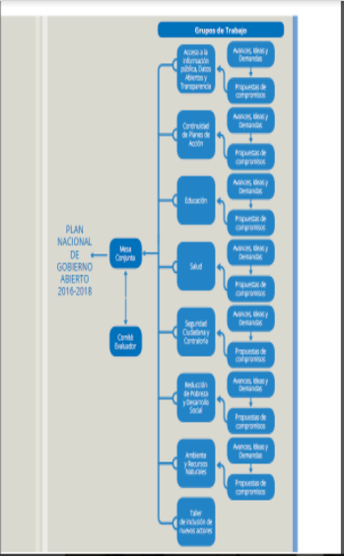

^{[1]} Launching of the Open Legislative Data Portal and the Legislative applicationPy. 25-11-15. Sessions Room of the National Congress. / Day of Analysis of Public Policies with emphasis on "Open Government". 24 and 25-11-15. Aula Magna UC / International Seminar on Access to Public Information. 01, 02 and 03-12-15. Hotel del Paraguay / Citizen's Day for Transparency. 05-12-15. Pantheon of the Heroes. / Course on Social Innovation and Transparency through Open Data. 01 and 02-16. Polytechnic Faculty of the National University of Asunción. (UNA) / # OpenDataDay16. 05-03-16. Ko Working Gua. / Cono Sur Meeting of Contact Points. 07-04-16. Montevideo, Uruguay / Workshop on Open Government organized by the CIRD Foundation. 4/19-16. National Archives of Asunción / Workshop on the Alliance for Open Government with international consultant Sandra Elena. 04-28-16. Granados Park Hotel / Workshop "Participation of Civil Society in Open Government" with international consultant Sandra Elena. 04-28-16. Hotel Villa Morra Suites. / Scholastic Program Workshop Citizenship Paraguay 16-05-16 / Regional Meeting of the Americas of the Alliance for Open Government - Paraguay Panel. 06-16-16. Montevideo, Uruguay. / Also, prior to the start of the Co-creation Process, Paraguay hosted the Second Regional Dialogue on Open Government Policy in Latin America and the Caribbean | Citizen-Centered Governments, co-organized by the STP and the Inter-American Development Bank (IDB). 17 and 18 -06-15, Open Government Expo 7-09-16 http://www.gobiernoabierto.gov.py/articulo/se-realiza-expo-gobierno- abierto
^{[2]} Open Government Seminar Paraguay + 15 sessions of the Working Groups.

3) Evaluation, Prioritization and Definition of the Action Plan

The first level was based on the process of segmentation and ordering of the strategic actors (stakeholder map) and the preparatory works of contact and convocation. The next level was based on the Thematic Groups division, the Joint Open Government Board and the Evaluation Committee.

Joint Open Government Board

The Technical Secretariat for Economic and Social Development Planning (STP) under the Presidency of the Republic is the public institution that exercises Paraguay's representation before OGP and is the institution responsible for promoting the principles of Open Government in Paraguay.

In addition, it is responsible for ensuring that governmental organizations and non-governmental organizations participate in the design, implementation and monitoring of the Action Plans of Open Government in Paraguay.

The Joint Open Government Board is composed of:

1) Ministry of Justice
2) Ministry of Public Health and Social Welfare
3) Ministry of Education and Science
4) Ministry of Finance
5) Technical Secretariat for Economic and Social Development Planning
6) National Anti-Corruption Secretariat
7) Secretariat of the Civil Service
8) National Secretariat of Information and Communication Technologies
9) National Directorate of Public Contracts
10) Directorate General of Anti-Corruption and Integrity, of the Civil Cabinet of the Presidency of the Republic
11) Comptroller General of the Republic
12) Representatives of organized civil society 1) NGOs (all those who contribute to the implementation of any of the commitments established in Action Plan 2) Academia (all those that contribute to the implementation of any of the commitments established in the Plan 3) Private Sector (Guilds) (all those who contribute to the implementation of any of the commitments established in the Action Plan).

Activities of the Joint Open Government Board

At the meeting of the Joint Committee on April 21, 2016, the Evaluation Committee was elected, 40 commitments were presented with 181 goals and submitted to an online public consultation. The Evaluation Committee was integrated through a voluntary nomination process of those present, in which five members of public institutions and five members of society organizations were appointed by consensus, who were in charge of the integral revision of the commitment templates.

Evaluating committee

The Evaluation Committee met three times. The first two days had as purpose the evaluation of the commitments presented according to the Evaluation Grid and its subsequent return to the institutions for the inclusion of the recommendations made. The Evaluation Grids and the recommendations were socialized with the citizenship in general through the portal of Open Government. A tour of the cities of Caacupé and Ciudad del Este was also held to raise awareness of the Open Government initiative and make the Draft Plan known. This dynamic of joint and coordinated work between the citizens and the government, sifted through 40 commitments and 181 activities were approved by the Evaluation Committee of NAP 2016-2018.

The institutions then made the corresponding improvements and were returned to the Evaluation Committee for prioritization and final ordering. Thus, after 15 sessions of the various working groups, on the 8 specific topics mentioned above.The participation of 46 public institutions (including an extra-power body outside the Executive Branch such as the Comptroller General of the Republic in addition to the Chamber of Deputies and the Senate); 62 civil society organizations; the academic sector; agencies and international working groups (Thematic Working Groups on Access to Public Information, Open Data, Anti-Corruption, Fiscal Transparency and Openness of Natural Resources, Access Inflo Europe, Transparency and Access to Public Information Network (RTA), National Institute Transparency, Access to Information and Protection of Personal Data (INAI), USAID, World Bank, IDB and international experts); the Evaluation Committee re-grouped the templates and initial goals into 10 commitments and 62 targets, and were arranged for online public consultation. On June 21, the Plan was presented to the Joint Committee for final approval and referral to the corresponding instances. Thus, on September 6, 2016, Decree No.5894 decrees the approval of the Open Government Action Plan for the period from July 2016 to June 2108.

4) Main Achievements of the Co-creation Process of the Third Action Plan 2016-2018 of Open Government Paraguay

Linking the Open Government Action Plan with Development Goals to improve quality of life

The definition of the working groups allowed linking the commitments of the third Action Plan with the main challenges of the National Development Plan Paraguay 2030 and the 2030 Sustainable Development Targets. The plan included strategic issues of these agendas such as Poverty Reduction and Social Development; Health; Education; Environment and Natural Resources.

Increased participation of Civil Society in the co-creation process

62 civil society organizations, academia, agencies and international working groups participated in the process of co-creation (in the previous Action Plan only 9 participated). The public consultation incorporated the recommendations regarding: availability of the process and co-creation timeline, advance notification, awareness, multiple channels, consultation breadth, documentation and feedback.

Towards an Open State

The Third Action Plan includes for the first time goals of an outer entity, such as the Comptroller General of the Republic. In addition of the Congress, accompanied by the Open Government Forum, are working in parallel with civil society to define its first Action Plan of the Open Parliament Partnership 2016-2018.

Local governments.

9 goals of the Plan include municipal and departmental governments across the country on issues such as participatory design of public policies and access to public information.

Prioritization of Citizen Participation

The priority of the third Action Plan was to improve citizen participation and dissemination of transparency and accountability tools. This is reflected in the participation and dissemination activities included in the commitments.

Increased participation of Government Institutions.

In the Second Action Plan, 15 government institutions participated, of which 12 submitted commitments. In the Third Plan 46 participated and 26 presented commitments.

5) IRM Recommendations

Incorporation of IRM recommendations

The key recommendations of the Independent Review Mechanism of the 2014-2015 Progress Report were incorporated in relation to: defining specific topics and specific problems; coordinate with other powers and levels of the state; involve international working groups; improving public participation and involvement of key actors and institutions; incorporate specific commitments and targets into several commitments to ensure accountability; include working groups and environmental and natural resource commitments; and address commitments that help the transparency and accountability of FONACIDE.

MONITORING RESULTS OF THE THIRD NATIONAL ACTION PLAN

The progress monitoring board of the goals and commitments of the Open Government Plan 2016-2018 can be found here:

http://gobiernoabierto.gov.py/content/plan-de-accion-2016-2018

A visualization of it is as follows:

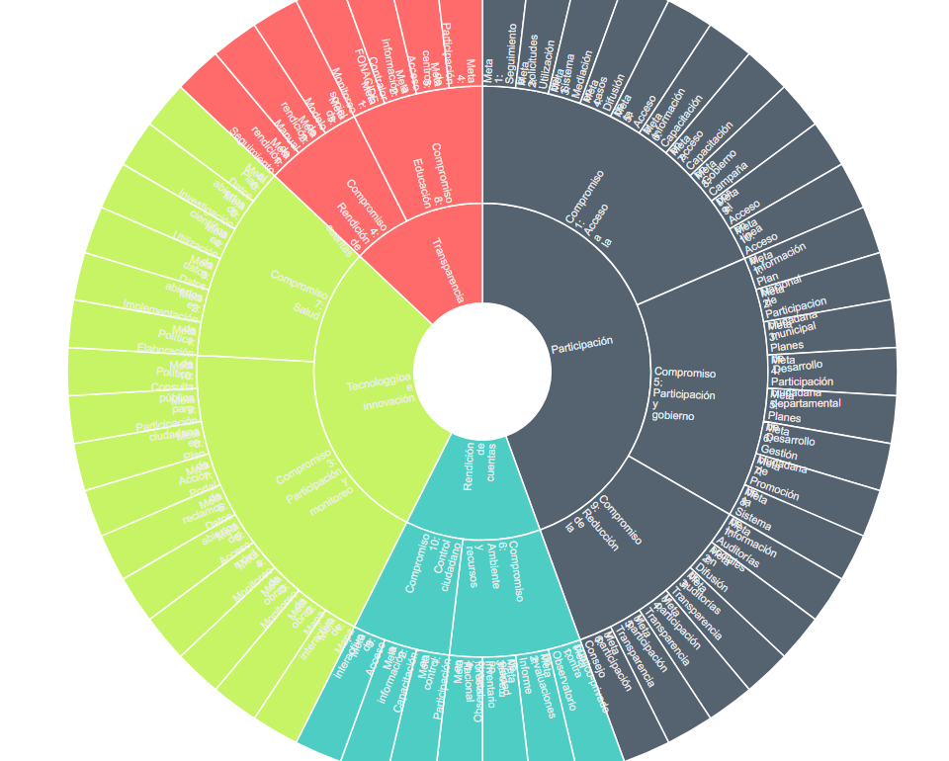

The DGGA/STP has results of the monitoring of the execution of NAP 2016-2018. Taking into account that the NAP contains 62 goals dispersed in 10 commitments, our evaluation of them is as follows:

1. To date, out of 100% of goals, 17 have been completed out of a total of 62 targets. This corresponds to 27% of the NAP 2016-2018 targets.

2. The number of completed goals is very positive, since we only had 5 targets to be met in the second half of 2016 and the first half of 2017, and we have exceeded our initial goal of 5 goals by 340%.

3. 22 goals are advanced and close to being 100% complete. This classification corresponds to 35% of the NAP targets.

4. Another 23 goals are being implemented, but the activities in these goals are not as advanced as the previous ones. This classification corresponds to 37% of the NAP.

Viewing Progress Monitoring:

The interface of progress of goals and commitments, also known as the "traffic light targets" or "display cake" of progress has not yet been completed. Its main feature is its visual impact by the use of colors to demonstrate the level of progress of the goals. In its replacement, we present the following timeframe for monitoring goal progress:
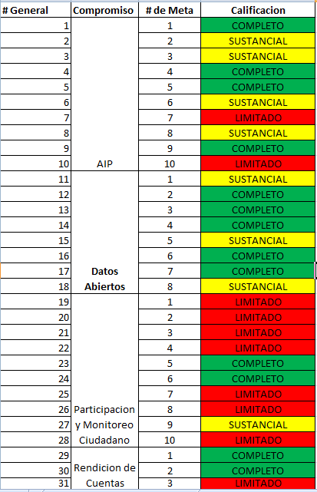

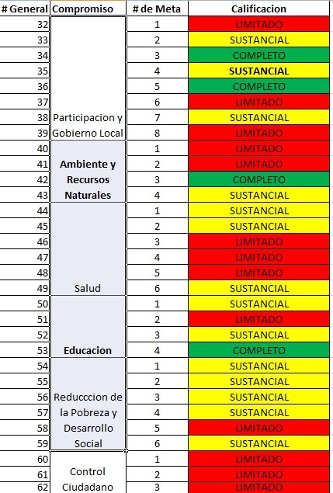

Below, we present the specific templates of all the commitments and their goals.

The presentation format corresponds to the new matrix of presentation of goals requested by the OGP.

Self-Assessment Report Template
Commitment 1
Access to Public Information

July 1, 2016 - June 30, 2017
Lead implementing agency/actor |  | Ministry of Justice (MJ)  National Anti-Corruption Secretariat (SENAC)  National Secretariat of Information and Communication Technologies (SENATICS)  Technical Secretariat for Economic and Social Development Planning (STP)  Civil Cabinet of the Presidency of the Republic  National Secretariat for the Human Rights of Persons with Disabilities (SENADIS)
Commitment description
What is the public problem that the commitment will address? |  | The Law on Access to Public Information (API) in Paraguay entered into force in September 2015. This fact, although a breakthrough, does not guarantee access to information in and of itself, since civil society actors and public are not aware of this right and there is no tradition of requesting information from the State. The current reality is that people still do not have access to the information they need to assert their rights and to monitor the public sector, partly because of the lack of availability of information and partly due to lack of knowledge of existing mechanisms. Equally the principles of Open Government need greater ownership by the actors.
What is the commitment? |  | Higher level of ownership of the API Act and the principles of Open Government to improve the quality of life.  Carry out activities that promote, disseminate and facilitate the exercise of API, the API and Open Government laws with civil society and public officials.
How will the commitment contribute to solve the public problem? |  | Adequate implementation of the Law on access to public information, which includes, on the one hand, wide dissemination of the law, the way of exercising the right, its importance as a means to access other fundamental rights and, on the other, the progressive increase of the minimum information that is compulsorily available on institutional websites and a higher percentage of responses to requests for information in a timely manner; in addition to promoting the principles of Open Government will contribute to reducing information asymmetries to achieve more inclusive institutions and more empowered citizens.
Why is this commitment relevant to OGP values? |  | Considering the following values of OGP linked to this commitment: 1) Improvement of public services 2) Increase in public integrity and 3) Effective management of public resources. Increased public information will contribute to the development of an institutional culture of transparency and accountability by the Government.
Additional information |  | This commitment is aligned with the Strategic Objectives of the 2030 National Development Plan and the 2030 Sustainable Development Goals.  22) Increase access to public information and procedures through electronic networks / SDG 16 Peace, justice and solid institutions.  25) Decentralization of the management of public policies / SDG 10 Reduction of inequalities.  47) Ensure transparency of public spending at the three levels of government and in the three branches of government/SDG 16 Peace, justice and sound institutions.
Completion Level |  | Not Started | Limited | Substantial | Completed
 |  |  |  | X
Description of the results  Next steps |  | The commitment, which is composed of 10 goals, detailed below, obtained a level of Substantial compliance in the first year of the Action Plan 2016-2018. Of the 10 goals of this commitment 4 have been met, 3 have made substantial progress and 3 goals have limited progress, which means that they have been planned to be implemented or are being implemented but have not yet reached substantial progress.
Milestone Status |  |  | Start Date | End Date | Completion Level
Goal 1 - Ministry of Justice (MJ)  1 legal practice created within the chair of API of the Faculty of Law of the National University of Asunción to carry out and follow up on practical cases of requests for public information, both administrative and judicial. |  |  | 2nd Semester 2016 | 1st Semester 2018 | Full
Goal 1 Breakthroughs
Planned. Maintaining conversations with the professors in charge of the API chair of the Faculty of Law and Social Sciences, ensuring that in August they begin classes on to this subject.
Goal 2 - SENAC  30 Institutions of the Executive Branch are 100% compliant with the requirements established in Article 8 of the API Law, of minimum information available, using the standardized system of active transparency developed by SENAC and linked to the Single API Portal. |  |  | 2nd Semester 2016 | 1st Semester 2018 | Limited
Goal 2 Breakthroughs

In action. According to the monitoring carried out by the SENAC there are currently 17 institutions, it is expected for the next monitoring to reach the number of 30 institutions. Likewise, regarding the Active Transparency Module developed by SENAC and linked to the Unified Portal for Access to Public Information, it is available as a test at the following link: https://devaip.senatics.gov.py/portal/

On the other hand, SENAC was carrying out during the month of June several workshops addressed to Transparency officials of the different public institutions where they were presented with the Portal and its functionalities.
Goal 3 - Ministry of Justice (MJ)  1 instance of pre-judicial administrative mediation created in the API Directorate, in coordination with the mediators of Houses of Justice of the MJ. |  |  | 2nd Semester 2016 | 1st Semester 2018 | Substantial
Goal 3 Breakthroughs
In action. In February 2017, the Negotiation and Mediation Training Program for municipal officials was initiated, initially attended by representatives of 5 municipalities (Capiatá, Encarnación, Ñemby, Concepción and Villa Hayes).
Goal 4 - Technical Secretariat of Planning (STP).  1 call for proposals of diffusion directed to the citizenship to strengthen the relation between the agenda of Open Government and the improvement of quality of life. A winning proposal was implemented. |  |  | 2nd Semester 2016 | 1st Semester 2018 | Full
Goal 4 Breakthroughs

In July of 2017, a Data Bootcamp for journalists and communicators, representatives of civil society and civic developers or hackers, and all those citizens who supported the project, supported by the NGO TEDICs and the financing of the PDAM Program of CEAMSO/USAID,and were interested in knowing the possibilities of using the information available in portals of access to public information.

The PDG program of CEAMSO/USAID carried out a public call for proposals addressed to citizens. The winning proposal was the Data Boot Camp implemented by TEDICs, which fulfilled the purpose of strengthening the relationship between the Open Government agenda and the improvement of quality of life.

This was accomplished by training, over three weekends, more than 50 journalists, communicators, developers, civic hackers, who received master classes from 3 international experts to use the available Open Government tools to create prototypes that allow detecting facts from corruption, visualizing spending and management in the health and education sectors. A jury chose the three best proposals and these received a small monetary incentive so that it can continue implementing its proposals.

Goal 5 - SENATICS  50 Municipalities adapt their web pages with the support of SENATICS to comply with the minimum information requirements, as established in Article 8 of the API Law, and also adhere to the Single API Portal. |  |  | 2nd Semester 2016 | 1st Semester 2018 | Full
Goal 5 Breakthroughs

Complete.

78 municipalities have a presence with web pages provided and with SENATICs support to publish minimum information required by the Law.
Goal 6 - Ministry of Justice (MJ)  1,000 young people between the ages of 15 and 29, 50 journalists and 300 public officials trained in API in at least 15 events. |  |  | 2nd Semester 2016 | 1st Semester 2018 | Substantial
Goal 6 Breakthroughs

In action. To date, and according to data from the Ministry of Justice, the institution responsible for this goal, more than 1000 people were trained on the scope of the Law on Access to Public Information, its applications and benefits. Of these 1,000 individuals, 443 are civil servants and 703 are citizens. This was achieved through the implementation of workshops and training talks held in the city of Asunción (Ministry of Justice, National Electricity Administration, Consumer and User Defense Secretariat, National Institute of Technology, Standardization and Metrology, Municipality of Asunción) , City of Encarnación (Autonomous University of Encarnación), city of Coronel Oviedo (Municipality of Coronel Oviedo and Polytechnic and Artistic University of Paraguay), city of Lambaré (Municipality of Lambaré), city of Mariano Roque Alonso (Municipality of MRA), city of Horqueta (Municipality of Horqueta and Technological University Intercontinental), city of Concepción (Municipality of Concepción, National University of Conception, Regional Center and Polytechnic and Artistic University of Paraguay), city of Benjamín Aceval (Municipality of Benjamín Aceval) and city of Yaguarón (Municipality of Yaguarón) during the first half of 2017.

On June 26, 27 and 29, the international consultant and journalist Ginna Morelo developed, respectively, in Ciudad del Este, Encarnación and Asunción the workshops through which they intend to approach the mechanisms to carry out research journalism from the use and analysis of open data that are available in different public institutions and increase public awareness of public affairs.

Regarding the training of 1,000 young people, an average of 500 young people was trained through the training provided by the MJ, SENAC, SENATICS and STP through the talks held at the universities mentioned above.

In addition, the company KOGA will carry out GRAMO (the cycle of inspiring conversations) performing two events the first in the city of Villarrica (June 1) and the second in Encarnación (12 July). Both in the first and in the second edition of GRAMO, issues related to citizen participation will be presented, encouraging the involvement of civil society and citizens in general in public affairs. Some of the topics developed at GRAMO Villarrica were: 1) Digital Rights; the platform for the control of citizenship addressed by Maricarmen Sequera, Director of TEDIC, NGO 2) Intelligent Territories; methodology focused on rural municipalities for the development of territorial plans under the perspective of sustainability supported by three pillars, environmental management, economic development and community empowerment, addressed by Román Cuyer, entrepreneur 3) Transparency and the history of access to public information, addressed by Daniel Vargas Téllez 4) Creative economies and exponential technology, addressed by Rodrigo Weiberlen, Director of ICON (Creative Industries ON) among other topics such as music, government and participation. In GRAMO Encarnación the topics to be presented will be: 1) Promoting Citizen Control, Ofelia Yegros 2) Transparency as a pillar of organizations, Adolf Sauer 3) Innovate in citizen participation, Leonardo Gómez 4) The power of digital tools, Rodrigo Valdez 5) How we protect the San Rafael National Park, Alicia Eisenkorbl 6) Opportunities and Challenges of Encarnación, Verónica Serafini.
Goal 7 - STP  500 trained people (civil society and public officials) through Short Courses of Open Government. |  |  | 2nd Semester 2016 | 1st Semester 2018 | Limited
Goal 7 Breakthroughs

Planned. Proposals related to "Tutorial Videos on the use of Open Data" were accepted. The idea is that these courses are timeless, pragmatic content, accessible to the public, modular and easily replicable on any platform by WhatsApp, YouTube and even for Public Television and that these courses can be incorporated into the permanent modules of the National Institute of the Public Administration of Paraguay (INAPP). Of these 10 courses, 7 courses will be directed to the public sector and 3 to civil society.

See also Annex A of training activities of the General Directorate of Open Government.

Even so, the GDOG has carried out and participated in independent trainings of public officials and members of civil society. More information on this can be found in the annex to this report.

Goal 8 - Ministry of Justice  1 awareness campaign carried out on the API right with technical support and dissemination of the Secretariat of Information and Communication (SICOM) and CSOs, and training and awareness materials available in a friendly format on the API Directorate website. |  |  | 2nd Semester 2016 | 1st Semester 2018 | Substantial
Goal 8 Breakthroughs

In action. Proposals were accepted for the "Consultancy for the development of a play for the dissemination of the use of API tools for students of Higher Institutes of Teacher Education". Among the activities of this consultancy that took place from July 17, 2017 to August 9, 2017, the development of a script for a play of 15 to 20 minutes based on a conventional theater format is outstanding; of an educational nature with simple and everyday messages that aim to socialize with the citizens, in a playful way, about access to public information. The staging will take place in the following cities: Lambaré, San Lorenzo, Luque, Villa Elisa, Mariano Roque Alonso and Asunción, at different times and public spaces. (Note: As of the date of writing and publication of this report, the consultancy for the development of a play for the dissemination of API tools has been carried out and has managed to reach a target audience of X people.)

In addition, the National Development Bank (BNF) disseminated information on Law No. 5282/14 of "Free Citizen Access to Public Information and Government Transparency" through the placement of 10,000 inserts and brochures within the debit card statements and credit of the BNF clients for the months of June and July. The information answers the following questions: What is Public Information? How do I access Public Information? and What information can be requested?

On 24 August, SICOM led a training, along with, for journalists who are members of the State Communicators Team (ECOE) on effective procedures to facilitate access to public information and ensure transparency. The event was supported by members of the Ministry of Justice, SENAC, STPS who highlighted key aspects for compliance with Law 5282/2014. The event had more than 70 people registered.

Goal 9 - Presidency of the Republic  Copies of the Gazette and all signed decrees of previous periods available on the websites www.gacetaoficial.gov.py and www.presidencia.gov.py respectively. |  |  | 2nd Semester 2016 | 1st Semester 2018 | Full
Goal 9 Breakthroughs
Complete. The information is available at the following link: www.gacetaoficial.gov.py

Goal 10 - SENADIS  Information updated quarterly on the management of the National Commission for the Rights of Persons with Disabilities (CONADIS) available on the electronic platform accessible to people with disabilities and with a mechanism for interaction with citizens. |  |  | 2nd Semester 2016 | 1st Semester 2018 | Limited
Goal 10 Breakthroughs
Planned.

(The General Directorate of Open Government (GDOG) / STP has not received inputs for this goal).
Contact information
Institution responsible for implementation  Name of responsible person, Title, Department, Email and telephone |  | Goal 1  MJ  Elida Dávalos, Director, Directorate of Access to Public Information  accessalinformation@ministeriodejusticia.gov.py  +595 21 497618  Goal 2  SENAC  Ariel Ojeda, Director General, Directorate General for Prevention and Transparency  ariel.ojeda@senac.gov.py  +595 21 450001  Goal3  MJ  Elida Dávalos, Director, Directorate of Access to Public Information  accessalinformation@ministeriodejusticia.gov.py  +595 21 497618  Goal 4  STP  Federico Sosa, Director General, Directorate General of Open Government  fsosa@stp.gov.py  +595 21 450422 int 151  Goal 5  SENATICS  Javier Quiñones, Director, Directorate of Electronic Government  governmentelectronico@senatics.gov.py  +595 21 2179000  Goal 6  MJ  Elida Dávalos, Director, Directorate of Access to Public Information  accessalinformation@ministeriodejusticia.gov.py  +595 21 497618  Goal 7  STP  Federico Sosa, Director General, Directorate General of Open Government  fsosa@stp.gov.py  +595 21 450422 int 151  Goal 8  MJ  Elida Dávalos, Director, Directorate of Access to Public Information  accessalinformation@ministeriodejusticia.gov.py  +595 21 497618  Goal 9  Civil Cabinet of the Presidency of the Republic  Diana Correa, Director General, Anti-Corruption and Integrity Division  dcorrea@presidencia.gov.py  +595 21 4140375  Goal 10  SENADIS  Anahi Escudero, Director General, Planning Division  anahiescudero@hotmail.com  +595 21 670093
Other actors involved | Ministries of government, departments, institutions | Goal 1  National University of Asunción (UNA)  Goal 2  Transparency and Anti-Corruption Network  Goal 5  ICT Headquarters in affected municipalities  Goal 6  National Youth Secretariat (SNJ)  Goal 8  Secretariat of Information and Communication (SICOM)  Goal 10  Ministry of Public Health and Social Welfare (MSPBS)  Ministry of Education and Science (MEC)  Ministry of Women  Treasury  Ministry of Justice  Ministry of Labor, Employment and Social Security  National Secretariat for Children and Adolescents  Public Function Secretary  SNJ  STP  Council of Governors of Paraguay and Paraguayan Organization of Intermunicipal Cooperation (OPACI).
Other actors involved | CSOs, the private sector, multilateral organizations, working groups | Impulse Group for Access to Public Information  (IDEA, Seeds for Democracy, CIRD, Free Foundation, Center for Judicial Studies, Chair of Access to Public Information of the National University of Asunción) CEAMSO, CEDEP, Saraki, Teletón, ParIgual, Mechanisms Independently formed by - OACNUDH, Let us Decide, TEDIC, Trinidad Association, AGORA-Py, civil society organizations members of the National Commission for the Rights of Persons with Disabilities (CONADIS), OGP Working Group of API, Transparency Network and Access to Public Information (RTA), OGP Anti-Corruption Working Group, International Cooperation: NED, British Embassy, World Bank, European Union (Eurosocial) and USAID.
Additional Information
Comment from the NGO CIRD:
Seminars, workshops, trainings: on this point we suggest that agendas between public institutions and CSOs can be reconciled. The CIRD Foundation throughout the period of the 2ndplan and part of the 3rdplan has maintained this type of joint work so that a greater impact has been achieved with great efficiency.
Courses on Open Government: From the 2ndAction Plan we mentioned that the institution responsible for the implementation of the Open Government Program Paraguay could, in conjunction with other institutions, carry out diploma courses on Open Government.
We believe that people not linked to the public function should receive these theoretical trainings - practice and should receive certificates as a motivational strategy in the development of the concept of citizenship.
New functionality of the web www.informaciónpública.gov.py:We recognize the effort made to include an option where the citizen requesting information can give his/her opinion about whether he/she feels satisfied or not about an answer, however, we believe that to achieve the goal of improving the quality of responses, it is necessary to continue with the training to respond to requests from designated officials.
Following the context mentioned above, we suggest that to achieve a positive impact in relation to the provision of answers, the officials designated to the access offices are permanent in this function. Also, that they have an adequate profile for the constant relationship with people and permanent training at a national and international level.
All that is cordially suggested above is because in many occasions statistical data are presented as advances, for example "there are x quantities of requests in the portal as opposed to that year". What we do not discredit at all these data, but also highlight that there is a notable difference between the quality and quantity of responses.
Next, we suggest the following academic university profiles:
Sociologist.
Political Scientist.
Communicator.
Journalist.
On the other hand, when using the button to qualify the response by the institution, it is known that the citizen is requested to enter their mail, to send it to an email, however, the mail does not leave any link to qualify the answer. (This can be a computer detail that SENATICs can solve quickly).

Annexes
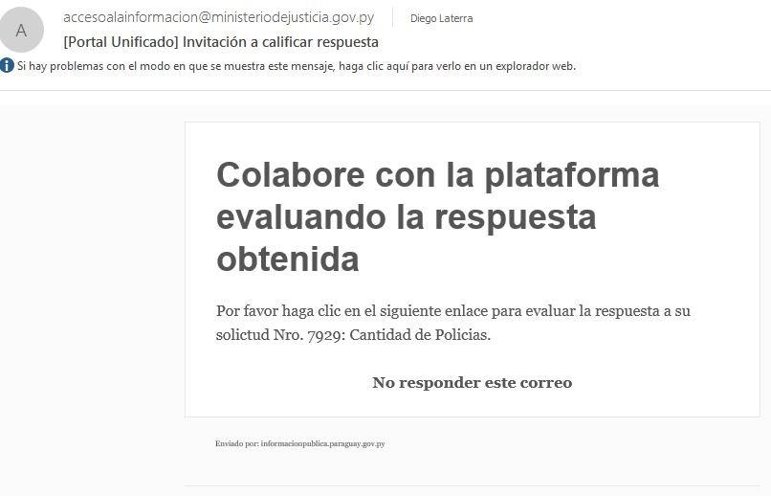
A)

Self-Assessment Report Template
Open Data

Commitment 2

July 1, 2016 - June 30, 2017

Lead implementing agency/actor |  | National Anti-Corruption Secretariat (SENAC)  National Secretariat of Information and Communication Technologies (SENATICS)  Secretariat of Public Function (SFP)  Ministry of Finance (MH)  National Customs Office (DNA)  National Directorate of Public Procurement (DNCP)  Technical Secretariat for Economic and Social Development Planning (STP).
Commitment description
What is the public problem that the commitment will address? |  | Paraguay has been in the process of opening public data for two years. This process is still under way: on the one hand, few institutions have opened their databases and published them in the open data portal. On the other hand, use is still limited and the level of data use that has been open by the State is unknown. Neither have the data sets made available according to the needs of civil society been prioritized.
What is the commitment? |  | Continuous implementation of an open data policy and promotion of capacity building in Civil Society for its use.  Opening of new catalogs of data prioritized, under public consultation, in state institutions and promotion of open data.
How will the commitment contribute to solve the public problem? |  | The Decree that regulates Law number 5.282/14 "Free public access to public information and government transparency" (API Act) establishes that public information that the Government must be gradually transformed into open data format. The increase of data sets available in open formats, particularly salary policies, selection of public servants, election data, political parties, culture, industry, commerce, public tenders, as well as promotion and training for the use of data will make it possible to sensitize and empower the population on the usefulness of open data to improve access to rights.
Why is this commitment relevant to OGP values? |  | Considering the following values of OGP linked to this commitment: 1) Improvement of public services 2) Increase in public integrity and 3) Effective management of public resources. The regular updating of information in open formats will contribute to improving the collaborative participation of civil society and establishing a culture of public transparency.
Additional information |  | This commitment is aligned with the Strategic Objectives of the 2030 National Development Plan and the 2030 Sustainable Development Goals.  21) Increase the proportion of public servants incorporated or promoted based on merit and aptitude / SDG 16 Peace, justice and sound institutions.  22) Increase access to public information and procedures through electronic networks / SDG 16 Peace, justice and solid institutions.  47) Ensure transparency of public spending at the three levels of government and in the three branches of government / SDG 16 Peace, justice and sound institutions.
Completion Level |  | Not Started | Limited | Substantial | Completed
 |  |  |  | X
Description of the results  Next steps |  | The commitment, which is composed of 8 goals, achieved a level of Substantial compliance in the first year of the 2016-2018 Action Plan. Of the 8 goals of this commitment 5 were met, 1 has substantial progress and 1 goal has limited progress, which means that they have been planned to be implemented or are being implemented but have not yet reached substantial progress.
Milestone Status |  |  | Start Date | End Date | Completion Level
Goal 1 - SENATICS  Open data published from 5 new institutions prioritized in public consultation and added to the portal www.datos.gov.py |  |  | 2nd Semester 2016 | 1st Semester 2018 | Substantial
Goal 1 Progress

Planned. It is planned to launch the public consultation through the open data portal www.datos.gov.py in June 2017. Survey of what people want to be published. The aim is to listen to the citizens.

Despite this, SENATICs has been working with dozens of institutions to get them to present open databases.
Goal 2 – SFP  Portal "Paraguay Concursa" with new system implemented to facilitate the availability of information in open data format and the usability of the citizen. |  |  | 2nd Semester 2016 | 1st Semester 2018 | Full
Goal 2 Breakthroughs

Executed. The data sets of the “Paraguay Concursa” Portal are available in the form of open data: 1) Administrative career competitions. It corresponds to the list of all competitions made or published in the Integrated System of the Civil Administrative Career detailing in each record the state in which the Contest (Application, Evaluation, Adjudicated or Declared Deserts) the type of contest, type of link with the institution (Permanent or contracted) the salary, date of beginning and end of the reception of applicants, source of financing, object of expenditure, concept, classification, category, position, location, address, additional benefits. 2) Roster of civil servants. It corresponds to the list of all the civil servants who belong to the Public Administration. The information available on each official is: Year, Month, Level, Entity, OEE, Document, Names, Surnames, Budget, Accrued, Sex, State, Year of Entry, Disability, Disability Type, Date of Birth, Time. 3) State Organizations and Entities (OEE).

Corresponds to the description of dependencies of agencies and entities generally established by programmatic sub-axes, legally designated as mission. The information available on OEEs is: Code Level, Description Level, Entity Code, Description Entity, OEE Code, Description OEE, Telephone, Address, Web Page.
Goal 3 - SFP  Open data published on rosters (gains and losses) and competitions with interactive visualizations available. |  |  | 2nd Semester 2016 | 1st Semester 2018 | Full
Goal 3 Breakthroughs
Executed. The Open Data portal of the SPF was developed, which contains the list of civil servants and public tenders corresponding to the administrative civil career. The data set of the rosters of registrations and decreases has been available since September 10, 2016. The data of the competition index are already public and the visualizations of the same can be observed. To improve the veracity of the data, a quality control is being carried out, through a data crossing of the SPF and MH.
Goal 4 - National Customs Office  Open data of statistical information on foreign trade published and disseminated periodically |  |  | 2nd Semester 2016 | 1st Semester 2018 | Full
Goal 4 Breakthroughs
In action. Formation of a Work Group. O.S. number 169/16. Definition and approval of statistical data to be published in open data formats. Design of the Query Window. Currently, officials of the SOFIA Information Management Area are able to make the necessary adjustments to the Query Window for subsequent publication.
Goal 5 - SENATICS  Open data disseminated through 1 Online Courses, 1 Agreement with Universities, a Guide to open data, 2 promotional events (Open data day and Segurinfo). |  |  | 2nd Semester 2016 | 1st Semester 2018 | Substantial
Goal 5 Breakthroughs

In action. There are 2 open technical data guides (Open data implementation guide, Technical guide for the publication of open data). Verbal agreement with Universities.
Goal 6 - SENATICS - SFP - MH  1 Annual Open Data Hackathon with winning applications developed |  |  | 2nd Semester 2016 | 1st Semester 2018 | Full
Goal 6 Breakthroughs

Executed. The third Hackathon Innovando PY was held on November 25, 26 and 27, 2016, with three categories (public budget, public sector human resources and solutions for civil society), to develop strategies in different areas of public life. They were winners in the following categories: 1) Budget Category "PresupuestApp" a bilingual application that seeks to show how the General Budget of the Nation is executed through a friendly language. 2) Civil Society Category "VOSA" a search by zone of the products of the family basket and returns a list of possible suppliers of the products at the best price. 3) Human Resources Category "ConcursaPy" an application that seeks to provide a mobile solution to the communication of calls for competition for public office. Currently, winning applications are under development; it is estimated that both "PresupuestApp" and "ConcursaPy" will be implemented by the end of 2017.

In addition, in July 2017, the Technical Secretariat for Economic and Social Development Planning (STP) will make public the Source Code of the Results Planning System (SPR) and the Presidential Control Board (TCP) software, and the data contained in both systems.
Goal 8 - STP  1 course for communicators and journalists on tools generated in the framework of Open Government and Data Journalism. |  |  | 2nd Semester 2016 | 1st Semester 2018 | Full
Goal 8 Breakthroughs
Executed. On June 26th, 27th and 29th the international consultant and journalist Ginna Morelo developed, respectively, in Ciudad del Este, Encarnación and Asunción workshops through which they intend to approach the mechanisms to carry out investigative journalism based on the use and analysis of data that are available in different public institutions.
Goal 9 - DNCP  Dissemination in the portal of public contracting of open data linked to Open Contracting and carrying out promotional activities to promote the use of this data by citizens or guilds linked to public contracting. |  |  | 2nd Semester 2016 | 1st Semester 2018 | Limited
Goal 9 Breakthroughs - DNCP

The DNCP Open Data Portal was created to promote access to data on public procurement in Paraguay. It seeks to provide information on public procurement to all citizens, in real time and in a friendly way. Likewise, the data generate the possibility of exercising control throughout the bidding process and that the different institutions are accountable for their actions. To facilitate the use of available information on purchases made by the State, the DNCP conducted an open data workshop on public procurement. The workshop was aimed at journalists, members of civil society and citizens in general. The workshop showed practical exercises on how to find, download and analyze these data.

It has been defined that for the dissemination of the data will carry out 3 Workshops with specific sectors: civil society, supplier companies and potential suppliers of the State and university students.

On 07/27/2017, the first workshop aimed at civil society organizations was successfully executed.

Next steps: we are currently in communication with the Chamber of MSMEs for the organization of the second workshop addressed to suppliers of the State.

The organization of the Workshops is carried out with the support of USAID/CEAMSO.
Contact information
Institution responsible for implementation  Name of responsible person, Title, Department, Email and telephone |  | Goal 1  SENATICS  Javier Quinonez, Director, Directorate of Electronic Government  governmentelectronico@senatics.gov.py  +595 21 2179000MJ  Goal 2  SFP  Francisco Riveros, Director, ICT Directorate  dgtic@stp.gov.py  +595 21 451 926  Goal3  SFP  Francisco Riveros, Director, ICT Directorate  dgtic@stp.gov.py  +595 21 451 926  Goal 4  DNA  Julio Pérez, Chief of Integrity Department - CSGS  jperez@aduana.gov.py  + 595 21 4134513  Goal 5  SENATICS  Javier Quinonez, Director, Directorate of Electronic Government  governmentelectronico@senatics.gov.py  +595 21 2179000MJ  Goal 6  SENATICS  Javier Quinonez, Director, Directorate of Electronic Government  governmentelectronico@senatics.gov.py  +595 21 2179000  MH  María Teresa Díaz de Agüero, Director, General Directorate of Public Accounting  maria_aguero@hacienda.gov.py  +595 21 440010  Goal 8  STP  Federico Sosa, Director General, Directorate General of Open Government  fsosa@stp.gov.py  +595 21 450422 int 151  Goal 9  DNCP
Other actors involved | Ministries of government, departments, institutions | Goal 1  Superior Court of Electoral Justice (TSJE)  National Directorate of Civil Aviation (DINAC)  Ministry of Industry and Trade (MIC)  Municipality of Asunción  Goal 2 and 3  SENATICS  Goal 7  MJ
Other actors involved | CSOs, the private sector, multilateral organizations, working groups | (IDEA, Seeds for Democracy, CIRD, Free Foundation, Center for Judicial Studies, Chair of Access to Public Information of the National University of Asunción) CEAMSO, CEDEP, Saraki, Teletón, ParIgual, Mechanisms Independently formed by - OACNUDH, Let us Decide, TEDIC, Trinidad Association, AGORA-Py, civil society organizations members of the National Commission for the Rights of Persons with Disabilities (CONADIS), AGA Working Group of AIP, Transparency Network and Access to Public Information (RTA), AGA Anti-Corruption Working Group, International Cooperation: NED, British Embassy, World Bank, European Union (Eurosocial) and USAID.
Comment of the NGO CIRD:

Applications: We celebrate the fact that there are applications developed to improve public services, but nevertheless upon entering the Play store the amount of download is low in relation to the success that is mentioned.
For example, Akuerapp 5000 and DNCP 1000 See Annex B – C.

In order to improve the public service, not only should technological tools be made available to citizens, this must be done through training or workshops or citizens, where the benefits of these innovations are transmitted both theoretically and practically.

We suggest that the institutions that develop these applications go to colleges and universities and carry out practical workshops where students can download and use digital tools, as well as evacuate all queries they have.
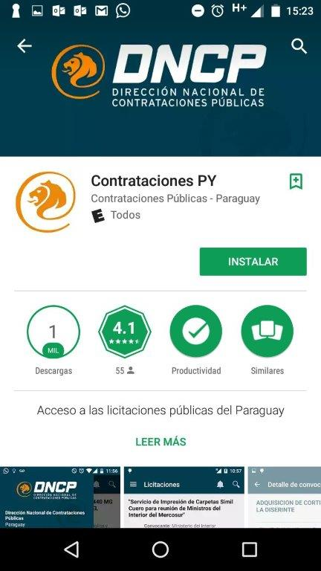
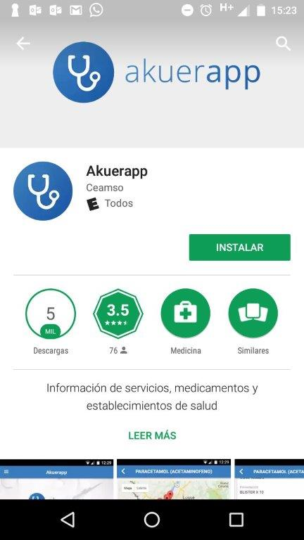

Self-Assessment Report Template
Commitment 3
Citizen participation and monitoring
July 1, 2016 - June 30, 2017
Lead implementing agency/actor |  | National Directorate of Public Procurement (DNCP)  Ministry of Public Works and Communications (MOPC)  Sanitary Services Company of Paraguay S.A. (ESSAP)  National Anti-Corruption Secretariat (SENAC)  National Secretariat of Information and Communication Technologies (SENATICS)  National Secretariat for the Human Rights of Persons with Disabilities (SENADIS)  Ministry of Finance (MH)
Commitment description
What is the public problem that the commitment will address? |  | Limited integrated management tools for easy access for citizen interaction/reclamation and monitoring of public works and services; and insufficient information on the management of complaints about corruption in public management makes it difficult for citizen control.
What is the commitment? |  | Implementation of new channels of citizen monitoring of public works and services.  Creation of new systems of social monitoring of public works, complaints about services and complaints.
How will the commitment contribute to solve the public problem? |  | Citizen participation in the control of the execution of public works, social and civil services, will improve the quality of the public service.
Why is this commitment relevant to OGP values? |  | Considering the following values of OGP linked to this commitment: 1) Improvement of public services. 2) Increased public integrity and 3) Effective management of public resources. The tools and functionalities of the systems to be developed using information technologies will contribute to the transparency of the management of resources and will promote citizen monitoring and control.
Additional information |  | This commitment is aligned with the Strategic Objectives of the 2030 National Development Plan and the 2030 Sustainable Development Goals.  22) Increase access to public information and procedures through electronic networks/SDG 16 Peace, justice and solid institutions.  29) Universal access to drinking water/SDG 6 Clean water and sanitation  30) Universal access to improved sanitation/SDG 6 Clean water and sanitation  40) Consolidate an efficient multimodal transport network that reduces average logistic costs to international competitive levels / SDG 9 Industry, innovation and infrastructure.  47) Ensure transparency of public spending at the three levels of government and in the three branches of government / SDG 16 Peace, justice and sound institutions.
Completion Level |  | Not Started | Limited | Substantial | Completed
 |  |  | X | X
Description of the results  Next steps |  | The commitment, which is composed of 10 goals, which are detailed below, obtained a limited level of compliance in the first year of the 2016-2018 Action Plan. Of the 10 goals of this commitment 2 were met, 1 has substantial progress and 6 goals have limited progress, which means that they have been planned to be implemented or are being implemented but have not yet reached substantial progress.
Milestone Status |  |  | Start Date | End Date | Completion Level
Goal 1 - DNCP  In the Web Portal of Public Contracts, develop, implement and update an interactive map of public works awarded, with the option that citizens make complaints by this means and follow-up. |  |  | 1st Semester 2017 | 1st Semester 2017 | Limited
Goal 1 Breakthroughs - National Directorate of Public Procurement (DNCP)

The goal is in the planning stage and definition of the model to follow for the development of the computer system necessary to have the interactive map. The first meetings were also held to analyze the impacts and modifications from the legal point of view that will be necessary for the implementation of the interactive map.

Considering USAID/CEAMSO budget cuts, the next step is to evaluate the possibilities of developing the system with external resources.
Goal 2 - MOPC  MOPC interactive public works map (MAWIO) with citizen feedback and monitoring module developed, implemented, disseminated and regularly updated. |  |  | 1st Semester 2017 | 1st Semester 2018 | Limited
Goal 2 Breakthroughs

Nearing full deployment.
- SYSTEM OF GEOLOCALIZATION OF PUBLIC WORKS AND BRIDGES THROUGHOUT THE COUNTRY:

Within the framework of its policy of transparency and citizen participation, the MOPC designed a computer program to make citizens aware of the site and the progress of public works being executed in real time, these are two new web platforms.

The first is called TEMBIAPO and allows anyone with internet access to know in detail all the public works of MOPC and their respective national advances, using the platform Google Maps. You can enter site http://tembiapo.mopc.gov.py/

The second platform allows identifying all the bridges and replacement work carried out in each department. This can be observed by entering: http://puentes.mopc.gov.py/

- SENAC awarded MOPC the first place in the Competition for Good Practices of Transparency and Integrity, for the implementation of its "System of Management, Administration and Control of Fuels". The MOPC now spends less on fuel doing more than previous administrations.

- The MOPC approved the Quality Management Audit ISO 9001-2008, which is a guarantee of efficiency, efficiency and transparency in the Procurement Operations Unit (UOC) for the management of Procurement of Goods and Services, the certification was overseen bythe company SGS PARAGUAY SA.

- The MOPC improves its MECIP rating, the rating increased from 3.55 (adequate) to 4.30 (satisfactory), by having a Code of Ethics, a High Performance, a People Management Index Report and a Quality Control Manual.

- The MOPC's Patrol Director Caminera has organized its new internal structure with some fundamental departments, which are starting their activities as the Unit of Transparency, Internal Control, Control of Dominion Strip and Free Animals and the creation of more Infringements and Misdemeanors Courts. In relation to the new Transparency Unit, the same will attend the 24 hours consultations, complaints and suggestions of the citizens through personal presentations, by phone or via WhatsApp to the Nº 0986-835049.
Goal 3 - MOPC  2 electronic tools: a) Computer system for interaction management-citizen complaints and  b) Web system for physical, financial, environmental and social monitoring of public works developed, implemented and disseminated. |  |  | 1st Semester 2017 | 1st Semester 2018 | Limited
Goal 3 Breakthroughs

Near full deployment.

- The MOPC achieves the highest rating in response to citizen complaints. The Ministry of Public Works and Communications (MOPC) obtained 100% in the citizen satisfaction survey regarding the response received by the State Portfolio when any claim or suggestion is made at the institution's headquarters or through the channel enabled for the effect.

It is the Citizen Satisfaction Report issued by the Ministry of Justice and the National Secretariat of Information and Communication Technologies (SENATICs), where it also places the MOPC in the No. 7 ranking of the Top Ten Institutions Ranking by number of applications adhered to the Access to Public Information Portal, in accordance with Law No. 5282/14
Goal 4 - ESSAP  2 electronic tools (Citizen interaction-citizen management system and web system for physical, financial, environmental and social monitoring of works) of water and sanitation works and services developed, implemented and disseminated |  |  | 2nd Semester 2016 | 2nd Semester 2017 | Limited
Goal 4 Breakthroughs

In action. The process of drawing up a short list of companies that have expressed interest in participating in the process for the development of the SIGIRCI and SIMFFASO systems has been completed.

The Request for Proposals has already been initiated and it is planned to receive them by September 22, 2017.

The call for tenders was made for the development of the tool. As evidence, the public procurement portal can be accessed under ID: 330294.
Goal 5 - SENAC  Development and dissemination of a mobile application for the corruption allegations web portal. |  |  | 2nd Semester 2016 | 1st Semester 2018 | Full
Goal 5 Breakthroughs

Full. It is not a web application per se, but a user can access the website from a mobile device to register a complaint.

SENAC constantly carries out campaigns to disseminate the complaints portal. The portal is constantly promoted through advertising on television and radio.
Goal 6 - SENAC  Open data published on public information of active transparency, information on complaints, summaries, criminal cases and preliminary investigations that allows to know the procedure and results of complaints and cases. |  |  | 2nd Semester 2016 | 1st Semester 2017 | Full
Goal 6 Breakthroughs

Executed.

The following datasets are currently available in the SENAC Open Data Portal:

1) List of Complaints. Information available is: Case ID, Case Status, Type of Complaint, Institution Affected, Designated Institution, Record Date, Date of Fact, Place of Fact, Amount Denounced, Date Updated;

2) List of Administrative Summaries. The data available are: Case ID, Case status, Institution orders summary, Case registration date, Resolution Date, Number Resolution Summary, Violated Legal Standard, Date Resolution Designation, Resolution Number Designation, Document Number Judge, Institution Judge, Institution Date, Summarized Notification Date, Recurrence Court Accounts, Name Representative, Date Resolution, Number Resolution, Criminal case in progress

3) Criminal Cases. Data available are: Case ID, Case State, Affected Institution, Whistleblower Institution, Criminal Case Number, Case Record Date, Case Date Update, Date Filing Complaint, Date Asset Damage, Currency Damage, Jurisdiction, Identification Fiscal unit, Cause State, Date of indictment filed

4) Preliminary Investigations. The data available are: Case ID, Case Status, Type of Complaint, Institution of the Complainant, Institution Affected, Date of Case Update, Date of Registration, Official Person, Person Denounced, Date Denounced, Date Modified , Place made known, Requires cause, Requires summary, Start date investigation, Recommendation, Recommendation date.
Goal 7 - SENATICS  Web portal and mobile claims application on public services developed and disseminated among users. |  |  | 2nd Semester 2016 | 1st Semester 2018 | Limited
Goal 7 Breakthroughs

Planned/In execution. We explored options to carry out this tool with the Municipality of Asunción, but a consensus was not reached. The tool was already developed with the NGO TEDIC, but the possibility of being able to implement it in the Municipality of Encarnación and / or other municipalities that are interested is being explored.
Goal 8 - SENADIS  1 electronic tool developed, and 17 departmental meetings held for citizen monitoring of the National Action Plan for the Rights of Persons with Disabilities. |  |  | 1st Semester 2017 | 1st Semester 2018 | Limited
Goal 8 Breakthroughs:
Planned,

The DGGA / STP has not yet received information on this target.
Goal 9 - Ministry of Finance  1 technological tool of citizen interaction for the monitoring and monitoring of the budget, execution of the budget, payroll, public debt, public investment and cadaster. Disseminate, promote citizen participation and the use of open MH data. |  |  | 2nd Semester 2016 | 1st Semester 2018 | Substantial
Goal 9 Breakthroughs
In action. Currently, 10 sets of data are available on the website of the Ministry of Finance: 1) Roster 2) Stages of formulation, preparation, consolidation and approval of the General Budget of the Nation 3) General budget of the Nation in force 4) Public Debt 5) Debt Projection 6) Debt Service 7) Debt Balance 8) Disbursement of Debt 9) Bank Transfers of FONACIDE 10) Budget Execution of FONACIDE.

Data on cadaster and public investment and development of the tool are missing. With regard to the development of the technological tool of citizen interaction for the monitoring and monitoring of the budget; it is being developed and implemented as a result of the Hackathon Innovando PY 2016 "Presupuest App" which aims to be a tool that facilitates the understanding of the General Budget of the Nation to the general public by encouraging monitoring and citizen participation.
Goal 10 - SENATICS  Public consultation, through 2 on-line consultations to users and institutions required to prioritize services and procedures to be included in the single window of www.paraguay.gov.py |  |  | 2nd Semester 2016 | 1st Semester 2018 | Limited
Achievements of Goal 10

In action. It has enabled a public consultation, through which citizens are requested by means of an electronic form located in the National Portal of Paraguay:
www.paraguay.gov.py with various procedures and documents required, as well as the institutions responsible for their provision.
Contact information
Institution responsible for implementation  Name of responsible person, Title, Department, Email and telephone |  | Contact information Goal 1  DNCP  Melinna Vázquez, Coordinator of Communication and Statistical Information.  mvazquez@dncp.gov.py  +59521 4154118  Goal 2 and 3  MOPC  Carolina Centurión, Director, Directorate of Transparency and Citizen Participation  see@mopc.gov.py - utpc@mopc.gov.py  Phone: +59521 4149606  Goal 4  Lic. Derliz O. Cabrera, General Coordinator Component 2 of the Water and Sanitation Sector Modernization Project  dcabrera75@gmail.com  +595 21 210319  Goal 5 and 6  Ariel Ojeda, Director General, Directorate General for Prevention and Transparency  ariel.ojeda@senac.gov.py  +595 21 450001  Goal 7  SENATICS  Javier Quiñonez, Director, Directorate of Electronic Government  governmentelectronico@senatics.gov.py  +595 21 2179000  Goal 8  SENADIS  Anahi Escudero, Director General, Planning Division  anahiescudero@hotmail.com  +595 21 670093  Goal 9  MH  María Teresa Díaz de Agüero, Director, General Directorate of Public Accounting  maria_aguero@hacienda.gov.py  +595 21 440010  Goal 10  SENATICS  Javier Quiñonez, Director, Directorate of Electronic Government  governmentelectronico@senatics.gov.py  +595 21 2179000
Other actors involved | Ministries of government, departments, institutions | Goal 4  MOPC  Goal 5 and 6  SENATICS and Transparency and Anti-Corruption Network  Goal 7  National Electricity Administration (ANDE), ESSAP and Municipality of Asunción  Goal 8  Responsible in the matrix of the National Action Plan for the Rights of Persons with Disabilities: MSPyBS, MEC, MM, MT, SNJ, SNNA, SFP, STP, Board of Governors, and Paraguayan Organization of Intermunicipal Cooperation (OPACI).
Other actors involved | CSOs, the private sector, multilateral organizations, working groups | (IDEA, Seeds for Democracy, CIRD, Free Foundation, Center for Judicial Studies, Chair of Access to Public Information of the National University of Asunción) CEAMSO, Decidamos, TEDIC, Asociación Trinidad, AGPRA -PY, Saraki, Teletón, ParIgual and other civil society organizations in the disability sector. AGA Open Data Working Group, AGA Anti-Corruption Working Group, World Bank and USAID.
Additional Information
Please review Annex A, Annex B and Annex C for additional comments.

Self-Assessment Report Template
Commitment 4

Accountability
July 1, 2016 - June 30, 2017
Lead implementing agency/actor |  | National Anti-Corruption Secretariat (SENAC)  Technical Secretariat for Economic and Social Development Planning (STP)
Commitment description
What is the public problem that the commitment will address? |  | The limited institutional mechanisms of accountability, timely reports and data on public expenditure and the difficulty of accessing electronic goods and services offered by the state constitute obstacles to citizen participation in public management.
What is the commitment? |  | Improvement of accountability mechanisms available to citizens.  Making data available, improving information and accountability mechanisms for citizens.
How will the commitment contribute to solve the public problem? |  | The institutionalization of accountability and the timely provision of strategic information by the State will improve the quality of citizen participation and the efficiency of government.
Why is this commitment relevant to OGP values? |  | Considering the following values of OGP linked to this commitment: 1) Increased public integrity and 2) Effective management of public resources. The development of institutional mechanisms and the availability of information on public management will contribute to increased accountability.
Additional information |  | This commitment is aligned with the Strategic Objectives of the 2030 National Development Plan and the 2030 Sustainable Development Goals.  27) Accountability at all levels of government / SDG 16 Peace, justice and sound institutions.
Completion Level |  | Not Started | Limited | Substantial | Completed
 |  |  |  | X
Description of the results  Next steps |  | The commitment, which is composed of 3 goals, detailed below, obtained a level of Substantial compliance in the first year of the Action Plan 2016-2018. Of the 10 goals of this commitment 2 were met and 1 has made substantial progress. We hope that soon the Commitment will be fulfilled.
Milestone Status |  |  | Start Date | End Date | Completion Level
Goal 1 - STP  Catalog of action plans and accountability related to the National Development Plan 2030 implemented and disseminated. |  |  | 2nd Semester 2016 | 1st Semester 2018 | Full
Goal 1 Progress
Completed.

Data can be found here: https://github.com/stppy
Goal 2 - SENAC  Manual of accountability designed, developed and socialized. |  |  | 2nd Semester 2016 | 2nd Semester 2016 | Full
Goal 2 Breakthroughs
Executed.

SENAC Resolution No. 44/17 approves an Accountability Manual for entities of the Executive Branch, which attempts to modify accountability, transforming the traditional vision from a simple management report to a constant and participative surrender of the institutional commitments assumed.
Goal 3 - SENAC  Implementation in 2 Institutions of the Model of Accountability provided in the manual. |  |  | 1st Semester 2017 | 1st Semester 2018 | Substantial
Goal 3 Breakthroughs
In action.

Until June 8, proposals will be accepted for the "Consultancy to support SENAC in the implementation of the Manual of Accountability in the Ministry of Finance and the Ministry of Public Works and Communications."
Contact information
Institution responsible for implementation  Name of responsible person, Title, Department, Email and telephone |  | Goal 1  STP  Jorge Galeano Robledo, Deputy Minister - General Coordinator of Public Development Management  jgaleanorobledo@stp.gov.py  + 595 21 450 422  Goal 2 and 3  SENAC  Ariel Ojeda, Director General, Directorate General for Prevention and Transparency  ariel.ojeda@senac.gov.py  +595 21 450001
Other actors involved | Ministries of government, departments, institutions | Goal 2 and 3  Transparency and Anti-Corruption Network
Other actors involved | CSOs, the private sector, multilateral organizations, working groups | Impulse Group for Access to Public Information  (IDEA, Seeds for Democracy, CIRD, Free Foundation, Center for Judicial Studies, Chair of Access to Public Information of the National University of Asunción) CEAMSO, Decidamos, TEDIC, Asociación Trinidad, Grupo of work of AGA de Anticorrupción, AGA Working Group of Fiscal Transparency and USAID.
Additional Information
Please review Annex A, Annex B and Annex C for additional comments.

Self-Assessment Report Template
Participation and Local Government

Commitment 5
July 1, 2016 - June 30, 2017
Lead implementing agency/actor |  | National Secretariat of Culture (SNC)  Technical Secretariat for Economic and Social Development Planning (STP)  Ministry of the Interior (MDI)  Ministry of Women (MINMUJER)  National Secretariat for Children and Adolescents (SNNA)
Commitment description
What is the public problem that the commitment will address? |  | Limited participation of citizens at the local level in the processes of formulation, implementation and evaluation of public policies, cultural plans, development plans and citizen security. There is also a low level of political representation of women and there is a lack of up-to-date and disaggregated information on investment in children and adolescents of local and central governments.
What is the commitment? |  | Strengthening citizen participation in the design of public policies at the municipal and departmental levels.  Creatingspaces where the municipal and department plans regarding Culture, Safety, Women, Sustainable Development and Investment in childhood and adolescence are delineated and enriched.
How will the commitment contribute to solve the public problem? |  | The construction and promotion of instances of participation at the national level that include the citizens in the process of building public policies will contribute to improving and democratizing the decision making, making them have more legitimacy.
Why is this commitment relevant to OGP values? |  | Considering the following values of OGP linked to this commitment: 1) Improvement of public services 2) Effective management of public resources. The development of spaces and institutional mechanisms for decentralization and consultation will improve the conditions for municipal and departmental citizen participation.
Additional information |  | This commitment is aligned with the Strategic Objectives of the 2030 National Development Plan and the 2030 Sustainable Development Goals.  13) Raise the participation of women in the formal working world by 75% under equal conditions / SDG 5 Gender equality.  18) Reduce by 75% the rate of intentional homicides (deaths / 100,000) / SDG 16 Peace, justice and solid institutions.  25) Decentralization of the management of public policies / SDG 10 Reduction of inequalities.  26) Territorial planning at the municipal level that determines the use of rural and urban land considering the economic, social, cultural and environmental effects, in order to have an adequate population density that facilitates the provision of public services with efficiency / SDG 11 Cities and sustainable communities.
Completion Level |  | Not Started | Limited | Substantial | Completed
 |  |  |  | X
Description of the results  Next steps |  | The commitment, which is composed of 8 goals, which are detailed below, obtained a level of Substantial compliance in the first year of the Action Plan 2016-2018. Of the 10 goals of this commitment 2 were met, 3 have substantial progress and 3 goals have limited progress, which means that they have been planned to be implemented or are being implemented but have not yet reached substantial progress.
Milestone Status |  |  | Start Date | End Date | Completion Level
Goal 1 - SNC  125 Culture Tables developed as a citizen participation mechanism for access to information and interaction in cultural management within the framework of the National Culture Plan. |  |  | 2nd Semester 2016 | 1st Semester 2018 | Limited
Goal 1 Breakthroughs
"Cultural Management with Subnational Governments" was the theme addressed in the First Working Table of Culture that brings together members of the Network of Departmental Secretariats of Culture and representatives of civil society.

SCOPE SUMMARY

4 Departments - Boquerón - Alto Paraná - Paraguarí - San Pedro.

7 Municipalities - Philadelphia - Loma Plata - Mcal. Estigarribia - Minga Guazú - Pirayú - Villa del Rosario - Itacurubí del Rosario.

1) BOQUERÓN 3 districts (1. Philadelphia 2. Loma Plata 3. Mcal. Estigarribia)

24 people in total

1. 11 people, 9 civil society, 2 of the Municipality.
2. 5 people, 4 civil society, 1 departmental board of Boquerón.
3. 7 people, 6 civil society, 1 of the Municipality 1 of the governorate

OEE participation by the Department of Boquerón 21% (5/24).
Citizen Participation by the Department of Boquerón 79% (19/24).
OEE participation by Philadelphia 18% (2/11).
Civil Society Participation for Philadelphia 82% (9/11).
Participation of OEE by Loma Plata 20% (1/5).
Civil Society Participation by Loma Plata 80% (4/5).
Participation of OEE by Mcal. Estigarribia 14% (1/7).
Civil Society Participation by Mcal. Estigarribia 86% (6/7).

2) HIGH PARANÁ 1 district Minga Guazú

23 people in total

1. 22 people, 20 civil society, 2 of the municipality. 1 of the governorate

Participation of OEE by the Department of Alto Paraná 13% (3/23).
Citizen Participation by the Department of Alto Paraná 87% (20/23).
Participation of OEE by Minga Guazú 9% (2/22).
Civil Society Participation by Minga Guazú 91% (20/22).

3) PARAGUARÍ 1 district Pirayú

16 people in total

1. 15 people, 14 civil society, 1 of the municipality. 1 of the governorate

Participation of OEE by the Department of Paraguarí 12% (2/16).
Citizen Participation by the Department of Paraguarí 88% (14/16).
Participation of OEE by Pirayú 6% (1/15).
Civil Society Participation by Pirayú 93% (14/15).

4) SAN PEDRO 2 districts (1. Villa del Rosario and 2. Itacurubí del Rosario)

13 people in total

1. 7 people, 5 civil society, 2 of the municipality.
2. 4 people, 4 of the municipality. 2 of the governorate

Participation of OEE by the Department of San Pedro 62% (8/13).
Citizen Participation by the Department of San Pedro 38% (5/13).
Participation of OEE by Villa del Rosario 29% (2/7).
Civil Society Participation by Villa del Rosario 71% (5/7).
Participation of OEE by Itacurubí del Rosario 100% (4/4).
Civil Society Participation by Itacurubí del Rosario 0% (0/4).

Goal 2 - STP  175 Municipal Development Councils strengthened from the universe of 250 municipalities in the country |  |  | 2nd Semester 2016 | 1st Semester 2018 | Substantial
Goal 2 Breakthroughs

Within the process of strengthening the District Development Councils, training, technical assistance and distribution of methodological tools have been carried out.

Training:

· 1st. Development Council Congress:

- 117 Strengthened municipalities
- 678 trained officials

And now we have added the strengthening of:

Municipality of Ybytymi, in its Council of Development and Organization of Fairs of
small producers.
-Municipality of Mbaracayú, in its Development Council.

There are currently 119 strengthened Development Boards.

Methodological tools:

-Development, publication and distribution "Support Material for Development Councils"

Tripod: Departmental and Municipal Development Councils, Coordination and Participation for Local Development.

Goal 3 - STP  200 "Municipal Development Plans" developed in a participatory manner and available online |  |  | 2nd Semester 2016 | 1st Semester 2018 | Full
Goal 3 Breakthroughs

Plans: As of June 2017, 232 District Development Plans have been prepared and at the date of publication of this report there are already 240 Sustainable Development Plans prepared.

Training:

28 Workshops where 1,481 participants have been trained, of which 573 women and 908 men.

Methodological tools:

Elaboration, publication and distribution "Supporting Material for the elaboration of District Development Plan"
Goal 4 - STP  12 Departmental Development Councils strengthened from the universe of 17 departments in the country. |  |  | 2nd Semester 2016 | 1st Semester 2018 | Substantial
Goal 4 Breakthroughs

Within the process of strengthening the Departmental Development Councils, training, technical assistance and distribution of methodological tools have been carried out.

Training:

• 1st. Development Council Congress:

13 Strengthened Governments
26 trained staff

We have also strengthened the following Departmental Councils:

High Paraná Governorate, with its Development Council strengthened.
Governor of President Hayes, with its Development Council strengthened.

At present there are 15 Departmental Development Councils strengthened.

Methodological tools:

Elaboration, publication and distribution "Support Material for Development Councils"
Tripod: Departmental and Municipal Development Councils, Coordination and Participation for Local Development.

Goal 5 - STP  15 Departmental "Development Plans" developed in a participatory manner and available online. |  |  | 2nd Semester 2016 | 1st Semester 2018 | Full
Goal 5 Breakthroughs

Within the process of elaboration of Departmental Development Plans, training, technical assistance and distribution of methodological tools have been carried out.

Plans:
- As of June 2017, 15 Departmental Development Plans have been prepared.

Training:

- 28 workshops where 1,481 participants have been trained, of which 573 women and 908 men

Methodological tools:

- Elaboration, publication and distribution "Supporting Material for the elaboration of Departmental Development Plan"
-

Goal 6 - Ministry of the Interior  16 regional meetings of security and citizen coexistence developed with 300 managers trained to manage security and elaboration and implementation of local crime prevention plans. |  |  | 2nd Semester 2016 | 1st Semester 2018 | Limited
Goal 6 Breakthroughs

To date, it has been possible to establish 11 regional tables for security and citizen coexistence. Working groups were held in vulnerable areas of the districts of 1) Asunción (capital), 2) San Lorenzo, 3) Limpio, 4) Mariano Roque Alonso, 5) Itá, 6) Guarambaré, 7) Capiatá, 8) Areguá, 9) Luque, belonging to the Central Department; also in 10) Arroyito and 11) Mbaracayú.

Currently, the Ministry of the Interior, within the framework of the SEAMOS CIUDADANOS Program, is coordinating actions with the following Municipalities (Asunción, Areguá, Capiatá, Fernando de la Mora, Guarambaré, Ita, Limpio, Luque, Mariano Roque Alonso, San Lorenzo, Arroyito, Encarnación, San Bernardino, Mbaracayú, Bella Vista and Borja).

Also in the framework of the SEAMOS CIUDADANOSProgram, in the first six months of execution in 2017, only 585 young men and women, aged 14 to 18 years, belonging to the four large national schools selected by the respective Area Coordinators of the Ministry of Education and Culture received awareness training.

Next steps

Regarding the training of managers in citizen security, in September of this year there will be the course of trainers of managers in citizen security, who are responsible for replicating the course in municipalities to be prioritized among those who participate in the framework of the Program. To this end, it is planned to train 24 trainers, who, after being evaluated, will be responsible for replicating the course within the framework of the SEAMOS CIUDADANOS Program.
Goal 7 - MINMUJER  1 awareness campaign, 17 departmental meetings and 4 roundtables for the promotion of women's political and social participation. |  |  | 2nd Semester 2016 | 1st Semester 2018 | Substantial
Goal 7 Breakthroughs

MINMUJER redoubled its efforts in the area of ​​women's political participation, coordinating actions with the Higher Electoral Justice Tribunal (TSJE), organized civil society, among which stand out from political parties and cooperation agencies working on the issue.

The main lines of work are:

● Promotion, accompaniment and lobbying for the promulgation of the Law on Democratic Parity
● Awareness raising, promotion and promotion of women's participation in all decision-making areas.
● Strengthening the capacities of women, political leaders.

In that sense, we participated in the presentation of the Proposed Draft Law of Democratic Parity that promotes the concept of Joint State, this is political parity in all public institutions and other entities. Likewise, the institution is part of the Grupo Impulsor de la Paridad Democrática (GIPD) and at the same time, all the lobbying is accompanied by the enactment of the aforementioned Law. The promulgation of this Law will undoubtedly mark a milestone in the structure and management of decision-making spaces in Paraguay.

Likewise, in the framework of the Program Empowering Women for Parity in Democracy, implemented by the institution from June 2016 to June 2017, experiential workshops have been held with the objective of encouraging and encouraging the participation of women in decision-making positions. Work has been carried out in 12 departments of the country, reaching a total of 2,255 women.

For its part, in the framework of the project Strengthening capacities for the political participation of women (MINMUJER, UNDP and UN WOMEN), in execution; to date the following results have been achieved:

- Preparation of materials and printing of 4 training books and other merchandising. The topics covered by the booklets are:
1. Democracy and Gender
2. Participation of Women at the local level
3. Political participation, gender and electoral systems
4. Women and Leadership

- Training workshops, which are directed both to the MINMUJER civil servants and to referrals and groups of political parties.

Under the motto "We want Parity - Roipota kuña ha kuimba'e hekojoja", the run/walk FEM 2017was carried out, in its fourth edition. On this occasion, women, men, boys and girls reaffirmed their commitment to generating a conscience for equality in the empowerment of women. Participated in it, authorities of public institutions, delegations from different parts of the country and the public. Under the same slogan, this action was replicated in different parts of the country (Ciudad del Este, Villa Elisa, Luque and Pilar) with support from local governments. Approximately 5,000 people participated in the activities.

In addition, to date, in all the meetings that are held with women, the campaigns "More Candidates, Better Democracy" and "More Women, Better Democracy" are tackled, with which the inclusion of more women is promoted, in better places of party lists in the different elections.

In addition, a communication campaign "Paraguay votes Parity" is in the process of being designed. As well as the 2015 elections report. The final document is expected by September 2017.

1 awareness campaign | 2 (Run/walk and "+ candidate, better democracy" and "+ Women, better democracy")  1 "Paraguay votes Parity", in the process of design
17 departmental meetings | 12 departments involving 78 municipalities
4 political dialogue tables | 0

Goal 8 - SNNA  Information system on investment in children and adolescents accessible and timely, with disaggregated data to make visible and make known the investment of the central government, at least 5 departmental governments and 15 municipal governments. |  |  | 2nd Semester 2016 | 1st Semester 2018 | Limited
Goal 8 Breakthroughs
In action.

National Secretariat for Children and Adolescents
- Internal Meetings: Planning Directorate, General Directorate of Administration and Finance.
- Meeting in the STP, with the General Direction of Management by Results.
- SPR Board Access Key Application
- Referral of the Products Matrix by the STP, for the review and analysis of relevance in terms of investment in Children and Adolescents
- Review of the Matrix of Products forwarded by the STP, to select those that make an investment in childhood and adolescence, directly and indirectly.

In this sense, the Institutions would be:
- Secretariat of Social Action
- National Secretariat for Housing and Habitat
- Secretariat of National Emergency
- National Secretariat for the Rights of Persons with Disabilities
- Directorate of Beneficence and Social Assistance
- Paraguayan Institute of the Indigenous
- National Institute of Rural and Land Development
- Ministry of Women
- Ministry of Interior
- Ministry of Education and Science
- Ministry of Health and Social Welfare
- Ministry of Public Works and Communications

Steps to follow
- Send to the STP the matrix of selected products in order to make the corresponding procedures about the institutions for the authorization of the use of the data generated by them.
- Request support and advice for the construction of the platform to SENATICs.
- Generate the platform on the WEB page of the SNNA.
Contact information
Institution responsible for implementation  Name of responsible person, Title, Department, Email and telephone |  | Goal 1  SNC  Delhani Baez, Director, Planning Division  plan.sicpy.snc@gmail.com  Goal 2, 3, 4, and 5  STP  Florencia Villalba, Director General, Directorate General for Development and Territorial Planning  fvillalba@stp.gov.py  +595 21 450422  Goal 6  Ministry of Interior  Vice Ministry of Political Affairs  Abog. Ariel Martinez  paourunaga92@gmail.com  +59521 4152238  Directorate of Departmental and Municipal Governments  Abog. Gustavo Florentín  gustavoflorentin77@hotmail.com  +59521 4152069  Citizen Participation Address  Abog. Silvio Chirife  schirife@yahoo.es  +595 984617159  Directorate of Interinstitutional Relations  César Urbieta  cesarurbieta.mi@gmail.com  +595 981677777  Institutional link to the Open Government Board  General Direction of Strategic Planning  Abog. Hernán Mayor  hernan.mayor@mdi.gov.py  +59521 4152110  Abog. Analía Rolón  Department of Plans and Budget  cheffyrolon@gmail.com  +59521 4152254  Goal 7  Ministry of Women  Full professional proficiency  Director General of the General Directorate of Planning and Cooperation  gbrizuela@mujer.gov.py  +59521 450036/8 internal 132  Rossana Delgado  Director of Planning and Evaluation Directorate  rdelgado@mujer.gov.py  +59521 450036/8 internal 109  Goal 8  SNNA  Ida Maida, Director of the Standard Internal Control Model of Paraguay - MECIP and Transparency  imaida@snna.gov.py  +595 21 228777
Other actors involved | Ministries of government, departments, institutions | Goal 1  Mandu'ara Cultural Association  Goal 6  National Police, National Anti-Corruption Secretariat (SENAC), Ministry of Finance, Superior Court of Electoral Justice (TSJE), and Gender Commissions of the Chambers of Deputies and Senators.  The SEAMOS CIUDADANOS Program has the support of: Ministry of Public Health and Social Welfare (MSPyBS), National Police, National Secretariat for Housing and Habitat (SENAVITAT), Health Services Regulator (ERSSAN), Paraguayan Communications Company COPACO), Paraguayan Health Services Company (ESSAP), National Electricity Administration (ANDE), National Secretary for the Rights of Persons with Disabilities (SENADIS), Civil Registry, Ministry of Public Defense (MDP), Secretariat of Action Social Security (SAS), Directorate of Social Assistance and Assistance (DIBEN), National Cement Institute (INC), National Emergency Secretariat (SEN), National Professional Promotion Service (SNPP), General Directorate of Migration (DGM).  Goal 7  National Police, National Anti-Corruption Secretariat (SENAC), Ministry of Finance, Superior Court of Electoral Justice (TSJE), and Gender Commissions of the Chambers of Deputies and Senators.  Goal 8  National Police, SENAC, MH, Superior Court of Electoral Justice (TSJE) and Gender Commissions of Chambers of Deputies and Senators.
Other actors involved | CSOs, the private sector, multilateral organizations, working groups | Goal 6  Neighborhood Commissions in 6 departments of the country, Sajonia Libre y Segura, CIRD, CEAMSO  Goal 7  Women political and networks of political women, authorities (structure) of political parties and communicators  Goal 8  Investment boardfor Children and Adolescents
Additional Information
Commentary of the NGO CIRD:

Municipal and Departmental Development Councils: There are no indicators of functionality, as well as the impact on local public policies, as well as the correct functioning.

The number of workshops or meetings in local governments (does not reflect the quality of the incidence). Therefore, we cordially suggest that the following commitments include a feasibility analysis of these Boards, their functionality and the objectives achieved.

Please review Annex A, Annex B and Annex C for additional comments.

Self-Assessment Report Template
Environment and Natural Resources

Commitment 6
July 1, 2016 - June 30, 2017
Lead implementing agency/actor |  | Ministry of the Environment (SEAM)  National Forest Institute (INFONA)
Commitment description
What is the public problem that the commitment will address? |  | The scarce or nonexistent publication of information related to environmental impact assessment reports, air quality, water resources, land use plans and related to the forest sector hinders the possibilities of control and citizen participation.
What is the commitment? |  | Improvement of quantity and quality of public information available on environment and natural resources.  Open data and public information available on environment and natural resources, such as environmental project assessments, air quality and water reports, as well as the national forest inventory.
How will the commitment contribute to solve the public problem? |  | The publication of information and the opening of channels of citizen participation in issues such as: environmental impact, air quality, water resources, land use plans and the forestry sector, will contribute to increase monitoring and the possibility of influencing decision-making in environmental matters.
Why is this commitment relevant to OGP values? |  | Considering the following values of OGP linked to this commitment: 1) Improvement of public services 2) Effective management of public resources. The opening of data on environmental impacts and the forestry sector, whether positive or negative, contribute to citizen participation, involving citizens in the process of evaluating environmental projects and improving the quality of public policies in environmental matters.
Additional information |  | This commitment is aligned with the Strategic Objectives of the 2030 National Development Plan and the 2030 Sustainable Development Goals.  32) Reduce deaths attributable to air pollution (deaths/100,000) by 95% /SDG 11 Sustainable cities and communities.  33) Universalizing disposal and management of urban and industrial waste / SDG 11 Sustainable cities and communities.  52) Increase in renewable energy consumption by 60% / SDG 7 Affordable and non-polluting energy.  70) Reduce the costs of disaster recovery due to climate effects / SDG 13 Climate action.  72) Increase coverage of forest areas and protected biomass / SDG 15 life of terrestrial ecosystems.
Completion Level |  | Not Started | Limited | Substantial | Completed
 |  |  | X
Description of the results  Next steps |  | The commitment, which is composed of 4 goals, detailed below, obtained a limited level of compliance in the first year of the 2016-2018 Action Plan. Of the 4 goals of this commitment 1 was met, 1 has substantial progress and 2 goals have limited progress, which means that they have been planned to be implemented or are being implemented but have not yet reached substantial progress.
Milestone Status |  |  | Start Date | End Date | Completion Level
Goal 1 - SEAM  Publish information in a reusable format in an institutional portal, allowing citizens to participate by means of observations or objections in the evaluation of projects of Environmental Impact |  |  | 2nd Semester 2016 | 1st Semester 2018 | Limited
Goal 1 Breakthroughs
Publish information in a reusable format in an institutional portal, allowing citizens to participate through observations or objections in the evaluation of Environmental Impact projects. At this point, the Ministry of the Environment has worked to digitalize the Environmental Licenses (Environmental Impact Statements) in force to date. A geo-referencing system has been developed for the location of projects in three states: With Environmental License; In process; and No Environmental License.

Goal 2 - SEAM  Periodic reports of the State of Air Quality and Water Resources published. |  |  | 2nd Semester 2016 | 1st Semester 2018 | Limited
Goal 2 Breakthroughs

Periodic reports of the State of Air Quality and Water Resources, published - Secretariat of the Environment (SEAM)

Air: The SEAM currently has two (non-standard) equipment for measuring particulate matter with sensors, installed in the SEAM and in the Technological Park of Itaipú. They launch measurements every 5 minutes and are displayed through an APP. They are not published because they are in a trial period.

On the other hand, it is in the process of acquiring with institutional funds 10 kits (non-standard) and is subject to the procedures of the UOC.

Goal 3 - INFONA  National Forest Inventory and annual reports of forest and forest nurseries available in the institutional portal. |  |  | 2nd Semester 2016 | 1st Semester 2018 | Full
Goal 3 Breakthroughs

The National Forest Inventory and Cadaster Maps of Forest Industries and Nurseries are published on the INFONA website.
Goal 4 - INFONA  Forest Management Plans and Land Use Plans published in an institutional portal that allows citizens to participate through observations or objections in the evaluation. |  |  | 2nd Semester 2016 | 1st Semester 2018 | Substantial
Goal 4 Breakthroughs
A Cooperation Agreement with Global Forest Watch for the launch of the INFONA website on the online platform of Global Forest Watch is expected, which is an international platform for hosting information in which all maps will be included by the UN RED Program with data from the year 2000 to the year 2016, with information from the Forest Cadaster since 1986 to date including all the Management Plans and Land Use Plans, with the commitment of the INFONA to keep it updated. One of the most important counterparts that is expected is the incorporation of Paraguay within the list of deforestation monitoring that will be carried out weekly and nationally. All this data will be available for free access to all stakeholders and citizens in general.
Contact information
Institution responsible for implementation  Name of responsible person, Title, Department, Email and telephone |  | Goal 1  SEAM  Amelia Ramírez, Director, Anticorruption Directorate  ameramirez.a@gmail.com  +595 21 615811/14  Goal 2  SEAM  Ing. Rafael Sosa, General Director of Air  Ing. Gilda Torres, Technical Director of Air  Chem. Federico Schroeder, Head of the Department of Air Quality Monitoring  air.seam@gmail.com  +59521 2879000  Goal 3 and 4  INFONA  Gloria Ramírez, Director, Anti-Corruption Directorate  gloria.ramirez@infona.gov.py  +595 21 570515/9
Other actors involved | Ministries of government, departments, institutions | SENATICS
Other actors involved | CSOs, the private sector, multilateral organizations, working groups | CEAMSO, IDEA, Moisés Bertoni Foundation, Industrial Union Paraguaya (UIP), World Wildlife Fund (WWF), Lezcano and Associates, San Carlos University, Technical University of Commercialization and Development (UTCD), ECOPLOM Paraguay, Paraguayan Organization of Conservation and Sustainable Development (ODAPES), FCBT (Tropical Forest Conservation Fund), World  Resources Institute (WRI), Prof. Dr. Reinaldo Decoud Foundation, Polytechnic Faculty of the National University of Asunción and AGA Working Group on Natural Resources Opening, USAID.
Additional Information
Please review Annex A, Annex B and Annex C for additional comments.

Self-Assessment Report Template
Health

Commitment 7
July 1, 2016 - June 30, 2017
Lead implementing agency/actor |  | Ministry of Public Health and Social Welfare (MSPBS)  Institute for Social Security (IPS)  Institute for Social Security (IPS)
Commitment description
What is the public problem that the commitment will address? |  | Citizens do not use massively the data provided to monitor health services delivered to the community. There are no systematic channels for measuring the compliance of the users of the health system with the services provided and there are no channels for citizen participation in the elaboration of health policies that improve the quality of services.
What is the commitment? |  | Quality improvement of public health services.  Implementation of quality policy on health services and open data and public information available for the use of users and professionals.
How will the commitment contribute to solve the public problem? |  | Informed and participatory citizenship contributes to improving the quality of health services. This generates a monitoring system that collaborates in the construction of an open and transparent nexus between the citizenship and the MSPBS and the IPS. The quality of the services provided is better than the one that currently exists according to user reports.
Why is this commitment relevant to OGP values? |  | Considering the following values of OGP linked to this commitment: 1) Improvement of public services 2) Increase in public integrity 3) Effective management of public resources.  The process of construction and implementation of the Quality Policy promotes participation and control by the citizens. The availability of public information and open public data, contributes to increasing the appropriation of this right by the citizenry forces the State to develop e-government tools that facilitate the enjoyment of a better quality of life.
Additional information |  | This commitment is aligned with the Strategic Objectives of the National Development Plan 2030 and the 2030Sustainable Development Goals.  3) Reduce child undernutrition by 90% (percentage of children <5 years with height-for-age retardation) with an emphasis on vulnerable groups / SDG 2 Zero Hunger.  4) Reduce maternal mortality by 75% (deaths / 100,000 live births) / SDG 3 Health and well-being.  5) Reduce child neonatal mortality by 70% (deaths / 1000 live births) with an emphasis on vulnerable groups / ODS 3 Health and well-being.  16) Reduce deaths by non-communicable diseases by 50% (death probability between 30 and 70 years) / SDG 3 Health and well-being.  17) Reduce the obesity rate of the population by 50% (% of population) / SDG 3 Health and well-being.  22) Increase access to public information and formalities through electronic networks (% of regular queries and formalities carried out in digital form) / SDG 16 Peace, justice and solid institutions.
Completion Level |  | Not Started | Limited | Substantial | Completed
 |  |  | X | X
Description of the results  Next steps |  | The commitment, which is composed of 6 goals, which are detailed below, obtained a level of Limited-Substantive compliance in the first year of the 2016-2018 Action Plan. Of the 6 goals of this commitment 3 have substantial progress and 3 goals have limited progress, which means that they have been planned to be implemented or are being implemented but have not yet reached substantial progress.
Milestone Status |  |  | Start Date | End Date | Completion Level
Goal 1 - MSPBS  National Health Quality Policy developed, validated and published with the participation of representative sectors of society linked to the sector. |  |  | 2nd Semester 2016 | 1st Semester 2017 | Substantial
Goal 1 Breakthroughs
In the final stage. The National Quality Policy was developed and validated in collaboration with several sectors and the support of foreign experts financed by PAHO.
The same has already been approved by Ministerial Resolution No. 0316 of July 4, 2018 and the official version is in the process of printing (final stage).

Meta 2 - MSPBS  National Health Quality Policy implemented in a participatory way through the Pilot Plan in 2 health regions; with dissemination actions to promote the participation of citizens; using various communication strategies |  |  | 1st Semester 2017 | 1st Semester 2018 | Substantial
Goal 2 Breakthroughs
In action. The pilot plan will be implemented in Central and Alto Paraná.
In the first stage, it is planned to hold participatory workshops to define the operational guidelines of the Regional and Hospital Patient Quality and Safety Committees that implement the policy. The logistics of these workshops (agenda, documents to be discussed, participants, place, etc.) are already defined. The request for cooperation for these workshops, to PAHO, is already under way.
To support the implementation, a virtual course on "Quality in patient care and safety" will also be carried out with the support of the Strategic Direction of Health HR Development and PAHO. This course already has all the educational resources elaborated. The call is addressed to health professionals from all over the country, giving priority to representatives of the Central and Upper Paraná departments.
Meta 3 - MSPBS  3 new sets of health data, defined in consultation with citizens, available in open data format in the institutional portal and with options for feedback with citizens. The data will be updated periodically according to the data set type. |  |  | 2nd Semester 2016 | 1st Semester 2018 | Limited
Goal 3 Breakthroughs
In action. In February 2017, the new open data group corresponding to the "Family Health Units of the Central Region" was launched. On the other hand, the following group of data "Health Professionals" is in its final phase for its next publication. The publication of the data sets "Maternal Deaths" and "Neonatal Deaths" is under analysis. As well as the design of a citizen consultation project for the election of a set of data that the citizen designates.
The Professional Health Data Groups and Availability of Health Professionals are ready to be published, but the final validation of the General Directorate of Human Resources would be lacking.
The Maternal Death Data group is functional, although a technical problem has now been detected, the resolution of which is already in charge of the DGTIC.
Goal 4 - MSPBS  1 campaign of dissemination on the use of open data in health implemented through various channels and communication strategies (training materials, country level talks, media, institutional social networks, mobile applications such as "Akuerapp" and SMS menu. |  |  | 2nd Semester 2016 | 2nd Semester 2017 | Limited
Goal 4 Breakthroughs

In action. Broadcasts have been made on radio, television, newspapers, exhibitions, on Open Government applications such as AKUERAPP and the OPEN DATA PORTAL. The campaign for the dissemination of health establishments and talks throughout the country is in the planning stages. For this, financing is required to elaborate the materials that will be given in the talks and the banners to place in each place
The "Transparency and anti-corruption Toolkit" of the Ministry of Public Health and Social Welfare has been designed and printed in 500 copies. It has a section dedicated to the Alliance for Open Government, Akuerapp and the Open Data Portal. Workshops will soon be given to hospital officials so that they empower the tool and transmit it to users.
Goal 5 - MSPBS  1 competition aimed at students and alliance with 2 universities to produce scientific research and use of open health data. |  |  | 2nd Semester 2016 | 1st Semester 2018 | Limited
Goal 5 Breakthroughs

In action. The first definition meetings and guidelines have already been held. It also has a draft term of reference for the contest.
Goal 6 - IPS  Information on 100 IPS service positions available on-line and in real time on: stock of available drugs, online data for the tool of consultation of free shifts and scheduling of medical consultations; as well as mechanisms of denunciations available in the institutional web (www.ips.gov.py) |  |  | 2nd Semester 2016 | 1st Semester 2018 | Substantial
Goal 6 Breakthroughs
1) Stock of Available Medications - Not Fulfilled
2) Online data for the tool of consultation of free shifts and scheduling of medical consultations - Fulfilled
3) Mechanisms of complaints on the institutional web - Fulfilled

Contact information
Institution responsible for implementation  Name of responsible person, Title, Department, Email and telephone |  | Goal 1, 2, 3, 4 and 5  MSPBS  Goal 6  IPS  Hugo Diarte, Head of the Department of Analysis and Development of Information Technologies and Communications  hdiarte@ips.gov.py  +595 21 2197100 IP 10111 or IP10115
Other actors involved | Ministries of government, departments, institutions | Goal 1, 2, 3 and 5  All Directorates General of the MSPBS, Superintendence of Health, STP, IPS, Police and Military Health. In addition to the previous ones for Goals 1 and 2: MOPC, MEC, SNNA, SENADIS, SAS, SEAM, SEN  Goal 3 and 4  SENATICS and Hospital de Clínicas
Other actors involved | CSOs, the private sector, multilateral organizations, working groups | Goals 1 to 5 Paraguayan Red Cross, CIRD, Paraguayan Association of People with Rheumatoid Arthritis and Allied (APPARA), with a woman's perspective, Federation of Associations for life and family (FEDAVIFA), Good Neighbors, GG y Asociados, Instituto Superior Professional Advanced (ISPA), scientific societies, academy and related cameras and USAID.  In addition to goals 1 and 2: Pan American Health Organization (Technical Assistance)
Additional Information
Please review Annex A, Annex B and Annex C for additional comments.

Self-Assessment Report Template
Education

Commitment 8
July 1, 2016 - June 30, 2017
Lead implementing agency/actor |  | Ministry of Education and Science (MEC)  National Youth Secretariat (SNJ)
Commitment description
What is the public problem that the commitment will address? |  | Management and corruption problems are reported in the use of resources from FONACIDE (National Fund for Public Investment and Development), delivery of school kits, school feeding and granting of scholarships.
What is the commitment? |  | Citizen participation in the control of investment in education (FONACIDE, food, school kits and scholarships).  Extension of information linked to the use of FONACIDE and consolidated by other institutions involved and scholarships; with tools of monitoring and dissemination actions and citizen empowerment.
How will the commitment contribute to solve the public problem? |  | The use of FONACIDE resources, the management of the delivery of school kits and school feeding, as well as the granting of scholarships is transparent and is not questioned by external actors because there are channels of communication and monitoring between state institutions and actors key enabling early detection and resolution of management or corruption problems that may exist.
Why is this commitment relevant to OGP values? |  | Considering the following values of OGP linked to this commitment: 1) Improvement of public services 2) Increase public integrity.  Expansion of information will contribute to the transparency of public spending at all three levels of government. Electronic tools (social audit platform, Unified Scholarship and Scholarship Register) and the application for mobile phones that will be put into operation will contribute to the participation and control of citizenship in school feeding services, kits and scholarships. In turn, it will open a line of interaction between the citizens and the responsible areas in the MEC and in the SNJ.
Additional information |  | This commitment is aligned with the Strategic Objectives of the 2030 National Development Plan and the 2030 Sustainable Development Goals.  6) Increase to 70% initial education coverage / SDG 4 Quality education.  8) Increase to 5 times the average schooling of the indigenous population / SDG 4 Quality education.  10) Universal coverage of basic school education / SDG 4 Quality education.  11) Increase the coverage of secondary education to 92% with emphasis on vulnerable populations / SDG 4 Quality education.
Completion Level |  | Not Started | Limited | Substantial | Completed
 |  |  | X | X
Description of the results  Next steps |  | The commitment, which is composed of 4 goals, which are detailed below, obtained a level of Limited-Substantive compliance in the first year of the 2016-2018 Action Plan. Of the 4 goals of this commitment, 1 has been met, 2 have made substantial progress and 1 goals have limited progress, which means that they have been planned to be implemented or are being implemented but have not yet reached substantial progress.
Milestone Status |  |  | Start Date | End Date | Completion Level
Goal 1 - MEC  Tool of social monitoring kits and school feeding developed, implemented and disseminated, in 25 districts with participation of actors of the educational community, through an electronic platform with mobile application. |  |  | 2nd Semester 2016 | 1st Semester 2018 | Substantial
Goal 1 Breakthroughs

In action. A computerized social audit system (Community Reporting and Centralized Data Platform) was developed for kits and school feeding services, which will be tested in the first weeks of September in two schools (parents, teachers and directors) in the Central Department to be implemented in 300 school posts in 15 districts.
Goal 2 - MEC  Expanded "FONACIDE Contralor" platform - with data on school feeding, linked to public contracting (DNCP), reports from the Comptroller General of the Republic (CGR) and the Ministry of Finance (MH) - including a citizen control module with mobile application.Disseminated for use in schools, universities, educational communities and the media. |  |  | 2nd Semester 2016 | 1st Semester 2018 | Limited
Goal 2 Breakthroughs
In action. Merged the databases of the different institutions (DNCP, CGR, MH, MEC) to generate a single database.
Goal 3 - National Secretariat for Youth  Increase of 30% of institutions and agencies of the State that report their data on scholarships for inclusion in the Register of Scholarships and Scholars (RUBB) available on institutional website. |  |  | 2nd Semester 2016 | 2nd Semester 2017 | Substantial
Goal 3 Breakthroughs
In action. Currently there is an increase to 54 of 80 institutions and agencies of the State that report their data on scholarships but are not available on the institutional website. The SNJ needs financial resources for the development of the webpage.
Goal 4 - National Youth Secretariat  Communication campaign implemented in 200 Student Centers for the dissemination and use of available electronic tools - on issues related to the education sector - and that promotes the participation of young people. |  |  | 2nd Semester 2016 | 2nd Semester 2017 | Full
Goal 4 Breakthroughs
Completed. 227 Student Centers from 76 cities in 14 Departments were trained in the use of technological tools such as the FONACIDE Controller and the MEC and MH web pages.
Contact information

Institution responsible for implementation  Name of responsible person, Title, Department, Email and telephone |  | Goal 1 and 2  MEC  Celeste Mancuello  Laura Ramírez, Director, Directorate General of Educational Planning  celestemacuello@yahoo.es  +595 21 493 880  Goal 3 and 4  SNJ  Linda Vera Marchuk, Director, Programs and Projects Director  linda.vera@snj.gov.py  linda.veramar@gmail.com  +595 994 150146
Other actors involved | Ministries of government, departments, institutions | MH, CGR, DNCP, General Audit of the Executive Branch, SENATICS
Other actors involved | CSOs, the private sector, multilateral organizations, working groups | Goals 1, 2 and 3  Education Community: parents, students and civil society organizations linked to Education (Paraguay Educa, ReAcción Paraguay, Good Neighboor, Saraki Foundation, Trinidad Association, TEDIC, and CEAMSO). Academy, Municipal Development Council, Parent Associations and Student Centers, and USAID.  Goal 4  Centers of Students and Young Controllers
Additional Information
Comments of the NGO reAcción in charge of Mr. David Riveros García:

"" Firstly, we invite you to visit our website: https://www.reaccion.org.py/ to see documented irregularities on the use of FONACIDE in Ciudad del Este.

With respect to the above, the problem is that the MEC turns a blind eye to the prioritization lists it approves.

Also, it is not that the schools want something, is that the neediest do not even receive resources because the municipalities do not respect the listing. And they do not respect it, because the MEC itself approves lists of institutions sent to them by the Municipality without even checking if they are in high priority positions.

The Controller of FONACIDE today is not a control tool (and almost nobody uses it). Our organization, ReAction, monitors FONACIDE since 2013, before Open Data and before the Access to Information Act.

We have encountered several errors and inconsistencies in loading data. That is why even we do not use it as a reference for monitoring. But the dream is very far, if not even the Open Data portal of the MEC is kept up to date.
The Finance portal gives the financial execution nothing more; this does not test or control that resources have reached the prioritized institutions. The MEC does not do that either.

Today, municipalities invest where they want, when they want. The micro-planning of the MEC does not make sense or use in that context, because the actors who should use it and those who should control it do not respect or take it into account.

It would be important for civil society to work with government actors and with local governments, so that they can also begin to provide some data in an open format.

In addition, in the monitoring process of FONACIDE, we understand that municipalities as contractors take longer than due to provide DNCP with the code for contracting their works. This constantly results in that we locally already have or know of the existence of contracts made, but that months later they are only available in the DNCP. Naturally, this situation limits the possibility of citizen social auditing, especially the basic one.

On the other hand, the SENATICs could consider providing or facilitating some virtual machine for visualizations of data that use Open Data of the government to make the [processes moretransparent. I understand that the cost of virtual machines is quite high so that CSOs can pay them monthly. This would be a great support to promote the use and visualization of Open Data from academia and civil society. "

Self-Assessment Report Template
Poverty reduction and social development

Commitment 9
July 1, 2016 - June 30, 2017
Lead implementing agency/actor |  | Technical Secretariat for Economic and Social Development Planning (STP)  Secretariat of Social Action (SAS)  National Secretariat of Housing and Habitat (SENAVITAT)  Ministry of Agriculture and Livestock (MAG)
Commitment description
What is the public problem that the commitment will address? |  | Limited mechanisms for citizen participation and control in the design and implementation of public policies linked to poverty reduction and social development.
What is the commitment? |  | Citizen participation for the improvement of actions that contribute to the reduction of poverty.  Various tools and actions that promote citizen participation and control in poverty reduction programs, including dissemination actions.
How will the commitment contribute to solve the public problem? |  | Strengthening the feedback cycle in service delivery and empowerment of beneficiaries will contribute to improving the performance of social programs based on information obtained by beneficiaries and staff responsible for implementation. Likewise, local and departmental governments will promote the articulation of inter-institutional coordination based on citizen monitoring to improve delivery of services.
Why is this commitment relevant to OGP values? |  | Considering the following values of OGP linked to this commitment: 1) Improvement of public services 2) Increase of public integrity 3) More efficient management of public resources 4) Increase of Corporate Responsibility  Access to public information and increased citizen participation through the adequate application and awareness of social auditing tools will create the right conditions to use the voice of participants / citizens to detect and solve problems in the provision of services and improve the performance of public institutions. In addition, strengthen inter-institutional links and develop capacity for monitoring civil society. Likewise, through the spaces of debate will promote the participation and empowerment of citizens.
Additional information |  | This commitment is aligned with the Strategic Objectives of the 2030 National Development Plan and the 2030 Sustainable Development Goals.  2) Eradicate extreme poverty of men and women (incidence with the national extreme poverty line equal to or less than 3% in men and women) / SDG 1 End poverty  27) Accountability at all levels of government / SDG 16 Peace, justice and sound institutions.  28) Reduce the housing deficitby 70% / SDG 11 Sustainable cities and communities.  34) Maintain the income growth rate of 40% of the lower income population above the average growth rate of the economy / SDG 10 Reduction of inequalities.
Completion Level |  | Not Started | Limited | Substantial | Completed
 |  |  |  | X
Description of the results  Next steps |  | The commitment, composed of 6 goals detailed below, obtained a level of Substantial compliance in the first year of the Action Plan 2016-2018. Out of the 6 goals of this commitment, 5 have made substantial progress and 1 goal has limited progress, which means that it has been planned to be implemented or is being implemented but has not yet reached substantial progress.
Milestone Status |  |  | Start Date | End Date | Completion Level
Goal 1 - SAS  2 social audit tools (Report Card and Community Report) to the Tekopora Program implemented in the 5 districts established in the Ñanomoiru Project |  |  | 2nd Semester 2016 | 1st Semester 2018 | SUBSTANTIAL
Goal 1 Breakthroughs

Secretariat of Social Action (SAS)
2 social audit tools (Citizen Qualification Pad (LCC) and Community Report-RC) implemented in the 5 districts:

❖ The first round of the LCC was concluded in September 2016. The process of implementation of the 2nd round is now beginning. Round of the LCC, scheduled for October and November this year.
❖ Implementation of the RC has been initiated in April of this year and to date the complete round of RC and the first round of monitoring (Repetition) have been completed in all 5 districts. In this way, the first two rounds of RC have already been finalized
Meta 2 - SAS  1 technological tool "Control Panel Citizen" - with information on results of the social audit to the Tekopora Program, available in open data format - developed, implemented and disseminated. |  |  | 2nd Semester 2016 | 1st Semester 2018 | SUBSTANTIAL
Goal 2 Breakthroughs
Secretariat of Social Action (SAS)
To date, 90% of the Board has already been developed, with only adjustments and final tests pending, as well as training in the use and administration of the tool to the SAS and CIRD technical staff. It is planned to have the Monitoring Board active and in operation by the end of September of this year.
Goal 3 - MAG  2 citizen feedback mechanisms of the Sustainable Rural Development Project - PROSTER (Buzón and a social audit tool) implemented and disseminated through various strategies and means (website, geoportal of the program, information workshops, information materials, etc). |  |  | 2nd Semester 2016 | 1st Semester 2018 | SUBSTANTIAL
Goal 3 Breakthroughs
In action. This interactive map will be used as the 2 mechanisms of citizen feedback. Geoserver with data of PRODERS beneficiaries. These are disseminated through the community report (social survey conducted); publications of works by PRODERS via WhatsApp, Facebook; radio programs regarding PRODERS activities in the radios of the interior of the country and news and information of interest on the PRODERS website.

See video explaining data usage on the PRODERS website: https://drive.google.com/file/d/0Byqpv-eXU_uPQkozVThZUTZtcnM/view
Goal 4 - SENAVITAT  Mechanism of citizen control to the FONAVIS-National Social Housing Fund-available online, through the Integral System of Management of Housing Projects for the approval of 20 housing projects and for the authorization of the corresponding disbursements. |  |  | 2nd Semester 2016 | 2nd Semester 2017 | SUBSTANTIAL
Goal 4 Breakthroughs

The Integral System of Management of Housing Projects is in the test phase of all its functionalities with the areas involved in the evaluation of the social housing projects that will be presented. The test period by the areas will be until the second half of September of 2017, after which they will proceed to its implementation. The System was developed in such a way that all the information uploaded to it can be processed in an open data format for publication. Likewise, the mechanism for the consultation of information to the System is in the final phase of development, so that citizens can access, on the one hand, the data processed by the system, and on the other hand, control the information of the projects and the progress of the evaluation of the same.

Goal 5 - STP  6 joint visits by Ministers of the Executive Power, National Country Strategy Team (ENEP) and journalists to families in extreme poverty who participate in the "Sowing Opportunities" program to propose improvements to the program. |  |  | 2nd Semester 2016 | 1st Semester 2018 | LIMITED
Progress of Goal 5:

From June 2016 to date, according to information received, a joint visit of the ENEP with Ministers of the Executive Power has been carried out. We are planning and coordinating additional visits for the remainder of the semester and the next.
Goal 6 - STP  2 proposals developed and implemented by the Private Public Council for Poverty Reduction, for the fight against extreme poverty in the Program "Sowing Opportunities" |  |  | 2nd Semester 2016 | 1st Semester 2018 | SUBSTANTIAL
Goal 6 breakthroughs

The Technical Secretariat of Planning, with the suggestions of the members of the private sector of the Council, added a component focused on extreme poverty to PRODERS, which to date concentrated its efforts exclusively on producers in the "Producers Committee". Through various efforts, at different levels, PRODERS was integrated with the "Graduation of Poverty" methodology, which was being implemented within the framework of a Pilot Project called Family by Family. This pilot was being executed by the STP, the Capital Foundation, with support from the Spanish Agency for International Cooperation for Development (AECID). The integration into a project initiated several years ago by the Ministry of Agriculture and Livestock, requested many coordination efforts between MAG and STP. At the same time, members of the private sector saw an opportunity to integrate alternative productive models into the Family for Family Project. In this way, the project participants would be able to receive other production options, especially for the winter season. To this end, the STP Minister suggested using the model of the Trust to attract private sector investments to finance productive projects. From this suggestion, two trusts were created: one to producechamomile, and the other for the production of firewood through reforestation.
Contact information
Institution responsible for implementation  Name of responsible person, Title, Department, Email and telephone |  | Goal 1  Secretariat of Social Action (SAS)  Cinthia Paola Arrúa, Gómez,  Director, Directorate of Research and Dissemination of the Secretariat of Social Action  Email: cparrua@gmail.com  +595 981788497  Goal 2  Secretariat of Social Action (SAS)  Cinthia Paola Arrúa, Gómez,  Director, Directorate of Research and Dissemination of the Secretariat of Social Action  Email: cparrua@gmail.com  +595 981788497  Goal3  Mirtha Balbuena  MAG  Goal 4  SENAVITAT  Adolf Sauer, Coordinator of the Transparency and Citizen Participation Unit  asauer@senavitat.gov.py  adolfsauer@gmail.com  +595982361234  Goal 5  Jacinto Santa María  ENEP  Goal 6  Diego Codas  STP
Other actors involved | Ministries of government, departments, institutions | Goals 1 and 2  MEC, MSPBS, SENATICS, municipal and departmental authorities  Goals 5 and 6  Executive Power and Municipalities
Other actors involved | CSOs, the private sector, multilateral organizations, working groups | Goals 1 and 2  Civil society representatives and community representatives. CIRD, Conscious Living, Fundación Paraguaya, Fundación PDA, GG and Associates, Seeds for Democracy, CEAMSO and World Bank  Goal3  world Bank  Goal 4  Inter-American Development Bank (IDB), Techo Paraguay and neighborhood commissions with recognition,  beneficiaries of FONAVIS  Goal 5 and 6  National Country Strategy Team (ENEP) and Private Public Council
Additional Information
Please review Annex A, Annex B and Annex C for additional comments.

Self-Assessment Report Template
Citizen Control
Commitment 10
July 1, 2016 - June 30, 2017
Lead implementing agency/actor |  | Comptroller General of the Republic (CGR)
Commitment description
What is the public problem that the commitment will address? |  | Limited channels of citizen participation, accountability, reporting mechanisms, access to public information and insufficient training in citizen control.
What is the commitment? |  | Improvement of capacities in citizen control.  Open new spaces for citizen participation and accountability and promote social monitoring.
How will the commitment contribute to solve the public problem? |  | Limited channels of citizen participation in accountability, complaint mechanisms, access to public information and insufficient training in citizen control.
Why is this commitment relevant to OGP values? |  | Considering the following values of OGP linked to this commitment: 1) Increased public integrity 2) More efficient management of public resources.  Improving the system of citizen requirements and public spaces will increase transparency. And by strengthening the capacities of CSOs, the help of technology will increase participation and accountability.
Additional information |  | This commitment is aligned with the Strategic Objectives of the 2030 National Development Plan and the 2030 Sustainable Development Goals.  22) Increase access to public information, complaints and formalities through electronic networks / SDG 16 Peace, justice and solid institutions.  27) Accountability at all levels of government / SDG 16 Peace, justice and sound institutions.  47) Ensure transparency of public spending at all three levels of government and in the three branches of government (transparency, corruption and use of public information systems) SDG 16 Peace, justice and sound institutions.
Completion Level |  | Not Started | Limited | Substantial | Completed
 |  |  | X
Description of the results  Next steps |  | The commitment, which is composed of 3 goals, detailed below, obtained a limited level of compliance in the first year of the 2016-2018 Action Plan. Of the 3 goals of this commitment, 3 goals have limited progress, which means that they have been planned to be implemented or are being implemented but have not yet reached substantial progress.
Milestone Status |  |  | Start Date | End Date | Completion Level
Goal 1 - Comptroller  Mechanisms of citizen participation implemented through 5 fairs, 6 public hearings on audit reports and 5 planning workshops for prioritization of audits on issues related to environment, FONACIDE, education, health and public procurement. |  |  | 2nd Semester 2016 | 1st Semester 2018 | Limited
Goal 1 Progress

Planned. Accountability events are planned for this fiscal year, and 3 for the next.
Goal 2 - Comptroller  Training workshops for 300 citizens in government control. |  |  | 2nd Semester 2016 | 1st Semester 2018 | Limited
Goal 2 Breakthroughs

Trainings have been held for citizens in the city of Coronel Oviedo, within the framework of the fair organized by SENAC, on September 28, 2016, and at least 3 more training is planned for this year.
Goal 3 - Comptroller  Improvement of the system of citizen complaints and access to public information; as well as the CGR web portal. The processing of at least 200 queries to this technological system in a year is foreseen. |  |  | 2nd Semester 2016 | 1st Semester 2018 | Limited
Goal 3 Breakthroughs
In action. The new Citizen Complaints and Access to Public Information portal is in the process of being installed in the CGR's systems, and the tests for use and training will be started for the officials who will oversee the maintenance and administration of the same.

Currently, the computer system is being implemented that will allow the automation of the standardized processes of MECIP (Request for access to public information). In addition, the module for the management of summaries was developed and the development of a Correspondence Analysis module is underway which will allow the cross-checking of the sworn statements of public officials.
Contact information
Institution responsible for implementation  Name of responsible person, Title, Department, Email and telephone |  | CGR  Fernando Guggari, Center for Citizen Control  controlciudadano@contraloria.gov.py  +595 21 6200414
Other actors involved | Ministries of government, departments, institutions | Goal 1 and 2  STP, Search for synergies of actions with the Municipal Development Councils  Goal3  SENAC and MJ
Other actors involved | CSOs, the private sector, multilateral organizations, working groups | CEAMSO, Federation of Neighborhood Entities of Paraguay (FEDEM), Center for Judicial Studies, IDEA, Seeds for Democracy, Media and USAID.
Additional Information
Please review Annex A, Annex B and Annex C for additional comments.

5. Advance the eligibility criteria.

Paraguay is not yet part of the Open Budget Index, which is one of the original AGA eligibility criteria.

The STP has carried out negotiations with the representatives of the Open Budget Index for the inclusion of Paraguay in the report. On July 26, 2016 we received information from representatives of the Open Budget Index that Paraguay would be officially included in the 2017 report.

In December 2016 Paraguay was on the report's progress list. A look at Paraguay's qualification can be found here:
http://www.internationalbudget.org/opening-budgets/open-budget-initiative/open-budget-survey/update/

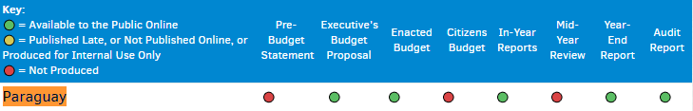

The Open Government Plan 2016-2018 contains a Ministry of Finance goal that refers to improving performance in terms of the indicators analyzed by the Open Budget Index. It is goal 9, commitment 3.

6. Exchange of knowledge and learning

In October 2016, Paraguay provided technical assistance to its peers in Panama (ANTAI) who had requested the source code of the Open Government website. The STP complied with this request for assistance, which was greatly appreciated by colleagues from Panama.

In March 2017, Paraguay provided technical assistance to its peers in the Philippines, through the intermediary of AGA, who had requested a copy of Paraguay's communication plan. The STP complied with this request for assistance, which was greatly appreciated by colleagues from the Philippines.

In the first half of 2017, the General Directorate for Development and Land Management, led by Florencia Villalba and her team, made several trips to exchange experiences with their peers in Costa Rica, Guatemala and El Salvador on the experience of formulating the Departmental, Municipal Development Councils and their Development Plans.

The DGGA / STP helped organize the learning and exchange of experiences organized by GIFT, the Ministry of Finance, the World Bank and the National Transparency Team. The day included experts in fiscal transparency from more than 10 countries.

Paraguay has actively worked closely and participated in meetings of various working groups:

1. Meetings, videoconferences and a meeting in Asuncion of the Working Group on Fiscal Transparency / GIFT
2. Videoconferences and face-to-face meetings of the Working Group on the Environment
3. Videoconferences from the Open Education Resources Group
4. Meetings of the Anti-Corruption Working Group

We have received extensive cooperation and international assistance from the Support Unit of the Open Government Alliance, of which we are very grateful for all your accompanimentand support. We highlight the constant support of Alonso Cerdán and Rosario Pavese, who have continuously advised the STP in several decisions to implement the PAGA.

The DGGA / STP has presented and shared the experience of Open Government in Paraguay in the following forums:

- International Open Government Summit, Paris, France, December 2016
- Meeting on the Latin American Outlook, OECD, Paris, France, May 2017
- Smart City Expo, Puebla, Mexico, May 2017

SENAC has also participated in exchanges and forums in the following countries, related to Open Government values:

- Exchange with peers from Colombia, SENAC, January 2017
- Meeting of the Integrity Council, OECD, Santiago de Chile, Chile, May 2017

7. Conclusion, other initiatives and next steps

A. Lessons Learned:

The challenges that emerged regarding the implementation of the NAP between July 2016 and June 2017 were the following:
1. The veto of the Executive Power to the Budget Bill 2017 at the end of 2016. This forces many institutions to use the same budget of the previous year, affecting the budgets required for some of the activities planned for the 2016-2018 Action Plan.
2. The reduction of certain resources coming from international cooperation, which suffered unexpected cuts.

The lessons learned regarding the implementation of the NAP between July 2016 and June 2017 were as follows:

1. We learned that there is a lot of value in implementing thematic PAGA monitoring tables. We had greater participation and opportunity to deepen the follow-up of goals and commitments with the thematic tables.
2. The importance of carrying out trainings to citizens, university students, authorities and public officials of the municipalities and departments of the interior of the country.

The lessons learned and challenges of PAGA development are mentioned in the first sections of this report.

B. Other initiatives:

Other initiatives or reforms that, during this period, contributed to the values ​​of the PMO but were not incorporated into the APR were:

National Transparency Team

Through Presidential Decree No. 4719/2015, the National Transparency Team is created, composed of the institutions that make up the national economic team and the National Anti-Corruption Secretariat. The STP has the executive coordination of the NCD and the SENAC has the operational coordination.

Some NCD activities during this period were:

- Participation of the International Anti-Corruption Summit in December 2016 in Panama
- Counterpart at the International Conference on Open Government and Transparency held in the framework of the Board of Governors of the IDB on March 31, 2017.
- Co-organizer of the day of learning and exchange of experiences, organized by GIFT, Ministry of Finance, World Bank and the General Directorate of Open Government
- Local counterpart of the Open Data Review Assessment and Implementation Assessment Tool conducted by World Bank consultants and Carter Center consultants between February and June 2017.

The ODRA is a tool that analyzes the availability of information in the Open Data format at the country level. The IAT is a tool that analyzes the state of implementation of the Access to Information legislation in Government Ministries and Agencies.

The website of the NCD is the following: http://www.transparencia.gov.py

Open Parliament

Citing the website of the Open Parliament:

"It is a worldwide paradigm that seeks to build a new relationship between citizens and legislators. An Open Parliament is to have greater transparency, access to information and accountability, and incorporates other components such as effective citizen participation and the use of technologies that will pave the way for this new relationship, so as to result in receptive parliaments, innovative and effective, working for the people.

We have the objective of installing the Open Parliament in Paraguay as a platform for collaboration between civil society organizations, legislators and citizens in general, to promote jointly and coordinated the opening of the legislative institution in our country through the signature of a declaration that indicates the commitment to develop a national agenda of open parliament that includes the creation of specific action plans, through all the mechanisms of possible participation and dialogue.

The Open Parliament Principles are:
1.Transparency and Access to Information
2.Citizen Participation
3. Accountability
4.Probity and parliamentary ethics
5.Technology and Innovation "

The open parliamentary self-evaluation report of the Open House can be found here:

http://parlamentoabierto.senado.gov.py/index.php/download_file/view_inline/139

The website of the initiatives of the Senate and Lower House can be found here:

http://parlamentoabierto.senado.gov.py/
http://www.diputados.gov.py/ww5/index.php/institucion/parlamento-abierto-paraguay

National Plan for the Prevention of Corruption:
The National Plan for Prevention of Corruption is led by the National Anti-Corruption Secretariat. The plan can be found here:
http://www.senac.gov.py/archives/documentos/a%20plan%20Nacional_4s3cxq3n.pdf

ICT Master Plan

The Master Plan of Technology, Information and Communications, led by the National Secretariat of Information and Communication Technologies (SENATICS). The plan can be found here:

http://gestordocumental.senatics.gov.py/share/s/evCYv5fBSTiuKfTwHiJ5-Q
https://www.senatics.gov.py/institution/marco-legal

C. Next steps:

The next steps to follow in the process of OGP in the country are the following:

1. Continue the effective implementation of the Third Open Government Plan 2016-2018. Ensure all goals are met before completion of the Third Plan on June 31, 2016.
2. To begin the co-creation of the Fourth Open Government Plan 2018-2020 according to the AGA's institutional calendar for the calendar countries.
3. Strengthen the process of institutionalization and deepening of the reforms related to Open Government implemented thanks to the 1st, 2nd and 3rd Open Government Plan.

D. Conclusion:

The positive impacts of the activities and results of the 10 commitments have had a direct impact on the improvement of the standard of living in Paraguay.

During the period from June 2016 to July 2017, the public information access page (www.accesoalainformacionpublica.gov.py)has received more than 4,300 requests for access to public information. To date, there are 150 institutions adhering to the portal.

The www.datos.org.py website has more than 120 open data sets available for citizenship. The page of www.denuncias.gov.py of the SENAC has more than 1447 complaints provided by citizens, many of them delivered anonymously.

The activities and results of the 10 PAGA commitments have had an impact on the improvement in the following international indices, which directly or indirectly collect information on progress in transparency, citizen participation, accountability and technology and innovation, including Open Data.

Transparency International Corruption Perceptions Index
Paraguay ranked 130 of 168 countries (27 points) - 2015
Paraguay post 123 of 176 countries (30 points) - 2016
http://www.transparency.org/cpi2015
https://www.transparency.org/news/feature/corruption_perceptions_index_2016

Paraguay improved 7 places in Transparency International's Corruption Perceptions Index ranking from 130 in 2015, advancing to 123 in 2016. We are still waiting for the data for 2017, which will be published in January 2018.

Open Data Index
http://index.okfn.org/place/
https://index.okfn.org/place/py/
Paraguay ranked 37 out of 94 countries (2016)
Paraguay ranked 50 of 122 countries (2015)

Paraguay improved 13 places in the Open Data Index ranking from 50 in 2015, advancing to 37 in 2016. We are still waiting for the data for 2017.

Electronic Government Index
https://publicadministration.un.org/egovkb/en-us/Data/Country-Information/id/132-Paraguay
Paraguay ranked 95 of 193 countries (2016)
Paraguay ranked 122 out of 193 countries (2014)

Paraguay improved 27 places in the Electronic Government Index ranking, going from 122 in 2014 to 95 in 2016. We are still waiting for the data for 2017.

Electronic Participation Index (e-Participation)
Paraguay ranked 72 out of 193 countries (2016)
Paraguay ranked 122 out of 193 countries (2014)
https://publicadministration.un.org/egovkb/en-us/Data/Country-Information/id/132-Paraguay

Paraguay improved 50 places in the ranking of the Electronic Participation Index (e-Participation), going from 122 in 2014 to 72 in 2016. We are still waiting for the data for 2017.

Press Freedom Index
http://www.rsf-es.org/grandes-citas/clasificacion-por-paises/
Paraguay ranked 110 of 180 countries (2017)
Paraguay ranked 111 of 180 countries (2016)

Paraguay improved 1 place in the ranking of the Index of Freedom of the Press going from the 111thposition in 2016, advancing to the 110th position in 2017.

Although these indices have not been updated recently, we consider them to evaluate the impact of the Plan:

Laws of access to public information
Paraguay - 61 points out of 150 possible
http://www.rti-rating.org/view_country/?country_name=Paraguay
Position 98 of 111 countries http://www.rti-rating.org/country-data/

Democracy Index
Paraguay http://country.eiu.com/paraguay
Paraguay
Position 72 of 167
6.27 points
Imperfect Democracy
http://elelectoral.com/internacional/indice-democracia/

ANNEX A
WRITTEN COMMENTS RECEIVED FROM CIVIL SOCIETY DURING THE PUBLIC CONSULTATION PERIOD
SEPTEMBER 8 TO 22, 2017

CIRD (Francisco Samaniego, Jazmin Cardozo and Diego Laterra)

New functionality of the websitewww.informaciónpública.gov.py: We recognize the effort made to include an option where the citizen requesting information can give his opinion on whether he feels satisfied or not about a response, however, we believe that for to close the objective of improving the quality of responses, should continue with the training of management of responses to requests by designated officials.

In keeping with the above-mentioned context, we suggest thatto have a positive impact in relation to the provision of responses, the officials appointed to the access offices should be permanent in this role. Also, that they have an adequate profile for the constant relationship with people and a permanent training at national and international level.

All that is suggested cordially above is because in many cases statistical data are presented as progress, for example "you have x amounts of requests in the portal unlike that year". What we do not demerit at all these data, but also, we emphasize that there is a remarkable difference between the quality and quantity of answers.

We suggest the following academic university profiles:

Sociologist. Political scientist. Communicator. Journalist.

On the other hand, at the moment of using the button to qualify the response by the institution, it is known that the citizen is requested to enter his mail, to send an email to him, however, in the mail does not leave any link to qualify the answer. (This can be a computer detail that SENATICs can solve quickly). See Annex A

Municipal and Departmental Development Councils: There are no indicators of functionality, as well as the impact on local public policies, as well as the correct functioning.

The number of workshops or meetings in local governments (does not reflect the quality of the incidence). Therefore, we cordially suggest that the following commitments include a feasibility analysis of these Boards, their functionality and the objectives achieved.
Civil Society Counterpart: We note the difference between the 2ndaction plan and the 3rd, with respect to monitoring by commitments by CSOs.

We believe that for each commitment it is necessary to delegate CSO organizations so that they can monitor the development and effective fulfillment of the commitments and above all because it is where the basis of the Open Government theory rests.

We do not know that to achieve monitoring different strategies could be applied, we believe that the strategy applied to this 3rdaction plan is to appoint all CSOs in all the commitments, but we point out that this does not necessarily represent an effective counterpart civil society.

Seminars, workshops, training: on this point we suggest that you can reconcile agendas between public institutions and CSOs. The CIRD Foundation during the entire period of the 2ndplan and part of the 3rdplan has kept this type of work together so that greater impact has been achieved with great efficiency.

Applications: We celebrate that there are applications developed to improve public services, but nevertheless when entering the Play store, the number of downloads is low in relation to the success that is mentioned.

For example, Akuerapp 5000 and DNCP 1000 See Annex B-C

To improve the public service, not only must technological tools be made available to citizens, this must be done with training or workshops or citizens, where theoretical and practically the benefits of these innovations are transmitted.

We suggest that the institutions that develop these applications go to universities or high schools and carry out practical workshops where students can download and use the digital tools, as well as remove all the queries they have.

Open Government Courses: Since the 2ndAction Plan we mentioned that the institution responsible for the implementation of the Open Government Program Paraguay could, in conjunction with other institutions, hold diplomas on Open Government.

We believe that people not linked to the public function must receive these theoretical - practical training and must receive certificates as a motivational strategy in the development of the concept of civism.

Dissemination: We emphasize the need for greater dissemination of the Open Government Program. We suggest the implementation of better transmission mechanisms for better information to citizens. We propose that each month through a virtual open means can be offered two hours of training, answering questions (WEBINAR).

Joint Working Group Meetings: At this point we suggest that the meeting with the corresponding presentation of each institution be divided into two or three days according to needs.

Through previous experiences at this point, we notice that having many speakers and presentations, people lose concentration and interest of the data presented and everything seems to be a mere validation process.
María Elena García:

I have read the document carefully, I think it is a great job for the whole team, that surely as the citizens are incorporated into the use of open data will improve even more.

I have found no objection, I congratulate the effort and the achievement achieved.

I had an experience with the use of this data with the municipality where I live, Fernando de la Mora, and my claim motivated that they open or enable the office of citizen care, which by law should have been implemented. Finally, my claim had a response, but not what I expected, more action in the neighborhoods part of the municipality, but I think that as we are demanding, that will be achieved. For now, the paper continues to "endure" many issues, putting it into practice is what it costs.

As for UNA, where I work, I believe that authorities and officials have not yet fully understood the importance of open data and information in a timely manner so that citizens can audit our work. I hope it gets better soon.

For example, in "1 legal practice created within the chair of AIP of the Faculty of Law of the National University of Asunción to carry out and follow up on practical cases of requests for public information, both administrative and judicial”, but first I would like these people to ask themselves a question: "Has the Faculty of Law made any real effort to make available to the citizens all the data that is required so that we can be in control of their function?" I believe not. Then, we must make the effort from Higher Education because the authorities commit themselves in a real way and not in the roles and in official acts just.

From the Facultad Politécnica of the UNA (FPUNA) we have tried to do activities and point towards the opening of data, but it has been very complicated and very ineffective.

Regarding Commitment 7, related to the topic Health, the FPUNA has developed for the Faculty of Medical Sciences, the Hospital Management System, open source, based on international standards. I think this application can be used throughout the National Health System, with perhaps minimal changes or adaptations, given that it is a product of the Paraguayan State (being the state university) and where the UNA has already invested enough money. In addition, if this is achieved, there will be a large community in the field of medical informatics prepared to face the technological challenges in e-health that are envisaged.

I believe that this should be discussed at the level of high authorities to achieve the necessary agreements and not re-invent the wheel again and again.

Best regards,

Prof. Ing. María Elena García, M.Sc.
National University of Asuncion
Polytechnic Faculty
http://www.pol.una.py/cia/
@mgarciapy
skype: magarciapy

Emilce Sena:
First, I thank you for your deference, to trust me, to comment on the Action Plan. You will understand, that as an information professional, I cannotseparate myself from my profession to perform evaluation. I celebrate everything that is being done in the country, it is a great advance. Trainings, dissemination of plans, socialization of documents, citizen participation. But the input of everything related to open government, open data, access to public information, transparency comes from a good system of document management and archival organization.
Based on everything that has been read in the document that I have been sent, it is noted that there are interesting initiatives for training, dissemination and socialization. In the field of implementation, the reality is different ... "access to public information ... transparency ...", although it largely does not depend on the STP, but most public institutions, if not all, have not yet understood what this means for a country ... You see, there could be some resistance, fear to unveil information ... or is it all very bad? How do we access public information today? How do we make management transparent without good documentary organization? How is document production and its subsequent organization in public institutions?
It will not be possible even with a law on access to public information to access documents that are requested by citizens if we do not pass at the same time a law of archiving that obligingly forces the organization of the State in each one of its departments. "What we have today is an "organized disorder"in such a way that you can never access valuable documents that can allow you to make correct decisions in specific fields such as those related to the most basic citizen claim. - Dr. B.Fernández Bogado
Any initiative for transparency and access to public information depends to a large extent on the quality, reliability and accessibility of the "public archives" documents, which guard that information. If the archives are not organized and well managed, it will be very complicated: comply with the deadlines established for the response to citizenship and administration, according to Law No. 5282/14.
Access to public documents is the main transparency mechanism of institutions and, as such, one of the fundamental tools of open government. Their guarantee and effectiveness are, therefore, a challenge and an important responsibility for the public authorities, and especially for their archival institutions, responsible for collecting, managing and preserving the support of actions and decisions of the same, which are in the documents. How do we make this work in our public institutions?
An adequate implementation of document management systems can be considered as one of the basic supports for the application of the laws on transparency and access to public information. It is therefore essential to ensure that the document management and records policy is in line with the policies for access to public information, transparency, open government and open data.
It is necessary to include in the Third Action Plan: "strategies, policies, order the documents in public institutions", if we want to comply with what is established in the law.

ANNEX B

WRITTEN COMMENTS RECEIVED IN THE
OPEN GOVERNMENT OPEN SURVEY, DURING THE PUBLIC CONSULTATION PERIOD
SEPTEMBER 8 TO 22, 2017

-------------------------------------------------- -------------------------------------------------- ------
Comments to the Open Government Survey:

1. It is necessary to eliminate impunity regarding the facts of corruption, and give spaces to the patriots!!!
2. An effective sanction is lacking for institutions that do not comply with requests for Public Information. Institutions such as the Ministry of Agriculture and Livestock (MAG), vital for transparent management, ignores requests very easily.
3. Keep going!!
4. A greater communication impulse is necessary so that everyone understands the usefulness of the tool.
5. More training and information is needed for more precise indicators.
6. Corruption we must fight ... everyone. We must recover the values ​​of moral and Christian ethics. We must make a way of conversion ...
7. Go ahead, progress widely to two years of its effectiveness, but socialization of the use of this tool by citizens who are still in ignorance or the inhabitants of the interior need more accessible and easier to use tools.
8. I have used the portal and they have answered me! They called me! Every time I understand better how it works.... we will see later if public officials improve their respect for those who pay their salary, citizens. Thank you!
9. It is a job that takes time, but I believe that what contributed most is to realize that we did not manage concepts of data, information and much less systematization of it. This is the only way to begin.
10. Statistics would be useful with source specifications. (3 reviews)
11. It is necessary to give spaces to public servants who want to serve and not use others. Otherwise Open Government, will be just for the photo opportunity.
12. It is necessary to continue to open the data, but aiming at the interests of the citizens, could be consulted on issues and information that could be opened and more available.
13. There is a lack of dissemination of what is being done in ​​transparency.
14. The data ismisleading
15. It would be nice to update the data continuously.
16. To have access to the information immediately and Clara is useful to give a proper opinion on the transparency page. (2 reviews)
17. It makes citizens aware of who are the officials who work and who are still marking and disappearing from their place of work, not yet taken measures due to the complicity of other estates.
18. Impunity is losing strength!
19. Very good job.
20. Dissemination by other means, and especially the heads, authorities according to the institutional band
21. Excellent, we have already given the greater of the steps, the transparency in the Management of the entities, we seek that as civil society we are involved that those funds can improve the services in general.
22. It seems to me that if it works that it is transparent it should continue like this.
23. In accordance with the transparency project
24. I understand that civil society is not adequately informed and trained about the system of governance and open data.
25. That is all I can say.
26. "I think the open government project is good, but things are still lacking to reach the general public, we have to try to find and motivate people to use them, because often due to ignorance or not knowing of the mechanism, one does not use it.
27. I believe that it would be of value in the interior if it gives adequate use to the system to meet and advance the objectives of the program. "
28. There is a lack of control over accountability.
29. Excellent! Keep moving forward.
30. Continue to work on open data and there is much to be done, as well as inter-entity integration to avoid duplication of data and the presentation of roles in actions that should be available between institutions.

Next, the presentation of the "Survey on progress in access to public information. Third Action Plan GA 2016 -2018 "

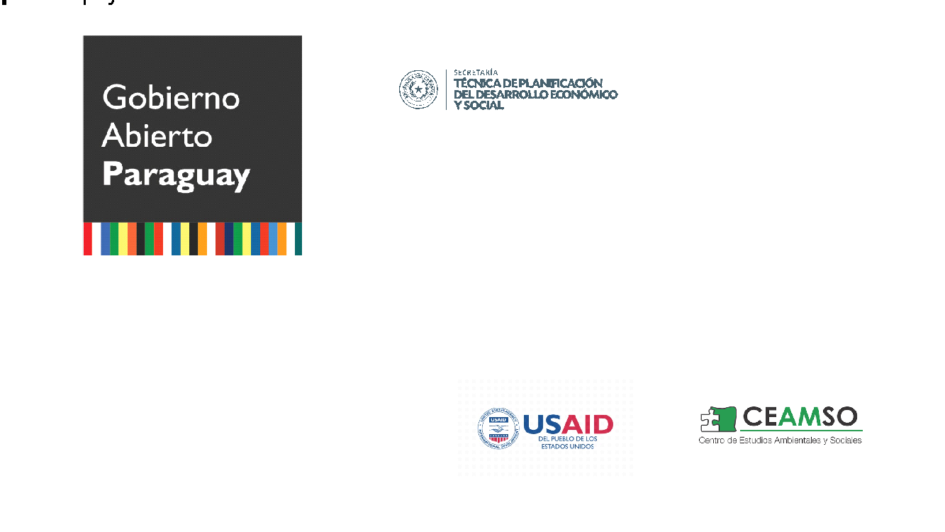
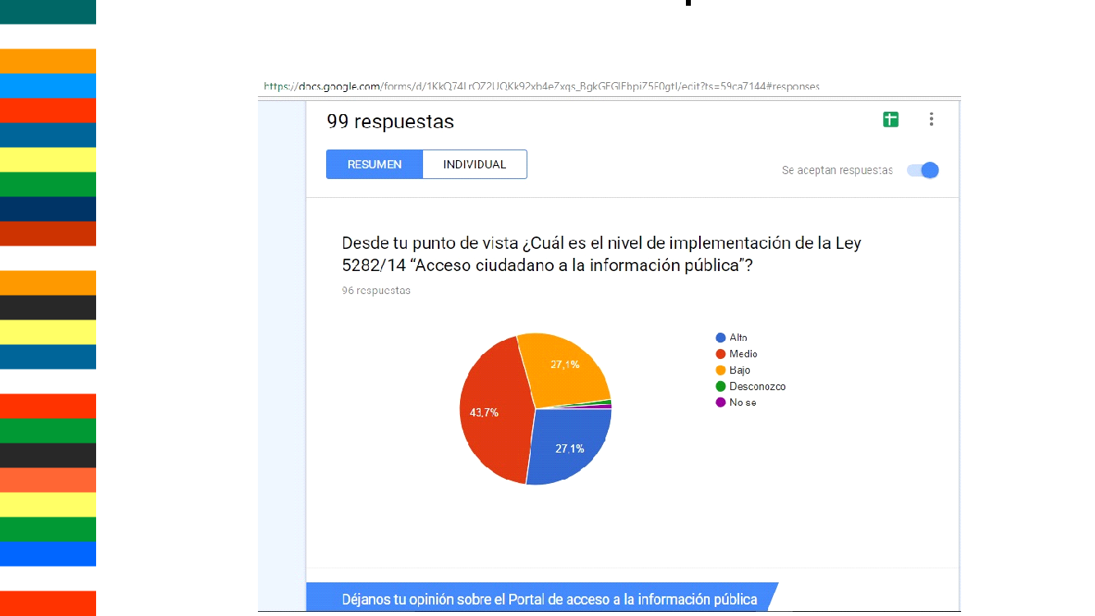
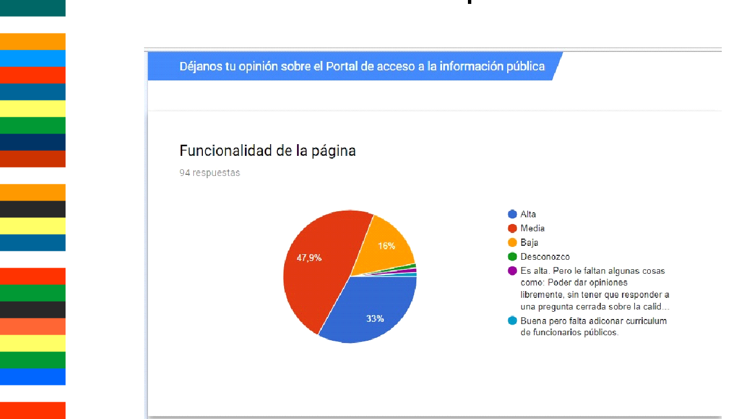
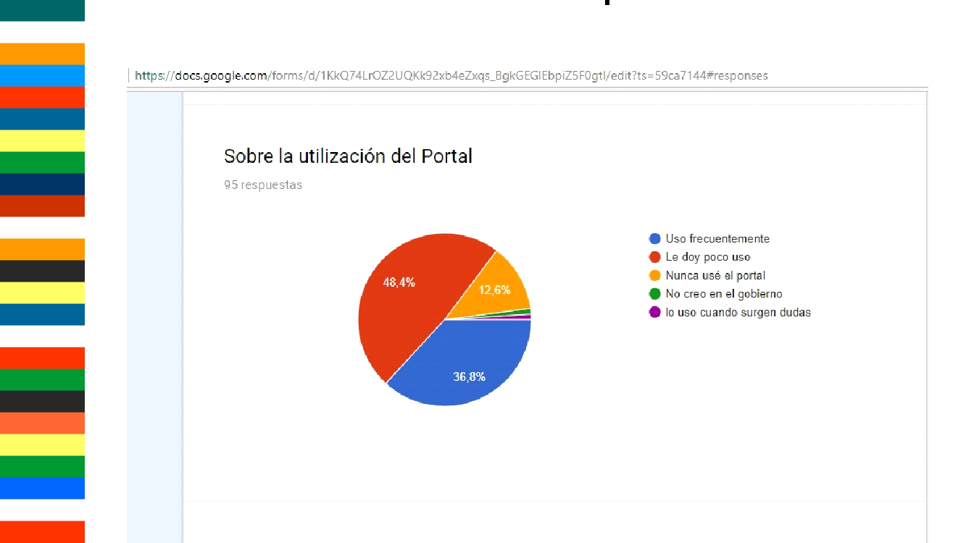
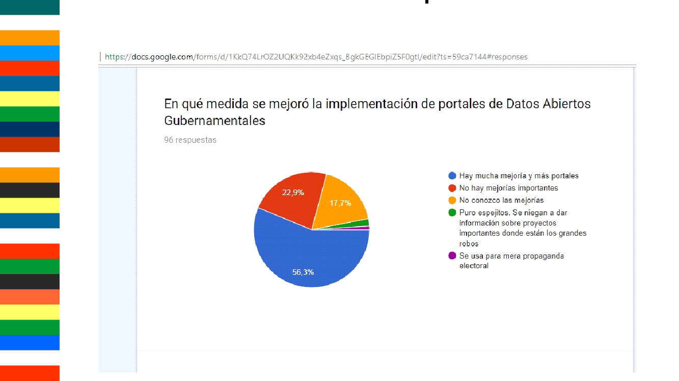
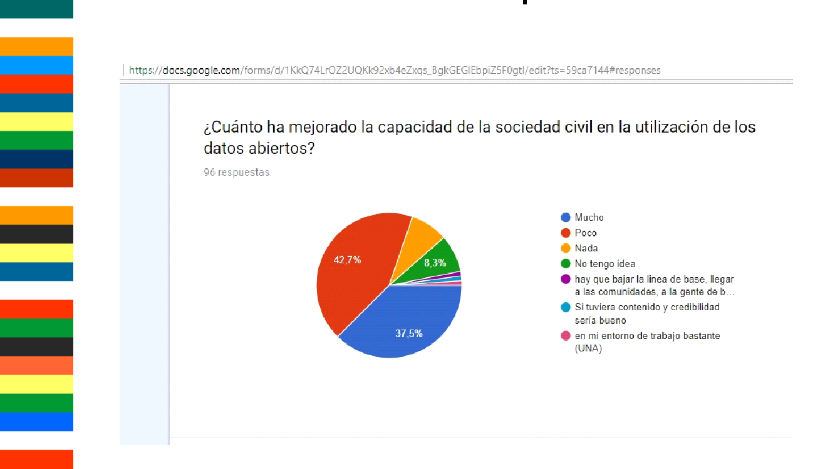
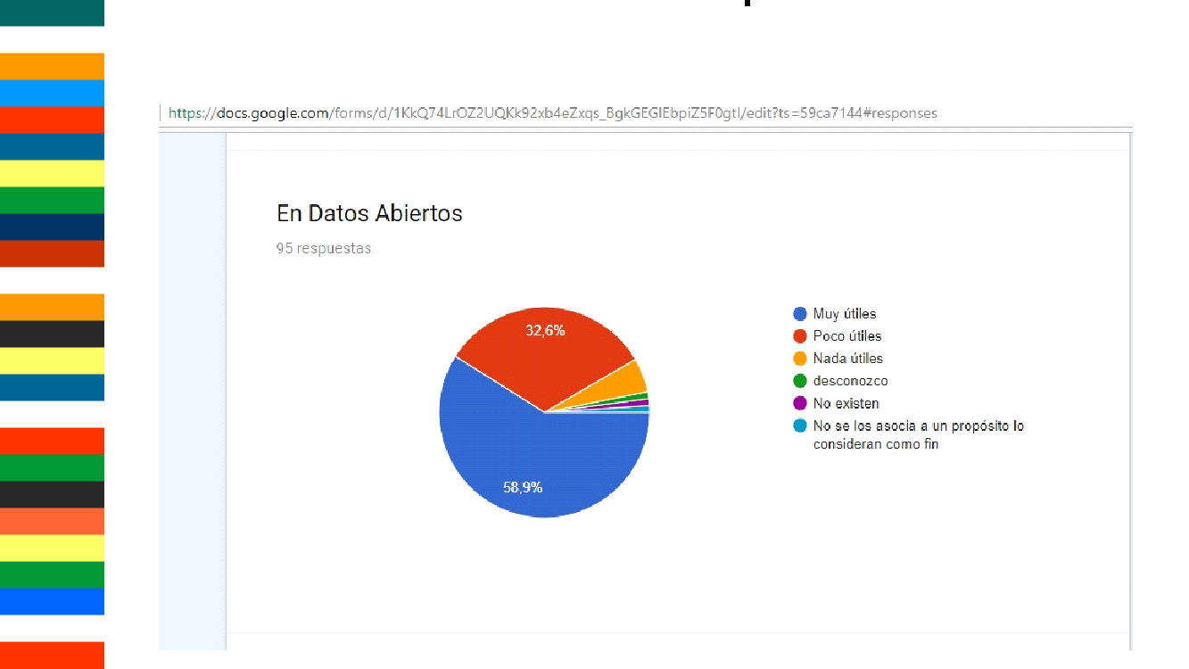
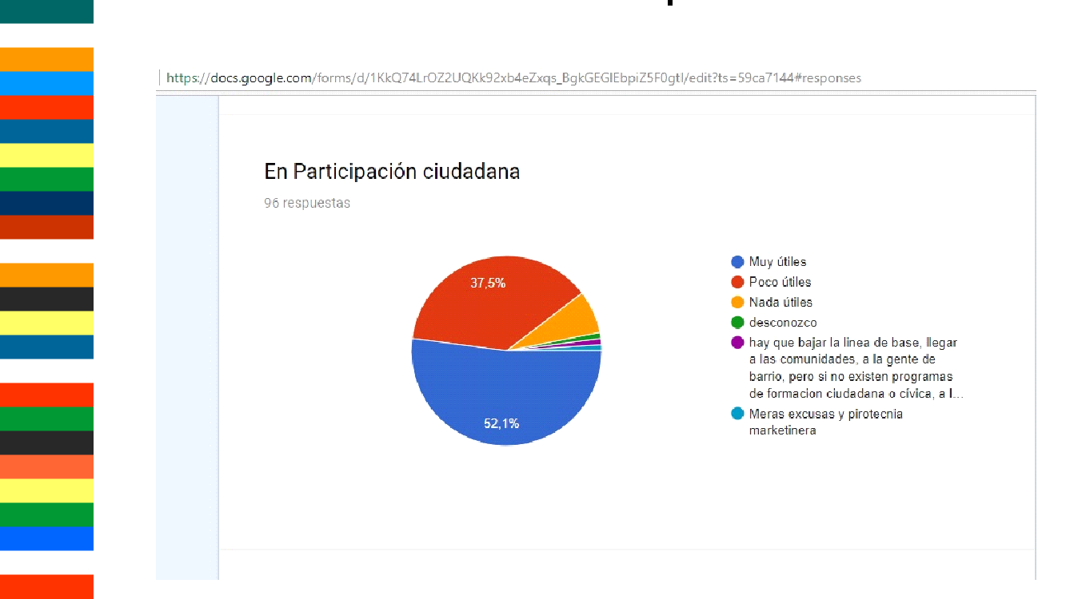
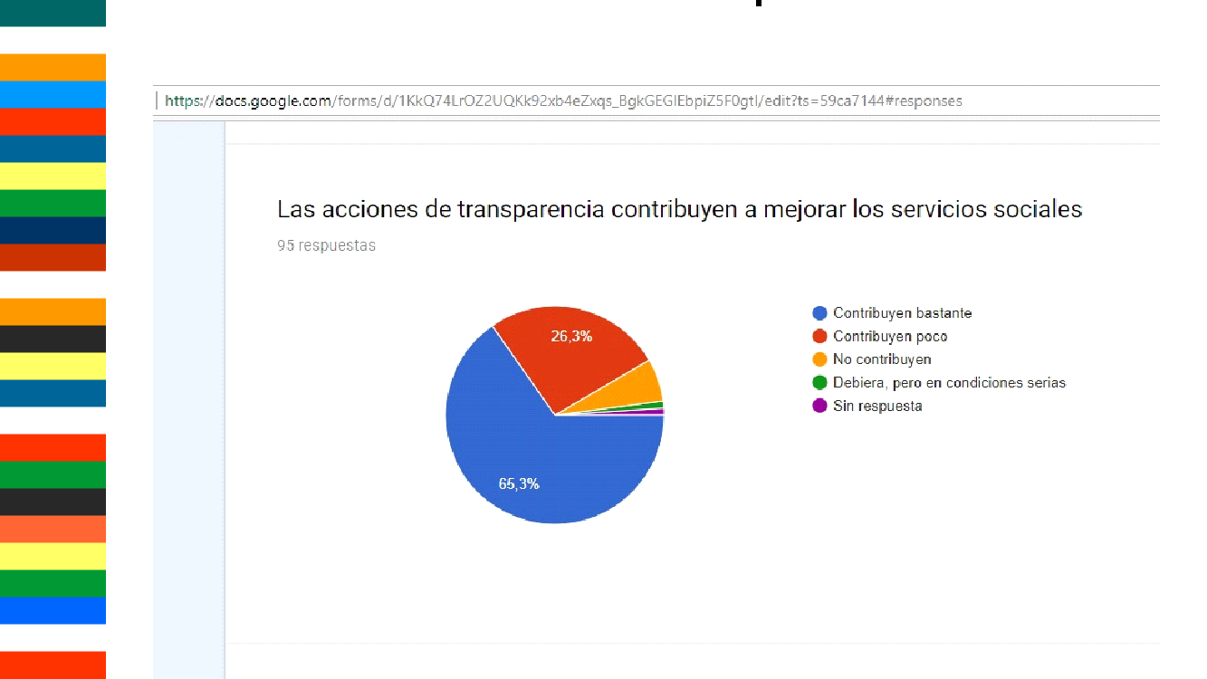
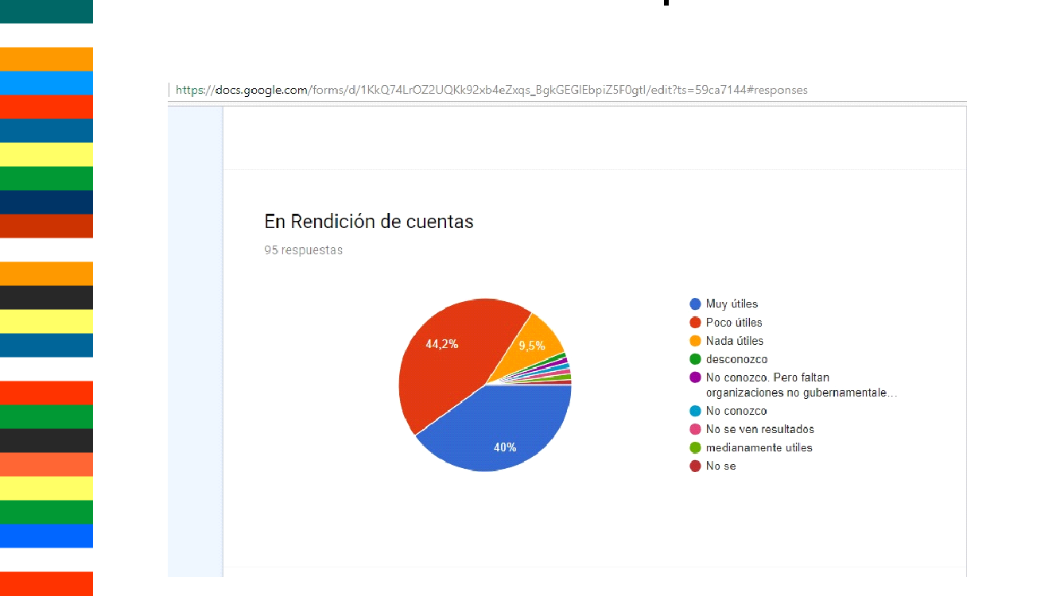
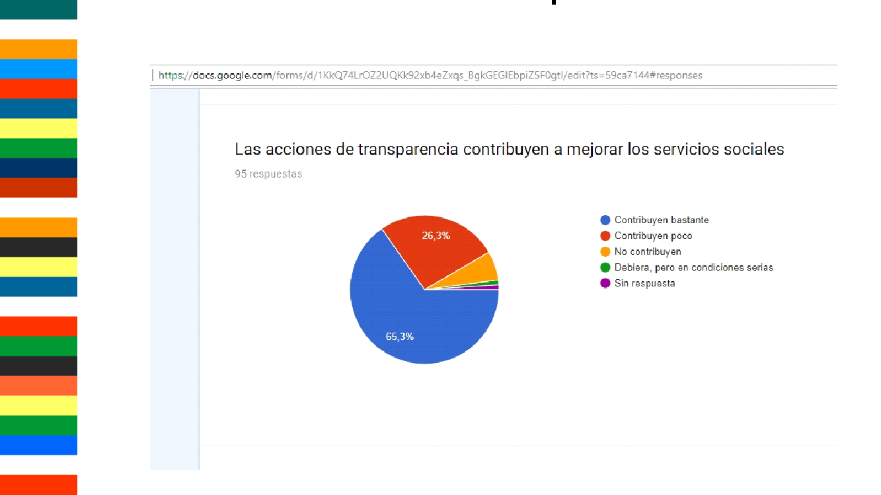
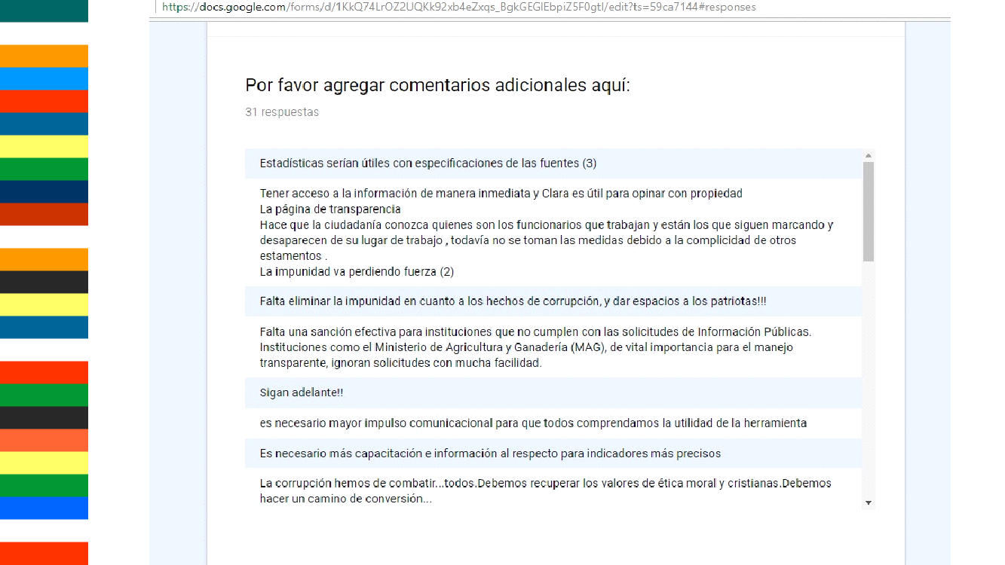
ANNEX B

ANNEX C

COMMENTS RECEIVED DURING
THE THIRD MEETING OF THE OPEN GOVERNMENT JOINT BUREAU AND THIRD SELF-EVALUATION REPORT PAGA 2016-2018

MINUTES
THIRD MEETING OF THE OPEN GOVERNMENT JOINT BUREAU AND THIRD SELF-EVALUATION REPORT PAGA 2016-2018

September 2017
Asuncion, Paraguay

MINUTES
Meeting of the Joint Open Government Board.

Presentation

The General Direction of Open Government of the Technical Secretariat of Planning, coordinating instance of Open Government, invited the Meeting of the Third Joint Open Government Board to carry out several items of the agenda and the evaluation of the report of the Report of PAGA 2016-2018 End-to-End Self-Assessment.

The event was held on Tuesday, September 26, 2017, from 2:15 p.m. to 4:10 p.m., in the Hall Auditorium of the Library and Central Archive of the Congress of the Nation, located in the street Rio Ypané almost José Asunción Flores.

A total of 62 people, including 31 women and 31 men, representing 8 civil society organizations, 1 university, 2 international organizations, 2 state representatives and 22 public institutions (2 of the Honorable Chambers of Senators and Deputies) participated, respectively

Among civil society organizations present:

- Seeds for Democracy
- CIRD Foundation
-IDEA, representing the GIAI
-TEDIC
- APPG
-Academy Trinidad
-CEAMSO
-FEDEM

Likewise, the representatives of Academia were:

-The Chair of Open Data of the Polytechnic Faculty of the National University of Asunción (UNA)
On the other hand, a representative of the World Bank, four representatives of the Organization for Economic Co-operation and Development (OECD) and two representatives of states: Embassy of the United States of America and the Presidency of the Republic of Costa Rica, respectively .

In addition, representatives from the following public institutions attended:

-Instituto de Previsión Social
-Ministry of Justice
-Treasury
-Ministry of Education and Culture
- National Secretariat of Information and Communication Technologies
-Ministry of Foreign Affairs
-National Anti-Corruption Secretariat
- Secretariat of Social Action
National Commission of Telecommunications
- Ministry of Labor, Employment and Social Security
- Ombudsman
- National Cadaster Service
National Secretariat for Children and Adolescents
-Honorable Chamber of Deputies
-Honorable House of Senators
- Technical Secretariat of Planning
- National Secretariat of Tourism
- Ministry of Interior
-Ministry of Public Works and Communications
- Central Bank of Paraguay
- Paraguay TV
-Municipality of Encarnacion

The event was developed as follows:

1) Welcoming and Introductory Remarks - Federico Sosa, Directorate General of Open Government, STP

2) Brief Presentation of the OECD Mission on the Study of Public Governance
Adam Ostry, OECD

3) Summary of Progress Monitoring of Goals and Commitments of the Third Open Government Action Plan, Gabriela Porro, CEAMSO, and Federico Sosa, STP

4) Draft Law on General Archive of the Nation and National System of Archives in the Republic of Paraguay - Ombudsman's Office, Director Jorge Rolon Luna

5) Evaluation Day with Civil Society on the Medium Term Self-Assessment Report of the Third Open Government Action Plan

Presentations

Twelve suggestions and recommendations from civil society were presented on the mid-term self-evaluation report of the Third Open Government Action Plan:

Then, the presentation of the comments and suggestions of the participants of the day.

• Comments and suggestions on the Midterm Self-Assessment Report of the Third Action Plan 2016-2018. (IDEA, Seeds for Democracy, Free Foundation, Center for Judicial Studies), in charge of Romy Fisher (IDEA, Institute for Environmental Law and Economics), representing the Impulsor Group for Access to Public Information

"We believe that the self-assessment report we received would be rather a kind of draft report by the government and it was not jointly co-written with civil society, so we propose to revise another methodology. To take advantage of this space with the Joint Table, we would like to analyze what we did well, what we are advancing and what our challenges are. We systematized the meeting and we can have an evaluation report with participation of both partners as required by the Alliance.
About the process: I think we had several advances in relation to what was the First PAGA. In the third PAGA, to the present one, there was co-creation, although in some commitments the Government had the last word. However, we must try to improve the participation of civil society as a partner on an equal footing so that its participation and what it proposes has real value.
Regarding the commitments: We see that we have very relevant commitments such as the opening of crucial data of the health system, such as the transparency of the stock of medicines available at public health centers, as well as the local development councils as a space for dialogue and articulation between government and civil society, above all the linkage of the process of implementation of the Law on access to public information, 5282/14 to the Action Plan.
We insist the conceptual theme of Open Government, where the Executive, Legislative and Judicial participate, not to separate the Open Parliament Plan. In Paraguay, the government exercises the 3 powers of the state, we do not understand open government only as the Executive Branch. According to our Constitution, Art. 3 in Paraguay, the government is exercised by the 3 branches of the State, the Legislative, Executive and Judicial. A formalism should not be an obstacle to having a Plan per country, including the 3 branches and extra-power bodies."

• Comments and suggestions on the Midterm Self-Assessment Report of the Third Action Plan 2016-2018. Association Trinidad by Arturo Bregaglio

"Although it is not an interview I want to express opinions about the process as I was a member of the evaluation committee and the feeling that I have after this formidable effort of the group of actors but that I do not see reflected in the whole of the society and that I am going to say why. Thank you for the mea culpa on the processes and the self-criticism about the unfulfilled training workshops, but I believe that things go beyond that.This schizophrenia that occurs in the media throughout Latin America does not reflect reality. In the Andean countries that was frequent criticism, cute, blond, pretty and the part of the indigenous population and so on etc., etc.
I say this because I wonder what ideas you make before the report, its results, and the political expression that transparency has in Paraguay every day, we cannot stay in what assessment we put, no! There are two public opinion makers that unfortunately are not us and those are those who put or take away value of transparency. There are very important facts that have occurred in recent years in our country, and this is opposed in many parts to our reports. I understand what you want to say Federico and literally take your phrase: "Open Government is not only about corruption and transparency, but the improvement of procedures." There is no possibility of improvements in the procedures if there is corruption, that is, do not start from the back if we do not resolve the previous premises because there will be no improvement no matter how much we have this project with cooperation or without state cooperation, as Marta said. And finally, I looked forward with great interest to the report of the President before the United Nations Assembly and precisely the President stressed as he usually does in transparency, and stated that thanks to transparency, the clientelist politics ended in Paraguay and was born a world of opportunities. If that is the case, either I do not know in which country I am or literally the one who gave the speech I did not know from which country he came from.”

2ndComment (sent in writing):

Evaluation methodology recommendations: I believe that evaluations, from previous experiences and a long bibliography about this, must take certain precautions, so that they are rigorous, the present feel in a framework of confidence and their expressions may be far from the natural inhibitions which produce protocol acts.

From the proscenium to more than one meter of height of the public, (I understand that they are the conditions of the place), but this already was raised from Paulo Freire up to here by many people. The most recent is precisely what was adopted in Costa Rica around "discontent". And from this you can get more information from the Minister and the current Vice Minister, who have applied it in Internet Governance Forums (IGF). It is a friendlier and inviting methodology that warrants discussion.

On the other hand, I value the comments of people from the present outside, but the unknown always involves retaining positions, although that may not happen with you and not a matter of secrecy or natural neutrality. It is interesting but insufficient.

Is it enough to ask the US Charge d'Affaires if he knowsmore or less well the situation in Paraguay? See interviews in UH ​​and cross-references with the Chancellery. So I see the external presence unnecessary to give transparency to our actions. I do not think it is convenient to measure things from your comfort or from mine.
If we have the methodology previously defined, we do not enter that absurd vote, where I personally have no interest in your unnecessary exposure to third parties and where the "democratic and transparent act" giventhe number of those present. Already the international indicators are not the best. (See international transparency 1/10/2017). So it is not enough to change the external perception.

Report: Finally, on the report, I reiterate what was proposed at the beginning of the day, which was not registered by Facebook.

It would be very useful to have two pages with the most outstanding achievements in qualitative and conceptual terms based on the pre-set indicators. The weaknesses that our work has in the context of a political scenario such as those that present us with a reality to which we are not alien. And those things that we have not been able to log or are part of the obstacles, difficulties or threats that our reality presents.

• Comments and suggestions on the Midterm Self-Assessment Report of the Third Action Plan 2016-2018. Vice Minister of the Government of Costa Rica by Ana Gabriel Zúñiga.

Referring to the conceptualization of Open Government and that it is fundamental to understand that Open Government is not a digital or platform government, she argues that it should support and reduce the gaps and not increase them. Open Government should serve to reduce social unrest, and the product of a good result is that one of its commitments in Costa Rica is to develop a protocol to care for the population.

The young generation has had a disenchantment with the political system, but with an impact on government from the outside and from the government what we are trying to do is to make it more flexible and more accessible through open data, creating space for empowerment and peer relations.Finally, on the indigenous population and vulnerable population, the only way for Open Government to get there is to go to those places, leaving the offices and the experience is extremely positive. And she comments on her experience with the natives of her country, what it took to give them participation and how they achieved their empowerment, which today, one year, is the same indigenous people who demand the fulfillment of the goals.

The passage of the law on access to information promoted by civil society in Paraguay was an important achievement that Costa Rica does not have.

• Comments and suggestions on the Midterm Self-Assessment Report of the Third Action Plan 2016-2018. Federation of Neighborhood Entities of Paraguay (FEDEM) by Miguel Olmedo.

He stated that while we have accompanied the process since its inception, what concerns us has to do with the empowerment of people outside Asunción. Paraguay does not end in Asunción, because the rest is as a mere spectator and not as a participant, so I think that Open Government must include in the next plans the training of people so that they can participate, because citizen participation is not constant, the construction of a joint participation and to the extent that the government invests in the training of people will be able to demand better governments

• Comments and suggestions on the Midterm Self-Assessment Report of the Third Action Plan 2016-2018. Institute of Social Security (IPS) by Mónica Vargas.

I believe that we are understanding what is Open Government participating in the tables so I consider that we should be more aggressive when it comes to publicizing the same, because that is how people find out and thus can participate and get to know.

• Comments and suggestions on the Midterm Self-Assessment Report of the Third Action Plan 2016-2018. Center for Information and Resources for Development (CIRD) by Francisco Samaniego.

Since the CIRD Foundation, in our agenda as a Civil Society initiative we have several two-hour trainings to introduce what is Open Government to social groups, and I think that is little, so I propose that a course be designed teaching what Open Governmentis so that from the history of it, people can understand and value much more what has been achieved.

According to the PAGA in the commitment 1 Access to the public information "Greater level of appropriation of the API law and principles of Open Government to improve the quality of life".

Goal 7 aims to train 500 people (civil society and public officials) through short Open Government courses.

This short course can be used for people who do not yet have a base or job in relation to work within the Paraguay Open Government. It would serve as introduction and dissemination.

But when I refer to "course" I mean something equivalent to a diploma or specialization, which lasts for at least 120 hours, is semi-presential (virtual and face-to-face). This would be somewhat more specific already for civil servants and individuals working in the achievement of the PAGA objectives.

With these two types of courses I believe it is the most viable way to better understand the concept, history and progress of Paraguay within the Alliance. Many actors at the joint table still do not unify criteria about what we interpret aboutOpen Governmentand this creates confusion many times.

I see this as a real option to have people capable of understanding what Open Government means and that they can be prepared to create, implement and control that decisions made within Open Government are fulfilled.

• Comments and suggestions on the Midterm Self-Assessment Report of the Third Action Plan 2016-2018. Public Policy Center by María José García.

From the Center we work as observers of the process and I understand that it is a good time to perhaps agree on a response based on what was said and in that sense, we had seen the need to systematize or how to systematize everything that is developing in these spaces and on the other side, co-participation on an equal footing of all members in the process and also see what the process of monitoring the plan is something different.

• Comments and suggestions on the Midterm Self-Assessment Report of the Third Action Plan 2016-2018. Consultant, Mariju Fukuoka.

She suggests looking for methods to get youth interested in these issues more closely and to get involved in the process and the only way for transparency to win its trust.

2ndComment (sent in writing):

My suggestion is to link the actions of the ENEP, Network of Planners, Technical Secretariat of Planning to optimize the results and combat corruption. In addition, we seek a methodology to reach more closely all the youth groups engaged in the Construction of a Participatory Democracy, Representative and Plural. Technology is young people's current currency, which makes it difficult for older people to also be encouraged to participate. Greetings.

• Comments and suggestions on the Midterm Self-Assessment Report of the Third Action Plan 2016-2018. Researcher, with degree in Information Sciences, Sonia Melgarejo.

She commented that she is studying a post-graduate course and has been researching the subject of Open Government and the implication of the archives, so she has read everything about it and analyze it. It seems very important that the government deal with the archives and systematization of the information and archives so that the society has access to this information.

2ndComment (sent in writing):

I have read and appreciated the opinion and collaboration provided with reference to the Open Government that has described in the document and I consider it pertinent since it is practically what I want to capture from my research, the importance of organizing the information embodied in the documents in the different Institutions of the State and the creation of Archives in each of them. This would make efficient use of state services and there would be no loss of time or chaos when handling cases or issues of different kinds and of course from this, the fusion with the technologies when digitizing them, thus facilitating to society its access and not to fall in bureaucratic procedures and long as occasionally these processes tend to be. More professionals in ​​Information Sciences to support these cases. I hope this contribution is useful.

• Comments and suggestions on the Midterm Self-Assessment Report of the Third Action Plan 2016-2018. Seeds for Democracy, by Marta Ferrara.

Expresses concern for the sustainability of the process, it is necessary to include in the General Budget of the Nation to support the Open Government because so far has been advanced, but supported by cooperation and yet not included in the PGN.

• Comments and suggestions on the Midterm Self-Assessment Report of the Third Action Plan 2016-2018. Center for Environmental and Social Studies (CEAMSO), by Raúl Quiñonez.

It seems to me that it would be important for these suggestions and recommendations from civil society to be dealt with in the mid-term report and to analyze where bottlenecks are to achieve what was not achieved, technical assistance, resources, institutional political will, etc.

Asunción, September 26, 2017

ANNEX D:

REPORT ON THE SELF-EVALUATION OF THE MEDIUM TERM OF THE OPEN PARLIAMENT

“We are building a new way of interacting with citizens”

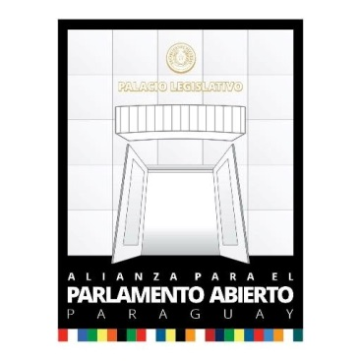

Paraguay
Half-term self-assessment report (2017)
First Action Plan, 2016-2018

- Introduction and Background.

In our country, during 2014, two legal tools were developed, that allowed citizens to exercise their right to information access (guaranteed in our Constitution in the article 28) that were the laws 5282/14 of “Free Access to Public Information” and 5189/14 of “Government Transparency”.

Our first action plan was co-created with Civil Society Organizations (in its role of monitoring and control), which allowed us to establish a governability structure that also integrates the officials of the Senate (for the sustainability of the project) and the Senators (that imprint the political will). For this objective, a Special Follow-up Committee to the Implementation of our first Action Plan, was integrated in a multi-representative way.

How do our commitments reflect the principles of the Alliance?

The five commitments assumed in our first Action Plan are in line with the principles of Open Government and Open Parliament, which are:

a) Transparency and Access to Information.
b) Citizen Participation.
c) Accountability.
d) Probity and Parliamentary Ethics.
e) Technology and Innovation.

In the case of “Transparency”, “Citizen Participation” and “Technology and Innovation”: our commitments 1, 2, 3, and 4 are directly linked to them, through various activities that each Directorate General has designed to encourage citizen participation and through ICTs, facilitate access to the information that the institution generates, for example:

- Public hearings in the interior of the country: it approached part of the process of creating the laws to the main departmental heads, allowing the local citizen participation in bills of law that directly influenced them. In addition, they were transmitted live via Streaming (and YouTube).

- General budget of the nation: We have created a virtual space for the socialization of the preliminary draft of the General Budget of Expenses of the nation that has allowed a high participation citizen during the whole process. In addition, the meetings of the sub-committees and plenary sessions are transmitted via Streaming.

- Environment: We have established an interinstitutional working group for the joint elaboration of Law Enforcement Projects that affect the environment, with the participation of CSOs and other state institutions.

The commitments made by the Senate in this First Action Plan, are aligned with the Strategic Plan of the Legislative Power (2012-2016) and contribute to the increase of public integrity and more efficient management of public resources. The processes of design and development of the legal tools that the Executive has for the management of public affairs have been influenced by citizen participation in an environment of total transparency.

- The Process of the Action Plan.

From February 22 to February 29, 2016: we held the first meetings in an internal framework to socialize the initiative and identify possible dependencies whose institutional roles would be linked to some of the principles of Open Government and that could collaborate in the design of the Plan and/or its implementation.

From March 4 to March 18 of 2016: we made the first public call, by means of which we were approached by several CSOs interested in forming part of the Alliance. We had identified the sectoral activities and had integrated the Parliamentary Commission.

From 21 March to 22 April: the process of validation of the activities and their alignment with the proposals for institutional commitments by the Parliamentary Commission and the multi-disciplinary technical teams took place.

From May 2 to May 6: a review of everything acted out to date, with all the actors.

From May 10 to May 20: the 1stCo-Creation Day of the First Action Plan of the Alliance for the Open Parliament - Paraguay, 2016-2018, and the signing of the Joint Declaration by all members.

From May 24 to May 26, 2016: the 2ndCo-Creation Day of the First Plan of Action of the Alliance for the Open Parliament - Paraguay, 2016-2018; review and consolidation. In addition, the presentation of "Paraguay Experience" within the framework of the Annual Meeting of the Open Parliament Network - ParlAmericas, which was hosted by our Legislative Palace.
With the aim of encouraging citizen involvement and commitment for the control and monitoring of public management, we design actions based on the principles of the alliance. Various activities and mechanisms were used for this purpose, each designed according to the needs and requirements of each sector.
The participation of the institutional working teams in conjunction with civil society organizations in forums for the dissemination of the Law on Access to Public Information and its institutional implementation mechanism, the development of printed and audiovisual materials and participation in events of mass attendance has allowed citizens to know and use the tools available to conduct their public consultations.
Our 1stAction Plan, its implementation and self-evaluation were socialized through forums and the creation of virtual spaces accessible to all public. The recommendations and suggestions have been incorporated into the documents prepared and published.

At the end of the first semester of implementation, a meeting was convened between government and civil society actors, an opportunity in which the Senate has shared its progress and the civil society organizations present on this occasion have done the same; the event took place in the Education Commission of the Senate in February 2017.
After the first year of implementation, we developed a self-assessment tool that mainly serves to monitor the progress achieved, which is available on the web (parlamentoabierto.senado.gov.py). To implement it, each direction responsible for the activities indicated their own achievements, which were presented in two meetings, attended by government and civil society actors.
It is important to highlight the role of legislators who are members of the Open Parliament Committee during the process of socializing the initiative, identifying commitments, and implementing the Plan of Action.

- Recommendations of the Independent Review Mechanism

There is currently an Interinstitutional Cooperation Agreement with the NGO Semillas para la Democracia (Seeds for Democracy) and the National Democratic Institute (NDI), which has as one of its objectives the installation of an independent and ongoing review mechanism.

At the time of the formal referral of our 1stAction Plan to the Focal Point of Open Government in Paraguay, we had consulted on this particular point, if the same IRM that works with them, would also do it with us; to date we have not received a response.

4. Implementation of the Commitments of the Action Plan.
The following tables reflect the level of compliance with the activities and commitments of the First Action Plan of the Alliance for the Open Parliament - Paraguay, 2016/2018.
Activities under Commitment 1: "We will develop new channels of interaction with citizens that allow and encourage their contribution and monitoring throughout the legislative process."
Activities Description | Responsible Unit | Verification methods | Deadline for implementation | Progress
1.1. Space of communication and interaction between legislators, technicians of the institution and citizens in general, from the moment in which the Executive Branch sends the bill of General Budget until its sanction. | Directorate General of the Bicameral Budget Commission.  Person in charge: Lic. Ramón Duette. | Publication on the web www.bicameral.congreso.gov.py, dissemination in social networks, and repercussion in mass media. | June 30th 2018 | Website in operation.  To date they were received and answered:  79 WhatsApp messages,  24 emails and  12 forms.
1.2. Quarterly evaluation of budgetary, financial and productive execution, and by geographical areas of the ministries of Education, Health, Public Works, Interior, ANDE, IPS, Ministry of Justice, and SENAVITAT; annual evaluation of ESSAP budget execution; and publish them on the website. | Directorate General Technical Unit for Evaluation and Monitoring of Budgetary Management.  Person in charge: Econ. Casilda Delgado. | Publication in the web www.senado.gov.py, "Control de ejecución presupuestaria” (Control of Execution Budget); dissemination in social networks, and impact on mass media. | June 30th 2018 | The information is updated until December 31, 2016 on the website http://www.senado.gov.py/index.php/general-hide/37-pggn/171807-categoria-tablero-control  The technical unit is including the geographical area evaluation of the XI Depto. From Central and IX Dept. From Paraguarí to 12/31/2016, where the comparison of health services, education, public works, housing, social development, defense, justice, productive development and the environment is carried out by municipality. NGOs.
1.3. We will provide the historical documentation of the Congress of the Nation (reports, minutes, legislative history, retrospective legislation), in digital format, free of legal restrictions. | General Direction of the Library and Central Archive of the National Congress.  Person in Charge: Lic. Evangelina Cabrera | Dissemination of updates via social networks, publications on the website  www.bacn.gov.py | June 30, 2018 | http://www.bacn.gov.py/  http://www.bacn.gov.py/buscador-de-leyes-paraguayas  Web page in perfect operation with the publications to the day of laws and file.
1.4 Inter-institutional worktable for the preparation of environmental content projects. | Directorate of Process and Environmental Legislative Digest of the National Commission for the Defense of Natural Resources “CONADERNA”.  Person in Charge: Lic. Liduvina Vera. | Dissemination of updates via social networks, publications on the website  www.conaderna.gov.py  Annual goal: 2 meetings and 1 Environmental Bill. | June 30, 2018 | • Conformed 15 inter-institutional working groups  • Conducted 3 citizen hearings in Asunción, Villeta, Pilar  • 1 draft bill declaring Cerro Bogarin a protected wild area.  • 1 preliminary bill that modifies the Law on valuation and compensation of environmental services
1.5 Official communication mechanisms in the departmental capitals in order to make the daily sessions of the Chamber of Senators available to citizens. | Directorate General of Journal of Sessions.  Responsable: Dr.Lilian Patricia Hidalgo de Figueredo. | Verification methods: Assessment of the data set through citizen participation through consultations through the OAC.  Reports on the number of interventions requested on a monthly basis. Survey on the web, social networks, mailing, and telephone  .  Annual Goal: Reaching 4 governorates. | June 30, 2018 | In Process
1.6. Data sets in open format. | General Directorate of Information Technology.  Person in Charge: Lic. José Ovelar. | Publications on the web www.senado.gov.py, social networks, mass media.  Half-yearly goal: 1 Data set downloadable in open format. | June 30, 2018 | Results:  All the types of files available in the SILpy (System of Legislative Information) are currently open, such as resolutions, declarations, agreements, appointments, among others, apart from the bills.  Although the SILpy constitutes a Bicameral System, the development was exclusively in charge of this Directorate General of the Senate, from the beginning to its conclusion.
1.7. We will improve the "LegislativoPY" mobile application. | General Directorate of Information Technology.  Person in Charge: Lic. José Ovelar. | Installable application in smart electronic devices (Android) available in the Google PlayStore.  Half-yearly goal: 1 query functionality. | June 30, 2018 | Results:  The mobile application "LegislativoPY" has new features: "Search for parliamentarians", "Commissions" and "Sessions", tested and in operation.  This update was made available in the PlayStore, after SENATICS carried out the quality control and compliance with the standards.
1.8. We will transmit in real time the development of Public Hearings that take place within our facilities. | Directorate of Attention to Citizenship.  Person in Charge: Ms. Gabriela Cantero. | Publication on the web www.senado.gov.py, diffusion on social networks, and repercussion on mass media.  Half-yearly goal:  Reach 80%. | June 30, 2018 | The following were held: 10 Public Hearings of the Senate facilities  10 Public Hearings in the interior of the country.  All transmitted in real time on the Senate's website www.senado.gov.py  through YouTube and Live streaming.
1.9. We will publicize the Public Hearings and publish the results on the Web. | Directorate of Attention to Citizenship.  Person in Charge: Ms. Gabriela Cantero. | Methods of verification: Publication on the web www.senado.gov.py, dissemination on social networks, and repercussion on mass media.  Half-yearly goal: 4 public hearings. | June 30, 2018 | A total of 20 Public Hearings were held, surpassing the commitment assumed.
1.10. We will disseminate the legislative process and the use of tools on the website of the Chamber of Senators in educational environments nationwide. | General Directorate of Legislative Digitization.  Person in Charge: Lic. Ana Silva. | Verification methods: Assistance sheets. Publications on the web www.senado.gov.py and repercussion in the mass media.  Semiannual goal: 3 educational institutions. | June 30, 2018 | Two workshops on the normative process were held  1. School "Villa San Francisco" with the participation of 178 students on October 11, 2016 at the school site.  2. National School of EMD "Our Lady Stella Maris" with the participation of 80 students on November 7, 2016 in the Bicameral Room of the National Congress.
1.11. We will make scheduled visits to groups of legislators in the main departmental capitals to promote meetings and debates between representatives and represented. | Directorate of Attention to Citizenship.  Person in Charge: Ms. Gabriela Cantero. | Methods of verification: Publication on the web www.senado.gov.py, dissemination on social networks, and repercussion on mass media.  Half-yearly goal: 2 visits. | June 30, 2018 | Two visits were made with the presence of the President of Congress and Legislators  • City of Pilar  • City of Pedro Juan Caballero

Activities under Commitment 2: "Develop mechanisms that facilitate citizens' effective participation in legislative processes."
Components: Citizen Participation; Technology and Innovation
Activities Description | Responsible Unit | Verification methods | Deadline for implementation | Progress
2.1. Technical Cooperation Agreement for the application of environmental laws with Municipalities. | Directorate of Agreements of the National Commission for the Defense of Natural Resources “CONADERNA”.  Person in charge: Lic. Liduvina Vera. | Dissemination of updates via social networks, publications on the website www.conaderna.gov.py  Half-yearly goal: 1 Agreement by Municipality or Departmental Board. | June 30, 2018 | In process
2.2. Collect environmental laws and make them available to the public by digital means. | Directorate of Agreements of the National Commission for the Defense of Natural Resources “CONADERNA”.  Person in charge: Lic. Liduvina Vera. | Dissemination of updates via social networks, publications on the website www.conaderna.gov.py  Annual goal: 100% of sanctioned laws. | June 30, 2018 | http://www.conaderna.gov.py/ley-4090-  http://www.conaderna.gov.py/ley-54132015-  2 laws published on the web
2.3 Environmental day in the municipalities to socialize environmental laws and Environmental Law Projects. | Directorate of Agreements of the National Commission for the Defense of Natural Resources “CONADERNA”.  Person in charge: Lic. Liduvina Vera. | Dissemination of updates via social networks, publications on the website www.conaderna.gov.py  Half-yearly goal: 1 Day with Municipality or Departmental Board. | June 30, 2018 | we developed 25 environmental education activities in the municipalities of Asunción, Hohenau, Obligado, Minga Guazu, Presidente Franco.
2.4. We will develop a monitoring mechanism for the implementation of the action plan. | General Directorate of Institutional Development and External Cooperation, General Directorate of Information Technologies.  Person in Charge: Lic. María Liz Sosa. | Verification methods: Available on the web www.senado.gov.py, in the Open Parliament section, social networks, and impact on mass media.  Goal: Total implementation before the first year. | June 30, 2018 | 7 Meetings held with general directors responsible for the implementation of the Action Plan.  Follow-up meeting of the Action Plan with civil society organizations. Feb, 2017  1 External presentation of the Open Parliament initiative.
2.5. We will participate in national and/or international forums where the theme of the convocation refers to one of the objectives of the Open Parliament. | Dependencies Responsible: Open Parliament Commission, General Secretariat, General Directorate of Institutional Development and External Cooperation.  Person in Charge: Lic. María Liz Sosa. | Methods of verification: Publication on the web www.senado.gov.py, dissemination on social networks, and repercussion on mass media.  Semiannual goal: 1 participation. | June 30, 2018 | Declaration of the Open Parliament signed with civil society organizations, legislators and legislative officials. July, 2016  Approval of the Action Plan PA -Paraguay  Participation in the launch of the Open Parliament Colombia - November 2016.  Participation in the Study Visit on Legislative Opening. Chile - set, 2016  Participation in the OGP Global Summit. Paris - Dec, 2016  Participation in the global meeting of Open Government focal points. Paris - Dec, 2016  2 working meetings of Paraguayan legislators with a Colombian legislator on the Renewable Energy Law Project.

Activities under Commitment 3: "Strengthen inter-institutional links with the other Powers of the State; and establish them with Civil Society Organizations related to good practices of Open Government ".
Activities Description | Responsible Unit | Verification methods | Deadline for implementation | Progress
3.1. We will sign agreements with other State institutions that aim to contribute to the implementation of good legislative practices. | General Secretariat, General Directorate of Institutional Development and External Cooperation.  Person in Charge: Lic. María Liz Sosa. | Publication on the web www.senado.gov.py, diffusion on social networks, and repercussion on mass media.  Half-yearly goal: 2 agreements. | June 30, 2018 | Agreement with the Organization Seeds for Democracy, National Democratic Institute, Institute of Economics and Environmental Law. National University of Asunción and the National University of the East.
3.2. Description: We will have on the web and instructions for signing Inter-institutional Cooperation Agreements. | General Directorate of Institutional Development and External Cooperation.  Person in Charge: Lic. María Liz Sosa. | Publication on the web www.senado.gov.py, diffusion on social networks, and repercussion on mass media.  Goal: 1 instructional. | June 30, 2018 | Instructional concluded

Activities within Commitment 4:
"Transparent administrative and financial management through the development of simple tools for easy citizen consultation".
Activities Description | Responsible Unit | Verification methods | Deadline for implementation | Progress
4.1. We will publish in the framework of Law 5189/14: a) The structure  organic and functions, b) Full list of parliamentarians, officials  permanent and contracted, c) Budget of income, assigned expenses. d)  Institutional, national and international trips. e) Inventory of goods  furniture and real estate. f) List of commissioned officers. | General Directorate of Administration and Finance.  Person in charge: Lic. Rubén Vázquez. | Publication on the web www.senado.gov.py, diffusion on social networks, and repercussion on mass media.  Half-yearly goal: 6 publications. | June 30, 2018 | All information is on the Senate's website.
4.2. We will establish a transparent human talent management model that allows for the monitoring and control by citizens. | General Directorate of Human Resources.  Person in charge: Ing. César Sánchez. | Verification methods: Publication on the web www.senado.gov.py, diffusion on social networks, and repercussion on mass media.  Half-yearly goal: 2 updates. | June 30, 2018 | In process

Activities within Commitment 5: “Implement good ethics practices and Legislative transparency.”.
Activities Description | Responsible Unit | Verification methods | Deadline for implementation | Progress
5.1. We will install the Parliamentary Ethics and Transparency Commission. | Open Parliament Commission, Parliamentary Commission of Ethics and Transparency.  Person in Charge: Senator Blanca Ovelar, President of the Open Parliament Commission | Publication on the web www.senado.gov.py, diffusion on social networks, and repercussion on mass media. | June 30, 2018 | In the process of formation.
5.2.We will promote the elaboration of a Code of Ethics and its respective Regulations. | Open Parliament Commission, Parliamentary Commission of Ethics and Transparency.  Person in Charge: Senator Blanca Ovelar, President of the Open Parliament Commission | Publication on the web www.senado.gov.py, diffusion on social networks, and repercussion on mass media. | June 30, 2018 | In the process of preparation

Comments from Civil Society Organizations on the presentation of the self-assessment of the action plan.

Marta Ferrara, Semillas para la democracia (Seed for Democracy):
As representatives of civil society, we have been involved since the beginning of “Open Parliament”, and it is gratifying to see the progress that it´s been made so far. It is also important that the central government is present and that it has decided to accept the reports sent by the Congress, because it was a pending point of Open Parliament.
The Congress has had so much progress and yet, the government has not officially accepted the reports that Congress sent, to be part of the country report.
On the other hand, it is important that we can continue the exercise of working together for self-assessments, with representatives of Civil Society actively. The spaces that we have created, reviewing the challenges that we had jointly and taking up that exercise that we had done with María Liz, Víctor and the Directorate of Institutional Development and External Cooperation to involve the different organizations that participated in the first report, the challenges that we had proposed. I invite you to do that exercise again, which is the challenge of Open Government; to have a co-creation both in the challenges and in the advances, in the whole process, to do it in a joint way. And, in the evaluation especially, it is important that together, we can measure the challenges. Civil society must give its contributions and that we can follow up, building and advancing together. I am grateful for the continuation of this process, I believe that we had advanced a lot, but we still have many challenges and active transparency is a fundamental challenge. It cannot be a fake transparency, it must be a transparency that allows us to access all the information that the law clearly establishes. Thank you very much.

Romy Fischer, representing the Institute of Environmental Law and Economics - IDEA and the Impulse Group for Access to Public Information – GIAI
The government is exercised by the three powers of the state; we do not understand open government only as the executive branch. According to our Constitution, Art. 3 in Paraguay, the government is exercised by the 3 branches of the State, the Legislative, Executive and Judicial. We also understand that until we have a real Open Government we must go through a process, in this sense, there have been advances and because we recognize this, we are at this table. This is the 3rdplan that the Executive presented, and it is the first time that the Legislative is involved, lacking the Judicial Branch, there is an advance, the first steps are being taken. However, there is still a way to go, on the other hand, to insist that when we talk about the Open Government Alliance, let us not forget that it has two indispensable partners, we speak of the government, represented by the three branches of government and civil society, that is a condition sine qua non. This does not mean that the government presents its proposal and we (civil society) we just say yes or no, there must be a process of co-creation, not only during the drafting of the Plan but in all stages as the implementation, self-evaluation, agendas for Joint Table meetings, among others.
The participation of civil society in equal conditions throughout the process, where we are sure that our proposals have a value. We must seek the mechanisms. This is a discussion that is taking place now in our joint table, which is a channel of discussion between the executive branch and civil society, how we make the self-assessments co-created with the two partners of the alliance, government and civil society. In this sense, the methodology is key.
We do not want the government to draft the reports and agendas and civil society must stick to that document to comment. We believe in the methodology of round table discussion and analysis to then systematize and take the products together. When we have a rigid form to analyze the commitments, we have the disadvantage that crucial and topical issues do not fit on paper. Thank you very much for the presentation, fantastic work is being done and we always recognize it, I want the spirit of constructive criticism to be clear, not to bring down what has already been done.

Benjamín Torres Herrera, President of the Chamber of Micro, Small and Medium Enterprises of Paraguay (Camipymes).
I must say Senator, I am pleasantly surprised by this initiative and I value it in its just measure because someone had to start, this is an event in which, if we can listen to civil society and our ruling representatives, it would be great, because from our experience we note the urgent need to reach agreement between the rulers and organized and non-organized civil society.
The people have concerns to improve different levels of our society. These are fantastic concerns, but this gesture is very valuable from our point of view. We have listened to farmers, we have listened to small market entrepreneurs, we have listened to entrepreneurs of certain development, because of their effort, and everyone agrees on the same. We need to agree and be a little more intelligent than the circumstances and develop that capacity for dialogue. Paraguayans should have the capacity to see past our differences, then I suggest, we continue with these events, where we all sit down to understand. I was surprised by your report. We are also working with the STP (technical planning secretariat). We are about to have a framework agreement. We made many agreements with universities trying to get everyone to do something to improve our society. Also with other ministries, and I think it is an interesting time to make a serious contact and in depth with this parliament. I think it is the most difficult organization to work with, but we must make the effort. I put our organization available to our camera for whatever might be and in the topics, that we could really contribute something and help make things better. Thank you very much, congratulations and successes for all. What I also wanted to say is that at this moment, we touched many public officials and we were surprised by the warmth, quality and responsibility in fulfilling their respective roles, they have helped us a lot and we are certain that they will continue along the same lines.

- Learning and collaboration between countries.

Our First Action Plan, like those of Chile and Costa Rica, had been used as a model for other countries in the region, our legislators have had an active participation in the construction of the Open Parliamentary roadmap in ParlAmericas, and they have participated in the days of co-creation of the Open Congress of Colombia.

- Conclusions, other initiatives, and next steps:

Lessons learned: It is very necessary to have a simple governance structure, and a transparent and participatory change control system, that includes all parliamentary actors, legislative officials and civil society. We must highlight the role of legislative officials on whom the sustainability of the project, as facilitators of the process, even for the initiatives that start from the CSOs and from the Executive Power itself.
Other initiatives: We are designing a collaborative space that involves Academia, the CSOs, and the Permanent Advisory Commissions of the Chamber of Senators, called the "Academic-Legislative Laboratory". With this project, we will approach the parliamentary work with the university work; the objective is to achieve more effective and efficient legislative products.

Next steps: Continue working to strengthen the institutionalization of the initiative and achieve greater and more effective participation of civil society. Specify that our next Action Plan effectively integrate the Open Government.

Conclusion: Open Parliament has allowed us to identify opportunities for the design of more transparent and representative citizen participation mechanisms, as well as allowing us to develop a proactive institutional culture that facilitates access to public information and accountability.

September 2017

Honorable Cámara de Senadores de la República del Paraguay
Comisión de Parlamento Abierto
Dirección General de Desarrollo Institucional y Cooperación Externa

Honorable Chamber of Senators of the Republic of Paraguay
Open Parliament Commission
General Directorate of Institutional Development and External Cooperation

Parlamentoabierto.senado.gov.py
parlamentoabierto@senado.gov.py

www.un.org/sustainabledevelopment/es/
Launching of the Open Legislative Data Portal and the Legislative applicationPy. 25-11-15. Sessions Room of the National Congress. / Day of Analysis of Public Policies with emphasis on "Open Government". 24 and 25-11-15. Aula Magna UC / International Seminar on Access to Public Information. 01, 02 and 03-12-15. Hotel del Paraguay / Citizen's Day for Transparency. 05-12-15. Pantheon of the Heroes. / Course on Social Innovation and Transparency through Open Data. 01 and 02-16. Polytechnic Faculty of the National University of Asunción. (UNA) / # OpenDataDay16. 05-03-16. Ko Working Gua. / Cono Sur Meeting of Contact Points. 07-04-16. Montevideo, Uruguay / Workshop on Open Government organized by the CIRD Foundation. 4/19-16. National Archives of Asunción / Workshop on the Alliance for Open Government with international consultant Sandra Elena. 04-28-16. Granados Park Hotel / Workshop "Participation of Civil Society in Open Government" with international consultant Sandra Elena. 04-28-16. Hotel Villa Morra Suites. / Scholastic Program Workshop Citizenship Paraguay 16-05-16 / Regional Meeting of the Americas of the Alliance for Open Government - Paraguay Panel. 06-16-16. Montevideo, Uruguay. / Also, prior to the start of the Co-creation Process, Paraguay hosted the Second Regional Dialogue on Open Government Policy in Latin America and the Caribbean | Citizen-Centered Governments, co-organized by the STP and the Inter-American Development Bank (IDB) 17 and 18 -06-15 / Open Government Expo 07-09-16 (http://www.gobiernoabierto.gov.py/articulo/se-realiz-expo-government-open)
Open Government Seminar Paraguay + 15 sessions of the Working Groups. http://www.gobiernoabierto.gov.py/articulo/se-realiza-expo-gobierno-abierto
The Joint Table was extended with the new actors involved in the co-creation process of this Plan.
The Evaluation Committee was integrated from Civil Society by: Jazmín Acuña (TEDIC), Arturo E. Bregaglio (Trinidad Association), Juan Pane (Facultad Politécnica UNA), Raúl Quiñónez (CEAMSO) and Francisco Samaniego (Fundación CIRD); and from Government by: Diana Correa (Civil Office of the Presidency), Santiago García (Technical Secretariat of Planning), Ariel Ojeda (National Anti-Corruption Secretariat), José Javier Quiñónez (National Secretariat of Information Technologies and Communication) and Celia Urbieta Access to Public Information - Ministry of Justice).
The evaluation criteria were: degree of ambition, relevance, compliance with SMART rules, dissemination activities, participation component and degree of linkage to the Paraguay 2030 National Development Plan.
http://www.presidencia.gov.py/archivos/documentos/DECRETO5894_865mxizx.pdf
https://devaip.senatics.gov.py/portal/ http://www.senac.gov.py/articulo/433-capacitan-a-las-unidades-para-el-cumplimiento-de-leyes-de-transparencia.html
http://www.ceamso.org.py/llamado/114-consultoria-para-contratacion-de-comunicador-especialista-en-investigaciones-de-periodismo-de-datos.
https://www.municipios.gov.py/municipios/
http://www.ministeriodejusticia.gov.py/index.php/noticias/mas-de-mil-ciudadanos-se-capacitaron-sobre-la-ley-de-acceso-informacion-publica https://www.facebook.com/MinisteriodejusticiaPy/posts/1405136092866126 https://www.facebook.com/MinisteriodejusticiaPy/posts/1400135253366210 http://www.ministeriodejusticia.gov.py/index.php/noticias/articulan-jornadas-de-difusion-de-herramientas-de-acceso-la-justicia-y-la-informacion-publica-en-misiones https://www.facebook.com/MinisteriodejusticiaPy/posts/1386310478082021 https://www.facebook.com/MinisteriodejusticiaPy/posts/1378556262190776 https://www.facebook.com/MinisteriodejusticiaPy/posts/1377843648928704:0 https://www.facebook.com/MinisteriodejusticiaPy/posts/1377621128950956 https://www.facebook.com/MinisteriodejusticiaPy/posts/1376795232366879 https://www.facebook.com/MinisteriodejusticiaPy/posts/1375599195819816 http://www.ministeriodejusticia.gov.py/index.php/noticias/funcionarios-de-la-municipalidad-de-lambare-desarrollan-habilidades-para-mejorar-la-atencion-ciudadana https://www.facebook.com/MinisteriodejusticiaPy/posts/1358859964160406 https://www.facebook.com/MinisteriodejusticiaPy/posts/1328789473834122 http://www.ministeriodejusticia.gov.py/index.php/noticias/la-informacion-publica-es-una-herramienta-de-empoderamiento-ciudadano-en-gestion-ambiental http://www.ministeriodejusticia.gov.py/index.php/noticias/funcionarios-municipales-de-coronel-oviedo-se-capacitan-en-acceso-informacion-publica-y-gobierno-abierto http://www.ministeriodejusticia.gov.py/index.php/noticias/se-realizo-el-1er-seminario-taller-sobre-gobierno-abierto-y-acceso-la-informacion-publica https://www.facebook.com/MinisteriodejusticiaPy/posts/1328893500490386 https://www.facebook.com/MinisteriodejusticiaPy/posts/1266798466699890 https://www.facebook.com/MinisteriodejusticiaPy/posts/1265980110115059 http://www.ceamso.org.py/noticia/377-gramo-se-realizo-por-primera-vez-en-villarrica-con-enfoque-en-participacion-ciudadana#sthash.ztWMXbNy.dpuf https://www.facebook.com/ceamso.ong/photos/a.185776638214184.21082.185189014939613/770647289727113/?type=3&theater
http://www.ceamso.org.py/llamado/109-videos-tutoriales-sobre-la-utilizacion-de-datos-abiertos
http://www.ceamso.org.py/llamado/122-consultoria-para-el-desarrollo-de-una-obra-de-teatro-para-difusion-de-uso-de-herramientas-de-aip-en-estudiantes-de-institutos-superiores-de-formacion-docente http://www.ceamso.org.py/noticia/404-realizaran-teatro-callejero-para-difundir-el-derecho-al-acceso-a-la-informacion-publica http://www.ministeriodejusticia.gov.py/index.php/noticias/alianza-interinstitucional-para-fortalecer-la-difusion-del-derecho-de-acceso-la-informacion-publica http://www.ceamso.org.py/noticia/388-difundiran-informacion-sobre-el-acceso-a-la-informacion-publica-en-el-bnf
www.gacetaoficial.gov.py
http://datos.sfp.gov.py http://datos.sfp.gov.py/data
http://datos.sfp.gov.py/data/funcionarios http://datos.sfp.gov.py/visualizaciones/resumen
https://www.senatics.gov.py/guias#datos-abiertos http://ideathon.innovando.gov.py/ https://www.senatics.gov.py/noticias/analizan-tendencias-y-desafios-en-ciberseguridad-en-segurinfo-2017
http://hackathon.innovando.gov.py/edicion-2017

