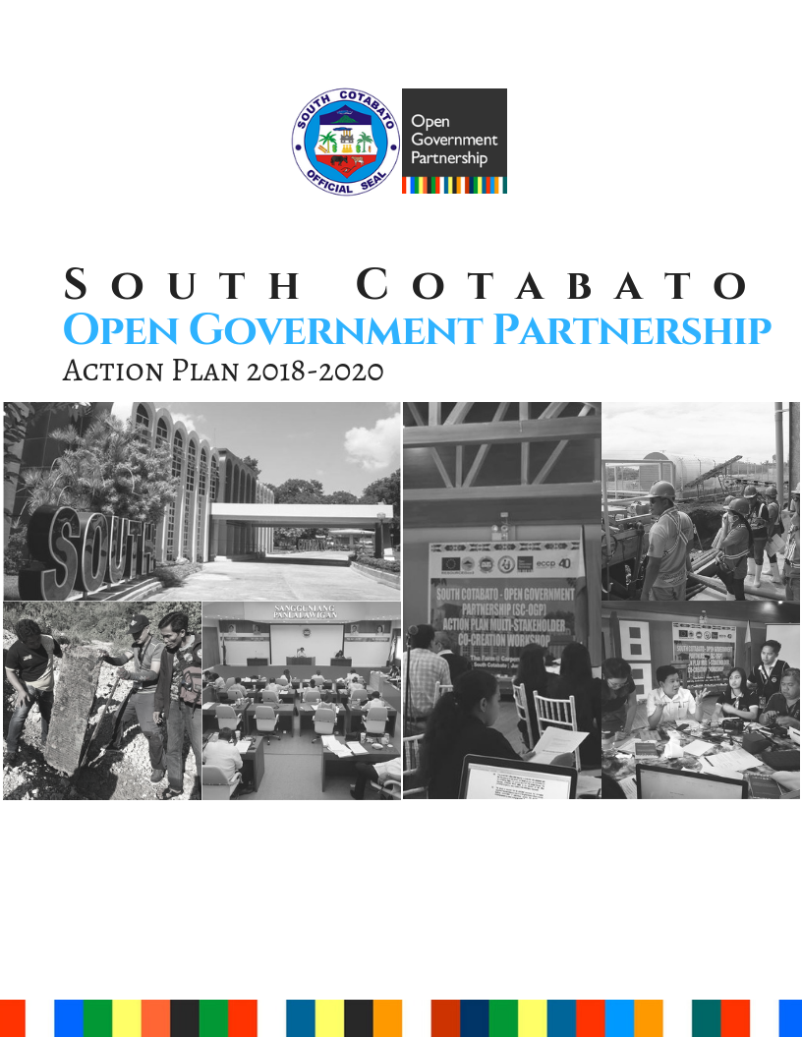

**South Cotabato Open Government Partnership Action Plan (2018-2020)**

**Table of Contents**

|  |  |
| --- | --- |
| *Table of Contents………………………………………………………………………………….……….* | **1** |
|  |  |
| *List of Acronyms…………………………………………………………………………………………...* | **2** |
|  |  |
|  |  |
| Chapter I  **Introduction………………………………………………………………..……** | **3** |
| Chapter II  **Open Government Efforts to Date…………………………………………...** | **3** |
| Chapter III **Action Plan Development Process………………………………………….** | **8** |
| Chapter IV **Commitments…………………………………………………………………...** | **12** |
| 1. *Open Information: Increasing Inclusivity in Public Access to Government Information…………………………………………………….* | **12** |
| 1. *Open Monitoring and Evaluation: Open and Participatory Monitoring For Quality Infrastructure……………………………………………………* | **18** |
| 1. *Open Contracting: Enhancing Efficiency and Transparency of the Public Procurement Process……………………………………………….* | **23** |
| 1. *Open Mining Information: Engaging Citizen’s Participation by Developing EI-TECh (Extractive Industry-Transparency E-system & Channels)……………………………………………………………….……* | **26** |
| 1. *Open Legislation: Establishing Online Channels to Broaden Civic Engagement and Increase Relevance of Local Legislations…………….* | **30** |
|  |  |
| ***List of Tables***  *Table 1. Thematic Area: Open Information……………………………………………..*  *Table 2. Thematic Area: Open Monitoring and Evaluation……………………………*  *Table 3. Thematic Area: Open Contracting………………………...……………………*  *Table 4. Thematic Area: Open Mining Information……………………………………..*  *Table 5. Thematic Area: Open Legislation………………………………………………* | **12**  **18**  **23**  **26**  **30** |
| ***List of Figures***  *Figure 1. South Cotabato’s Good Governance Framework ...................................….*  *Figure 2. South Cotabato’s Integrity Model: The Integrity Web of Institutionalization..*  *Figure 3. Convergence Framework for Poverty Reduction……………………………..*  *Figure 4. Results Framework for South Cotabato’s OGP Action Plan………………...* | **4**  **6**  **7**  **11** |

**LIST OF ACRONYMS**

AIDS Acquired Immunodeficiency Syndrome

BDC Barangay Development Council

CMGP Conditional Matching Grant to Provinces

CPM Critical Path Method

CSO Civil Society Organization

DENR Department of Environment and Natural Resources

DRR-CCA Disaster Risk Reduction and Climate Change Adaptation

ECCP European Chamber of Commerce of the Philippines

EI-TECh Extractive Industry-Transparency E-system and Channels

EITI Extractive Industries Transparency Initiative

EMB Environmental Management Bureau

FOI Freedom of Information

GIDA Geographically Isolated and Displaced Area

HIV Human Immunodeficiency Virus

iSEPPS Interactive Socio-Economic and Programs Profile System

ITU Information Technology Unit

LGU Local Government Unit

LITS Legislative Information Technology System

M&E Monitoring and Evaluation

MFI Mahintana Foundation, Inc.

MGB Mines and Geosciences Bureau

MOOE Maintenance and Other Operating Expenses

MPSA Mine Production Sharing Agreement

MSF Multi-stakeholder Forum

NCIP National Commission on Indigenous Peoples

ODK Open Data Kit

OGP Open Government Partnership

PACCO Provincial Accounant’s Office

PBO Provincial Budget Office

PCOO Presidential Communications Operations Office

PDC Provincial Development Council

PEMO Provincial Environmental Management Office

PEO Provincial Engineering Office

PERT Programme Evaluation Review Technique

PGO-IAS Provincial Governor’s Office-Internal Audit Service

PHILGEPS Philippine Government Electronic System

PIO Provincial Information Office

PLGU Provincial Local Government Unit

PLO Provincial Legal Office

PMRB Provincial Mining Regulatory Board

PPDC Provincial Planning and Development Coordinator

PPDO Provincial Planning and Development Office

PPMC Provincial Project Monitoring Committee

PPMC Provincial Project Monitoring Committee

REM Research, Evaluation, and Monitoring

SCIC South Cotabato Integrity Circle

SDG Sustainable Development Goals

SP Sangguniang Panlalawigan

SPD Special Projects Division

SRMA SOCCSKSARGEN Responsible Miners Association

TMC Tribal Mining Corporation

TWG Technical Working Group

**CHAPTER I**

**INTRODUCTION**

The Province of South Cotabato has become one of the most progressive and competitive provinces in the Philippines. It has been a 4-time awardee on Good Governance (*Galing Pook Award*) that resulted from its efforts in promoting and practicing transparency, accountability, partnership and proper management of resources. All these undertakings are deeply rooted in the belief that good governance as the enabling environment is the key in reducing poverty in the province.

South Cotabato is composed of ten (10) resource-rich and competitive municipalities and one (1) rapidly growing component city, Koronadal, which is also the Provincial Capital and Administrative Seat of Region XII. With an estimated population of 970,000 by the end of 2018 growing at an annual average rate of 1.94%, the provincial government is confronted with bigger challenges that 21st century settlements face today such as persistent poverty, particularly in far-flung communities with rapidly growing population and where more than half of families are below the poverty threshold; disparity of income and growth across the component local government units (LGUs) with the poorest left far behind the economically-primate LGUs; inadequate access to some basic yet important services; forest degradation due to scarcity pressure and encroachment of protected areas; increasing HIV-AIDS cases; and climate change vulnerability and disaster risks, among others.

The people of South Cotabato constantly endeavor to weave together their dreams in order to create a beautiful masterpiece of a home – one they can truly call ‘the Land of the *Dreamweavers’.* This can only be made possible by putting good governance at the core of South Cotabato’s development framework. Hence, in support of the shared vision of a caring, resilient, functionally-integrated, and equitably growing province that is highly responsive to the socio-economic needs and environmental concerns of every self-reliant South Cotabateño, the provincial government is committed in improving its efforts to promote participatory, transparent and accountable governance through open government.

**CHAPTER II**

**OPEN GOVERNMENT EFFORTS TO DATE**

In a country beset by economic, political, social and environmental instabilities and discontinuities, *good governance* has become a compelling agenda. Governance can be defined in various ways and may be viewed from different perspectives. Oftentimes, governance is used interchangeably with government. While definitions may vary, it is important to understand *“governance”* as a set of arrangements – be it systems, traditions, authority and power, or values – necessary to ensure that the affairs of the state are managed for the *“common good”* where intended outcomes for the stakeholders are defined and achieved.

Importantly, development is not only the function of governments in the public sector. Governance points to the dynamism of interactions within and among the ***government or the public sector, the business or private sector and the civil society*** as the major actors of managing the affairs of the state for the common good. However, the question remains, when is there good governance and when is there none?

Hence, taking off from the Philippine’s Good Governance Framework, South Cotabato developed its own Framework for Good Governance showing the relationships between and among the principles of governance focused on the understanding of governance as arrangements necessary for the government, the private sector and civil society to effectively define and achieve intended outcomes for stakeholders. The framework captures the measures of good governance in terms of three (3) components: *1) elements or principles, 2) primary actors, and 3) resulting socio-economic development outcomes.*

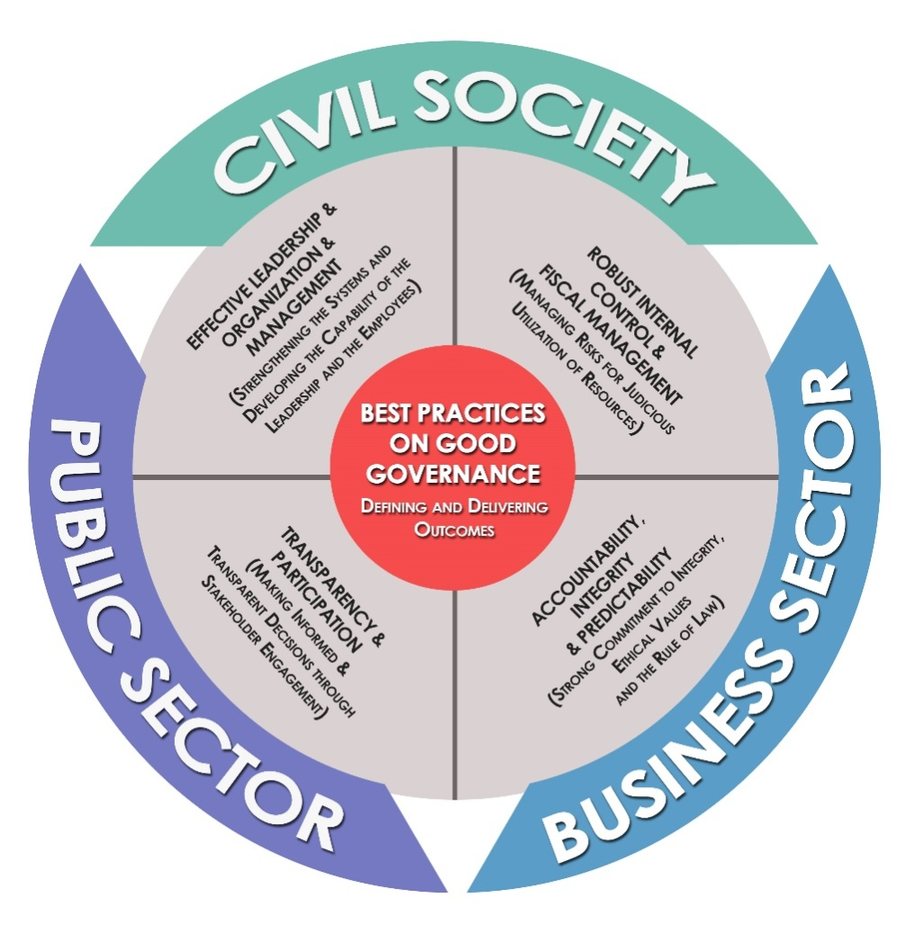

*Figure 1. South Cotabato’s Good Governance Framework*

South Cotabato’s Framework for Good Governance adopts four (4) clusters of principles, referred to as elements of good governance, namely:***1) Effective Leadership & Organization and Management; 2) Robust Internal Control and Fiscal Management; 3) Accountability, Integrity and Predictability; and 4) Transparency and Participation.*** These core principles will serve as parameters in assessing how well good governance is manifested in the province, and in developing action plans for improvement. When all these principles are embodied by all *three (3) actors of governance* – public sector, business or private sector and civil society, good governance will definitely manifest by way of impacts and outcomes to communities in terms of economic, social and environmental benefits. Significantly, awards and recognitions for *best practices in governance* are indicators of achieved developmental outcomes.

Hence, guided by South Cotabato’s Good Governance Framework, the current administration focused the first year of the first term in 2013 on advancing good governance initiatives, in addition to putting in place the development direction of the province for the next 3-6 years. Along this line, the administration has pursued the principle that good governance is fundamental in bringing about change, and in pursuing a kind of development and a brand of leadership that truly matter to people.

Transparency and participation are highly manifested in the province’s primary local special body - the **Provincial Development Council (PDC).** The PDC is a policy–making and primary planning body whose main concern is the overall socio-economic development of the province. It serves as the counterpart of the Regional Development Council (RDC) at the provincial level. The PDC acts as the primary institution that coordinates and sets the direction of all economic and social development efforts in the province. At the same time, the PDC serves as a forum where local efforts can be related and integrated with provincial and regional development activities.

Provincial development planning is necessary to address the uneven economic and social development in the region and in the country. This stems from the recognition that growth and advancement over the years remain unevenly distributed and that progress has been concentrated in a few provinces.

Currently, the PDC is composed of five (5) sectoral committees (economic, social, infrastructure and land use, institutional, environment and DRR-CCA) with representatives from the Civil Society Organizations (CSOs) and local government units and agencies. The civil society has a 48% representation in the PDC, with the Vice Chair coming from the private sector, and the five (5) sectoral committee chairs from the civil society.

The provincial government of South Cotabato has been practicing the basic values and principles of the Open Government Partnership (OGP) through its various mechanisms and initiatives in order to address societal issues, on top of which is poverty reduction. Among these initiatives is the Integrity Program, dubbed as, *“iSouthCotabato or South Cotabato for Integrity and Jobs”*. The overall objective of this project is to contribute in the reduction of poverty through integrity and sustainable creation of jobs.

The province accepted the challenge to be one (1) of the nine (9) pilot local government units in the Philippines to take part of the said program. *iSouthCotabato* is the province’s own version and local adaptation of Project I4J or Partnerships for Integrity and Jobs. The three (3) major strategies and approaches under this Integrity Program are: ***1) the creation of the South Cotabato Integrity Circle; 2) the adoption of the Web of Institutionalization Model in mainstreaming integrity themes in governance; and 3) the conceptualization and development of twenty four (24) Integrity Mechanisms to be implemented in the province.***

The South Cotabato Integrity Circle (SCIC) is the formation of network of friends – representatives of government, businesses, and civil society organizations who are active in the community – who are committed to the ideals of honesty, simplicity and professionalism, and who could contribute good ideas on integrity. By bringing together the network of friends from the local government, the business sector, and the civil society, the Integrity Circle was formed to serve as supervisory and partner body in the integrity and good governance efforts of the LGU by promoting exchanges of best practices and strengthening the implementation, monitoring and evaluation of South Cotabato’s Integrity and Business Promotion Mechanisms.

South Cotabato adopted the Web of Institutionalization Model introduced by Dr. Caren Levy in 1996 as the province’s conceptual framework to mainstream integrity in provincial governance and development. Guided by this framework, the iSouthCotabato TWG designed the Integrity Web of Institutionalization as the province’s Integrity Model where specific sets of mechanisms have been identified for each of the four (4) spheres of the web to ensure successful mainstreaming and institutionalization***: 1) the Citizen Sphere, 2) the Policy Sphere, 3) the Organizational Sphere, and 4) the Delivery Sphere.***



*Figure 2. South Cotabato’s Integrity Model: The Integrity Web of Institutionalization*

Despite what seems like insurmountable challenges especially for the political leadership, South Cotabato remains steadfast in successfully implementing its 24 integrity mechanisms. The SCIC, with its Chairperson, initially meets regularly every other month, and later, on a quarterly basis. Significantly, an overwhelming response from the members of the SCIC representing the business sector and the civil society has fuelled the initial activities of the Integrity Circle despite the lack of approved funding for the integrity program on its first year.

To date, about 92% or 22 of the 24 mechanisms are already either completed or being implemented.

All these initiatives and important accomplishments on integrity made South Cotabato the leading implementer of integrity and business promotion mechanisms among the nine (9) pilot LGUs. It is the first pilot LGU to conceptualize and develop its own Integrity Framework and Integrity Mechanisms following Caren Levy’s Web of Institutionalization Model. Thus, South Cotabato was positioned as the model for other LGUs in Project I4J’s replication phase to 300 more LGUs in the country initiated by Konrad Adenauer Stiftung.

Another initiative of the province in addressing its own poverty issues is the **Convergence Program for Poverty Reduction.** This program focuses on coordinating and consolidating efforts by mainstreaming programs and services of the provincial government and converge towards the achievement of equitable growth and social equity through poverty reduction. Deeply rooted in the principles of good governance, this initiative is a community-driven approach that basically aims to focalize the different programs and services of the provincial government and other public and private organizations in a specific geographically isolated and displaced area (GIDA). Its main strategy is to converge initiatives and resources of both the public and private sectors in order to reduce poverty one *sitio* at a time.

The program consists of seven (7) dimensions of poverty namely: ***1) Livelihood and Employment, 2) Food Security and Nutrition, 3) Health and Sanitation, Reproductive Health, Responsible Family Life and Gender Sensitivity, 4) Environmental and Human Security, 5) Education, 6) Community Empowerment and Participation, and 7) Spatial Integration***. Each dimension is composed of the different departments of the provincial government as well as other partner agencies that provide programs or services relative to their dimension.

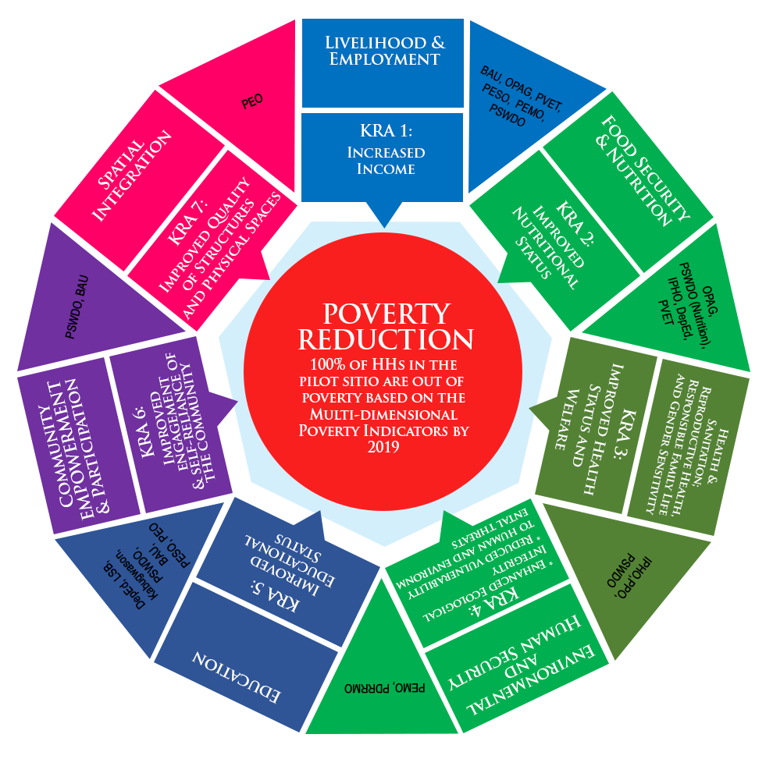

*Figure 3. Convergence Framework for Poverty Reduction*

Sitio Traan Leteng, Barangay Kematu in the Municiaplity of T’boli was chosen as the pilot area for the said program. Currently, it has already expanded to two (2) more areas, namely, Sitio Blit, Barangay Ned and Sitio Datal Ligaw, Barangay Tasiman, both of which are located in the Municipality of Lake Sebu.

All these initiatives for good governance occupy an important place at the core of South Cotabato’s developmental framework. Weaving all these good governance initiatives together with its vision for responsiveness in service delivery, and the mission to promote participatory, transparent and accountable governance are some primary thrusts in transforming the province to become a premier agro-industrial and tourism hub in the region.

By weaving the individual strands of standards, values, and systems that shape the principles and dimensions of good governance, people are indeed weaving their dreams together for a brighter and stronger South Cotabato.

**CHAPTER III**

**ACTION PLAN DEVELOPMENT PROCESS**

The development of the Province of South Cotabato is guided by the shared aspirations of its people for a safe and livable settlement that supports, nurtures, and promotes the sustainable and competitive growth of its city and municipalities. With this developmental direction, the province aims to achieve equitable and rational distribution of population, resources, income and opportunities across its eleven component local government units – small and medium-sized city and towns are supplemented with primary strategies for achieving poverty reduction and social justice. Significantly positioned at the core of the province’s developmental framework is good governance. South Cotabato is committed to promote participatory, transparent, and accountable governance as its primordial purpose towards the realization of its collective dream.

The co-creation of the South Cotabato Open Government Action Plan 2018 – 2020 has been based on this very framework. On May of 2018, four (4) commitments were initially presented during the Open Government Partnership Week Celebration of the OGP-Philippines based on previous discussions and consultations in the Provincial Development Council meetings of South Cotabato. The following were the initial commitments: 1) Open Information, 2) Open Monitoring and Evaluation, 3) Open Contracting, and 4) Open Mining Information.

On June 21, 2018, the provincial government conducted a multi-stakeholder co-creation workshop for the South Cotabato Open Government Partnership Action Plan. The workshop was actively participated in by the members of the South Cotabato Integrity Circle (SCIC), the different partners from the civil society, business sector, and, national and regional government agencies. In addition to the initial four (4) commitments, two (2) thematic areas were introduced by the participants. These commitments are: 1) Open Legislation, and 2) Open Planning and Budgeting. The participants were given the opportunity through a reasoned response process to choose which commitment or commitments they find has the most impact in society. Five (5) commitments were prioritized based on four (4) criteria: a) Relevance to a Priority Governance/ Public Problem or Issue; b) Relevance to OGP Values (Transparency, Accountability, Public Participation, Technology); c) Completion within the AP Cycle (2 years); d) Can be implemented within the existing PLGU-CSO-Private Sector Resources. The five (5) prioritized commitments were: 1) Open Information, 2) Open Monitoring and Evaluation, 3) Open Contracting, 4) Open Mining Information, and 5) Open Legislation. Small group workshops were then done to initially draft these commitments. During the co-creation workshop, it was agreed that the existing Integrity Circle would also serve as the Multi-stakeholder Forum for the OGP. Thus, the SCIC was also oriented on the OGP and the functions and responsibilities that they will also assume as the Multi-stakeholder Forum (MSF). On September 18, 2018, Ms. Ivy Ong of the OGP-Support Unit conducted a more detailed orientation of the functions of the MSF with the SCIC members.

After the OGP Summit in Tbilisi, Georgia, the Point-of-Contact introduced another relevant mechanism that could further ensure the delivery of relevant services and programs to the general public – Open Planning and Budgeting that aims to allocate the amount of P20 Million annually to fund project proposals directly generated from the public through both online and offline voting.

Two (2) consultations meetings/dialogues were then conducted with the SCIC as MSF in order to prioritize the five (5) commitments that will be submitted to OGP for implementation as well as to deliberate further the specific deliverables and milestones of each commitment. During the first consultation on August 2, 2018, a simple voting was made after each of the six (6) initial commitments were presented, with the following results: 1-Open Information, 2-Open Planning and Budgeting, 3-Open M&E, 4-Open Legislation, 5-Open Contracting, 6-Open Mining Information. During the second meeting on August 29, 2018, the initial commitments were further deliberated including the comments from the OGP Support Unit.

In order to ensure grassroots-level consultation and participation in the co-creation process, a multi-sectoral public consultation with the different barangay captains of the province was conducted on August 3, 2018. There were one hundred sixty (160) barangay captains in attendance to the said activity out of the 199 barangays. The OGP, as well as the six (6) initial commitments, were presented to the barangay captains through a “Thematic Area Marketplace” method. A simple voting scheme followed to determine which among the commitments are deemed as more relevant for the community leaders. The following is the result of the voting according to rank: 1-Open Information, 2-Open Monitoring and Evaluation, 3-Open Contracting, 4-Open Planning and Budgeting, 5-Open Legislation, 6-Open Mining Information. The primary reason of the barangay captains for prioritizing last the Open Mining Information commitment is that not all barangays have extractive industries (mining and quarrying) in their respective jurisdiction.

While the commitment on Open Mining Information has consistently ranked last in both the voting conducted with the SCIC members and the village chiefs, further discussions with the lead implementing actors of the commitments lead to the decision of dropping the commitment “Open Planning and Budgeting” from the five priorities to be submitted for the first cycle of OGP implementation (2018-2020). Feasibility of the commitment would require a wide range of manpower for online and offline tasks, tedious process to generate, process and conduct voting of the submitted budget proposals, and sufficient budget to fund the prioritized proposals. Given the time frame of 2018-2020, it would not be feasible to implement the commitment within such period since the Annual Plan and Budget for 2019 was already finalized. Further, ownership of the commitment cannot be handled by a single governing body – either the Provincial Budget Office (PBO) or the Provincial Planning and Development Office (PPDO) cannot take full responsibility in implementing the commitment since PPDO will already be the main implementing office of OGP as the secretariat while PBO cannot solely work for the commitment without PPDO. In addition to its secretariat and coordination functions to the implementation and monitoring of OGP commitments, the PPDO also is the lead implementer for two (2) more commitments – Open Information and Open Monitoring and Evaluation. This absence of a lead implementer that would fully own the implementation of the commitment would hinder the implementation success of the commitment considering OGP’s standards and timelines. However, despite its removal from the commitments to be submitted to OGP, the provincial government will still implement and find ways to pursue this commitment but will lie outside the scope of OGP. The provincial government will still pursue its implementation but outside the set guidelines, standards and timeframe of the OGP since manpower and financial requirements of the commitment will have to be considered.

Since mining is one controversial topic yet in need of rightful actions to be properly understood by the people, it was decided that Open Mining Information will be retained as a commitment. Misconceptions and allegations surrounding the platform of mining lead people to being skeptical on *whats, whys, and hows* of such activity. The Provincial Environmental Management Office (PEMO), as the lead implementer, has the leadership capacity, manpower and resources to ensure the success of the commitment. A co-ownership between PEMO and its CSO partners (EITI, Bantay Kita and BanToxics) in the implementation of the commitment is also already assured. This commitment’s success rate is high and will lead to the resolution of conflicts between the opposing sides of mining. Not only will the people benefit on this but as well as the government, for it can be a platform where discussions and concerns are much welcome than it will be before.

Other commitments that were retained include Open Information, Open Contracting, Open Legislation, and Open Monitoring and Evaluation.

Limited information leads to limited knowledge. Limited access to information is an important and timely issue that needs to be addressed. The general public does not have open access to basic data and information on the provincial government (i.e. SEP). PLGU data are not fully integrated into one database that would be fully available online for easy access. Sometimes, there is also difficulty in gathering data from different offices when there are requests. Giving access to essential and up-to-date data will create an open interaction between the government and the citizens. It will also give way to improve the services and interventions by the government as people will now be aware of their rights to such actions especially those who are living in the remote areas.

Increased engagement of CSOs, business sectors, and most especially the people, will be attained upon the implementation of this commitment. Giving them enough access will be beneficial as they can track the projects and raise concerns met along the way, from planning until the completion of projects. The projects to be conducted can now be done within its time-frame unlike when these are left unchecked. Presentation in a manner where it is easily understood by the people is also the key to the success of the commitment. When done properly this commitment can lead to lasting growth in putting to life significant and timely projects for the people.

Open Legislation was selected as a commitment because it is perceived to be a significant problem that is in need of immediate action. Lack of participation from the citizen in creating and evaluating the policies and ordinances leads to unsuccessful implementation and sustaining of such protocols. Word of the mouth is the most common source of legislative information that results in additional and deducted data; but with this commitment. The public will now have access and participation in formulating and assessing policies and ordinances. Providing an accessible platform for the people will definitely increase their interest to take part in this interactive process that can pave way for a brighter future.

Infrastructure projects sometimes suffer from delayed implementation and completion. There are times when project quality is poor. Ideally, isolated communities should have better access to basic social services while being economically interdependent. Most of these projects are unable to hit the supposed standards and therefore have poor quality. Mobility of people, goods and services should also be improved. During PDC meetings, the Provincial Project Monitoring Committee (PPMC) raised a number of issues concerning project implementation. If only access to project monitoring results would have been done in real-time, such issues would have been resolved. Hence, there became a need to keep the Open Monitoring and Evaluation commitment to resolve such problem. Public access to near real-time project monitoring results will significantly reduce incidence of poor implementation of projects. The public can also give feedback and comments on infrastructure project status. Improved collaboration will help address issues faced in project implementation. Findings and recommendations will be publicized for better accountability.

The planning process for South Cotabato’s OGP Action Plan can be best described as iterative so that through a continuous cycle of consultation-implementation-evaluation-replanning/improvement, the plan is continually revisited during the implementation phase until it comes closer to realizing the desired development results through the OGP principles. During the first year of implementation of the OGP Action Plan, the regular monitoring and assessment activities being conducted during the implementation phase required the revision and improvement of the plan. The change in political administration, hence development priorities, also necessitated the review and revisiting of the commitments and their specific milestones. These improvements include the expansion of CSO and other implementing partners to facilitate more participatory implementatioin and increase implementation success rate; introduction of additional milestones specifically the livestreaming of the Sangguniang Panlalwigan (legislative body) sessions under the Open Legislation commitment as an initiative to open its proceedings to the public through social media; revision of name of a milestone to adjust to the change in political leadership; and adjustments in target dates to make the timeframes more realistic.

Importantly, in response to the Call to Action for a More Inclusive OGP during the Ottawa Summit, an assessment of the milestones was done to make the commitments more inclusive and mainstream gender into these commitments. Concrete actions to advance women’s participation and gender-sensitive commitments have been considered in the assesment and revisiting of commitments. The selection of CSO members in the reconstituion of the South Cotbato Integrity Circle (SCIC) as a Multi-stakeholder Forum (MSF) will also take cognizant of the need to expand membership to organizations working on women or girls, or represented by women. The process will proactively encourage women’s organizations and women leaders to become members of the MSF.

Significantly, the participatory process of co-owning and co-creating the commitments across five (5) thematic areas and of identifying the specific deliverables for each commitment is always anchored on South Cotabato’s Good Governance Framework and Convergence Framework for Poverty Reduction as illustrated in the Results Framework for OGP (Figure 4). These frameworks guide the planning, implementation, monitoring and evaluation of all services, programs and projects of the provincial government as a public sector entity with the ultimate goal of promoting inclusive growth and reducing poverty among its people. In effect, all strategic interventions in the provincial government, as in any public sector agency, is focused on effecting tangible results and impacts to our people measured in terms of reduction in poverty incidence.

**OPEN INFORMATION**

**OPEN MONITORING & EVALUATION**

**OPEN CONTRACTING**

**OPEN LEGISLATION**

**OPEN MINING INFORMATION**

* 2 offline transparency and feedback initiatives conducted regularly *(Estoryaha si Gov and Provincial Townhall Meetings with Brgy. Captains & Grassroots Sectors )*
* 1 interactive/web-based iSEPS developed and functional
* 1 Provincial FOI Ordinance emacted or EO issued
* 1 ODK-based project monitoring system installed and utilized by PPMC
* 1 PLGU Website / FB Page and Provincial Online Database updated
* Near real-time posting of 100% of PPMC ODK-based monitoring reports
* PPMC membership expanded to include Barangay Captain, BDC-Infra Chair and BDC Private Sector Rep of project host communities
* 100% of BAC members, TWG and accredited CSOs capacitated on RA 9184
* 1 provincial procurement internal policy developed
* 100% of procurement data are processed to become user-friendly and documents are machine-readable
* Integrated EITI standards into PEMO monitoring and reporting forms/mechanisms
* 1 PEMO extractive industries database updated and linked into the Provincial Online Database
* 1 pool of trained community/grassroots experts trained
* Gold trading transparency systems and standards developed and

institutionalized thru PMRB resolution

* Strengthened policies on mining governance adopted by the PMRB
* 1 Ordinance institutionalizing the Open Legislation Commitment passed
* 1 SPO Official FB page established and linked to the Provincial Online Database
* 1 LITS developed, deployed and linked to the Provincial Online Database
* 1 Legislative Feedback Review Committee organized and functional

Empowered people thru increased inclusivity in public access to right government information

Fast and on-time completion of infrastructure projects resulting in faster delivery of public goods and services thru strengthened participation & transparency in the project monitoring process

Faster implementation of infrastructure projects resulting in faster delivery of public goods and services thru enhanced efficiency and transparency of the procurement process

Improved revenue collection and socio-cultural and environmental protection in the impacted areas thru enhanced transparency and increased participation in the extractive industries

Relevant and effective local legislation thru broadened online civic engagement

**INPUTS & PROCESSES**

**OUTPUTS**

**OUTCOMES**

**IMPACT**

**CHAPTER IV**

*Figure 4. Results Framework for South Cotabato’s OGP Action Plan*

**COMMITMENTS**

|  |  |  |  |  |  |
| --- | --- | --- | --- | --- | --- |
| **Commitment Template** | | | | | |
| Thematic Area: Open Information | | | | | |
| **1. Increasing Inclusivity in Public Access to Government Information** | | | | | |
| 31 August 2018 – 31 August 2020 | | | | | |
| Lead Implementing Agency/Actor | Provincial Government of South Cotabato – Provincial Information Office | | | | |
| **Commitment Description** | | | | | |
| *What is the public problem that the commitment will address?* | Among other factors, limited access to government information greatly hampers the delivery of the right services and interventions that would respond to the real needs of the people. Having access to the right information has a direct and reinforcing relationship in ensuring the delivery of the right interventions and services to the public. For instance, having limited access to the right information from government, the public tends to get these information from secondary sources that are not always right, hence, they only get to access services or projects that they “think” are only available for them even if these are not relevant to address their real needs. Similarly, many remote communities without access to radio, television, internet or other means of communication have limited knowledge on government data, projects and services that could help empower them to become self-sufficient.    Similarly, while the provincial government has the relevant programs and information to bring about lasting results and achieve economic progress to reduce poverty at the household level, many households at the far-flung and remote areas have limited knowledge of government interventions, and on how these can be accessed and maximized to improve the quality of their lives. In addition, there is also limited formal mechanisms for providing feedback on government services and programs.  Currently, the general public is able to access provincial government data by requesting through the Provincial Planning and Development Office (PPDO) or directly through the concerned department or office supported by a written letter of request. For walk-in clients, requests are being recorded though a Logbook. The Socio-economic Profile of the province is also available through a provincial government published book that can be bought at a very affordable price. Due probably to the inconvenience in accessing information and limited knowledge on how to access the information, only 83 formal requests for data were made through the PPDO in a period of five (5) years from 2014 to date where 72 of these or 86% have been provided by the PPDO while the remaining 11 have been referred to appropriate offices. Further, in a rapid survey conducted by the Provincial Information Office during the first quarter of 2018 on Audience Research and Listenership in South Cotabato, about 42% of the 7,252 sample respondents in the entire province (with a projected population of 969,599 in 2018) listen to the radio everyday while about 27% do not own a radio or has no access to other means of communication. Out of the 42% who listen to the radio, almost half or 47.29% are not aware of, hence, are not listening to the provincial government’s radio program where the local government’s programs, projects and services are being broadcasted for public information. About 81% of those who listen to the provincial government’s radio program feel that it is a good source of information about the programs and projects of the province. Among the reports in the radio program, the top 6 information that the respondents find useful are on agriculture, health and sanitation, social services, education and scholarships, barangay/sitio assistance and livelihood programs. It is also useful to note that aside from radio, people get much of their information on government programs and services from other people or through word of mouth (22.53%) and through barangay announcements (22.37%).  Ultimately, it is hoped that increased access to government information through both online and offline channels will significantly contribute in further reducing poverty incidence in the province recorded at 19.8% in 2015, especially in the geographically-isolated and disadvantaged communities. | | | | |
| *What is the commitment?* | The commitment aims to establish both online and offline channels to expand public access to government information, and to enable citizens to give feedback on government programs and services.  More and improved quality of information will be disclosed to include not only those required under the Philippine’s Full Disclosure Policy and basic data on the socio-economic profile of the province, but also information on programs/projects/ services and project monitoring reports. It entails the development of an interactive supply-driven online platform for the general public to access, view, save and print government data and information on programs and services right at their homes free of charge, with a special feature for the general public to provide their feedback on government services and programs. Part of the commitment includes the conduct of workshops to develop a mechanism for responding to feedbacks from the public. To further utilize the information from the processed feedbacks, the commitment shall be expanded in the second cycle for the feedbacks to inform development planning, budgeting and program implementation.  The commitment also entails localizing the national government’s Freedom of Information (FOI) policy through a provincial ordinance, institutionalizing the people’s right to information, or through an Executive Order to be issued by the Local Chief Executive.  As an offline mechanism, a direct community participation program shall be launched for communities without access to internet, where the citizens’ questions to the Governor will be recorded during the weekly conduct of the Outreach Program to poor and remote communities where the provincial government brings some of its services directly to the communities, and the Governor’s responses to these questions will be recorded and aired through the province’s official radio program on a weekly basis and on a specified date that will be announced to the community. Capability-building and public engagements shall be conducted to popularize the people’s right to information and how to access these information. | | | | |
| *How will the commitment contribute to solve the public problem?* | The development of the interactive online platform for people to access government information and communicate their feedback/opinion on public services right at their homes, which will be further advanced by the enactment of the FOI ordinance or issuance of Executive Order on FOI, will provide the people with the right information they need for better decision-making for their economic, social, and institutional development. The commitment will also ensure that the feedback loop is closed by designating a staff who would immediately respond to comments or by coordinating with the appropriate offices in addressing the communicated feedbacks in order to help improve public services and influence government decisions. Further, through public consultations during the regular conduct of the Provincial Outreach Program in the different villages, questions and messages of the citizens especially from remote communities without access to internet shall be recorded and responded to by the Governor through the radio, in addition to posting the responses through South Cotabato’s Facebook Page and the OGP Facebook Page. Increased inclusivity for access to right information will engage and empower people at the grassroots. | | | | |
| *Why is this commitment relevant to OGP values?* | * Increased inclusivity in public access to government information is relevant to **transparency**. * The commitment shall employ **technology** through the development of an interactive online system for the public to access information right at their homes. * **Gender and inclusion** are promoted in some of the milestones. | | | | |
| *Additional information* | President Rodrigo R. Duterte issued Executive Order No. 02 (series of 2016) or the Freedom of Information Order to institutionalize the people’s right to information as enshrined in Article III of the Philippine Constitution on the Bill of Rights. This operationalizes in the Executive Branch the people’s constitutional right to information and state policies to full public disclosure and transparency in public service. Freedom of Information or FOI is part of the 2017-2022 Philippine Development Plan under "Ensuring People-Centered, Clean, and Efficient Governance" specifically on “Subsector Outcome 4: Citizenry fully engaged and empowered”.  The commitment localizes the Freedom of Information (FOI) by passing the Provincial FOI Ordinance or issuing the FOI Executive Order and making information accessible through both online and offline platforms, expanding it to include not only demand-driven information but makes readily accessible all available data and information on the provincial government programs and services.  Hence, the Presidential Communications Operations Office – the lead agency for the implementation of Executive Order No. 02, is the lead partner of the provincial government in the implementation of this commitment, particularly in terms of providing both technical guidance and financial assistance.  The commitment will contribute to all the 17 SDGs but particularly on Sustainable Development Goals 1 (No Poverty), 2 (Zero Hunger), 3 (Good Health and Well-being), 4 (Quality Education), 5 (Gender Equality), 6 (Clean Water and Sanitation), 10 (Reduced Inequalities) and 17 (Partnerships for the Goals). | | | | |
| **Milestone Activity with a Verifiable Deliverable** | | **Responsibility** | **Source of Fund** | **Start Date** | **End Date** |
| 1. Roll-out of *“Estoryaha si Gov”,* an offline transparency initiative where the Governor will regularly respond to recorded questions from the general public especially from remote communities) through the radio as well as through South Cotabato’s Facebook Page and OGP Facebook Page. Special attention will be provided to getting the issues and concerns of women and women groups, IP groups and farmer groups in communities. | | Provincial Information Office | PGO-PIO | July 2018  *Note: The activity will be suspended during the campaign and elections period.* | August 2020 |
| 1. Conduct of workshop on information management and needs for producers, users and custodians.  * Identify data/information for disclosure, information that are part of the exceptions in the Data Privacy Act should be included in the agenda. * Specify mechanisms to ensure that feedback mechanism is established for the delivery of programs and services, and to ensure that these are immediately responded to for enhanced public service delivery. * As far as practicable, data shall be gender-disaggregated. | | Provincial Information Office (PIO) | PGO | November, 2018 | November 2018 |
| 1. Development and operationalization of the primarily supply-driven Interactive/Web-based Database where the public can access, view, save and print provincial data and information right at their homes. This web-based automated system will be called Interactive Provincial Online Database (iPOD). This shall be the Central Provincial Online Database that will link into one platform the iSEPS, the provincial government programs and services, and the other four (4) online systems of Open Contracting, Open Monitoring, Open Mining and Open Legislation.  * This includes system programming, encoding of socio-economic profile data and digitization of other PLGU documents and records to make them machine-readable based on the workshop outputs. * Information on citizens’ data needs and government programs/ projects/ services, plans and budget, procurement, financial, legislative, etc. shall be prioritized. | | PPDO-ITU, DICT, PCOO, PPDO-REM | PPDO, DICT, PCOO, HIVOS | January 2019 | December 2019 |
| 1. Conduct of consultation and updating of provincial government services and programs with the 199 barangay captains and other grassroots-level sectoral groups (women, IPs, farmers) through the *“Provincial Townhall Meetings”* at least once a year. | | PGO-BAU / PGO-PIO / PPDO-SPD | PGO | August, 2018 | December 2020 |
| 1. Enactment/Passage of Provincial Freedom of Information (FOI) Ordinance or Issuance of Executive Order FOI by the LCE  * Conduct Multi-stakeholder fora on the proposed FOI Ordinance (c/o Hivos) | | Presidential Communications Operations Office (PCOO), Sangguniang Panlalawigan Office (SPO) and Office of the Vice Governor | Office of the Vice Governor/ SPO | October, 2018  September, 2019 | December 2018  September, 2019 |

|  |  |  |
| --- | --- | --- |
| **Implementing Actors** | | |
| *Lead Implementing Office/ Agency/ Organization* | | Provincial Government of South Cotabato-Provincial Information Office (PGO-PIO)  Ms. Hydee Templonuevo, OIC-PIO  c/o Ms. Annaliz Cabrido  +6383-2283025 |
| *Other Actors Involved* | *PLGU / Government actors* | Presidential Communications Operations Office (PCOO)  Assistant Secretary Kristian Ablan  c/o Ms. Michelle Manza  +639177935871 / michellemanza@gmail.com  Department of Information and Communications Technology  c/o Christian Olan R. Dorado  +639466747784 / +639759157230  christian.dorado@dict.gov.ph  All Departments of the PLGU, Provincial Federation of Barangay Captains, Department of the Interior and Local Government – Provincial Office, Philippine Information Agency XII, Provincial Governor’s Office-Barangay Affairs Unit |
|  | *CSOs, private sector, multilaterals, working groups* | Tri-media Association of South Cotabato, Social Action Center-Diocese of Marbel, OND Hesed Foundation, Civil Society Organization (CSO) and business sector members of the South Cotabato Integrity Circle (SCIC), |

|  |  |  |  |  |  |  |  |
| --- | --- | --- | --- | --- | --- | --- | --- |
| **Commitment Template** | | | | | | | |
| Thematic Area: Open Monitoring and Evaluation | | | | | | | |
| **2. Open and Participatory Monitoring For Quality Infrastructure** | | | | | | | |
| 31 August 2018 – 31 August 2020 | | | | | | | |
| Lead implementing agency/actor | | Provincial Government of South Cotabato – Provincial Project Monitoring Committee (PPMC) | | | | | |
| **Commitment Description** | | | | | | | |
| *What is the public problem that the commitment will address?* | | Annually, the Provincial Government of South Cotabato is implementing development projects, which consist of both infrastructure and non-infrastructure projects, sourced from both local funds as well as funds from the national government. Infrastructure projects normally get the big chunk of the budget pie. However, many infrastructure projects suffer from delayed implementation and completion, poor quality, hence, poor utilization of funds. In 2017, the provincial government was able to complete only about 4.10% or 5 out of 122 local development projects at the end of the budget year, which resulted in slow or poor utilization of funds at the end of the year.  The Provincial Project Monitoring Committee (PPMC) of the provincial government, composed of members from the provincial government and the Civil Society Organizations (CSOs), conducts quarterly monitoring of infrastructure projects with more than -15% slippage or way behind schedule as per PERT-CPM. Thus, monitoring of these projects should be regular, efficient, transparent, and participatory. However, the public has no diorect access to monitoring results. The results of the monitoring are only confined to the members of the PPMC and to the Provincial Development Council (PDC) during PDC meetings. These are usually presented to the PDC one full quarter (3 months) after the conduct of monitoring. While the PDC is represented by accredited CSOs, not all CSOs are informing their members of the status of the projects. As such, there is no way the general public will know the real time status of the projects since the monitoring results are not posted or available online for public comment/feedback immediately after the conduct of inspection. With this, the public has limited opportunity to provide feedback on the actual status of the projects (e.g. delayed implementation, poor quality of materials or poor utilization of funds) or if the recommendations as reflected on the monitoring results are implemented/acted upon by the concerned agencies.  These issues in the monitoring and implementation of infrastructure projects hinder the immediate delivery of intended results and outcomes to the intended beneficiaries especially in improving mobility of people, goods and services, increasing access of lagging, poverty-stricken and geographically isolated rural communities to basic social services, and supporting the economic inter-dependencies between the rural and urban communities. Ultimately, realizing these expected results/outcomes would contribute in further reducing poverty of the 19.8% families or about 43,000 families below the poverty threshold based on the 2015 Census. | | | | | |
| *Main Objective* | | The commitment aims to strengthen transparency and participation in the project monitoring process. | | | | | |
| *What is the commitment?* | | The commitment involves making the monitoring results of the Provincial Project Monitoring Committee (PPMC) more open and accessible to the general public by posting these for the general public to provide feedback/comment and/or access the monitoring results. This entails posting the monitoring results to the provincial government website the day after the conduct of the quarterly monitoring of the PPMC in order to provide near real-time status of projects to the public. With this, the PPMC shall adopt the Open Data Kit (ODK) or mobile-based project monitoring system for near real-time monitoring of projects. The commitment also involves updating the website of the provincial government as well as its Facebook page for posting and/or accessing of project monitoring results by the public for feedback/comment/recommendations. The general public will also have the opportunity to upload pictures of on-going projects in their communities and post status of these projects online. The commitment will also cause the enhancement of the monitoring process and composition of the PPMC to strengthen engagement of the public or the directly impacted communities. If relevant to the projects being monitored, grassroots sectors such as women, IPs, and farmers may be invited and consulted during the scheduled inspections. | | | | | |
| *How will the commitment contribute to solve the public problem?* | | The commitment will provide a wider space for citizens, CSOs and disadvantaged sectors (women, IPs, farmers) to collaborate with the provincial government to address issues on project implementation such as delays, poor quality of projects and poor utilization of funds. Participation in this process will allow the public (citizens or CSOs) to provide feedback to improve project implementation. As the monitoring findings and recommendations are made public, contractors and concerned government officials will be held accountable for the project delays or slippages or for non-compliance of other concerned agencies/sectors to the recommendations in the report. In line with this, the existing grievance redress mechanism/s (e.g. blacklisting of contractors or filing of cases) of the province will be strengthened to ensure accountability | | | | | |
| *Why is this commitment relevant to OGP values?* | | The commitment is consistent with the OGP values of promoting **transparency, accountability, civic participation and technological innovations** at the sub-national / local government level, as well as with the call to be **more inclusive and gender-sensitive.** It will make the local government and the project contractors more inclusive, open, accountable, responsive and efficient in project implementation and monitoring. | | | | | |
| *Additional information* | | The EU-funded RESOURCEGov2 Project, implemented by Mahintana Foundation, Inc., has been using transparency tools/technologies, such as Open Data Kit (ODK) in project monitoring. The project has published a documentation on replicable practices on good local governance highlighting the use of ODK in increasing transparency, accountability and CSO participation in project monitoring of locally-funded projects of LGUs. The Mahintana Foundation, Inc., through the RESOURCEGov2 project will be providing technical and financial assistance in the implementation of this commitment.    The improved quality of infrastructure projects will increase rural-urban integration, support economic growth and improve access of the poor to basic socio-economic services as health, education and livelihood development. Hence, this commitment supports the achievement of all the sustainable development goals, particularly goals number 1-10 and goal number 17 on partnerships for the goals. | | | | | |
| **Milestone Activity with a Verifiable Deliverable** | | | | **Responsibility** | **Source of Fund** | **Start Date** | **End Date** |
| 1. Conduct Users’ Training, install and operationalize the ODK-based project monitoring system.   * *The training will be conducted/supported by Mahintana Foundation, Inc., through EU-funded RESOURCEGov project and will be participated by all members of the Provincial Project Monitoring Committee (staff from PLGU and CSO representatives)* * *ODK is a user-friendly mobile-based monitoring platform which non-programmers can easily learn. Android phones/tablets (commonly used by many) are used for ODK-based monitoring.* | | | | Mahintana Foundation, Inc. | RESOURCEGov | September, 2018 | December 2018 |
| 2. Update the website/page or Facebook page of the provincial government/SC-OGP to allow posting of and/or accessing of project monitoring results by the public for feedback. | | | | PIO, PPDO-ITU, ECCP | ECCP | September, 2018 | June, 2019 |
| 3. Conduct ODK-based project monitoring of locally-funded infra projects at least once every quarter.   * *The locally-funded infra projects that will be monitored quarterly will be those projects with more than -15% slippage. The amounts of projects are based on the Annual Investment Program (CMGP).* | | | | PPMC,  PEO, PPDO-REM, PPDO-SPD, | PLGU | December, 2018 | September2020 |
| 4. Post monitoring results at the provincial government website and/or Facebook page for public access and feedback (online posting of results the day after the conduct of quarterly monitoring inspection).   * *As designed/by default for ODK portal at provincial government website/page, monitoring results can be presented/viewed in charts/graphs, maps and/or tables/spreadsheets and can be accessed/downloaded by the public through xls, csv, zip and kml formats.* | | | | PPDO-REM, PPDO-SPD, PPMC | PLGU | August, 2019 | September 2020 |
| 5. Expand CSO membership and public participation to the PPMC through the participation of the Barangay Chairman, BDC-Chair of Infra and Grassroots-level basic sectors such as women, IPs, and/or farmers during the monitoring/inspection where the project is located.   * *Expand CSO Membership in the PPMC to include CSO working on women or represented by women leaders/heads thru an Executive Order.* * *Aside from the usual members of the PPMC (PLGU staff and CSO representatives), the PPMC will invite the barangay chairmen, BDC Chair on Infra and BDC grassroots-level sector representatives to participate in project monitoring where the infra projects are located in their respective barangays. This is to ensure that the monitoring process will be more transparent and inclusive and that their feedback will be considered and responded to.* | | | | PPMC | PLGU | February 2019 | September, 2020 |
| **Implementing Actors** | | | | | | | |  |
| *Lead Implementing Office/ Agency/ Organization* | | | Provincial Government of South Cotabato – Provincial Project Monitoring Committee  Mr. Eleazar Abellera – PPMC Head Secretariat  +639177909564  c/o Hazel Jace Rhudy – PPMC Secretariat  +6383-2286323 | | | | |  |
| *Other Actors Involved* | *PLGU / Government Actors* | | PEO, PPDO-REM, PPDO-ITU, PIO, PBO, PLO | | | | |  |
| *CSOs, private sector, multilaterals, working groups* | | Mahintana Foundation, Inc.,  Martiniano L. Magdolot  +639173059060  c/o Roel Ian P. Blanker, Project Manager  +639171085401 / rpblanker@gmail.com  South Cotabato Integrity Circle, Regional/City/Municipal Project Monitoring Committees | | | | |  |

|  |  |  |  |  |  |  |  |
| --- | --- | --- | --- | --- | --- | --- | --- |
| **Commitment Template** | | | | | | | |
| Thematic Area: Open Contracting | | | | | | | |
| **3. Enhancing Efficiency and Transparency of the Public Procurement Process** | | | | | | | |
| 31 August 2018 – 31 August 2020 | | | | | | | |
| Lead implementing Agency/ Actor | | Provincial Government of South Cotabato – Bids and Awards Committee | | | | | |
| **Commitment Description** | | | | | | | |
| *What is the public problem that the commitment will address?* | | In 2017, the provincial government was able to complete only 4.10% or 5 out of 122 development projects funded under the 20% Local Development Fund at the end of the budget year as reported in the Audit Observation Memorandum issued by the Commission of Audit in 2018. Most of the projects that are still on-going or not started are infrastructure projects. Among other factors, the delayed completion of infrastructure projects (slippages) may also be attributed to issues on the procurement process such as limited number of quality suppliers/contractors participating in bids and delayed response to concerns of contractors.  While the provincial government has disclosed 100% of the bidding documents required by law through the Philippine Government Electronic System (PHILGEPS), its website and in three conspicuous places, these, however, cannot be accessed in machine-readable or editable formats by the public. These technical documents are also not presented in a manner that would be interesting or easier for the general public to understand or utilize. Hence, the limited transparency of procurement documents further contributes to the identified procurement issues. There is also a limited number of capacitated CSOs and business sector representatives who can participate as observers in the bidding process as required by law. In fact, despite the issuance of invitations, there have been no Observer from the CSOs or bsiness sector during the regular bidding processes.  If not addressed, these delays will continue to hinder the timely achievement of expected results for the intended beneficiaries such as increased mobility of people and goods, improved access to basic social services, and strengthened rural-urban integration. | | | | | |
| *What is the commitment?* | | The commitment aims to make the public procurement process more efficient and transparent, and the procurement data more useful/readable and gender-sensitive, through the development of online and offline open contracting mechanisms, such as:   * tracking system to be made available to the public; * conduct regular market survey; * integrated internal process from planning to implementation; * expansion of capacitated accredited CSOs as observers; * proactive capacity building of CSOs as observers; * submission of observer’s report; * improvement in publication of procurement documents; * establishment of procurement feedback mechanism; and * gender-tagging of women-owned businesses joining biddings or awarded with contracts. | | | | | |
| *How will the commitment contribute to solve the public problem?* | | Making the procurement process more open, efficient and inclusive will enhance the capacity of the provincial government to implement quality infrastructure projects as scheduled, and consequently, deliver effective and efficient services to the public. The improved quality of procured goods and services will increase local competitiveness and accelerate local economic growth.  The improved procurement process will enhance the quality of infrastructure projects and ensure the timely implementation of these projects for socio-economic growth, hence, contribute in the achievement of all SDGs, particularly goals number 1 (No poverty), 5 (Gender Equality), 9 (Industry, Innovation and Infrastructure) and 17 (Partnerships for the Goals). | | | | | |
| *Why is this commitment relevant to OGP values?* | | * CSO **participation and disclosure of documents (transparency)** will enhance the integrity of the procurement process. * **Technology** will be used as a medium to enhance transparency & promote efficiency in procurement. * The commitment will encourage the public to provide feedback & participate in the government procurement processes. It will increase and enhance government response to citizens’ feedback. * **Gender-smart** procurement will also be advanced by tagging women-owned businesses participating and getting contracts in the procurement process. | | | | | |
| *Additional information* | | The Province of South Cotabato with the support of the European Chamber of Commerce of the Philippines (ECCP) conducted a series of consultation and focus group discussions with the contractors, Bids and Awards Committee, business sector and CSOs on how to improve the procurement process of the Province last June 2018. Among the major results are the need to improve its efficiency and transparency.  The commitment will be implemented by the provincial government, in partnership with the European Chamber of Commerce in the Philippines (ECCP) (funded by Hivos Philippines) and the South Cotabato Integrity Circle (SCIC), formalized through a signed Memorandum of Understanding. Under the Open Contracting project of the ECCP in South Cotabato, the ECCP shall assist in the co-creation process and implementation of the integrity commitment under the Open Procurement Framework as well as design the monitoring and feedback system for the full and effective implementation of the open procurement commitment. | | | | | |
| **Milestone Activity with a verifiable deliverable** | | | **Responsibility** | | **Source of Fund** | **Start Date** | **End Date** |
| 1. Conduct capability-building on RA 9184 and consultations with BAC Members, BAC-TWG and CSOs. | | | ECCP | | ECCP / Hivos | May 2018 | June 2018 |
| 1. Develop an internal policy through an Administrative Order that will be an input to the Provincial Procurement Manual as well as a Procurement Feedback Mechanism to enhance efficiency and transparency in the procurement process. | | | ECCP / BAC | | ECCP / Hivos | Sept 2018 | March 2019 |
| 1. Increase number of capacitated CSOs and business sector monitoring the procurement process from planning to implementation. | | | ECCP | | ECCP / Hivos | February 2019 onwards | |
| 1. Upload procurement documents from planning to implementation in machine readable format.  * Includes gender-tagging of women-owned businesses joining biddings or awarded with contracts. | | | ECCP | | ECCP / Hivos | February 2019 onwards | |
| **Implementing Actors** | | | | | | | |  |
| *Lead Implementing Office/ Agency/ Organization* | | | | Provincial Government of South Cotabato – Bids and Awards Committee (BAC)  Mr. John Magbanua  +63832289951 / bacpgsc2016@gmail.com | | | |  |
| *Other Actors Involved* | *PLGU / Government actors* | | | Provincial Administrator’s Office, PBO, PEO, PACCO, PTO, PGSO, PPDO, PLO, PIO, PGO-IAS | | | |  |
| *CSOs, private sector, multilaterals, working groups* | | | ECCP  Ms. Zyra Fastidio  zyra.fastidio@eccp.com  Hivos, SC Chamber of Commerce, SC Contractors Association, SCIC, Philippine Chamber of Commerce and Industry | | | |  |

|  |  |  |  |  |  |
| --- | --- | --- | --- | --- | --- |
| **Commitment Template** | | | | | |
| Thematic Area: Open Mining Information | | | | | |
| 1. **Engaging Citizen’s Participation by Developing EI-TECh (Extractive Industry-Transparency E-system & Channels)** | | | | | |
| 31 August 2018 – 31 August 2020 | | | | | |
| Lead implementing agency/actor | | Provincial Government of South Cotabato – Provincial Environment Management Office | | | |
| **Commitment Description** | | | | | |
| *What is the public problem that the commitment will address?* | | Inadequate access to and misinformation regarding the mining and quarry activities equate to revenue losses, environmental degradation and social conflicts. Oftentimes, communities in nearby illegal mining and quarrying activities would presume the regularities of these operations until such time when these communities have already been directly affected by the social and environmental impacts of these practices or if the illegal quarry and mining operators have been apprehended by the authorities. In fact, the province’s annual extractive industry report shows that 3-5% of the total collection of the provincial government is generated from fines and penalties from apprehensions of illegal mining and quarrying averaging at least five (5) incidents per month.  Aside from limited manpower of the provincial government to monitor these illegal activities, citizens’ participation in monitoring and reporting illegal extractive activities in their communities is low because they either lack access and capacity to understand information on mining and quarrying activities or they just simply lack the information on how and where to lodge or channel their complaints.    Further, majority of the citizens lack appreciation on extractive industry information because figures are not translated into something they can relate to or something that has of importance to them, for instance, information on whether the quantities of production/extraction are converted into tangible incomes or benefits to the host communities. This is further aggravated by issues relative to the degradation of the environment and conflicts in the application of mining and quarrying rights.  Presently, there are more or less 40 quarry operators with regular and special permits operating in the province. Further, there are two (2) declared “Minahang Bayan” or legal Small Scale Mining areas with more or less sixty (60) active tunnels in the Municipality of T’boli. These small-scale mining areas are mostly home to Indigenous Peoples called the Tbolis. These areas are also situated inside the Mine Production Sharing Agreement (MPSA) contract area of Tribal Mining Corporation (TMC), a large scale mining company. The mining and quarrying industry in the province generated about P21 Million in 2017 consisting of taxes, fees and permits, and fines and penalties. From this total collection, the host municipalities and barangays, which are dominantly IP populated for mining areas, will have a share from the tax revenues from mining and quarrying of about P19 Million.  Transparency with regards to taxes paid, land disputes, mining and Indigenous People’s rights are among the common source of conflicts and issues in the area. These issues are all forwarded to the Provincial Mining Regulatory Board (PMRB) with merely five (5) mandatory members, one of which is a CSO representative, discussing and trying to resolve these conflicts. | | | |
| *What is the commitment?* | | The commitment would be focusing on policy development and creation of transparency e-systems and channels (EI-TECh) to further engage citizens to participate in mining governance, hence, advance inclusion especially of the minority cultural groups in the mining areas. Access to mining and quarry information will be enhanced through the online mining portal that will be developed and linked to the provincial government website, Interactive Provincial Online Database (iPOD) and social media, among others, to help promote public interaction. Stakeholder consultation will be conducted as to what data are of public interest, relevance and appeal that would need to be disclosed. CSO and general public participation in the Provincial Mining and Regulatory Board (PMRB) or in other local special bodies of the provincial government will be expanded to include grassroots or impacted community participation. Transparency initiatives, incentives and branding (Compassionate Gold) will be institutionalized through a Provincial Mining Regulatory Board Resolution. | | | |
| *How will the commitment contribute to solve the public problem?* | | Through technology- and participatory-driven online portals, standards, channels and branding, there will be increased disclosure on social, environmental, and economic information, hence, strengthen public awareness and involvement on decision-making related to the extractive industries. This will result in increased access to information and grassroots participation in mining governance particularly of Indigenous Communities where small-scale mining areas are usually located, minimised mining and quarry related disputes and conflicts, and the growth of a culture with citizens-engaged monitoring system. Consequently, all these will improve revenue collection, provide increased local economic opportunities, enhance inclusion in mining governance, and promote socio-cultural and environmental protection in the impacted areas. | | | |
| *Why is this commitment relevant to OGP values?* | | * Access to information on the extractive industries promotes **transparency** that leads to increased public participation and action. * Public awareness leads to greater **accountability** and compliance of mining operators and concerned government agencies. * **Technology** will enable easy access to information on mining and quarrying operations. * **Grassroots empowerment** in monitoring of quarry and mining activities will advance **increased inclusion of the minority cultural groups or Indigenous Peoples in mining governance.** | | | |
| *Additional information* | | The commitment will be implemented by the provincial government, in partnership with the CSOs, people’s organizations, Bantay Kita, and Bantoxics. BanToxics, with funding from the International Labor Organization (ILO) and the US Department of Labor, will be providing technical and financial assistance in the online mining portal development, and in developing transparency standards, branding and incentive mechanism through its Compassionate Gold Project. Bantay Kita, on the other hand, will be providing technical and financial assistance in policy development in extractive industry governance and capacitation of identified grassroots leaders within mining and quarry impacted communities to include monitoring of standards and systems.  Further, the commitment is aligned with the Sustainable Development Goals particularly on goals 1 (No Hunger), 7 (Affordable and Clean Energy), 8 (Decent Work and Economic Growth), 10 (Reduced Inequalities), 12 (Responsible Consumption and Production) and 17 (Partnerships for the Goals). | | | |
| **Milestone Activity with a Verifiable Deliverable** | | **Responsibility** | **Source of Fund** | **Start Date** | **End Date** |
| 1. Update PEMO mining and quarrying reporting and monitoring forms to include relevant transparency information and integrate EITI standards in consultation with key stakeholders. | | PEMO / PH-EITI | PEMO-MOOE/ PH-EITI | September, 2018 | December, 2018 |
| 1. Enhance and update South Cotabato-PEMO software /database to become an Online Mining Portal in managing information on mining and quarrying operations (mining, quarrying, energy industries) and link/disclose information through the Interactive Provincial Online Database (iPOD). | | PEMO/ Bantoxics/ Bantay Kita | Bantoxics with funding from ILO and US Department of Labor | November 2018 | March, 2020 |
| 1. Develop transparency standards and systems in gold trading and institutionalize “Compassionate Gold” branding through a Provincial Mining Regulatory Board (PMRB) resolution. | | Bantoxics/ PMRB | PEMO-MOOE/  Bantoxics | June, 2018 | September, 2020 |
| 1. Conduct stakeholder outreach, dialogue and capacity-building activities for policy development/ improvement to strengthen participation and engagement of impacted grassroots sectors within the PMRB or other related local special bodies of the provincial government by developing a pool of trained community experts (Grassroots empowerment). | | PEMO/Bantay Kita | Bantay Kita | September, 2018 | September, 2020 |
| 1. Institutionalize grassroots participation/engagement in quarrying and mining governance through the participation in the provincial government’s local special bodies of representatives from the pool of trained community experts from the impacted communities or by expanding the membership of the Provincial Mining Regulatory Board (PMRB) to include trained community experts | | PMRB/ Bantay Kita | PEMO-MOOE/ Bantay Kita | January, 2019 | September, 2020 |
| **Implementing Actors** | | | | | |
| *Lead Implementing Office/ Agency/ Organization* | | Provincial Government of South Cotabato – PEMO  Mr. Siegfred Flaviano: [cgfred8@gmail.com](mailto:cgfred8@gmail.com)  +6383 520 2220 | | | |
| *Other Actors Involved* | *PLGU / Government actors* | Provincial Treasurer’s Office, PPDO-ITU, DENR-MGB XII, DENR-EMB XII, NCIP XII, PACCO, PLO | | | |
|
|
|
|
| *CSOs, private sector, multilaterals, working groups* | Bantay Kita, Bantoxics, PH-EITI, OND HESED Foundation, JP SAC, South Cotabato Foundation Inc., SSM Association, SRMA  Beverly Besmanos(Bantay Kita): bfbesmanos@bantaykita.ph  Atty. Karla Espinosa (PH-EITI): mklespinosa@gmail.com  Elias Salazar (Bantoxics): esalazar@bantoxics.org | | | |

|  |  |  |  |  |  |  |  |  |
| --- | --- | --- | --- | --- | --- | --- | --- | --- |
| **Commitment Template** | | | | | | | | |
| Thematic Area: Open Legislation | | | | | | | | |
| **5. Establishing Online Channels to Broaden Civic Engagement and Increase Relevance of Local Legislations** | | | | | | | | |
| 31 August 2018 – 31 August 2020 | | | | | | | | |
| Lead implementing agency/actor | | Provincial Government of South Cotabato – Sangguniang Panlalawigan Office and Office of the Vice Governor | | | | | | |
| **Commitment Description** | | | | | | | | |
| *What is the public problem that the commitment will address?* | | In democracy, the involvement of the citizens in the political process is essential. Ideally, when citizens participate, they themselves must assess their own needs and inform the local government what these needs are, may it be through an online or offline public channel. The same must also go with the legislation process.  Despite the gains realized in reducing poverty incidence, 19.8% of families remain poor in 2015. The nature and quality of local policies and legislation greatly influence and shape the process and outcomes of local development administration. Hence, for governance to be effective in reducing poverty, only relevant ordinances and policies that can effectively alleviate poverty based on the outputs of intensified engagement with the general public must be enacted and implemented.    Currently, involvement of citizens to provide input on proposed legislative measures as well as to propose possible new legislative measures that matter to them is limited since the constituents have limited knowledge on passed and proposed legislative measures especially that public hearing is not mandatory for all legislative measures. For legislative measures that require public consultations, only a small percentage of the local population is reached due to limitations of funds in sending communications and conducting face-to-face (offline) assemblies and gatherings. There is a lack of understanding and awareness among the general public that they can actually be involved in the formulation of local policies and ordinances, and on how to access existing policies/ordinances. Further, records of existing legislations (resolutions and ordinances) are also not readily accessible and available both offline and online.  All these lead to majority of people not actively participating in the decision-making process during legislation. While those who are aware of their right to participate or access legislative information lose interest since the process is not clear on how to voice out essential opinions. | | | | | | |
| *What is the commitment?* | | The commitment aims to create more space for citizen engagement in order to improve the local legislative process through online channels, hence, increase the relevance of local legislation in addressing the people’s felt needs and perceived priority development issues. This can be done by first establishing an automated database for legislations – Legislative Information Technology System (LITS) - that would serve as the central database for all current and on-going legislations that can be easily accessed. Information on the status of on-going legislations will also be viewed through the system. To be able to generate more gender-sensitive information on legislation, legislations will also be classified and tagged as authored by women legislators or primarily benefit women. The Sangguniang Panlalawigan Office will set-up a computer where researchers and the general public may search, query and access records on existing and on-going legislations. The LITS will serve as a database for legislative records where people can readily search current and on-going/pending policies and ordinances. This legislative database will also be linked to the Interactive Provincial Online Database (iPOD) so that this can be accessed by the public anytime online.    Online platforms also include setting-up of an official Facebook page for the Sangguniang Panlalawigan of South Cotabato and linking this to South Cotabato’s official website and Facebook page where anyone can suggest new policies and ordinances as well as give comments on current or existing policies and ordinances. This will be the platform for the general public to be consulted and propose ideas on new legislations, and provide feedback both on existing and proposed local policies and ordinances that will truly make a difference to their lives. This is in addition to the face-to-face public consultations being currently conducted for legislations that require public consultation.  In addition, to make the legislative processes truly open to the public, the regular Monday Sangguniang Panlalawigan (SP) Sessions will be live-streamed thru the SP’s official Facebook page. This will also enhance accountability of the elected legislators as their performance or non-performance during the sessions as well as their viewpoints on certain issues will be made accessible to the general public. | | | | | | |
| *How will the commitment contribute to solve the public problem?* | | Establishing online media/channels to disseminate and consult citizens on legislative processes and measures will further broaden citizen engagement in legislation and ensure the enactment and implementation of relevant pieces of legislation that will be truly effective in responding to the real issues and development problems of communities. | | | | | | |
| *Why is this commitment relevant to OGP values?* | | 1. Increase **transparency, openness and citizen participation** by providing more avenue/platform for citizens to access relevant information on local legislative processes and measures. 2. Leveraging **technology** for better governance by establishing online mechanisms and digital information systems to open legislative processes. 3. Enhance **accountability** of public officials through the livestreaming of the regular sessions and proceedings of the Sangguniang Panlalawigan, the provincial government’s legislative body. 4. Promote **inclusion and gender-sensitivity** by tagging enacted legislations that are authored by women or those that primarily benefit women. | | | | | | |
| *Additional information* | | The commitment under open legislation will be implemented in partnership with a local CSO, Mahintana Foundation, Inc. (MFI), as lead partner. MFI has already developed an automated system for the legislative records and processes of the Office of the Sangguniang Panlalawigan but would only need to enhance it in order to make the system more open and accessible online by linking it to the Provincial Online Database.    As relevant policies and legislation provide the environment for equitable and inclusive growth to prosper, this commitment will significantly contribute to the realization of all the Sustainable Development Goals, particularly on goals 1 (No Poverty), 5 (Gender Equality), 10 (Reduced Inequality) and 17 (Partnerships for the Goals). | | | | | | |
| **Milestone Activity with a Verifiable Deliverable** | | | **Responsibility** | | **Source of Fund** | **Start Date** | **End Date** | |
| * + - 1. Draft and pass ordinance institutionalizing the open legislation mechanism. | | | Vice Governor/ Sangguniang Panlalawigan Office | | Sangguniang Panlalawigan Office | Nov. 2018 | December2018 | |
| 1. Establish the Official Facebook Account of the Sangguniang Panlalawigan (SP) of South Cotabato as an online platform for Open Legislation.  * This is where the general public can make comments and give feedback on both existing and proposed legislations to promote and establish people-powered legislations. | | | Vice Governor/ Sangguniang Panlalawigan Office | | Sangguniang Panlalawigan Office | January 2019 onwards | | |
| * Conduct of a workshop in identifying data for public online sharing through the Official FB Page of the SP | | | Vice Governor/ Sangguniang Panlalawigan Office | | Sangguniang Panlalawigan Office | Nov. 2018 | | Nov. 2018 |
| 1. Form and designate a committee that will review and act on the feedbacks from citizens on proposed legislative actions and ensure online publication of status report of actions taken on the citizens’ feedback through the SP Official Facebook Page.  * The committee will also act on inputs solicited from the general public for new legislative measures that can be crafted which needs actions and are identified as priority by citizens during the regular conduct of Outreach activities by the provincial government (offline / face-to-face channel). | | | Vice Governor/ Sangguniang Panlalawigan Office | | Sangguniang Panlalawigan Office | November, 2018 | December, 2018 | |
| 1. Establish the Legislative Information Technology System (LITS), an automated database for the legislative records and processes of the Office of the Sangguniang Panlalawigan that will be linked to the Provincial Online Database for easy access of the public. A desktop computer will also be set up at the Office of the Sangguniang Panlalawigan for walk-in researchers and clients. | | | Mahintana Foundation, Inc., PPDO-ITU | | Mahintana Foundation, Inc. | Nov. 2018 | March 2019 | |
| 1. Livestreaming of the regular sessions of the SP through the Official FB Page of the SP | | | Vice Governor/ Sangguniang Panlalawigan Office | | Sangguniang Panlalawigan Office | January, 2020 onwards | | |
| **Implementing Actors** | | | | | | | | |  |
| *Lead Implementing Office/ Agency/ Organization* | | | | Provincial Government of South Cotabato - Sangguniang Panlalawigan Office and Office of the Vice Governor | | | | |  |
| *Other Actors Involved* | *PLGU / Government actors* | | | **Senior Accountable Officer:**  Hon. Vicente R. De Jesus – Vice Governor  +639209622158  +6383-2283448  **Technical Focal Person:**  Gloria S. Duco, OIC-Secretary to the Sanggunian  gloriaduco@yahoo.com  c/o Karla Angelica O. Gabales; Pricille G. Heyra  kaogena@gmail.com ; pricillegaiji@yahoo.com  +6383-2282338 | | | | |  |
| *CSOs, private sector, multilaterals, working groups* | | | **Partner CSO:** Mahintana Foundation, Inc.  Martiniano L. Magdolot - +639173059060  c/o Roel Ian P. Blanker, Project Manager  +639171085401 / rpblanker@gmail.com  **Media Partners:** Tri-media Association  **Partner LGU Offices:** PPDO- ITU, PIO | | | | |  |