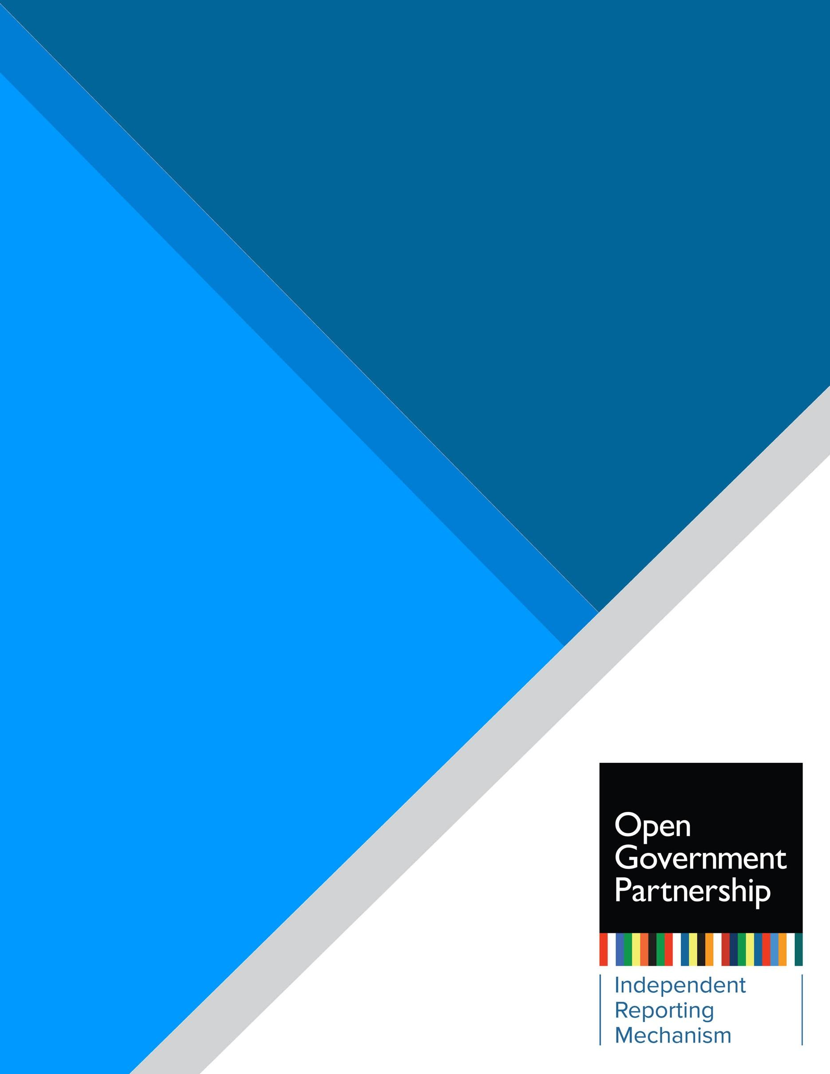

Independent Reporting Mechanism

Action Plan Review:

[Country] [20XX-20XX]

Microsoft Office User

**Introduction**

Starting in January 2021 the IRM began rolling out the new products that resulted from the IRM Refresh process.[1] The new approach builds on the lessons after more than 350 independent, evidence-based and robust assessments conducted by the IRM and the inputs from the OGP community. The IRM seeks to put forth simple, timely, fit for purpose and results-oriented products that contribute to learning and accountability in key moments of the OGP action plan cycle.

The new IRM products are:

1. **Co-creation brief** - brings in lessons from previous action plans, serves a learning purpose, and informs co-creation planning and design. This product is scheduled to roll out in late 2021, beginning with countries co-creating 2022-2024 action plans.
2. **Action Plan Review** - an independent, quick, technical review of the characteristics of the action plan and the strengths and challenges the IRM identifies to inform a stronger implementation process. This product is scheduled to roll out in early 2021 beginning with 2020-2022 action plans. Action Plan Reviews are delivered 3-4 months after the action plan is submitted.
3. **Results report** - an overall implementation assessment that focuses on policy-level results and how changes happen. It also checks compliance with OGP rules and informs accountability and longer-term learning. This product is scheduled to roll out in a transition phase in early 2022, beginning with 2019-2021 Action Plans ending implementation on August 31, 2021. Results Report are delivered up to four months after the end of the implementation cycle.

This product consists of an IRM review of (Country) (years) action plan. The action plan is made up of (number) of commitments that the IRM has filtered and clustered into (number). This review emphasizes its analysis on the strength of the action plan to contribute to implementation and results. For the commitment-by-commitment data see Annex 1. For details regarding the methodology and indicators used by the IRM for this Action Plan Review, see section IV. Methodology and IRM Indicators

**Table of Contents**

Section I: Overview of the [2021-2023] Action Plan 3

Section II: Promising Commitments in [Country] [2021-2023] Action Plan 4

Section III: Minimum Requirements for Acting According to OGP Process 6

Section IV. Methodology and IRM Indicators 7

Annex I. Commitment by Commitment Data 9

# Section I: Overview of the [20XX-20XX] Action Plan

*Headline text here*

**AT A GLANCE**

**Participating since:** 20XX

**Action plan under review:** 20XX-20XX

**IRM product:** X

**Number of commitments:** X

**Overview of commitments:**

* Commitments with an open gov lens: [# (%)]
* Commitments with substantial potential for results: [# (%)]
* Promising commitments: #

**Policy areas**

carried over from previous action plans:

* Policy area #1
* Policy area #2
* Policy area #3
* XXX

Emerging in this action plan:

* Policy area #1
* Policy area #2
* XXX

**Compliance with OGP minimum requirements for Co-creation:**

* Acted according to OGP process: [yes/no]

***[IRM Guiding Text]*** *This overview section* ***does not need to be more than two pages.*** *First, provide an overall view of the action plan. Describe the characteristics of the action plan, total number of commitments, the policy areas covered by commitments and how the IRM organized the commitments for the purpose of this review. For example, if the plan is structured per themes, other broader national/subnational policies, national development plans or Sustainable Development Goals (SDGs) note it here.*

*Then cover the following:*

* *How does the action plan respond to stakeholder priorities or feedback from consultations or recommendations in previous IRM reports?*
* *Does the plan carry over policy areas or initiatives from the previous plan, if so, what is the main difference or added value?*
* *Does the plan include commitments in policy areas for the first time? Which ones? Is this a positive development?*
* *Has the ambition or quality of the action plan improved compared to previous action plans?*
* *What was the CSOs/ Gov perspective on strengths and weaknesses of this action plan development process?*
* *What are the overall shortcomings or weaknesses in the Action Plan? This may be contributing factors or barriers that limited ambition, diversity, the policy objectives or design quality of commitments. Provide examples of the commitments that were not identified as having high potential for change or that did not make it through the filtering process and explain the main constraints in that subset of commitments.*

*Finally, describe the strengths of the action plan and indicate which commitments were selected as promising and key reasons why.*

# Section II: Promising Commitments in [Country] [2021-2023] Action Plan

The following review looks at the (n=number) commitments that the IRM identified as having the potential to realize the most promising results. This review will inform the IRM’s research approach to assess implementation in the Results Report. The IRM Results Report will build on the early identification of potential results from this review to contrast with the outcomes at the end of the implementation period of the action plan. This review also provides an analysis of challenges, opportunities and recommendations to contribute to the learning and implementation process of this action plan.

*Add 3 – 4 sentences about the filtering and clustering process and the criteria applied to select the “promising commitments” and include a call out to table 1. If the action plan has particularities that differ from typical action plans like open state approaches, other branches of government chapters or any other characteristic that have implications on the IRM assessment, also note here.*

**Table 1. Promising commitments**

|  |
| --- |
| **Promising Commitments** |
| 1. *List the commitments or cluster of commitments that the IRM found to be promising. Five is an ideal number, but it doesn’t have to be 5 if there aren’t enough commitments that fit the criteria. It shouldn’t be just five if there are more that meet the criteria.* |
| 2. |
| 3. |
| 4. |
| 5. |

**[Commitment # and Short title] [Implementing agency and CSO collaborators]**

For a complete description of the commitment see commitment # in [action plan link]

**Commitment cluster [#]: [Short title]**

(Implementing agencies and CSO collaborators)

For a complete description of the commitments included in this cluster see commitments #, # and # in the [action plan link]

**Context and objectives:**

* *4-5 sentences that cover (a) the origins of the commitment (or cluster), who proposed it or influenced it? Was this a priority for civil society, government, other branches of government, or did it come directly from proposals in broader consultations, (b) how does the commitment compare to past OGP commitments or efforts – in or outside of OGP action plans, to address the public problem, (c) the policy problem.*
* *2-3 sentences with the IRM (a) analysis on what the commitment will undertake, (b) what the open government lens is, making sure it is clear what OGP value (transparency, civic participation, public accountability) is used, and (c) why this commitment is important in the country context or how it fits in the context of ongoing open government efforts in the government.*

**Potential for results** (add coding e.g “Substantial”)

* *2- 3 paragraphs that lay out what is the starting point and what are foreseeable changes that the implementation of this commitment/reform may yield to open government or for open government to address economic, social, political or environmental issues. An analysis of how those changes will contribute to advancing the policy areas and the potential outcomes. This needs to reflect the justification for the commitment or cluster of commitments being identified as promising. Where possible, baselines and indicators for transformative results should be provided.*

**Opportunities, challenges and recommendations during implementation**

* *2-3 sentences about the critical or key aspects of the commitment that need to be* *achieved to fulfill the potential of the commitment. This may include opportunities to increase the ambition or meaningfulness of results.*
* *4-5 sentences to highlight challenges that may derail or risk implementation or curtail the ambition of the commitment. Also include recommendations on how to overcome or mitigate the challenges. If needed, use concrete examples or reference good practices in the recommendations.*
* *Additional guidance for staff/researcher: keep the narrative fluid but use bold or bullet points to draw the reader’s attention easily to the recommendations.*

# Section III. Methodology and IRM Indicators

The purpose of this review is not an evaluation as former IRM reports. It is intended as an independent quick technical review of the characteristics of the action plan and the strengths and challenges the IRM identifies to inform a stronger implementation process. This approach allows the IRM to highlight the strongest and most promising commitments in the action plan based on an assessment of the commitment per the key IRM indicators, particularly commitments with the highest potential for results, the priority of the commitment for country stakeholders and the priorities in the national open government context.

To determine which reforms or commitments the IRM identifies as promising the IRM follows a filtering and clustering process:

**Step 1:** determine what is reviewable and what is not based on the verifiability of the commitment as written in the action plan.

**Step 2:** determine if the commitment has an open government lens. Is it relevant to OGP values?

**Step 3:** Commitments that are verifiable and have an open government lens are reviewed to identify if certain commitment needs to be clustered. Commitments that have a common policy objective or commitments that contribute to the same reform or policy issue should be clustered and its “potential for results” should be reviewed as a whole. The clustering process is conducted by IRM staff, following the steps below:

* 1. Determine overarching themes. They may be as stated in the action plan or if the action plan is not already grouped by themes, IRM staff may use as reference the thematic tagging done by OGP.
  2. Review objectives of commitments to identify commitments that address the same policy issue or contribute to the same broader policy or government reform.
  3. Organize commitments by clusters as needed. Commitments may already be organized in the Action Plan under specific policy or government reforms or may be standalone and therefore not clustered.

**Step 4:** assess the potential for results of the cluster or standalone commitment.

The filtering process is an internal process and data for individual commitments is available in Annex I below. In addition, during the internal review process of this product the IRM verifies the accuracy of findings and collects further input through peer review, the OGP Support Unit feedback as needed, interviews and validation with country-stakeholders, and sign-off by the IRM’s International Experts Panel (IEP).

As described in the filtering process above, the IRM relies on **three key indicators** for this review:

**I. Verifiability**

* “Yes” Specific enough to review. As written in the action plan the objectives stated and actions proposed are sufficiently clear and includes objectively verifiable activities to assess implementation.
* “No”: Not specific enough to review. As written in the action plan the objectives stated and proposed actions lack clarity and do not include explicit verifiable activities to assess implementation.

*Commitments that are not verifiable will be considered “not reviewable”, and further assessment will not be carried out.

**II. Does it have an open government lens? (Relevant)**

This indicator determines if the commitment relates to open government values of transparency, civic participation or public accountability as defined by the Open Government Declaration, the OGP Articles of Governance and by responding to the guiding questions below.

Based on a close reading of the commitment text, the IRM first determines whether the commitment has an open government lens:

* **Yes/No:** Does the commitment set out to make a policy area, institutions or decision-making process more transparent, participatory or accountable to the public?

The IRM uses the OGP Values as defined in the Articles of Governance. In addition, the following questions for each OGP value may be used as a reference to identify the specific open government lens in commitment analysis:

* **Transparency:** Will the government disclose more information, improve the legal or institutional frameworks to guarantee the right to information, improve the quality of the information disclosed to the public, or improve the transparency of government decision-making processes or institutions?
* **Civic Participation**: Will government create or improve opportunities, processes or mechanisms for the public to inform or influence decisions? Will the government create, enable or improve participatory mechanisms for minorities or underrepresented groups? Will the government enable a legal environment to guarantee freedoms of assembly, association and peaceful protest?
* **Public Accountability**: Will the government create or improve opportunities to hold officials answerable for their actions? Will the government enable a legal, policy or institutional frameworks to foster accountability of public officials?

**III. Potential for results**

Formerly known as the “potential impact” indicator, it was adjusted taking into account the feedback from the IRM Refresh consultation process with the OGP community. With the new results-oriented strategic focus of IRM products, this indicator was modified so that in this first review it laid out the expected results and potential that would later be verified in the IRM Results Report, after implementation. Given the purpose of this Action Plan Review, the assessment of “potential for results” is only an early indication of the possibility the commitment has to yield meaningful results based on its articulation in the action plan in contrast with the state of play in the respective policy area.

The scale of the indicator is defined as:

* **Unclear:** the commitment is aimed at continuing ongoing practices in line with existing legislation, requirements or policies without indication of the added value or enhanced open government approach in contrast with existing practice.
* **Modest:** a positive but standalone initiative or changes to process, practice or policies. Commitments that do not generate binding or institutionalized changes across government or institutions that govern a policy area. For example, tools like websites, or data release, training, pilot projects
* **Substantial:** a possible game changer to the rules of the game (or the creation of new ones), practices, policies or institutions that govern a policy area, public sector and/or relationship between citizens and state. The commitment generates binding and institutionalized changes across government

This review was prepared by the IRM in collaboration with [researchers/consultants] and overseen by the IRM’s International Experts Panel (IEP). The current IEP membership includes:

* César Cruz-Rubio
* Mary Francoli
* Brendan Halloran
* Jeff Lovitt
* Juanita Olaya

For more information about the IRM refer to the **“About IRM” section of the OGP website** available [here](https://www.opengovpartnership.org/process/accountability/).

# Annex 1. Commitment by Commitment Data[2]

|  |
| --- |
| **Commitment [#]: [Short Title – can be edited by staff to make it self-explanatory]** |
| * Verifiable: [Yes/No] * Does it have an open government lens? [Yes/No] * Potential for results: [Unclear/Modest/ Substantial] |
|  |
| **Commitment [#]: [Short Title]** |
| * Verifiable: [Yes/No] * Does it have an open government lens? [Yes/No] * This commitment has been clustered as: [name of cluster] (commitments X, X and X of the action plan) * Potential for results: [Unclear/Modest/ Substantial]* |
|  |

# Annex 2: Minimum Requirements for Acting According to OGP Process

According to OGP’s Procedural Review Policy, during development of an action plan, OGP participating countries must meet the “Involve” level of public influence per the IRM’s assessment of the co-creation process.

To determine whether a country falls within the category of “involve” on the spectrum, the IRM assesses different elements from OGP’s Participation & Co-creation Standards. The IRM will assess whether the country complied with the following aspects of the standards during the development of the action plan, which constitute the minimum threshold:

1. **A forum exists:** there is a forum to oversee the OGP process.
2. **The forum is multi-stakeholder:** Both government and civil society participate in it.
3. **Reasoned response:** The government or multi-stakeholder forum documents or is able to demonstrate how they provided feedback during the co-creation process. This may include a summary of major categories and/or themes proposed for inclusion, amendment or rejection.

The table below summarizes the IRM assessment of the three standards that apply for purposes of the procedural review. The purpose of this summary is to verify compliance with procedural review minimum requirements, and it is not a full assessment of performance under OGP’s Co-creation and Participation Standards. A full assessment of co-creation and participation throughout the OGP cycle will be provided in the Results Report.

**Table 2. Summary of minimum requirements to act according to OGP Process**

|  |  |
| --- | --- |
| ***OGP Standard*** | ***Was the standard met?*** |
| A forum exists. (Add a sentence with evidence eg. An MSF was established by an executive decree) | Green (#009848) /Yellow (#F7981D) /Red (#EE3C24) |
| The forum is multi-stakeholder. (Add a sentence with evidence eg. The MSF includes two representatives from government and two representatives from civil society) | Green/Yellow/Red |
| The government provided a reasoned response on how the public’s feedback was used to shape the action plan. (Add a sentence with evidence eg. The government published a summary of commitment suggestions that were not included in the action plan with an explanation of the criteria applied to dismiss the commitment suggestion) | Green/Yellow/Red |

*Additional guidance for staff/researcher: in* ***exceptional cases,*** *if a country had previously acted contrary to the OGP process then it warrants a line or two to reference if they improved or not and what was the most significant improvement. It may also be the case that a country is found to be acting contrary, in that case we may want to provide a concrete recommendation to improve during implementation.*

1. For more details regarding the IRM Refresh visit https://www.opengovpartnership.org/process/accountability/about-the-irm/irm-refresh/
2. ***Editorial notes:***

   1. *For commitments that are clustered: the assessment of potential for results is conducted at the cluster level, rather than the individual commitments.*
   2. *Commitment short titles may have been edited for brevity. For the complete text of commitments, please see [Country’s] action plan: [Link to NAP]*

  