Author(s) name(s)

Independent Reporting Mechanism

  - Co-Creation Brief to Support the Design of [AP Calendar] OGP Action Plan [Date]

Introduction
This brief from the OGP's Independent Reporting Mechanism (IRM) serves to support the co-creation process and design of the forthcoming Action Plan and to strengthen the quality, ambition and feasibility of commitments. It provides an overview of the opportunities and challenges for open government in the country’s context and presents recommendations drawing on lessons and examples from comparative international experience, previous IRM reports and third-party data in the design and implementation of OGP commitments. This brief does not constitute an evaluation of a particular action plan and its purpose is to inform the planning process for co-creation based on collective and country specific IRM findings.
Table of Contents
Section I: Open Government in Context 2
Section II: Action Plan Co-Creation Process 2
Section III: Action Plan Design 3
Section IV. Sources and Methods 3

Section I: Open Government in Context

(2 - 3 paragraphs max)
Highlight recent developments (positive or concerning) in the country relevant to open government policy and practice and/or OGP-relevant sectors that can be opportunities or challenges for future action plans (e.g., extractives, revenue collection, beneficial ownership transparency, electoral integrity), this may also include political shifts in power (e.g. elections). Provide up-to-date sources (e.g. independent analysis, media reports). This section should not be written as an evaluation of the country context, any opportunity or challenge highlighted in this section should be linked back to the scope of the forthcoming action plan.

Section II: Action Plan Co-Creation Process

THE RECORD SO FAR:
Table 1. Snapshot of co-creation processes in [country]
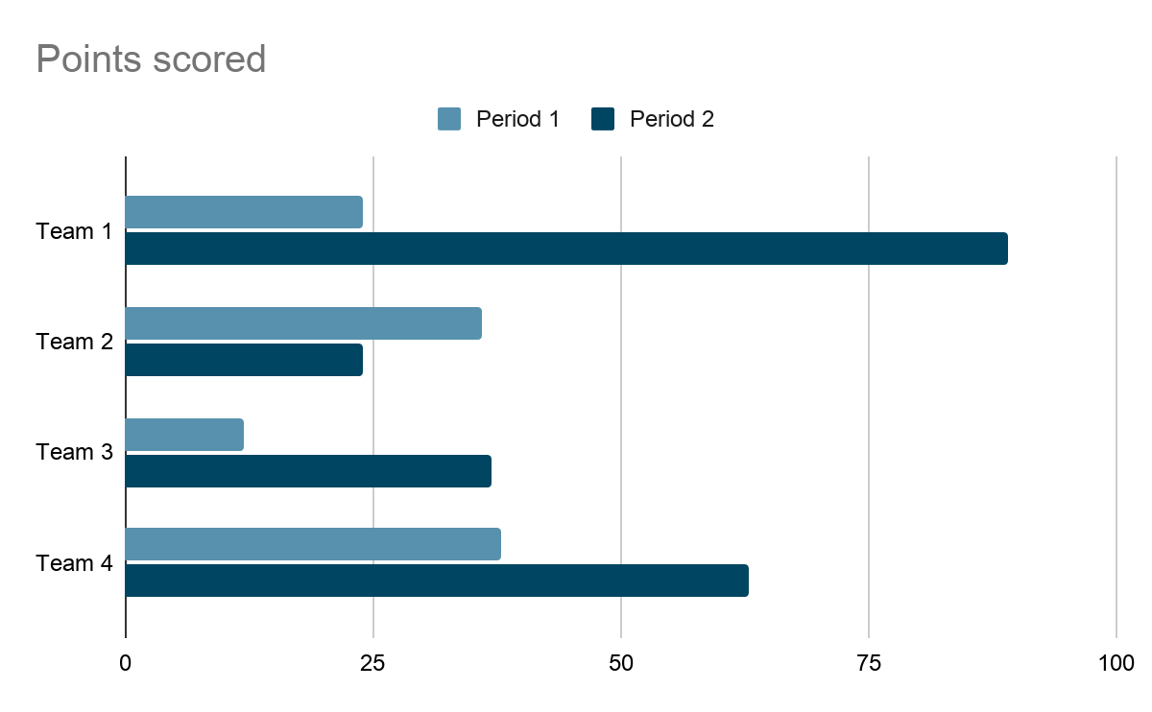
(2-3 paragraph narrative)
Briefly summarize the strengths and weaknesses of the evolution or maturity of OGP processes in the country. e.g. Has the MSF functionality improved, what is the direction over time in terms of inclusivity and of outreach to new stakeholders, and the breadth of actors engaged in proposing the commitments selected in Action Plans to date. For this section, draw on the existing IRM products (Action Plan review, previous IRM reports) and developments that have taken place since those were written. Very concisely answer the following:

- What have been the key obstacles or challenges in co-creation to date? How has the selection and finalization of the commitments progressed over time? Do CSOs and government have an equal voice at the table, and is there mutual confidence that they are partners in open government?

- Have the resources available been a constraint or not? What level of resources would stakeholders working on the co-creation process need, respectively the MSF, the government team and civil society (human resources and budget and skills-set)?

- Have there been (positive or negative) changes in the level of public awareness of OGP, the geographical and ethnic diversity of those engaged and in the approaches to co-creation (online, in-person, etc.)?

RECOMMENDATIONS

Recommendation 1
Lead with a set of recommendations on the process, namely how to improve the inclusivity and effectiveness of the co-creation process with a view to securing wider ownership and inclusion, and to building trust between government and CSOs and earning trust in government among the wider population. The OGP Participation &
Co-Creation Standards could serve as the source of overall principles and standards underpinning the recommendations.
The recommendations should draw on IRM reports for the given country (Action Plan review, implementation or results reports), other OGP documents (e.g. country support reports), and also on examples that have proved effective in other countries, either in the OGP framework or otherwise (see sources in Sources and Methods section). Sources for these examples should be stated, but the recommendations should not be limited by the sources and existing examples. They can and should be made country- and context-relevant, but should build on recommendations in prior IRM products, where relevant and applicable. Where appropriate, the recommendations can be separated to indicate the target user, e.g. as follows:
- (for government)
- (for CSOs)
- (for MSF as a whole).

Support Measures:
For each recommendation, outline some of the ways that support can be secured for effective implementation of the recommendations, e.g. to increase ownership of the co-creation process, and describe how the support measures could be provided, and from whom (e.g. OGP Country Support team, suggestions for expert facilitators in co-creation, mentoring, study visits, the OGP Multi-Donor Trust Fund or other sources). Such support measures should be identified in the knowledge that such support would have to be provided at short notice to be applicable in the forthcoming Action Plan co-creation timeline.

Recommendation 2

Recommendation 3

Recommendation 4

Section III: Action Plan Design

AREAS OF OPPORTUNITY FOR COMMITMENTS

(three or four paragraphs)

Building on the context opportunities or challenges referenced in Section I of this brief, propose new areas for commitments or how the existing commitments can be built upon, continued, made more ambitious and impactful. Where applicable, include lessons/examples from commitments or OGP-related measures in other countries on similar policy areas/challenges, and reinforce this by referring to emerging or established standards and tools in good practice in open government.

AREA 1. e.g. Beneficial Ownership Transparency
- Provide an overview of available resources to guide the development of commitments in this area:
- OGP resources on BOT
- Other OGP countries working on this policy area: [Chile, Nigeria etc.]
- Partners or experts that can provide technical support:
AREA 2 [Policy Area]
AREA 3 [Policy Area]

Section IV. Sources and Methods

The Co-Creation Brief draws on the results of the research in the prior IRM reports (Action Plan review, implementation/results reports), and draws recommendations from the data and conclusions of those reports. The Brief also draws on other sources (such as those outlined below) to ensure that the recommendations provided are up-to-date in the light of developments since those IRM reports were written, and to enrich the recommendations by drawing on comparative international experience in the design and implementation of OGP Action Plan commitments, and other context-relevant practice in the field of open government. The Co-Creation Brief has been reviewed by IRM senior staff for consistency, accuracy, and with a view to maximizing the context-relevance and actionability of the recommendations. Where appropriate, the briefs are also reviewed by external reviewers or members of the IRM International Experts Panel (IEP).

The sources used are as follows (replace the following with the actual sources and provide URL links as available):
- previous IRM findings (current or previous-format IRM reports) for the respective country
- other OGP findings/reports, e.g. country support team, Global Report, studies on co-creation
- interviews with PoCs, IRM country researcher, country support team, independent country analysts, analysts or practitioners on appropriate OGP topics/sectors
- Co-Creation toolkit
- OGP IRM and other OGP reports on other countries, clusters of commitments or other international comparative studies on OGP commitment implementation
- other independent, third-party analysis

