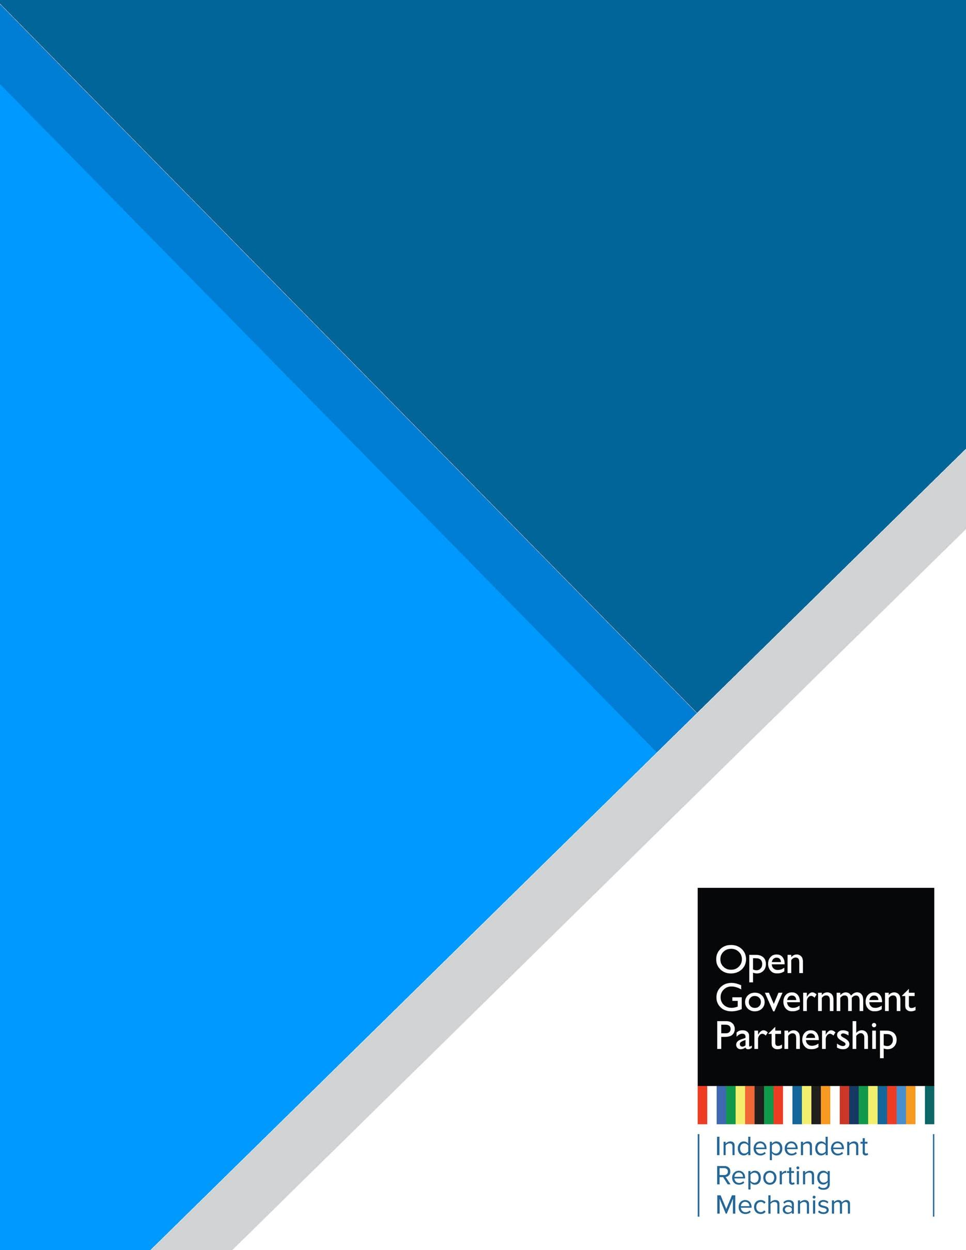

Independent Reporting Mechanism

Action Plan Review:
[Country] [20XX–20XX]

Introduction
In January 2021, the Independent Reporting Mechanism (IRM) rolled out the new products that resulted from the IRM Refresh process. The new approach builds on the lessons learned after more than 350 robust, independent, evidence-based assessments conducted by the IRM and inputs from the OGP community. The IRM seeks to put forth simple, timely, fit for purpose, and results-oriented products that contribute to learning and accountability in key moments of the OGP action plan cycle.
IRM products are:
- Co-Creation Brief: Brings in lessons from previous action plans, serves a learning purpose, and informs co-creation planning and design.
- Action Plan Review: A quick, independent technical review of the characteristics of the action plan and the strengths and challenges IRM identifies to inform a stronger implementation process.
- Results Report: An overall implementation assessment that focuses on policy-level results and how changes happen. It also checks compliance with OGP rules and informs accountability and longer-term learning. This product was rolled out in a transition phase in 2022, beginning with action plans ending implementation on 31 August 2022. Results Reports are delivered up to four months after the end of the implementation cycle.
This product consists of an IRM review of the (Country) (years) action plan. The action plan comprises (number) commitments that the IRM has filtered and clustered into (number). This review emphasizes its analysis on the strength of the action plan to contribute to implementation and results. For the commitment-by-commitment data, see Annex 1. For details regarding the methodology and indicators used by the IRM for this Action Plan Review, see Section III.

Table of Contents
Section I: Overview of the [20XX–20XX] Action Plan 2
Section II: Promising Commitments in [Country] [2021–2023] Action Plan 3
Section III. Methodology and IRM Indicators 5
Annex 1. Commitment by Commitment Data 8
Annex 2: Action Plan Co-Creation 9

Section I: Overview of the [20XX–20XX] Action Plan

Headline text here [3–4 sentences highlighting the key takeaways from the report, such as the action plan’s overall content, ambition, and main potential/challenges]
AT A GLANCE

Participating since: 20XX
Action plan under review: 20XX–20XX
IRM product: X
Number of commitments: X

Overview of commitments:
Commitments with an open government lens: [# (%)]
Commitments with substantial potential for results: [# (%)]
Promising commitments: #

Policy areas:
Carried over from previous action plans:
Policy area #1
Policy area #2
Policy area #3
XXX

Emerging in this action plan:
Policy area #1
Policy area #2
XXX

Compliance with OGP minimum requirements for co-creation:
Acted according to OGP process: [yes/no]
[IRM Guiding Text] This overview section does not need to be more than two pages. First, provide an overall view of the action plan. Describe the characteristics of the action plan, total number of commitments, policy areas covered by the commitments, and how IRM organized the commitments for the purpose of this review. For example, if the plan is structured per themes, other broader national/subnational policies, national development plans, or Sustainable Development Goals, note that here.

Then cover the following:
- How does the action plan respond to stakeholder priorities, feedback from consultations, or recommendations in previous IRM reports?
- Does the plan carry over policy areas or initiatives from the previous plan? If so, what is the main difference or added value?
- Does the plan include commitments in policy areas for the first time? Which ones? Is this a positive development?
- Has the ambition or quality of the action plan improved compared to previous action plans?
- What was the civil society organization’s (CSO’s)/government’s perspective on strengths and weaknesses of this action plan development process?
- What are the overall shortcomings or weaknesses in the action plan? These may be contributing factors or barriers that limit ambition, diversity, policy objectives, or design quality of commitments. Provide examples of commitments that were not identified as having high potential for change or did not make it through the filtering process and explain the main constraints in that subset of commitments.

Finally, describe the strengths of the action plan and indicate which commitments were selected as promising and the key reasons why.

Section II: Promising Commitments in [Country] [2021–2023] Action Plan

The following review looks at the (n=number) commitments that the IRM identified as having the potential to realize the most promising results. Promising commitments address a policy area that is important to stakeholders or the national context. They must be verifiable, have a relevant open government lens, and have modest or substantial potential for results. This review also provides an analysis of challenges, opportunities, and recommendations to contribute to the learning and implementation process of this action plan.

Table 1. Promising commitments
Promising Commitments
1. List the commitments or cluster of commitments that the IRM found to be promising. Five is an ideal number. However, if not enough commitments fit the criteria, you can have less than five. If more commitments meet the criteria, you can have more than five.
2.
3.
4.
5.

Guidance: use this format for standalone commitments. Use the number per the action plan and in Arabic numbering.
[Commitment # and Short title] [Implementing agency and CSO collaborators]
For a complete description of the commitment, see commitment # in [action plan link]

Guidance: use this format for commitment clusters
Commitment cluster [#]: [Short title]
(Implementing agencies and CSO collaborators)
For a complete description of the commitments included in this cluster, see commitments #, #, and # in the [action plan link]

Context and objectives:
- 4–5 sentences that cover (a) the origins of the commitment or cluster of commitments (Who proposed it or influenced it? Was this a priority for civil society or government, or did it come directly from proposals in broader consultations?), (b) how the commitment compares to past OGP commitments or efforts—in or outside of OGP action plans—to address the public problem, and (c) the policy problem.
- 2–3 sentences with IRM analysis on (a) what the commitment will undertake; (b) what the open government lens is, making sure the OGP value (transparency, civic participation, public accountability) used is clear; and (c) why this commitment is important in the country context or how it fits in the context of ongoing open government efforts in the government.

Potential for results (add coding, for example “Substantial”)
- 2–3 paragraphs that lay out the starting point and foreseeable changes that the implementation of this commitment/reform may yield to open government or for open government to address economic, social, political, or environmental issues; an analysis of how those changes will contribute to advancing the policy areas; and the potential outcomes. This needs to reflect the justification for the commitment or cluster of commitments identified as promising. Where possible, provide baselines and indicators for transformative results.

Opportunities, challenges, and recommendations during implementation

- 2–3 sentences about the critical or key aspects of the commitment that need to be achieved to fulfill the potential of the commitment. This may include opportunities to increase the ambition or meaningfulness of results.
- 4–5 sentences to highlight challenges that may derail or risk implementation or curtail the ambition of the commitment. Also include recommendations on how to overcome or mitigate the challenges. If needed, use concrete examples or reference good practices in the recommendations.
- Additional guidance for staff/researcher: Keep the narrative fluid and use bold or bullet points to draw the reader’s attention to the recommendations.

Other commitments

Other commitments that the IRM did not identify as promising commitments are discussed below. This review provides recommendations to contribute to the learning and implementation of these commitments.

Use this space to briefly summarize overarching characteristics of commitments’ design that limit their potential for results. For example, if the action plan lacks detail and specificity that will limit commitments’ verifiability, note that here with specific examples and recommendations. Similarly, you can use this space to explain why commitments do not have an open government lens and provide recommendations to strengthen their relevance during implementation.

Consider this subsection a summary, rather than an in-depth analysis of each commitment. However, depending on the context, you may find it necessary to identify specific commitments that are not promising. If so, clarify why a commitment is not promising and provide recommendations that contribute to future design or stronger implementation. The text should be concise (2–4 lines per commitment). Cluster commitments where useful, such as those for which you have identical recommendations.

Section III. Methodology and IRM Indicators

The purpose of this review is not an evaluation. It is intended as a quick, independent, technical review of the characteristics of the action plan and the strengths and challenges the IRM identifies to inform a stronger implementation process. The IRM highlights commitments that have the highest potential for results, a high priority for country stakeholders, a priority in the national open government context, or a combination of these factors.

The IRM follows a filtering and clustering process to identify promising reforms or commitments:

Step 1: Determine what is reviewable based on the verifiability of the commitment as written in the action plan.
Step 2: Determine if the commitment has an open government lens. Is it relevant to OGP values?
Step 3: Review commitments that are verifiable and have an open government lens to identify if certain commitments need to be clustered. Commitments that have a common policy objective or contribute to the same reform or policy issue should be clustered. The potential for results of clustered commitments should be reviewed as a whole. IRM staff follow these steps to cluster commitments:
  - Determine overarching themes. If the action plan is not already grouped by themes, IRM staff may use OGP’s thematic tagging as reference.
  - Review commitment objectives to identify commitments that address the same policy issue or contribute to the same broader policy or government reform.
  - Organize commitments into clusters as needed. Commitments may already be organized in the action plan under specific policy or government reforms.
Step 4: Assess the potential for results of the clustered or standalone commitment.

Filtering is an internal process. Data for individual commitments is available in Annex 1. In addition, during the internal review process of this product, the IRM verifies the accuracy of findings and collects further input through peer review, OGP Support Unit feedback as needed, interviews and validation with country stakeholders, an external expert review, and oversight by IRM’s International Experts Panel (IEP).

As described earlier, IRM relies on three key indicators for this review:

I. Verifiability
- Yes, specific enough to review: As written in the action plan, the stated objectives and proposed actions are sufficiently clear and include objectively verifiable activities to assess implementation.
- No, not specific enough to review: As written in the action plan, the stated objectives and proposed actions lack clarity and do not include explicitly verifiable activities to assess implementation.
- Commitments that are not verifiable will be considered not reviewable, and further assessment will not be carried out.

II. Open government lens

This indicator determines if the commitment relates to the open government values of transparency, civic participation, or public accountability as defined by the Open Government Declaration and the OGP Articles of Governance by responding to the following guiding questions. Based on a close reading of the commitment text, the IRM first determines whether the commitment has an open government lens:
- Yes/No: Does the commitment set out to make a policy area, institution, or decision-making process more transparent, participatory, or accountable to the public?

The IRM uses the OGP values as defined in the Articles of Governance. In addition, the following questions for each OGP value may be used as a reference to identify the specific open government lens in commitment analysis:
- Transparency: Will the government disclose more information, improve the legal or institutional frameworks to guarantee the right to information, improve the quality of the information disclosed to the public, or improve the transparency of government decision-making processes or institutions?
- Civic Participation: Will the government create or improve opportunities, processes, or mechanisms for the public to inform or influence decisions? Will the government create, enable, or improve participatory mechanisms for minorities or underrepresented groups? Will the government enable a legal environment to guarantee freedoms of assembly, association, and peaceful protest?
- Public Accountability: Will the government create or improve opportunities to hold officials answerable for their actions? Will the government enable legal, policy, or institutional frameworks to foster accountability of public officials?

III. Potential for results

The IRM adjusted this indicator—formerly known as the “potential impact” indicator—to take into account the feedback from the IRM Refresh consultation process with the OGP community. With the new results-oriented strategic focus of IRM products, the IRM modified this indicator to lay out the expected results and potential that would be verified in the IRM Results Report after implementation. Given the purpose of this Action Plan Review, the assessment of potential for results is only an early indication of the possibility the commitment has to yield meaningful results based on its articulation in the action plan in contrast with the state of play in the respective policy area.

The scale of the indicator is defined as:
- Unclear: The commitment is aimed at continuing ongoing practices in line with existing legislation, requirements, or policies without indication of the added value or enhanced open government approach in contrast with existing practice.
- Modest: A positive but standalone initiative or change to processes, practices, or policies. The commitment does not generate binding or institutionalized changes across government or institutions that govern a policy area. Examples are tools (e.g., websites) or data release, training, or pilot projects.
- Substantial: A possible game changer for practices, policies, or institutions that govern a policy area, public sector, or the relationship between citizens and state. The commitment generates binding and institutionalized changes across government.

This review was prepared by the IRM in collaboration with [researchers/consultants] and was externally expert reviewed by XXX. The IRM methodology, quality of IRM products, and review process are overseen by IRM’s IEP. For more information, see the IRM Overview section of the OGP website.

Annex 1. Commitment by Commitment Data

Commitment [#]: [Short Title—can be edited by staff to make it self-explanatory]
- Verifiable: [Yes/No]
- Does it have an open government lens? [Yes/No]
- Potential for results: [Unclear/Modest/Substantial]
Commitment [#]: [Short Title]
- Verifiable: [Yes/No]
- Does it have an open government lens? [Yes/No]
- This commitment has been clustered as: [name of cluster] (commitments X, X, and X of the action plan) [Guidance: use this format as needed for clusters.]
- Potential for results: [Unclear/Modest/Substantial]

Annex 2: Action Plan Co-Creation

OGP member countries are encouraged to aim for the full ambition of the updated OGP Participation and Co-Creation Standards that came into force on 1 January 2022. IRM assesses all countries that submitted action plans from 2022 onward under the updated standards. OGP instituted a 24-month grace period to ensure a fair and transparent transition to the updated standards. During this time, IRM will assess countries’ alignment with the standards and compliance with their minimum requirements. However, countries will only be found to be acting contrary to the OGP process if they do not meet the minimum requirements, starting with action plans submitted to begin in 2024 and onward. Table 2 outlines the extent to which the countries’ participation and co-creation practices meet the minimum requirements that apply during development of the action plan.

Guidance for researchers to complete Table 2: A country has met the minimum requirement when all the key measures for that requirement are met. Key measures are indicated here with roman numerals (i, ii, iii..). Be sure to refer to the IRM Guidance on Assessing the Minimum Requirements and the Researcher Questionnaire for details on how to assess compliance. Cite evidence as endnotes for each piece of information presented.

Table 2. Compliance with minimum requirements
Minimum requirement | Met during co-creation? | Met during implementation?
1.1 Space for dialogue: In 2–3 sentences, clearly state (i) if there was a multi-stakeholder space for dialogue (ii) that met at least once every six months and had (iii) basic rules publicly available. | Yes or No | To be assessed in the Results Report
2.1 OGP website: In 1–2 sentences, clearly state (i) if there is a publicly accessible website that (ii) contains the latest action plan, at a minimum. | Yes or No | To be assessed in the Results Report
2.2 Repository: In 2–3 sentences, clearly state (i) if there is a repository online that is (ii) updated at least twice a year (iii) with information on both co-creation and implementation. | Yes or No | To be assessed in the Results Report
3.1 Advanced notice: In 2–3 sentences, clearly state (i) if the co-creation timeline and the overview of opportunities for stakeholders to participate was published on the OGP website (ii) at least two weeks before the start of the co-creation process. | Yes or No | Not applicable
3.2 Outreach: In 1–2 sentences, clearly state (i) if at least one outreach activity was carried out to provide information on OGP and opportunities to get involved. | Yes or No | Not applicable
3.3 Feedback mechanism: In 2–3 sentences, clearly state (i) if there was a mechanism in place to gather inputs from a range of stakeholders (ii) for an appropriate period of time. | Yes or No | Not applicable
4.1 Reasoned response: In 2–3 sentences, clearly state (i) if contributions from stakeholders were documented and (ii) whether the Multi-Stakeholder Forum or government reported back or published written feedback to stakeholders on how their contributions were considered during development of the action plan. | Yes or No | Not applicable
5.1 Open implementation: The IRM will assess whether meetings were held with civil society stakeholders to present implementation results and enable civil society to provide comments in the Results Report. | Not applicable | To be assessed in the Results Report

Guidance for researchers: If the country is acting contrary to OGP process by not meeting one or more minimum requirements, use this space to briefly describe how and why the process fell short. Consider including recommendations in bullet points on how the country can improve its process and meet the minimum requirements during implementation.

Alternatively, you can also use this space to briefly describe any noteworthy or innovative participation or co-creation practices undertaken during development of the action plan. For example, describe improvements from the previous cycle or practices that could serve as an example for other countries.

Please note that adding further information is optional if the country is meeting the minimum requirements. Description of the co-creation process beyond completing Table 2 should be reserved for exceptional circumstances and remain brief.

IRM Refresh: https://www.opengovpartnership.org/process/accountability/about-the-irm/irm-refresh/
IRM Overview: https://www.opengovpartnership.org/irm-guidance-overview/
Editorial notes: - For commitments that are clustered, the assessment of potential for results is conducted at the cluster level, rather than the individual commitments. - Commitment short titles may have been edited for brevity. For the complete text of commitments, please see [Country’s] action plan: [Link to NAP]
2021 OGP Participation and Co-Creation Standards: https://www.opengovpartnership.org/ogp-participation-co-creation-standards/
IRM Guidelines for the Assessment of Minimum Requirements: https://www.opengovpartnership.org/documents/irm-guidelines-for-the-assessment-of-minimum-requirements/

