OGP EUSKADI 2021-2024
NEW PLAN 2021-2023 OF OGP EUSKADI

Collection of citizen proposals for the next Plan
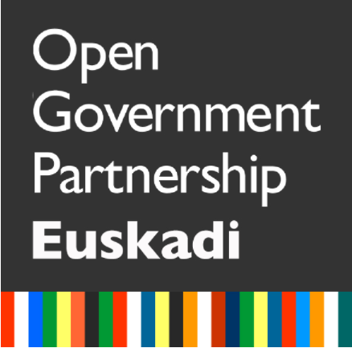
Until September 13, the deadline for collecting proposals to incorporate as commitments in the new OGP Euskadi 2021-2023 plan is open.
Between September and October, panels will be held to select proposals based on the need they cover, the opportunity to undertake them due to their link with other initiatives that are taking place, their viability and the value they provide (impact).
An Open Forum will be held in October for the selection of the final proposals.
The plan will be drawn up in November for delivery to the Open Government Alliance (OGP) in December.
Dare to collaborate and make your proposals through this form.
COLLECTION OF COMMITMENTS TO INCORPORATE TO THE 2021-2023 PLAN OF OGP EUSKADI (MEMBER OF THE ALLIANCE FOR THE OPEN GOVERNMENT)

Euskadi is part of the Alliance for Open Government (OGP). The Basque Government, the Provincial Councils of Araba, Bizkaia and Gipuzkoa, the City Councils of Vitoria-Gasteiz, Donostia-San Sebastián and Bilbao and Innobasque-Basque Innovation Agency, as promoter institutions of OGP Euskadi, in their long-term commitment to open government, we intend to develop the next open government plan 2021-2023.
The plan must contain 3 to 5 commitments to be more transparent, participatory or collaborative in the provision of its services, its programs or its policies. And it must be defined and developed in a collaborative way with citizens.
In the 2018-2020 plan, 5 commitments were included. All the information about OGP Euskadi and the commitments worked so far can be consulted on the web https://www.ogp.euskadi.eus/ogp-euskadi/-/gobierno-abierto-en-euskadi/
The commitments worked by other OGP member regions can be consulted on the organization's website https://www.opengovpartnership.org/policy-areas/ . The right to information, gender and inclusion, governance and digital rights, the protection of civic space, natural resources, integrity ... are some of these areas.
Results Open Forum: new plan and promoter group.
CO-DESIGN OF COMMITMENTS
Regular Forum Meeting 1-3-2021
- Announcement
- Session material
- Minutes of the session
- Commitment lines in contrast phase with Regular Forum
- Civil society contributions from the Regular Forum
- Criteria for the selection of commitment lines and work plan for the second phase
Engagement token templates
- Annex 2
- OGP Euskadi Template
REGULAR FORUM MEETING 06-30-2021
- Call and minutes

Open forums
- Invitation to participate in engagement 1
- Invitation to participate in engagement 2
- Invitation to participate in engagement 3
- Invitation to participate in engagement 4
- Invitation to participate in engagement 5

Call and presentations Open forum 12-7-2021
- Invitation to participate
- Presentations and full video of the open forum

