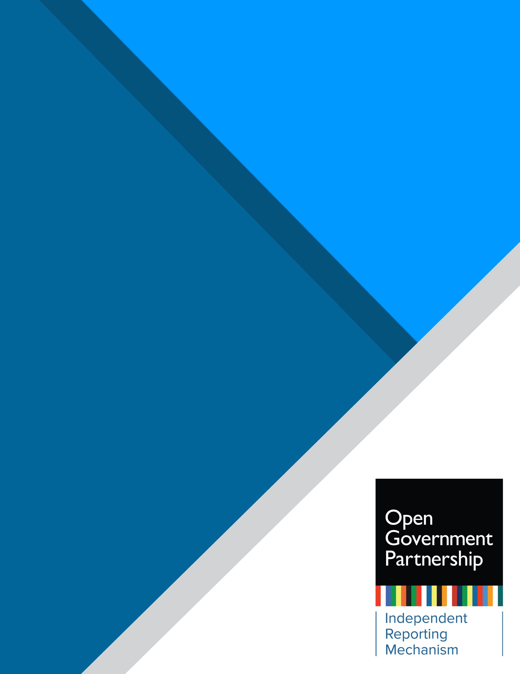

Independent Reporting Mechanism

  - Results Report:
  - [Country] [20XX-20XX]
Executive Summary
Write a 2–3 sentence headline highlighting the main takeaways on level of completion, early results, and/or key lessons across the action plan. The headline could also include a key message on the quality of participation and co-creation practices throughout the action plan cycle.

Early Results (5–7 sentences):
LEVEL OF COMPLETION
10/14
0/14
For all commitments
Complete or
substantially complete
No progress
For promising commitments
4/4
IMPLEMENTATION AT A GLANCE
0/4
10/14
For all commitments
Major or outstanding
No evidence of results
For promising commitments
0/14
4/4
0/4
Acting according to OGP process.
EARLY RESULTS
COMPLIANCE WITH MINIMUM REQUIREMENTS
- How many commitments achieved marginal, major, and outstanding early open government results? How many were identified as “promising” in the Action Plan Review? How does this level of early results compare with previous action plans?
- What are the main open government early results (if any) achieved through implementation of the action plan? What (if any) are the common characteristics or contributing factors across these commitments?
- If there were promising commitments that did not achieve notable early results, what factors inhibited their implementation?

Completion (5-7 sentences):
- What were some of the main topics covered in the action plan’s commitments?
- What was the overall level of progress in commitment implementation?
- How many commitments had “substantial” or “complete” implementation? Is this an improvement or decrease from the performance of the previous action plan?
- What were some of the factors that contributed to positive progress in implementation, or what were some of the factors that limited progress in implementation?
- Please describe which policy or commitment areas had the most completion and why.
  - Are the “Promising” commitments complete?
  - Which commitment areas had limited or no progress? Discuss why.

Participation and Co-Creation (5-7 sentences):
- What bodies/institutions oversee the Open Government Partnership (OGP) process in the country?
- What were the main achievements, innovations, and/or challenges regarding participation and co-creation throughout the action plan cycle?
- How did the country’s participation and co-creation practices impact the quality of stakeholder dialogue and the co-creation and implementation of commitments?
- How did participation and co-creation practices compare to previous cycles?
- If the country acted contrary to OGP process, note where they fell short.

Implementation in context (5–7 sentences):
Highlight the main domestic or international factors that positively or negatively impacted implementation of the action plan and how they were addressed (or not)—for example, increase or decrease in funding (such as grants), elections, reorganization or conflict in the multi-stakeholder forum (MSF), change in government leading institutions, pandemic, natural disasters or social movements or unrest, etc.

Table of Contents
Section I: Key Lessons 4
Section II: Implementation and Early Results 5
Section III. Participation and Co-Creation 6
Section IV. Methodology and IRM Indicators 8
Annex I. Commitment Data 10

Section I: Key Lessons

Distill 3–5 takeaways from the action plan cycle that provide lessons for reflection in the country’s open government efforts. The takeaways should provide analytical insight into factors that contributed and/or hindered reforms. Take into consideration the timing of this report’s publication in the country’s action plan cycle when identifying the key lessons to highlight. (Many countries will be at the stage of beginning to implement their next action plan.)

Guiding questions to inform this section:
- Looking broadly across the action plan, which good practices were introduced and/or which factors accelerated results or change in government practices?
- What were the key barriers to implementation? What were the common factors across commitments that didn’t achieve early results? In particular, are there factors that were not anticipated in the Action Plan Review that arose during implementation?
- What worked?
  - Which factors contributed (e.g., OGP Support Unit, civil society organization, or international partners)?
  - Did the country act on previous IRM recommendations?
  - How has the continuation of reforms (or lack of) across multiple action plans helped or hindered the implementation of open government reforms?
  - Did domestic and/or international contextual factors influence implementation?
- Are there lessons that can be learned from other countries or positive successes in these commitments or in the action plan design/implementation here that can be models for other countries?

Lesson 1: (Heading in the format of a short statement)
Narrative—3–5 sentences

Lesson 2: (Heading)
Narrative—3–5 sentences

Lesson 3: (Heading)
Narrative—3–5 sentences

Lesson 4: (Heading)
Narrative—3–5 sentences

Lesson 5: (Heading)
Narrative—3–5 sentences

Section II: Implementation and Early Results

[Do not change] The following section looks at the X commitments or clusters that the IRM identified as having the strongest results from implementation. To assess early results, the IRM referred to commitments or clusters identified as promising in the Action Plan Review as a starting point. After verification of completion evidence, the IRM also took into account commitments or clusters that were not determined as promising but that, as implemented, yielded significant results.

Guidance for researchers: 1–2 pages max per cluster or commitment as structured in the Action Plan Review

Commitment [#]: [Short Title] [Implementing Agency]

Context and Objectives:
- Briefly note the commitment’s or cluster’s overall objective and how it is significant within the national context.
- Include a brief analysis of whether the opportunities and roadblocks foreseen in the Action Plan Review impacted implementation of the commitment or cluster.

Did It Open Government? (Add coding: marginal, major, or outstanding):
- Please discuss results/outcomes from the commitment, referencing the baselines and likely indicators of change that were set out in the AP Review. There needs to be a clear link between what the AP Review identified as foreseeable changes or expected outcomes and a contrast with the results from implementation. Clearly state which aspects of the commitment or cluster were achieved, which were not, and any pending intended activities.
- How did the change happen and what were the enabling factors or constraints (internal or external) to achieve results? This will contribute to better understanding of changes in the culture of government and the IRM’s ability to note incremental changes that may be adding up to bigger reforms and results over time in OGP action plans.
- Clearly state the reason for coding “Did it open government?” (DIOG) as marginal, major, or outstanding. Use the coding DIOG definitions in the Methods Section (IV) and the definitions of OGP values (Action Plan Review Methods Section) as references.
- If the commitment was not identified in the AP Review as “promising” but as implemented had significant results, in addition to all of the above, include an explanation of what made the implementation meaningful and describe the unexpected results.

Looking Ahead:
- Where possible, based on the current trajectory and progress, what are the prospects for the expected longer-term outcomes of this reform? If this is a commitment that has been carried over multiple action plans, how have results added up and what has been the trajectory of change?
- Is this reform being carried forward under the next action plan? What are the recommendations to ensure that the next iteration contributes toward addressing the overall policy objective?

Section III. Participation and Co-Creation

2-3 sentence headline on the overall quality of participation and co-creation throughout the action plan cycle. The headline could highlight any significant innovations or challenges that impacted the quality of engagement. If the country acted contrary to OGP process, note how they fell short.

[Do not change] OGP member countries are encouraged to aim for the full ambition of the updated OGP Participation and Co-Creation Standards that came into force on 1 January 2022. The IRM assesses all countries that submitted action plans from 2022 onwards under the updated Standards. However, OGP instituted a 24-month grace period to ensure a fair and transparent transition. During this time, the IRM will assess countries’ alignment with the Standards and compliance with the minimum requirements. Therefore, countries will only be found to be acting contrary to OGP process if they do not meet the minimum requirements for submitted action plans to begin in 2024 and later.

Write a brief narrative that addresses the following (5−7 sentences):
- What is the agency or office in charge of OGP? If OGP is led by multiple entities, explain how offices or agencies coordinated.
- [If applicable, include and fill out the following paragraph:] There was a change in OGP leadership and/or point of contact during the action plan cycle. [2–3 sentences on what the change was and whether it affected the ability of the government to convene/work with or engage civil society during co-creation or implementation.]
- Were there any resource constraints (e.g., financial, cross-governmental coordination, or human resources) that affected the ability of the government to convene/work with or engage civil society during co-creation or implementation? If an OGP mini-grant was provided, note how it impacted the action plan process.

Guidance for researchers: Provide a general analysis of the main highlights (1–2 paragraphs).
In your analysis, explicitly refer to the five Participation and Co-Creation Standards as appropriate, particularly in instances where a country is excelling or facing challenges in regard to a standard: https://www.opengovpartnership.org/ogp-participation-co-creation-standards/.

- How did engagement, dialogue, or joint decision-making improve or decline compared to previous action plans?
- What was the role of the MSF or non-governmental actors during development and implementation? To what extent were diverse groups represented? How do they compare to previous action plans?
- What opportunities were made available for civil society to comment on implementation progress, ask questions of implementers, and suggest ways forward through back-and-forth dialogue?
- What are good practices or innovative approaches for decision-making or engaging non-governmental stakeholders throughout the action plan cycle?
- What were the challenges and weaknesses in engagement or decision-making throughout the action plan cycle?
- How did the development process impact the action plan or the individual commitments? How was the action plan shaped by who participated in the development process? How did the final commitment selection respond to the country’s and consulted stakeholders’ policy priorities?

Table 1. Compliance with minimum requirements

Minimum requirement | Met during  co-creation? | Met during  implementation?
1.1 Space for dialogue: In 2–3 sentences, clearly state (i) if there was a multi-stakeholder space for dialogue (ii) that met at least once every six months, (iii) with basic rules publicly available. | Yes or No | Yes or No
2.1 OGP website: In 1–2 sentences, clearly state (i) whether there is a publicly accessible website that (ii) at a minimum contains the latest action plan. | Yes or No | Yes or No
2.2 Repository: In 2–3 sentences, clearly state (i) whether there is a repository online, (ii) which is updated at least twice a year, (iii) with information on both co-creation and implementation. | Yes or No | Yes or No
3.1 Advanced notice: | Yes or No | Not applicable
3.2 Outreach: | Yes or No | Not applicable
3.3 Feedback mechanism: | Yes or No | Not applicable
4.1 Reasoned response: | Yes or No | Not applicable
5.1 Open implementation: In 1–2 sentences, clearly state (i) whether the government met with civil society stakeholders or whether the MSF met during implementation, and (ii) whether implementation results were presented and opportunity made for civil society to comment in these meetings. | Not applicable | Yes or No

Section IV. Methodology and IRM Indicators

[Do not change] This report supports members’ accountability and learning through assessment of (i) the level of completion for commitments’ implementation, (ii) early results for commitments with a high level of completion identified as promising or that yielded significant results through implementation, and (iii) participation and co-creation practices throughout the action plan cycle. The IRM commenced the research process after the first year of implementation of the action plan with the development of a research plan, preliminary desk research, and verification of evidence provided in the country’s OGP repository.
In 2022, OGP launched a consultation process to co-create a new strategy for 2023–2028. The IRM will revisit its products, process, and indicators once the strategy co-creation is complete. Until then, Results Reports continue to assess the same indicators as previous IRM reports:

Completion
The IRM assesses the level of completion for each commitment in the action plan, including commitments clustered in the Action Plan Review. The level of completion for all commitments is assessed as one of the following:
- No evidence available
- Not started
- Limited
- Substantial
- Complete

Did It Open Government?

The IRM assesses changes to government practices that are relevant to OGP values, as defined in the OGP Articles of Governance, under the “Did it open government?” indicator. To assess evidence of early results, the IRM refers to commitments or clusters identified as promising in the Action Plan Review as a starting point. The IRM also takes into account commitments or clusters with a high level of completion that may not have been determined as “promising” but that, as implemented, yielded significant results. For commitments that are clustered, the assessment of “Did it open government?” is conducted at the cluster level, rather than the individual commitment level. Commitments or clusters without sufficient evidence of early results at the time of assessment are designated as “no early results to report yet.” For commitments or clusters with evidence of early results, the IRM assesses “Did it open government?” as one of the following:
- Marginal: Some change, but minor in terms of its effect on level of openness
- Major: A step forward for government openness in the relevant policy area but remains limited in scope or scale
- Outstanding: A reform that has transformed “business as usual” in the relevant policy area by opening government

This report was prepared by the IRM in collaboration with [RESEARCHER] and was reviewed by [EXPERT REVIEWER], IRM external expert. The IRM methodology, quality of IRM products and review process is overseen by the IRM’s International Experts Panel (IEP). The current IEP membership includes:
- Snjezana Bokulic
- Cesar Cruz-Rubio
- Mary Francoli
- Maha Jweied
- Rocio Moreno Lopez
This review process, including the procedure for incorporating comments received, is outlined in greater detail in Section III of the Procedures Manual and in [COUNTRY’S ACTION PLAN REVIEW YEAR-YEAR]. For more information, refer to the “IRM Overview” section of the OGP website, available here.

Annex I. Commitment Data

Commitment 1: [SHORT TITLE]
Verifiable:  Does it have an open government lens?  This commitment has been clustered as: (delete if not clustered)  Potential for results: | - Completion: (no evidence available, not started, limited, substantial, or complete)  - Did it open government? (no early results to report yet, marginal, major, or outstanding)
Use this space to briefly (3–5 sentences) outline the level of completion for commitments that are not coded for early results. State why the commitment does not yet have early results to show (low level of ambition, limited implementation, etc.) and note any completed activities or overarching obstacles to implementation. If the commitment is coded for early results, simply state, “This commitment is assessed in Section II above.”
Commitment 2: [SHORT TITLE]
- Verifiable:  - Does it have an open government lens?  - This commitment has been clustered as: (delete if not clustered)  - Potential for results: | - Completion: (no evidence available, not started, limited, substantial, or complete)  - Did it open government? (no early results to report yet, marginal, major, or outstanding)
Use this space to briefly (3-5 sentences) outline the level of completion for commitments that are not coded for early results. State why the commitment does not yet have early results to show (low level of ambition, limited implementation, etc.) and note any completed activities or overarching obstacles to implementation. If the commitment is coded for early results, simply state, “This commitment is assessed in Section II above.”
Commitment 3: [SHORT TITLE]
- Verifiable:  - Does it have an open government lens?  - This commitment has been clustered as: (delete if not clustered)  - Potential for results: | - Completion: (no evidence available, not started, limited, substantial, or complete)  - Did it open government? (no early results to report yet, marginal, major, or outstanding)
Use this space to briefly (3–5 sentences) outline the level of completion for commitments that are not coded for early results. State why the commitment does not yet have early results to show (low level of ambition, limited implementation, etc.) and note any completed activities or overarching obstacles to implementation. If the commitment is coded for early results, simply state, “This commitment is assessed in Section II above.”
Commitment 4: [SHORT TITLE]
- Verifiable:  - Does it have an open government lens?  - This commitment has been clustered as: (delete if not clustered)  - Potential for results: | - Completion: (no evidence available, not started, limited, substantial, or complete)  - Did it open government? (no early results to report yet, marginal, major, or outstanding)
Use this space to briefly (3–5 sentences) outline the level of completion for commitments that are not coded for early results. State why the commitment does not yet have early results to show (low level of ambition, limited implementation, etc.) and note any completed activities or overarching obstacles to implementation. If the commitment is coded for early results, simply state, “This commitment is assessed in Section II above.”
Commitment 5: [SHORT TITLE]
- Verifiable:  - Does it have an open government lens?  - This commitment has been clustered as: (delete if not clustered)  - Potential for results: | - Completion: (no evidence available, not started, limited, substantial, or complete)  - Did it open government? (no early results to report yet, marginal, major, or outstanding)
Use this space to briefly (3–5 sentences) outline the level of completion for commitments that are not coded for early results. State why the commitment does not yet have early results to show (low level of ambition, limited implementation, etc.) and note any completed activities or overarching obstacles to implementation. If the commitment is coded for early results simply state, “This commitment is assessed in Section II above.”

“OGP Participation and Co-Creation Standards,” https://www.opengovpartnership.org/ogp-participation-co-creation-standards/.
Independent Reporting Mechanism, Guidelines for the Assessment of OGP’s Minimum Requirements, May 2022. https://www.opengovpartnership.org/wp-content/uploads/2022/05/IRM-Guidelines-for-Assessment-of-Minimum-Requirements_20220531_EN.pdf.
For definitions of OGP terms, such as co-creation and promising commitments, see “OGP Glossary,” https://www.opengovpartnership.org/glossary/.
[COUNTRY NAME]. OGP Repository. Date accessed: XX: LINK
See OGP, “Creating OGP’s Future Together: Strategic Planning 2023–2028,” https://www.opengovpartnership.org/creating-ogps-future-together/.
The IRM clusters commitments that share a common policy objective during the Action Plan Review process. In these instances, the IRM assesses “potential for results” and “Did it open government?” at the cluster level. The level of completion is assessed at the commitment level. For more information on how the IRM clusters commitments, see Section IV on Methodology and IRM Indicators of the Action Plan Review.
See OGP, Open Government Partnership Articles of Governance, published 17 June 2019, https://www.opengovpartnership.org/wp-content/uploads/2019/06/OGP_Articles-of-Governance_2019.pdf.
Independent Reporting Mechanism, IRM Procedures Manual, V.3, 16 September 2017, https://www.opengovpartnership.org/documents/irm-procedures-manual.
Editorial notes: - For commitments that are clustered: The assessment of potential for results and “Did it open government?” is conducted at the cluster level, rather than the individual commitment level. - Commitments’ short titles may have been edited for brevity. For the complete text of commitments, please see [COUNTRY’S] action plan: [LINK]. - For more information on the assessment of the commitments’ design, see [COUNTRY’S] Action Plan Review: [LINK].

