WORKSHOP REPORT

STAFF IN CHARGE: DOREEN M OHO

ABUJA MUNICIPAL AREA COUNCIL OGP SENSITIZATION AND ACTION PLAN DEVELOPMENT WORKSHOP

KEFFI- NASARAWA STATE
FROM MONDAY 9TH AUGUST TO WEDNESDAY 11TH AUGUST 2021.
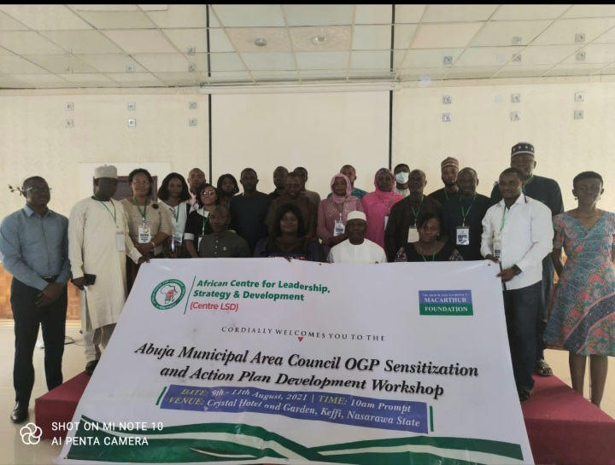
A group picture of all participants with the AMAC Chairman Hon. Abdullahi Adamu Candido
Table of Contents
- Introduction --------------------------------------------------------------------------2
- Background---------------------------------------------------------------------------2
- Location and Period of the Workshop---------------------------------------------2
- Attendance-----------------------------------------------------------------------------3
- Workshop Session and Discussion-------------------------------------------------3
- Next Steps------------------------------------------------------------------------------6
- Conclusion-----------------------------------------------------------------------------7
- Annex-----------------------------------------------------------------------------------8
- Introduction
The goal of the AMAC OGP workshop is to create a sensitization on OGP and to develop an action plan that entails the strategies and activities that will be carried out for the success of the AMAC OGP commitment. The workshop had facilitators from OGP secretariat and participants from AMAC, DEAN Initiative, Africa Centre for Leadership, Strategy & Development (Centre LSD), Partners West Africa Nigeria, Connected Development (CODE), BudgIt Nigeria, Action Aid Nigeria, and Africa Young Initiative. The workshop was hosted and implemented by Africa Centre for Leadership, Strategy & Development Centre (Centre LSD) and funded by John D. and Catherine T. Macarthur foundation.

- Background
Open Government Partnership (OGP) was founded in 2011 by government leaders and CSOs, who came together to create a partnership to promote more transparent, participatory, inclusive and accountable governance. The mission of OGP is to provide a domestic and international platform that will empower reformers inside and outside of government who are seeking to open up their government. Synchronously, OGP’s vision is to have more government that will become sustainably more transparent, accountable and responsive to their own citizens with the ultimate goal of improving the quality of public policies and services. The four cardinal principles of OGP are transparency, accountability, citizen’s participation, technology, and innovation.

- Location and Period of the Workshop
The workshop was held at Crystal hotel and garden conference hall, Keffi-Nasarawa state, from Monday 9th to Wednesday 11th August 2021.

- Attendance
The invited institutions which are listed below are mainly from AMAC, the OGP Secretariat and CSOs.

11 | AMAC
2 | DEAN Initiative
4 | Centre LSD
1 | PWAN
1 | BudgIt Nigeria
1 | CODE
1 | Action Aid Nigeria
2 | OGP Secretariat
1 | YDICL
1 | ASGLT

- Workshop Session and Discussion

Day 1; Monday, August 9th:
The workshop began with an opening remark by Mr. Uche of CLSD, outlining the purpose of the meeting. Afterwards, all participants introduced themselves. Moving further Mr. Abayomi from the OGP secretariat gave a brief overview on OGP which are as follows:

- An Overview of the OGP Process:
There are three processes which are embodied in OGP these are: partnership, development, and accountability.
Partnership- encompasses of identifying a lead ministry and collaborating with civil societies to create an action plan that will contain concrete reforms.
Development- necessitates the developing of an action plan. This action plan is the product of an open co-creation process between the government and CSOs.
Accountability – staying accountable by tracking progress and providing public accountability.
- What OGP is and what OGP is Not:
OGP is about the people, their general wellbeing, collaborative decision making, increased social impact and improved governance strategy.
OGP is not about change but transformation (i.e. OGP is a process), OGP is not about personal wellbeing, but the commonwealth of the people.
OGP is not about personal glory but about the collective elevation of the people.
- Eligibility Criteria:
For a government to be part of OGP, it must exhibit a demonstrated commitment to open government in four key dimensions:
- Fiscal transparency.
- Access to information.
- Public disclosure of assets.
- Citizen engagement.
- Nigeria’s OGP History:
Nigeria became a member of OGP in the year 2014, after achieving a score point of 12/16 (75%).

Day 2: Tuesday, August 10th:
The focus for the second day was on the chairman’s areas of focus for his second administration. This was presented by Mrs. Abiodun Essiet the special adviser to the chairman on ICT, donor agencies and civil societies.
The chairman’s area of focus for his second administration are:
- Education: to make education all inclusive including people living with disabilities.
- Development and Empowerment: to empower women and youths through skills acquisition, scholarships, capacity building and AMAC’s microfinance bank with zero interest to support small and medium businesses.
- Security: to create a more secure environment for the people of AMAC, through the creation of AMAC marshal.
She also spoke on that the strategy the chairman has used to achieve some of his programs which are:
- Multi-stakeholder partnership: multiple stakeholder partnership with CSOs and private investors to understand the needs of the people and to build a self-sustainable council.
- All Inclusive Governance: an all-inclusive governance which includes allowing women, marginal groups, vulnerable people contribute to the development of the council.
- Creation of a More United Area Council: through encouraging brotherhood between indigenes and other Nigerians- maintaining federal character in the council.

Important Questions from Day 2:
Question: How accessible is the Chairman’s empowerment program and is there a mechanism to track what the chairman is doing?
Answer: One of the ways the chairman’s empowerment program has become assessable to the people is through job creation by the invention of AMAC environmental cadet and marshal which has employed over 150 youths. Secondly through outreaches to people living with disabilities, the chairman distributes wheelchairs and other items to persons living with disabilities. Furthermore, everyone is been carried along during decision making this includes chiefs, members of communities and stakeholders.

After Mrs. Abiodun’s session, the chairman of AMAC Hon. Abdullahi Candido gave a brief speech in which he thanked the CSO’s for their partnership with AMAC and also emphasized on more partnership in the future. He also stated that he hopes the incoming administration picks up from where he stops as regards transparency and accountability. In conclusion he pledged to do the best he can and emphasized on the importance of accountability and transparency for good governance.

After the chairman’s speech, Mr. Abayomi gave a presentation on how to develop a good action plan. Key points from his presentation includes the following:
A good action plan must be ambitious, responsible and relevant to OGP and the people. A good action plan should take quality over quantity. A good action plan contains the following: objectives, commitments, goals, rationale, the problems to be addressed, milestone, activities, and expected results from the implementation of activities. Furthermore, Mr.Abayomi stated that a good action plan should reflects its objectives and illustrates specific commitments that the government, CSOs, private sectors and community based organization will work on in line with the principles of OGP.

On day 2, the AMAC OGP local steering committee was also inaugurated which was made up of officials from AMAC, DEAN Initiative, Centre LSD, CODE, Action Aid Nigeria and BudgIT Nigeria.

Day 3: Wednesday, August 9th:
At day 3, Mr. Uche started with the recap of day 2. The recap was followed by the focus for the third day which was creating the AMAC OGP action plan. This session was an exceedingly interactive session it was facilitated by Mr. Abayomi and Mrs. Terry Wills from the OGP secretariat.
The following were established:
- The first commitment for the action plan which is: to improve citizen’s engagement and participation in the budgetary process.
- The theme of the commitment which is: citizen’s engagement.
- The commitment description which is as follows: the commitment will ensure that information about the budgetary process is made available to citizens in an accessible and timely manner, so that citizens can make inputs across the budget cycle.
- Specific OGP challenges addressed by the commitment are: low citizen’s engagement, inadequate transparency and accountability mechanism around the budget process.
- The timeline for the action plan which is: August 2021 to September 2022.
- The rationale for the commitment: is that by increasing citizen’s awareness of the budgetary process, citizens will be equipped to make informed inputs to the various stages across the budget cycle which will further improve accountability in the government budgetary process and system.
- Planned activities are:
- Three zonal meetings are to be held by AMAC to sensitize and educate its citizens on their budget process.
- Creation of a budget calendar.
- Ward town hall meetings are to be held in order to collect community needs for the budget.

- Next Steps
The next steps are:
- The steering committee is to meet to develop the second commitment.
- A working group that will be part of the implementation of the action plan should be created.
- WhatsApp groups should be formed for all participants.
- AMAC is too schedule a meeting with the steering committee to give them a forecast on the 2022 budget process.

- Conclusion
Mrs. Olayinka the deputy director of CLSD thanked all the participants and gave an assurance for an exceptional support in the future. Mr. Semiye the Executive Director of DEAN Initiative, also thanked MacArthur foundation for providing all the funding needed for the success of the workshop. The workshop was officially closed at 3.30pm.

- Annex
AMAC OGP WORKSHOP- LIST OF ALL PARTICIPANTS
NO | NAME | ORGANIZATION | CONTACT
1 | Hon. Abdullahi Adamu Candido | AMAC | 09050709999
2 | Mr. Semiye Michael | DEAN Initiative | 08067616185
3 | Abiodun Esset | AMAC | 08060686872
4 | Olayinka Akeredolu Martins | Centre LSD | 07085362484
5 | Henry Omokhaye | BudgIT | 07068460897
6 | Ayodele.G. Shona | AMAC | 08034522555
7 | Doreen Mennom Oho | DEAN Initiative | 07088160467
8 | Yahaya Ojonugwa | AYFAI | 08145231261
9 | Patience Olaloye | AMAC | 0807884911
10 | ARCH. Gaza Z Andrew | AMAC | 07045381986
11 | Sani .M. Ibrahim | Action Aid | 0803683797
12 | Mustapha Alhaji Babakura | AMAC | 08037107063
13 | Victor Idajili | Greenkon | 08055581963
14 | Emmanuel Nwahiri | Centre LSD | 08169313873
15 | Mukhtar Halilu Modibbo | CODE | 08062919525
16 | Uche Ude | Centre LSD | 0803575468
17 | Samuel Asimi | CISLAC | 08136056279
18 | Hon. Mathias Aliyu | AMAC | 08058366726
19 | Usman Adamu | AMAC | 0805763617
20 | Ijeoma Igwe | PWAN | 08167903163
21 | Abdulwahab Ekekhide | YDICL | 07037057020
22 | Binta Attahiru | AMAC | 08069354531
23 | Hauwa Abubakar | AMAC | 07065088231
24 | Abdusalam Tanko | ASGLT | 08170632128
25 | Tari Wills | OGP Secretariat | 08039248859
26 | Abayomi Akimbo | OGP Secretariat | 08065434611

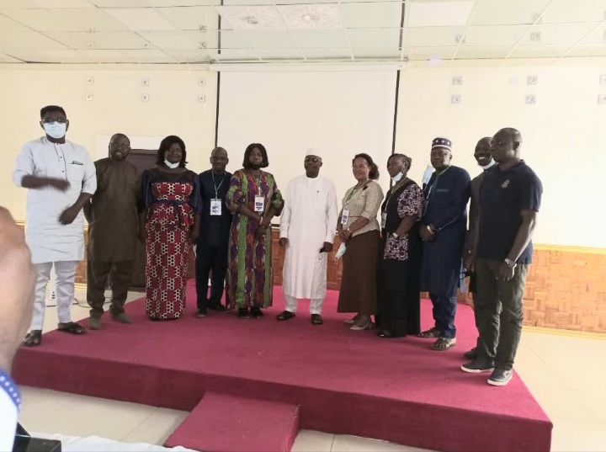
A group photo of the steering committee members.

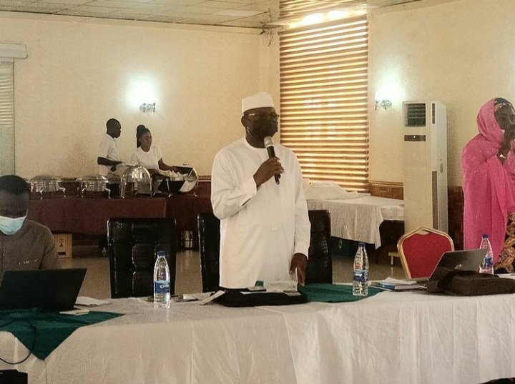
Honorable Chairman of AMAC Giving an Opening Remark during the Workshop.
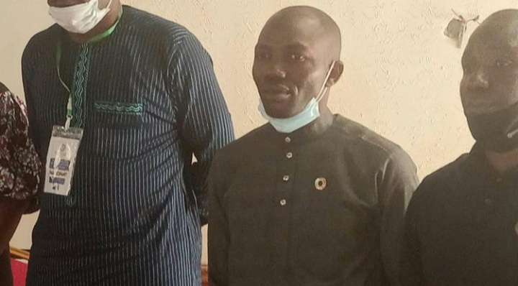
Mr. Semiye Michael Executive Director of DEAN Initiative during the workshop.

