SOUTH COTABATO OPEN GOVERNMENT PARTNERSHIP LOCAL ASSESSMENT REPORT
AS DECEMBER 2023

COMMITMENT TITLE: Harnessing Youth Power in Integrating Open Government Values and Mechanisms to Respond to Local
and Community-Interest Issues in the Province of South Cotabato

MILESTONE # | GOAL | DESCRIBE THE OUTPUT | START DATE | END DATE | RESPONSIBLE AGENCY | STATUS
1: Open Government Youth Ambassador Program for the Youth of South Cotabato  - Introduction to the Open Government Youth Ambassador Program | - Introduce participants to the program and to one another  - Go through initial program pitches and start working on teams  - Introduce the Open Government Partnership and open government values | - At least 50 ambassadors trained on open government values, processes, and best practices. | November 12, 2022 | November 12, 2022 | Youth Alliance for FOI, Sangguniang Kabataan Federation of South Cotabato, Provincial Youth Development Office and Provincial Planning and Development Office | It was conducted last November 12, 2022, at Provincial Covered Court, Capitol Compound, Alunan Avenue, Koronadal City. It was facilitated by OGP South Cotabato lead implementing partner, the Youth Alliance for Freedom of Information, based in Manila City. It was headed by their Emeritus Convenor, John Nelvin Santos, and Yuri Lemana Convenor and Renzo Polangco, Education and Research Coordinator. The Local Youth Development Office and Provincial Planning and Development Office-Special Projects Divisions also co-facilitated the activity. The activity was participated by youths from various SK members in the province (Youth Ambassador).
2: Issue-based Freedom of Activations – in Collaboration with the Youth of South Cotabato and the People of the Province of South Cotabato  - Freedom of Information: Policies and Practices  - Introduction to Open Contracting  - Introduction to Open Data | - Introduce the con freedom of information  - Introduce FOI EO and other pending/current legislation  - Discuss how can participants advocate for FOI  - Introduce the concept of open contracting  - Discuss how participants get involved in public procurement and ensure transparency and accountability in public contracting  - Introduce participants to the concept of open data  - Discuss how participants can advocate for open data | - At least three issue-based activations tied to need for better access to government information facilitated.  - The issues to be focused here will be based on a shortlist created during the co-creation sessions. | November 26, 2022  February 11, 2023 | November 26, 2022  February 11, 2023 | Youth Alliance for FOI, Sangguniang Kabataan Federation of South Cotabato, Provincial Youth Development Office and Provincial Planning and Development Office | The activity was conducted last November 26, 2023 via online platform Google Meet. The Basics of FOI and its Practical Use -E.O. No. 2, s. of 2016 -Status on bills for the right to FOI -Using the FOI for nation-building was presented by Ms. Jaya Illustrisimo, Training Specialist and Ms. Henessy Ozawa, FOI Engagement Officer from Freedom of Information -Project Management Office.  The Provincial Planning and Development Office together with the Local Youth Development Office and Youth Alliance for Freedom of Information facilitated the conduct of one of South Cotabato Open Government Partnership milestone activities, the Advocating for Open, Inclusive, and Participatory Governance session as part of the SC-OGP commitment to Harnessing Youth Power in Integrating Open Government Values and Mechanisms to Respond to Local and Community-Interest Issues in the Province of South Cotabato. It was conducted last February 11, 2023 and was actively participated by 75 youth leaders from various organizations/sectors in the province exceeding the original 67 participants.  The activity aimed to introduce youth leaders to open contracting, open data, and the importance of public inclusion in government processes. The session also unpacked how participants can advocate for citizens to participate in the government’s work and processes.  Mr. Vino Lucero, Emeritus Convenor of Youth Alliance for Freedom of Information, discussed the Concept of Open Contracting and Open Data. Mr. Redempto S. Parafina, Component Lead of USAID’s Cities for Enhanced Governance and Engagement (CHANGE) Project of the International City/Country Management Association (ICMA), shared his knowledge on Ensuring Inclusion and Citizen Participation in Public Processes.
3: Focus Issues Citizen Participation Drives  - Ensuring Inclusion and Citizen Participation in Public Processes | - Discuss the importance of public inclusion in government processes  - Unpack how participants can advocate for citizens to participate in the government’s work and processes | - At least three success stories on improving citizen participation in Open Government-related initiatives and locally relevant issues were highlighted. |  |  | Youth Alliance for FOI, Sangguniang Kabataan Federation of South Cotabato, Provincial Youth Development Office and Provincial Planning and Development Office
4: Issue-Based Open Government Capacity-Building Activities – for the Youth and Community Leaders of South Cotabato  - Introduction to Project Planning and Implementation  - Mentoring Break  - Program Culmination and Project Presentations | - Discuss project planning processes  - Provide tips on how to ensure smooth project implementation  - Review and improve project proposals  - Provide participants time to improve their proposals  - Provide time for participants to consult with program mentors  - Acknowledge the efforts of participants during the program  - Present end-of-program projects of the participants | - At least three capacity-building activities related to locally relevant issues and Open Government values facilitated.  - The topics to be focused on the capacity-building sessions will be based on a shortlist created during the co-creation sessions. | February 25, 2023  February 26, 2023  March 11, 2023 | February 25, 2023  March 10, 2023  March 11, 2023 | Youth Alliance for FOI, Sangguniang Kabataan Federation of South Cotabato, Provincial Youth Development Office, and Provincial Planning and Development Office | The Youth Ambassador Program: Introduction to Project Planning and Implementation was conducted on February 25, 2023. The activity aimed to capacitate the youth on project planning processes and provide tips on how to ensure smooth project implementation.  Mr. Yuri Lemana, Convenor of Youth Alliance for Freedom of Information, imparted his knowledge on the Basics of Project Planning and Implementation to the 75 youth leaders and representatives from different LGUs and Organizations in the Province of South Cotabato. The participants are expected to develop a project proposal on the OGP values of transparency, accountability, integrity, and citizen participation to address current issues and problems they encountered  On March 11, 2023 was the Culmination of Youth Ambassador. Seventy-five (75) youth leaders all over the Province successfully completed the said program. The highlight of the culmination was the presentation of the output of 5 groups which is the project proposals of youth projects and programs anchored on the OGP values of integrity, citizen participation, transparency, and accountability.  Panelists who commented on their project proposals were: Mr. Carlito Uy - Chairman of the SCIC, Mr. Yuri Lemana - Convenor of YAFOI, Ms. Carol Anne Balita - Asst. Convenor of YAFOI and Ms. Jobeelyn Baitus Corilla - Head of the Local Youth Development Office.  The event was an avenue for the youths - program ambassadors now, to showcase their proposals which reflect their desire to be the voice of their sector and community and their wanting to be actively involved in local governance as the future leaders in the province.
ADDITIONAL OGP ACTIVITY

Prepared and Submitted by: Noted by:

JENNIFER G. ILAO MARITES S. TANSECO
Project Development Officer II Project Development Officer IV
SPD Division Head

PHOTO DOCUMENTATION
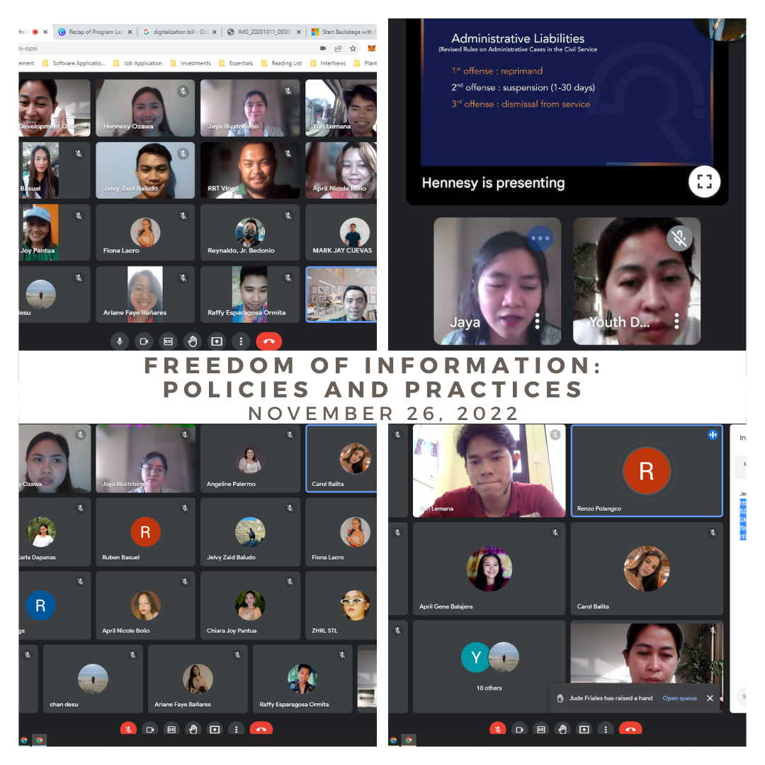
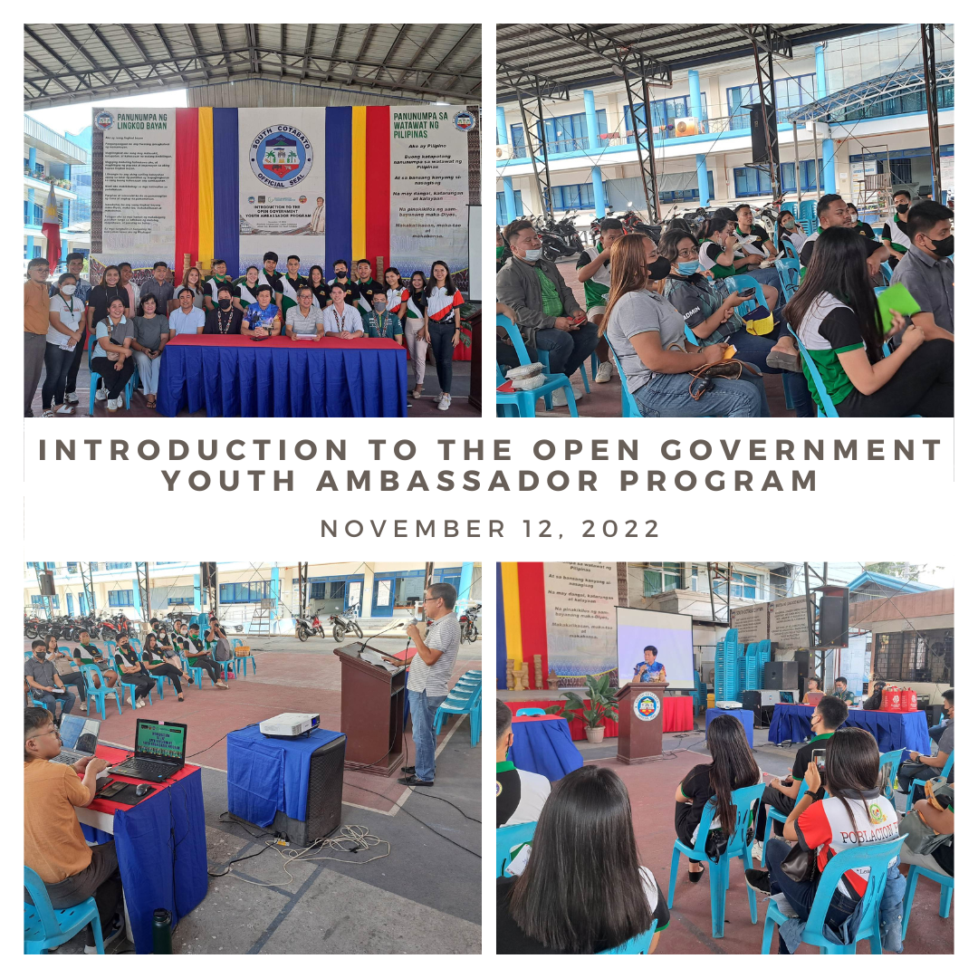

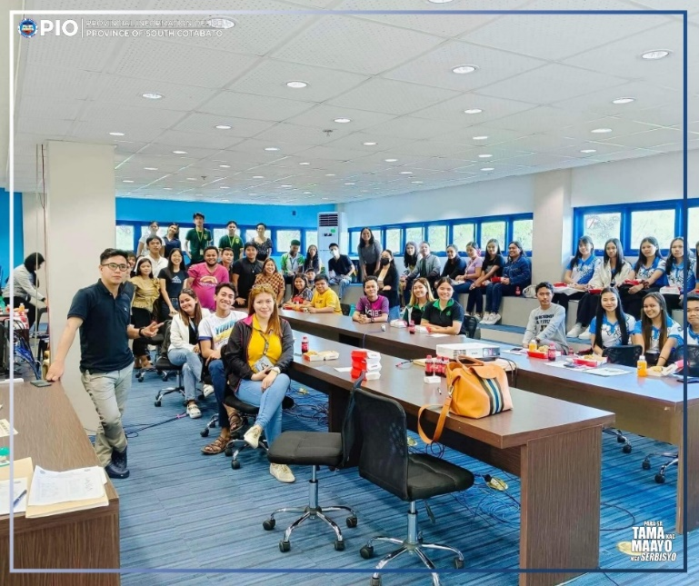
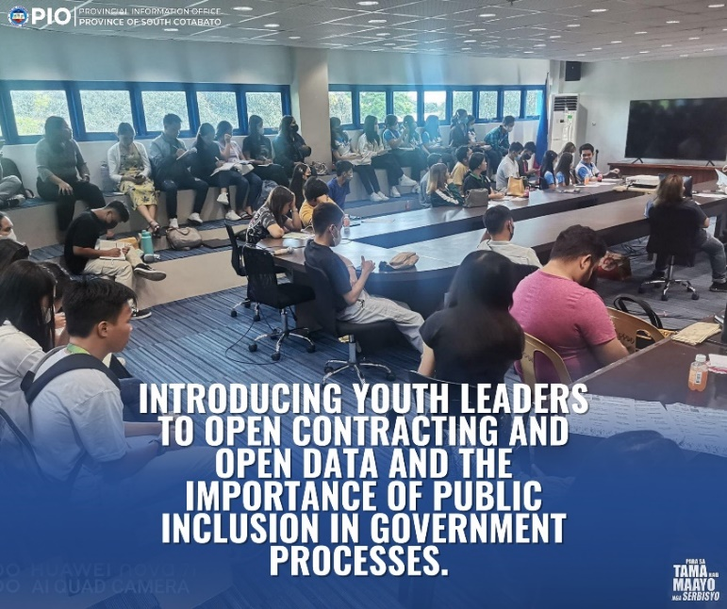
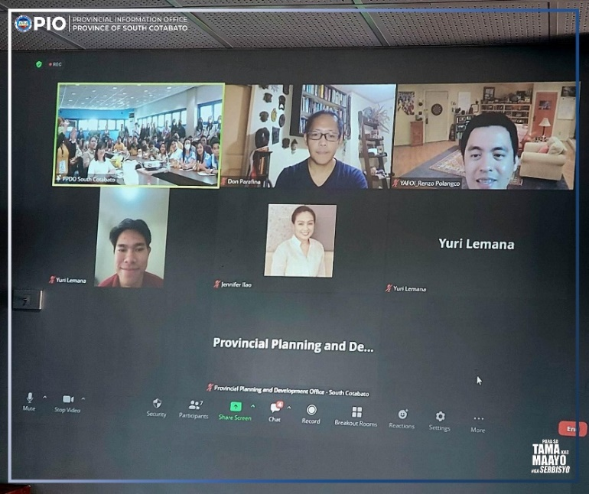
ADVOCATING FOR OPEN, INCLUSIVE, AND PARTICIPATORY GOVERNANCE

SOUTH COTABATO OPEN GOVERNMENT PARTNERSHIP YOUTH AMBASSADOR PROGRAM: INTRODUCTION TO PROJECT PLANNING AND IMPLEMENTATION
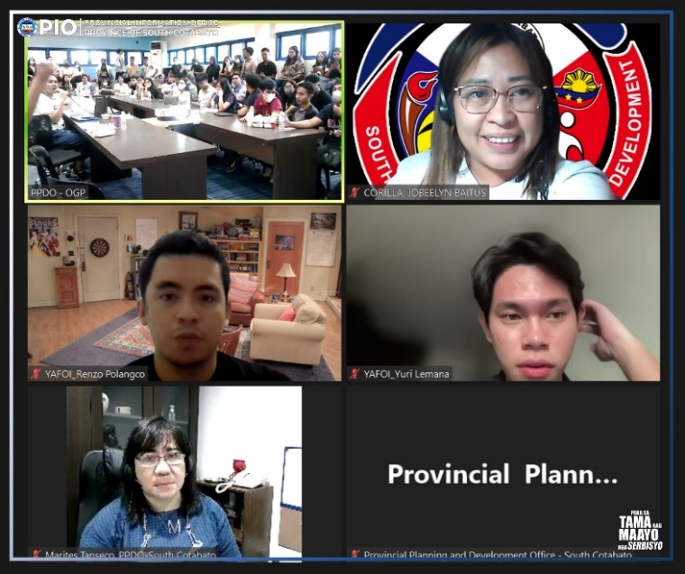
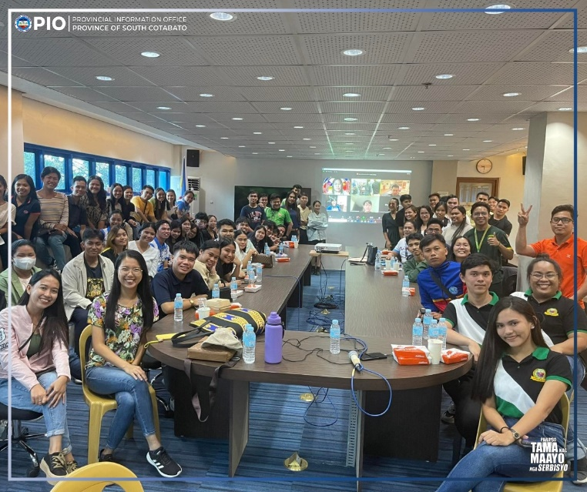
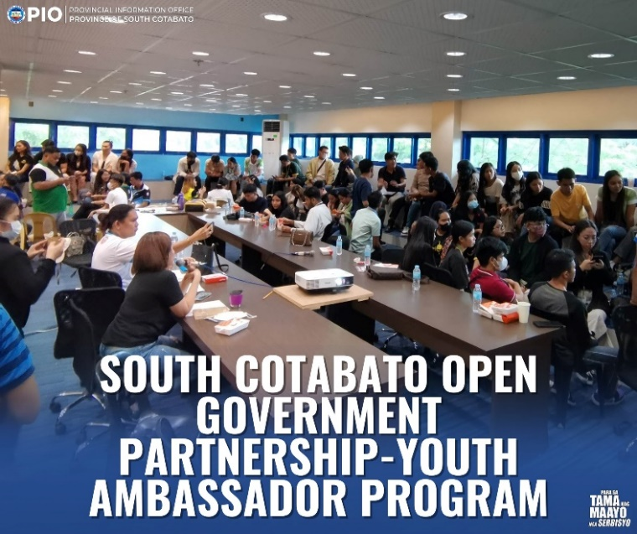
OPEN GOVERNMENT PARTNERSHIP YOUTH AMBASSADOR PROGRAM CULMINATION
