«e-Ternopil. Resident Portal»

1. Providing residents with quality municipal services through digital technologies, expanding the list of services, reengineering urban services and implementing a single information system of city management ((UATNP0001). Action Plan for the Implementation of the Open Government Partnership Initiative in the Ternopil Urban Territorial Community for 2021–2023
1.Description of the «e-Ternopil. Resident Portal» The «e-Ternopil. Resident Portal» is a unified digital platform for residents of the Ternopil urban territorial community, created to ensure access to administrative services, e-democracy tools, and communication with local self-government bodies.
The portal allows users to submit requests and inquiries, order services online, sign documents with an electronic signature, and participate in local surveys and consultations. The main goal of the platform is to improve the quality of municipal services, make them more accessible, reduce paper workload, and increase transparency in community governance.
The portal is available at: https://e-ternopil.gov.ua/

2.Overview of Sections
The portal includes three main functional sections:
Services – This section is designed for submitting applications for administrative services provided through the Administrative Services Center (CNAP). Residents can select a service, fill out an application, sign it with an electronic signature, track its status, and receive the result.
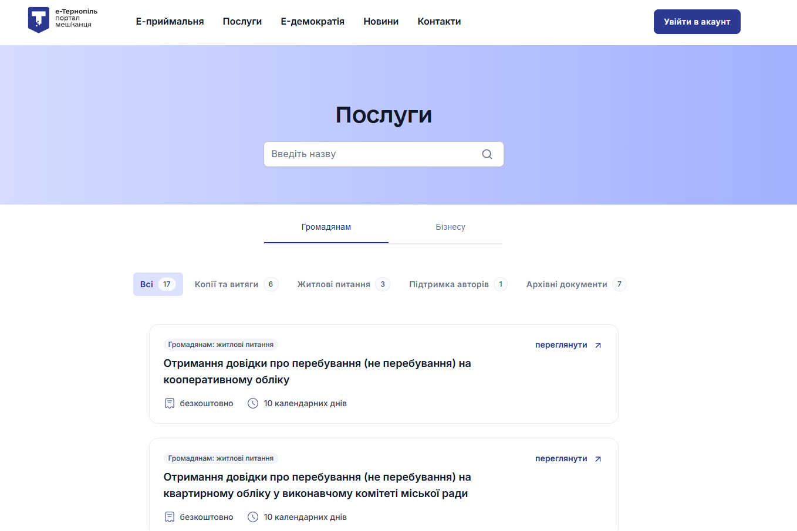
E-Reception – This section is intended for submitting citizen appeals, requests for public information, and electronic messages. All submitted documents are automatically registered in the document management system, and responses are delivered to the user’s electronic account.
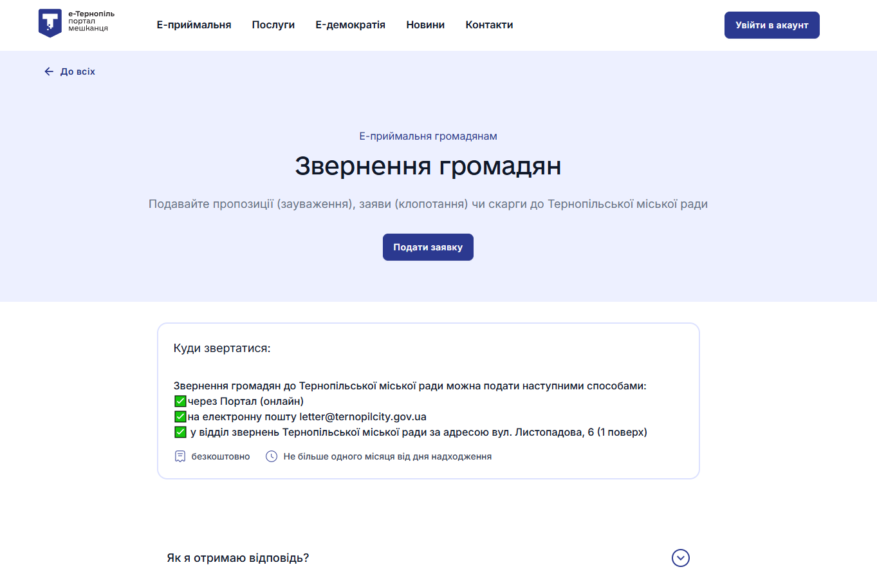

E-Democracy – This section allows residents to participate in public surveys and discussions on important issues. Voting is only available to authorized users.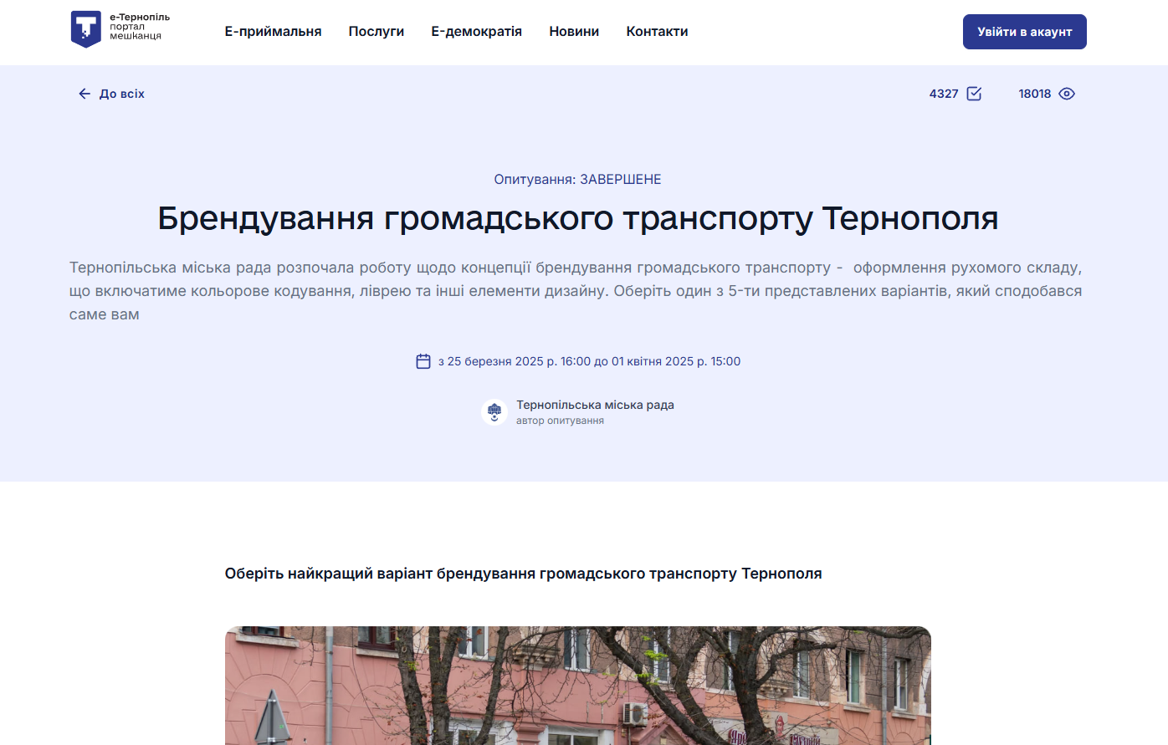

3. Results and statistics
The administrative panel of the portal provides tools for managing the platform’s functionality. Key modules include:
- Users – management of user profiles;
- Services – adding, editing, and monitoring administrative services;
- Surveys and Discussions – launching, moderating, and collecting statistics;
- Requests (e-Reception) – processing inquiries and requests;
- Activity Log – logging of administrative changes;
- Content Panel – management of textual content;
- Analytics – monitoring of service usage statistics.

The photo below shows the number of orders (as of the date of submission of the report - 380):
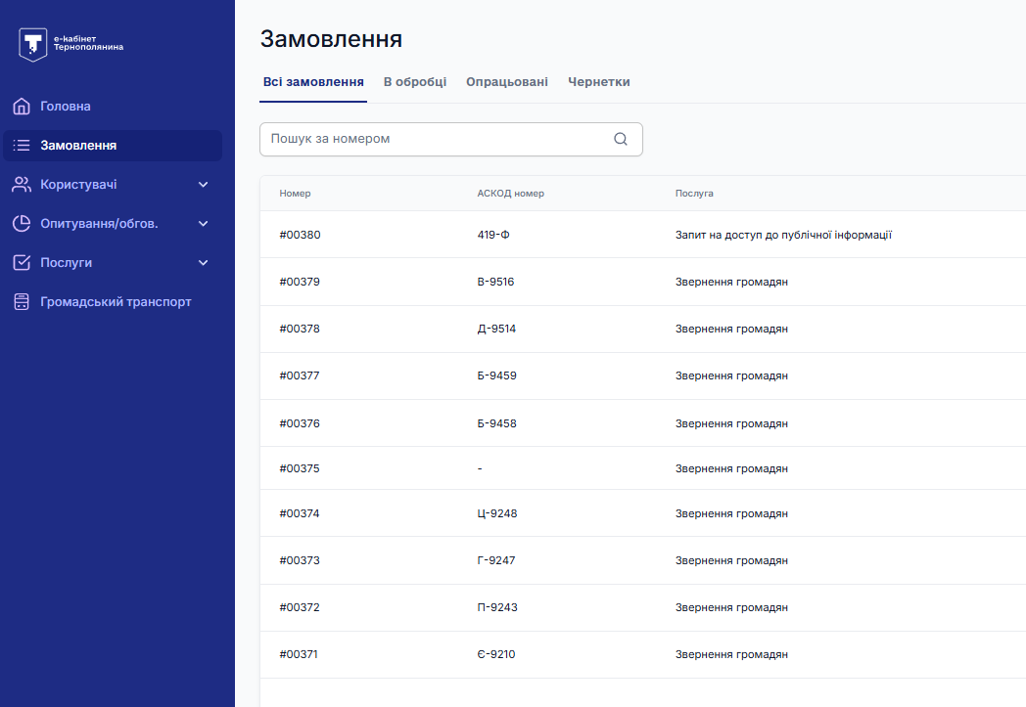
Number of Portal users: 6091 pages with 10 users on each page. Personal data of users is drawn
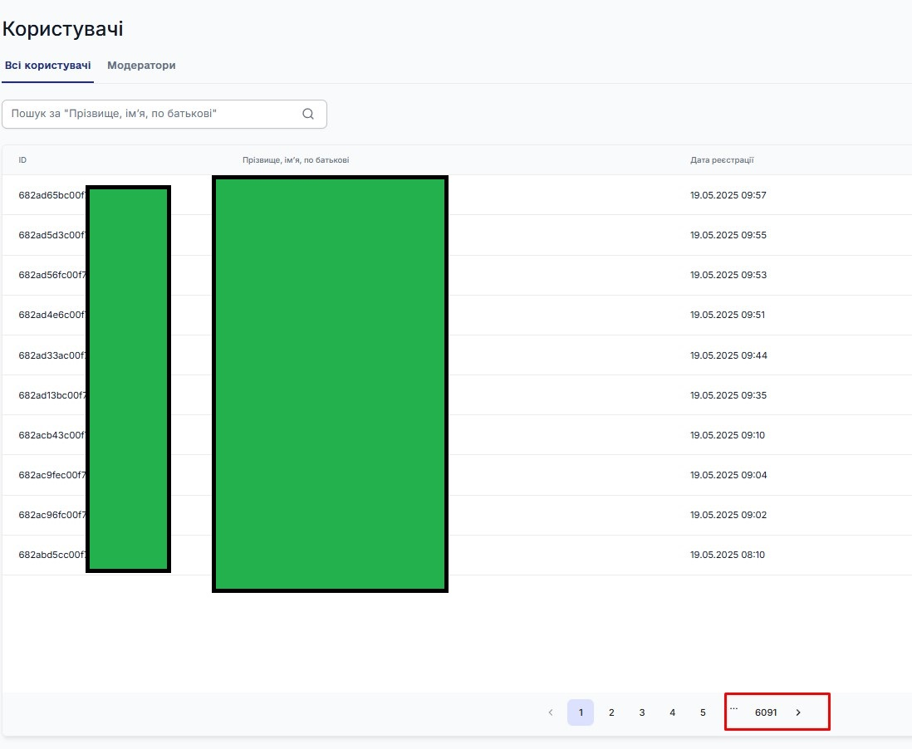
1,699 reviews collected through the new “Rate Your Ride” service:

